Android, iOS, iPhone, iPad &

Blackberry Web Service Connector

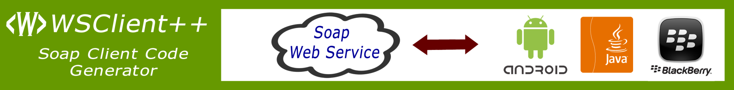

WSClient++ is a Soap (1.1 & 1.2) Web Service Client Code generation tool by NeuroSpeech, Inc for various Mobile Platforms.

**Java Edition for Android and Blackberry**

* Generates Soap 1.1/1.2 Client
* Asynchronous and Synchronous client
* Asynchronous responses are executed on UI Thread
* Support for Exceptions
* Support for Asynchronous Response Handler inner classes
* Support for Parcelable Implementation for Android, the Business data object can be easily moved between Activities.

**Cocoa Edition for iOS and Mac OS X**

* Generates Strongly Typed Soap 1.1/1.2 Client with Soap Headers
* Asynchronous and Synchronous client
* Support for Mac OS 10.5+, iPhone OS 3.0+, iOS 4.0+
* Display network activity animation while executing service call
* Support for NSError class
* Support for Web Service Method Response Protocols for Asynchronous calls

Small Memory Footprint, Faster execution compared to other limited free tools

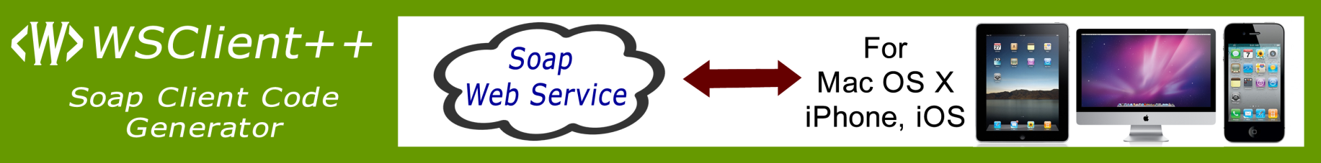

**Package Includes**

* Single Developer License
* Unlimited Royalty Free Distribution (Subjected to <http://wsclient.neurospeech.com/purchase/eula/> )
* Free Upgrades Subscription for 1 Year
* Email support within 2 Business Days

**Packages**

|  |  |
| --- | --- |
| WSClient++ for Java  For Android, Blackberry and Desktop Java | $199 |
| WSClient++ for Cocoa  For Objective-C on Mac OS 10.5+, iOS, iPhone OS 3.0+ | $199 |
| WSClient++ Mobile Edition  Combination of (Java and Cocoa)  For Android, Blackberry and Desktop Java  For Objective-C on Mac OS 10.5+, iOS, iPhone OS 3.0+ | $299 |
| WSClient++ for Flash  For Flex/Flex 4.5 Mobile | $199 |
| WSClient++ Suite  Everything in one Box | $399 |

Terms & Limitations:

For more detailed terms & limitations, please visit <http://wsclient.neurospeech.com> .

Prices are only valid till 31st December 2011 and are subjected to change thereafter.