Supplemental Material

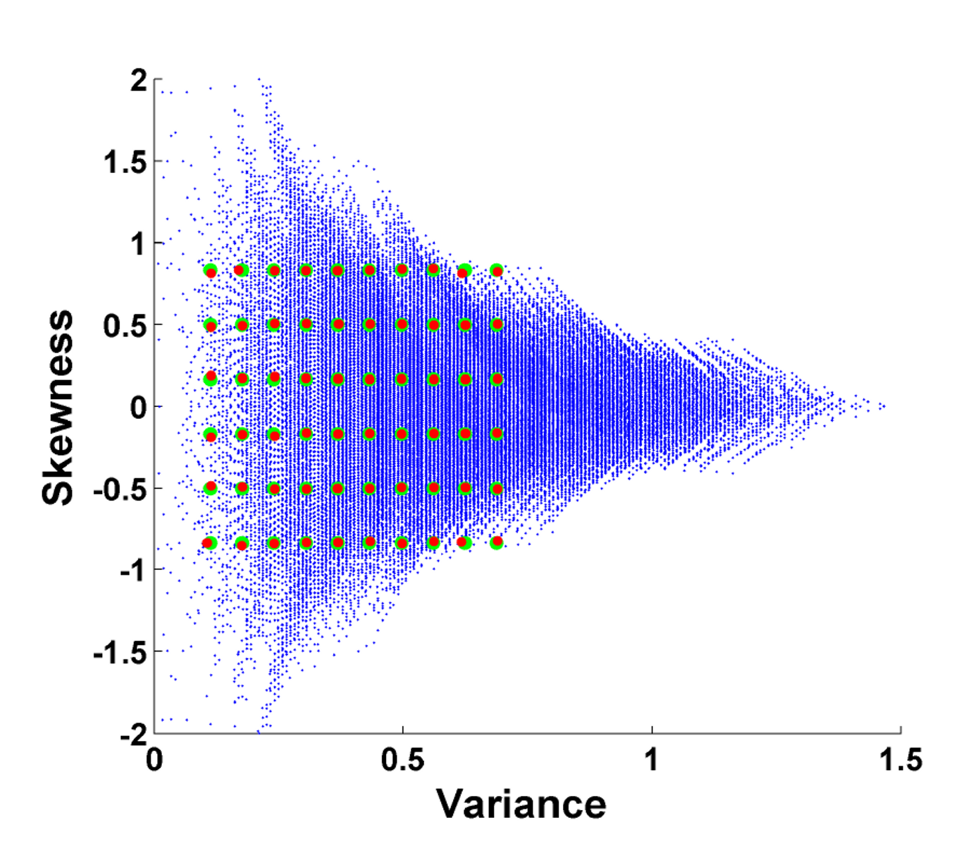

Supplementary Figure 1: Construction of stimulus set

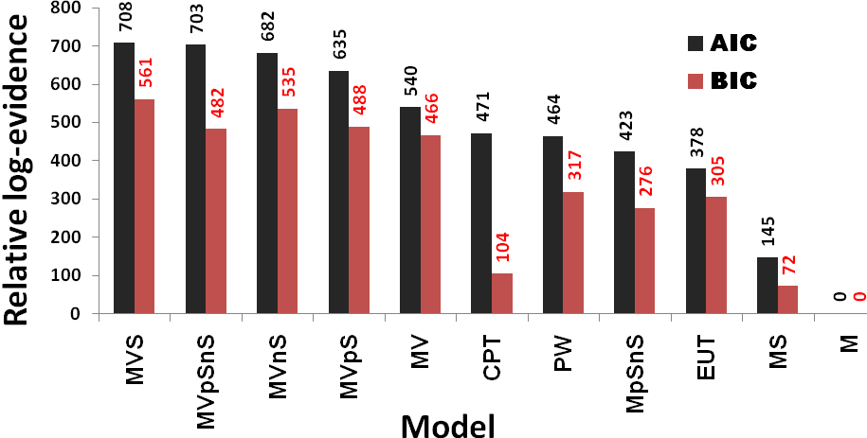

Supplementary Figure 2: Comparison of additional behavioural models

Supplementary Figure Legends

Supplementary Figure 1:
Figure of stimulus set construction, plotted as variance against skewness of lottery outcomes. Blue dots represent all possible gambles, constructed with EV = £1.26-£1.34, according to stimulus set constraints. Green dots represent desired array of stimuli, and red dots are the actual selected stimuli (n=60) for use in experiment, with independent manipulation of variance and skewness.

Supplementary Figure 2:
Comparison of models including: mean only (M), mean-variance (MV), mean-skewness (MS), mean-variance-skewness (MVS), power utility (EUT), mean-variance-positive skewness (MVpS), mean-variance-negative skewness (MVnS), mean-positve skewness-negative skewness (MpSnS), mean-variance-positive skewness-negative skewness (MVpSnS), probability weighting (PW) and cumulative prospect theory (CPT). Relative log-evidence, with model evidence approximated by either AIC or BIC to penalise for model complexity, calculated against worst performing M model, across subjects, and are given above each model. A higher relative log-evidence indicates a better model fit (higher model likelihood).

SUPPLEMENTARY TABLE 1
Table of lotteries used in experiment: 60 lotteries were generated to form the stimulus set for this experiment, orthogonal in variance and skewness by design. Lottery outcomes were between 20p and 260p, with associated probabilities varying in 0.1 intervals. The amounts and probabilities used for each lottery are shown (0 indicates that amount not shown in lottery). The expected value (pence), variance ((pence)² x 10⁻⁴) and skewness of each lottery are shown in the last 3 columns.

 | Amounts (p)
Lottery number | 0 | 20 | 40 | 60 | 80 | 100 | 120 | 140 | 160 | 180 | 200 | 220 | 240 | 260 | Expected value | Variance | Skewness
1 | 0 | 0 | 0 | 0.1 | 0 | 0.2 | 0.1 | 0.2 | 0.4 | 0 | 0 | 0 | 0 | 0 | 130 | 0.11 | -0.83
2 | 0 | 0 | 0 | 0.1 | 0 | 0.1 | 0.2 | 0.4 | 0 | 0.2 | 0 | 0 | 0 | 0 | 132 | 0.11 | -0.49
3 | 0 | 0 | 0 | 0 | 0.2 | 0.1 | 0.2 | 0.1 | 0.3 | 0.1 | 0 | 0 | 0 | 0 | 130 | 0.11 | -0.19
4 | 0 | 0 | 0 | 0 | 0.1 | 0.3 | 0.1 | 0.2 | 0.1 | 0.2 | 0 | 0 | 0 | 0 | 130 | 0.11 | 0.19
5 | 0 | 0 | 0 | 0 | 0.2 | 0 | 0.4 | 0.2 | 0.1 | 0 | 0.1 | 0 | 0 | 0 | 128 | 0.11 | 0.49
6 | 0 | 0 | 0 | 0 | 0.1 | 0.1 | 0.5 | 0.1 | 0 | 0.1 | 0.1 | 0 | 0 | 0 | 130 | 0.11 | 0.81
7 | 0 | 0 | 0.1 | 0 | 0.2 | 0 | 0.1 | 0.1 | 0.5 | 0 | 0 | 0 | 0 | 0 | 126 | 0.18 | -0.85
8 | 0 | 0 | 0 | 0.1 | 0.2 | 0 | 0.1 | 0.1 | 0.3 | 0.2 | 0 | 0 | 0 | 0 | 132 | 0.18 | -0.49
9 | 0 | 0 | 0.1 | 0 | 0 | 0.1 | 0.1 | 0.6 | 0 | 0 | 0 | 0.1 | 0 | 0 | 132 | 0.18 | -0.17
10 | 0 | 0 | 0.1 | 0 | 0 | 0 | 0.6 | 0.1 | 0.1 | 0 | 0 | 0.1 | 0 | 0 | 128 | 0.18 | 0.17
11 | 0 | 0 | 0 | 0.1 | 0.1 | 0.1 | 0.2 | 0.3 | 0.1 | 0 | 0 | 0.1 | 0 | 0 | 128 | 0.18 | 0.49
12 | 0 | 0 | 0 | 0.1 | 0 | 0.1 | 0.6 | 0 | 0 | 0.1 | 0 | 0.1 | 0 | 0 | 128 | 0.17 | 0.83
13 | 0 | 0.1 | 0 | 0 | 0.2 | 0 | 0.1 | 0.2 | 0.2 | 0.2 | 0 | 0 | 0 | 0 | 126 | 0.24 | -0.84
14 | 0 | 0 | 0.1 | 0.1 | 0 | 0 | 0.3 | 0.1 | 0.1 | 0.2 | 0.1 | 0 | 0 | 0 | 132 | 0.24 | -0.50
15 | 0 | 0 | 0.1 | 0 | 0.1 | 0.2 | 0 | 0.1 | 0.4 | 0 | 0 | 0.1 | 0 | 0 | 132 | 0.24 | -0.18
16 | 0 | 0 | 0 | 0.2 | 0 | 0.2 | 0.2 | 0.1 | 0 | 0.1 | 0.2 | 0 | 0 | 0 | 128 | 0.24 | 0.18
17 | 0 | 0 | 0.1 | 0 | 0.1 | 0.1 | 0.1 | 0.5 | 0 | 0 | 0 | 0 | 0.1 | 0 | 128 | 0.24 | 0.50
18 | 0 | 0 | 0 | 0 | 0.2 | 0.4 | 0.1 | 0 | 0 | 0.1 | 0.1 | 0.1 | 0 | 0 | 128 | 0.24 | 0.83
19 | 0 | 0.1 | 0 | 0.1 | 0.1 | 0 | 0 | 0.1 | 0.4 | 0.1 | 0.1 | 0 | 0 | 0 | 132 | 0.31 | -0.83
20 | 0 | 0 | 0.2 | 0 | 0.1 | 0.1 | 0 | 0 | 0.4 | 0.1 | 0.1 | 0 | 0 | 0 | 128 | 0.31 | -0.50
21 | 0 | 0.1 | 0 | 0 | 0.1 | 0.1 | 0.4 | 0 | 0 | 0 | 0.3 | 0 | 0 | 0 | 128 | 0.31 | -0.16
22 | 0 | 0 | 0.1 | 0 | 0.3 | 0 | 0.2 | 0.1 | 0 | 0 | 0.3 | 0 | 0 | 0 | 126 | 0.30 | 0.17
23 | 0 | 0 | 0 | 0.1 | 0.1 | 0.4 | 0 | 0 | 0.1 | 0.1 | 0 | 0.2 | 0 | 0 | 132 | 0.31 | 0.50
24 | 0 | 0 | 0 | 0 | 0.4 | 0.2 | 0.1 | 0 | 0 | 0.1 | 0 | 0.2 | 0 | 0 | 126 | 0.30 | 0.83
25 | 0.1 | 0 | 0.1 | 0 | 0 | 0 | 0.2 | 0.1 | 0.4 | 0 | 0 | 0.1 | 0 | 0 | 128 | 0.37 | -0.83
26 | 0 | 0 | 0.3 | 0 | 0 | 0 | 0.2 | 0 | 0 | 0.5 | 0 | 0 | 0 | 0 | 126 | 0.37 | -0.50
27 | 0 | 0 | 0.2 | 0.1 | 0 | 0 | 0.1 | 0.3 | 0 | 0.1 | 0.1 | 0.1 | 0 | 0 | 128 | 0.37 | -0.17
28 | 0 | 0 | 0.1 | 0 | 0.3 | 0 | 0.2 | 0 | 0 | 0.2 | 0 | 0.2 | 0 | 0 | 132 | 0.37 | 0.17
29 | 0 | 0.1 | 0 | 0 | 0 | 0.3 | 0.2 | 0.2 | 0 | 0 | 0.1 | 0 | 0 | 0.1 | 130 | 0.37 | 0.50
30 | 0 | 0 | 0.1 | 0 | 0.2 | 0.2 | 0.2 | 0 | 0 | 0.2 | 0 | 0 | 0 | 0.1 | 126 | 0.37 | 0.83
31 | 0.1 | 0 | 0.1 | 0.1 | 0 | 0 | 0.1 | 0 | 0.1 | 0.5 | 0 | 0 | 0 | 0 | 128 | 0.43 | -0.83
32 | 0.1 | 0 | 0.1 | 0 | 0.1 | 0 | 0.2 | 0.1 | 0 | 0.3 | 0 | 0.1 | 0 | 0 | 126 | 0.43 | -0.50
33 | 0 | 0 | 0.2 | 0.2 | 0 | 0 | 0 | 0.2 | 0 | 0.1 | 0.3 | 0 | 0 | 0 | 126 | 0.43 | -0.16
34 | 0 | 0.1 | 0 | 0.1 | 0 | 0.1 | 0.2 | 0.2 | 0.1 | 0 | 0 | 0 | 0.2 | 0 | 134 | 0.43 | 0.16
35 | 0 | 0 | 0.2 | 0 | 0 | 0.2 | 0.3 | 0 | 0.1 | 0 | 0 | 0 | 0.2 | 0 | 128 | 0.43 | 0.50
36 | 0 | 0 | 0 | 0.3 | 0 | 0.3 | 0 | 0.1 | 0.1 | 0 | 0 | 0.1 | 0 | 0.1 | 126 | 0.43 | 0.83
37 | 0.2 | 0 | 0 | 0 | 0 | 0 | 0.2 | 0.1 | 0.3 | 0 | 0.1 | 0.1 | 0 | 0 | 128 | 0.50 | -0.84
38 | 0 | 0.2 | 0.1 | 0 | 0 | 0 | 0.2 | 0 | 0 | 0.3 | 0.2 | 0 | 0 | 0 | 126 | 0.50 | -0.50
39 | 0 | 0.1 | 0.1 | 0.2 | 0 | 0 | 0 | 0 | 0.4 | 0 | 0 | 0.2 | 0 | 0 | 126 | 0.50 | -0.17
40 | 0 | 0.1 | 0 | 0.1 | 0.1 | 0.1 | 0.1 | 0.2 | 0 | 0 | 0.1 | 0 | 0.2 | 0 | 134 | 0.50 | 0.17
41 | 0 | 0 | 0.1 | 0.2 | 0.1 | 0 | 0.3 | 0 | 0 | 0 | 0.1 | 0 | 0.2 | 0 | 128 | 0.50 | 0.50
42 | 0 | 0 | 0.1 | 0.1 | 0 | 0.3 | 0.1 | 0.2 | 0 | 0 | 0 | 0 | 0 | 0.2 | 132 | 0.50 | 0.84
43 | 0.2 | 0 | 0 | 0 | 0 | 0.2 | 0 | 0 | 0.1 | 0.2 | 0.3 | 0 | 0 | 0 | 132 | 0.56 | -0.83
44 | 0.1 | 0 | 0.2 | 0 | 0.1 | 0 | 0 | 0 | 0 | 0.5 | 0 | 0.1 | 0 | 0 | 128 | 0.56 | -0.50
45 | 0.1 | 0 | 0.1 | 0 | 0.2 | 0.1 | 0 | 0 | 0.1 | 0.1 | 0.2 | 0 | 0.1 | 0 | 128 | 0.56 | -0.17
46 | 0 | 0 | 0.2 | 0.2 | 0 | 0 | 0 | 0.2 | 0 | 0.2 | 0 | 0.1 | 0 | 0.1 | 132 | 0.56 | 0.17
47 | 0 | 0 | 0.1 | 0 | 0.5 | 0 | 0 | 0 | 0 | 0.1 | 0 | 0.2 | 0 | 0.1 | 132 | 0.56 | 0.50
48 | 0 | 0 | 0.1 | 0.2 | 0.1 | 0.1 | 0.2 | 0 | 0.1 | 0 | 0 | 0 | 0 | 0.2 | 126 | 0.56 | 0.84
49 | 0.1 | 0.2 | 0 | 0 | 0 | 0 | 0 | 0 | 0.1 | 0.4 | 0.2 | 0 | 0 | 0 | 132 | 0.62 | -0.83
50 | 0.1 | 0.2 | 0 | 0 | 0 | 0 | 0.1 | 0 | 0.3 | 0.1 | 0 | 0.2 | 0 | 0 | 126 | 0.62 | -0.50
51 | 0.1 | 0.1 | 0.1 | 0 | 0 | 0 | 0.1 | 0.2 | 0.1 | 0.1 | 0.1 | 0 | 0 | 0.1 | 126 | 0.62 | -0.16
52 | 0 | 0.1 | 0.1 | 0.2 | 0.1 | 0 | 0 | 0 | 0.1 | 0.2 | 0 | 0 | 0.2 | 0 | 126 | 0.62 | 0.17
53 | 0 | 0.1 | 0.1 | 0 | 0.1 | 0.4 | 0 | 0 | 0 | 0 | 0 | 0 | 0.3 | 0 | 126 | 0.62 | 0.50
54 | 0 | 0 | 0 | 0.2 | 0.4 | 0 | 0.1 | 0 | 0 | 0 | 0 | 0.1 | 0 | 0.2 | 130 | 0.62 | 0.81
55 | 0.2 | 0.1 | 0 | 0 | 0 | 0 | 0 | 0 | 0.1 | 0.3 | 0.3 | 0 | 0 | 0 | 132 | 0.69 | -0.82
56 | 0.1 | 0.2 | 0 | 0 | 0 | 0 | 0 | 0.2 | 0.1 | 0 | 0.3 | 0 | 0.1 | 0 | 132 | 0.69 | -0.50
57 | 0.2 | 0 | 0 | 0 | 0.2 | 0.1 | 0 | 0 | 0 | 0.3 | 0.1 | 0 | 0 | 0.1 | 126 | 0.69 | -0.16
58 | 0 | 0.1 | 0.1 | 0.2 | 0 | 0 | 0.2 | 0 | 0 | 0.1 | 0 | 0 | 0.3 | 0 | 132 | 0.69 | 0.17
59 | 0 | 0 | 0.1 | 0.2 | 0.3 | 0 | 0 | 0 | 0 | 0 | 0.2 | 0 | 0 | 0.2 | 132 | 0.69 | 0.50
60 | 0 | 0 | 0 | 0.3 | 0.3 | 0.1 | 0 | 0 | 0 | 0 | 0 | 0 | 0.1 | 0.2 | 128 | 0.69 | 0.82

SUPPLEMENTARY TABLE 2

Response to Risk Dimensions: A. Anatomical locations of regions positively correlating with the lottery variance on each trial. B. Anatomical locations of regions correlating with increasing positive skewness on each trial. C. Anatomical locations of regions correlating with increasing negative skewness on each trial. We report significant clusters surviving correction at p≤0.05 († = cluster-level family-wise error whole-brain corrected p-value), or significant voxels at p≤0.05 within regions of interest (†† = voxel-level family-wise error corrected p-value). Peak voxel MNI coordinates within significant clusters are given, with corresponding voxel-level Z scores. We define anatomical ROIs by 2cm-diameter spheres centred upon MNI coordinates for anterior insula/inferior frontal gyrus, ventral striatum, and anterior cingulate/dorso-medial prefrontal cortex, where risk-related activation has previously been reported.
Area | L/R | MNI coordinates |  |  | Z score | P value | Cluster Extent
Area | L/R | x | y | z | Z score | P value | Cluster Extent
- Response to Variance
Posterior Parietal Cortex | R | 32 | -60 | 50 | 3.71 | 0.003† | 1318
Posterior Parietal Cortex | R | 28 | -46 | 46 | 3.66 | 0.003† | 1318
Posterior Parietal Cortex | R | 16 | -62 | 48 | 3.59 | 0.003† | 1318
- Response to Positive Skewness
Anterior insula / inferior frontal gyrus | R | 30 | 16 | -14 | 3.59 | 0.021†† | 117
Anterior insula / inferior frontal gyrus | L | -40 | 24 | -16 | 3.59 | 0.017†† | 67
Ventral Striatum | L | -10 | 4 | -14 | 3.36 | 0.033†† | 228
Ventral Striatum | L | -16 | 8 | -8 | 3.20 | 0.050†† | 228
- Response to Negative Skewness
Dorsal medial prefrontal cortex / medial frontal gyrus | R | 4 | 44 | 36 | 4.76 | <0.001† | 1673
Dorsal medial prefrontal cortex / medial frontal gyrus | L | -8 | 32 | 34 | 3.93 | <0.001† | 1673
Dorsal medial prefrontal cortex / medial frontal gyrus | L | -2 | 48 | 18 | 3.38 | <0.001† | 1673
SUPPLEMENTARY TABLE 3
Correlation of skew-related activity with skew-preference: 2nd-level analysis of anatomical locations of regions where the strength of the skewness response correlated with subject-specific skew-preferences (estimated from MVS model). We restrict our analysis to, and perform family-wise error correction for multiple comparisons within all voxels sensitive to skewness (identified at p<0.01 uncorrected). Voxels reported at p<0.05 corrected.

Area | L/R | MNI coordinates |  |  | Z score | P value | Cluster Extent
 |  | x | y | z
Anterior insula / inferior frontal gyrus | L | -36 | 24 | -16 | 4.36 | 0.007 | 80
Anterior insula / inferior frontal gyrus / BA45 | L | -56 | 18 | 6 | 4.09 | 0.018 | 38

SUPPLEMENTARY TABLE 4
Choice-related activity I: BOLD signal correlating with choice within variance- and skew-sensitive regions of interest. We report significant voxels at p<0.05, family-wise error corrected for regions of interest.

Area | L/R | MNI coordinates |  |  | Z score | P value | Cluster Extent
 |  | x | y | z
Posterior parietal cortex  (variance-sensitive voxels) | R | 26 | -60 | 54 | 4.03 | 0.008 | 547
Posterior parietal cortex  (variance-sensitive voxels) | R | 30 | -68 | 30 | 3.97 | 0.010 | 547
Posterior parietal cortex  (variance-sensitive voxels) | R | 18 | -62 | 30 | 3.70 | 0.023 | 547
Ventral Striatum  (skew-sensitive voxels) | L | -8 | 4 | -10 | 3.11 | 0.016 | 39
Ventral Striatum  (skew-sensitive voxels) | L | -16 | 4 | -15 | 2.83 | 0.033 | 39
Medial Prefrontal cortex  (skew-sensitive voxels) | R | 6 | 44 | 18 | 3.53 | 0.049 | 525

SUPPLEMENTARY TABLE 5
Choice-related activity II: Anatomical locations of regions expressing greater BOLD signal for gamble versus sure choices. We report significant clusters surviving correction at p<0.05 (cluster-level family-wise error corrected). Peak voxel MNI coordinates within significant clusters are given, with corresponding voxel-level Z scores.

Area | L/R | MNI coordinates |  |  | Z score | P value | Cluster Extent
 |  | x | y | z
Ventral Striatum | L | -6 | 8 | -4 | 4.59 | <0.001 | 2614
Ventral Striatum | R | 18 | 22 | -2 | 4.40 | <0.001 | 2614
Middle Frontal Gyrus | R | 20 | 40 | -14 | 4.43 | <0.001 | 2614
Occipital Lobe/BA17 | L | -14 | -94 | -8 | 4.34 | <0.001 | 1742
Occipital Lobe | L | -26 | -84 | -8 | 4.30 | <0.001 | 1742
Occipital Lobe/BA18 | L | -8 | -78 | -4 | 4.02 | <0.001 | 1742
Superior Parietal Lobe | L | -12 | -70 | 40 | 4.20 | 0.001 | 785
Superior Parietal Lobe | L | -20 | -60 | 52 | 3.42 | 0.001 | 785
Precuneus | L | -16 | -60 | 26 | 3.03 | 0.001 | 785
Superior Parietal Lobe | R | 26 | -60 | 54 | 4.03 | <0.001 | 1248
Parietal Lobe/Precuneus | R | 20 | -62 | 32 | 4.02 | <0.001 | 1248
Parietal Lobe/Mid-occipital gyrus | R | 30 | -68 | 30 | 3.97 | <0.001 | 1248

SUPPLEMENTARY TABLE 6
Interaction between choice and variance-preference: Regions where neural response to choice (gamble>sure) correlated with individual variance-preference. We report significant clusters at p<0.05 family-wise error whole-brain corrected († - family-wise error small volume corrected for region showing interaction between skew preference and choice). Peak voxel MNI coordinates within significant clusters are given, with corresponding voxel-level Z scores.

Area | L/R | MNI coordinates |  |  | Z score | P value | Cluster Extent
 |  | x | y | z
Superior Frontal Gyrus / Supplementary Motor Area | R | 6 | 20 | 58 | 4.10 | 0.014 | 790
Superior Frontal Gyrus / Supplementary Motor Area | R | 6 | 34 | 38 | 3.28 | 0.014 | 790
Superior Frontal Gyrus / Supplementary Motor Area | R | 8 | 24 | 36 | 3.73 | 0.014 | 790
Posterior Cingulate / BA29 | L | -2 | -38 | 20 | 3.76 | 0.026 | 699
Occipital Lobe / Lingual Gyrus | R | 20 | -72 | 0 | 3.43 | 0.026 | 699
Occipital Lobe - Cuneus | R | 12 | -70 | 6 | 3.36 | 0.026 | 699
Posterior Parietal Cortex / BA40 | R | 38 | -58 | 42 | 3.67 | 0.035 | 656
Posterior Parietal Cortex / BA40 | R | 48 | -58 | 40 | 3.14 | 0.035 | 656
Posterior Parietal Cortex / BA40 | R | 30 | -66 | 34 | 3.13 | 0.035 | 656
Anterior insula / inferior frontal gyrus | R | 46 | -4 | -14 | 3.31 | 0.040† | 57

SUPPLEMENTARY TABLE 7
Interaction between choice and skew-preference: Regions where neural response to choice (gamble>sure) correlated with individual skew preference. We report significant clusters at p<0.05 family-wise error corrected within regions of interest. Peak voxel MNI coordinates within significant clusters are given, with corresponding voxel-level Z scores.

Area | L/R | MNI coordinates |  |  | Z score | P value | Cluster Extent
 |  | x | y | z
Anterior Insula / Inferior Frontal Gyrus | L | -24 | 22 | -6 | 3.78 | 0.033 | 666
Anterior Insula / Inferior Frontal Gyrus | L | -10 | 12 | -12 | 3.29 | 0.033 | 666
Anterior Insula / Inferior Frontal Gyrus | L | -38 | 4 | -4 | 3.11 | 0.033 | 666
Insula / Superior Temporal Gyrus | R | 54 | -4 | -12 | 3.60 | 0.039 | 643
Insula / Superior Temporal Gyrus | R | 52 | 2 | -2 | 3.59 | 0.039 | 643
Insula / Superior Temporal Gyrus | R | 46 | -8 | -14 | 3.53 | 0.039 | 643

