Supplemental Material
Cingulate Cortex Functional Connectivity Correlates with Relapse in Alcohol Dependents
Yasmin Zakiniaeiz, Dustin Scheinost, Dongju Seo, Rajita Sinha, R. Todd Constable
- Supplemental methods and results
  - Individualized imagery method
  - Script development
  - Efficacy of script-driven imagery manipulation
  - Imaging parameters
  - Common space registration
  - Motion analysis
  - Scaling of ICD Maps
  - Global signal regression (GSR)
  - Additional Main Effects
  - Region of interest connectivity
- Supplemental tables and figures
  - Figure S1: Group comparisons of all AD patients and 30 HC participants
  - Figure S2: Group comparisons of all AD patients and 30 HC participants
- Supplemental references

Supplemental Methods and Results
Individualized imagery method
The script-driven, individualized imagery method was adapted from previously developed methods used extensively in anxiety-disordered patients (Lang et al, 1980; McNeil et al, 1993). These imagery methods have been adapted to study the interplay of emotion, stress, and drug craving in a number of laboratory and imaging studies (Cooney et al, 1997; Fox et al, 2012; Fox et al, 2007; Hommer et al, 2012; Jastreboff et al, 2011; Li et al, 2005; Potenza et al, 2012; Seo et al, 2011; Sinha et al, 2009; Sinha et al, 2011). These imagery scripts show reliable prospective association between biological stress responses (i.e. heart rate, blood pressure and cortisol levels) and drug craving in several substance abuse populations, including cocaine (Fox et al, 2012; Potenza et al, 2012) and alcohol dependents (Sinha et al, 2009; Sinha et al, 2011). This reliable association provides external validity of our methods.
Script development
Two individualized scripts each for condition (neutral, stress, and alcohol-cue states) were developed. Participants were ask to recount recent life experiences related to stress, and alcohol and to rate each experiences on a 10-point Likert scale (1 = not at all stressful and 10 = the most stressful). Only those situations rated as 8 or above were selected for script development. Stress scripts were developed from recent experiences of highly distressing and upsetting situations that include an inability to control the situation in that moment. Examples of stressful situations included unemployment, conflicts with significant others, or family problems. Alcohol-cue scripts were developed from personal experiences of alcohol-related situations and subsequent alcohol consumption (e.g., seeing others drinking alcohol, meeting friends at a bar). Drinking situations involving negative affect or emotional distress were excluded. Neutral scripts were developed based on commonly experienced, individual neutral-relaxing situations (e.g., laying on the beach and listening to the waves or sitting in a park and reading on a Sunday afternoon). AD patients and healthy control participants underwent identical procedures.
Efficacy of script-driven imagery manipulation
The following procedures were implemented to ensure efficacy of the imagery manipulation. First, all participants completed the Questionnaire on Mental Imagery (QMI(Sheehan, 1967)) for the assessment of mental imagery ability, and individuals with average or above levels of imagery ability were included (Sinha, 2009). There were no statistical differences in scores of QMI between the 30 AD (M = 68.07, SD = 23.84) and 30 HC (M = 67.37, SD = 22. 51) participants, suggesting that two groups had equivalent levels of mental imagery ability. Imagery ability in all 45 AD patients (M = 69.24, SD = 25.02) was also equivalent to this level.
Next, prior to the scanning session, a structured relaxation and imagery training procedure was implemented to minimize variability in imagery ability (Sinha, 2009).
Finally, immediately following each imagery trial, participants rated imagery vividness on a 10-point Likert scale (1 = cannot visualize the image and 10 = extremely clear, ‘as if’ it were happening right now). There were no differences between AD patients and healthy controls across conditions in vividness of the imagery (30 HC: M = 8.4, SD = 1.23; 30 AD: M = 8.8, SD = 0.79; 45 AD: M = 8.8, SD = 0.86).
Imaging Parameters
Participants were scanned on a Siemens 3T Tim Trio scanner. For each subject, a high-resolution 3D Magnetization Prepared Rapid Gradient Echo (MPRAGE) sequence was acquired (repetition time (TR) = 2530 ms, echo time (TE) = 3.34 ms, bandwidth = 180 Hz/pixel, flip angle (FA) = 7°, field of view (FOV) = 256x256 mm, matrix=256x256, slice thickness = 1mm). A 2D anatomical image with the same slice locations as the functional data parallel to the AC-PC line was acquired (TR = 300 ms, TE = 2.5 ms, bandwidth = 300 Hz/pixel, FA=60°, FOV=220x220 mm, matrix = 256x256, slices =32, slice thickness = 4mm). Functional data were collected using a T2*-sensitive gradient-recalled single shot echo-planar pulse sequence (TR=2000 ms, TE=25 ms, bandwidth = 300 Hz/pixel, FA=85°, FOV=220x220 mm, matrix = 64x64, slices = 32, slice thickness = 4mm). The first ten volumes of each functional time series were discarded to allow the signal to reach a steady state.
Common space registration
To facilitate comparisons of imaging data, all single participant ICD results were warped to common space through the concatenation of a series of linear and non-linear registrations. The functional series were linearly registered to the 2D anatomical image. The 2D anatomical image was linearly registered to the 3D anatomical image. The 3D anatomical image was non-linearly registered to the template brain. All transformation pairs were calculated independently and combined into a single transform warping the single participant results into common space. This single transformation allows the single participant images to be transformed to common space with only one transformation, reducing interpolation error. All transformations were estimated using the intensity-only component of the method implemented in BioImage Suite.
Motion analysis
As group differences in motion have been shown to confound functional connectivity results (Van Dijk et al, 2012), frame-to-frame displacement was calculated for each subject and condition. We performed a 3x2 repeated measure analysis of variance using R. There were no significant effects for the cue condition (F=3.06, p=0.051), group (F=0.05, p=0.986), or interaction (F=2.30, p=0.11) terms. As the condition and groupXcondition interaction were approaching significance, we employed an iterative smoothing algorithm during preprocessing and z-score normalization of individual ICD maps. Both methods have been shown to minimize motion confounds associated with fMRI connectivity even when significant between group motion is present (Scheinost et al, 2014; Yan et al, 2013).
Global signal regression (GSR)
Notably, GSR can possibly induce some negative relationships (Murphy et al, 2009), thus complicating interpretation. However, competing evidence demonstrates that this pre-processing step is critical to optimize specificity of findings (Fox et al, 2009), removing CO2 variation, and minimizing motion confounds (Power et al, 2014). Current GSR is widely used in the literature and by other groups conducting whole connectivity analyses (Anticevic et al, 2013). Irrespective of this issue, both groups underwent identical preprocessing steps – thus, observed differences cannot be driven by GSR alone.
Region of interest connectivity
Follow-up region of interest (ROI) analysis was performed to explore (post-hoc) the nodes which might have contributed to the cingulate connectivity changes for the AD patients. Three ROIs (ACC, MCC, and PCC) were defined on the reference brain based our main effects of condition (Figure 1). ROIs were, then, transformed back (via the inverse of the transforms described above) into individual participant space. The time course of the reference region in a given participant was then computed as the average time course across all voxels in the reference region. This time course was correlated with the time course for every other voxel in the gray matter to create a map of r-values, reflecting ROI-to-whole-brain connectivity. These r-values were transformed to z-values using Fisher's transform yielding one map for each participant representing the strength of correlation to the seed region.
These ROI connectivity analysis revealed significant main effects of as shown in Figure S1. ROI connectivity from the ACC showed weaker connectivity to the ventral medial prefrontal cortex (PFC) and the left caudate for the alcohol and stress conditions compared to the neutral conditions. Additionally, comparisons of stress and neutral conditions showed reduced connectivity in the auditory cortex and greater connectivity in left BA 17 and left BA 37. ROI connectivity from the MCC showed weaker connectivity to the PFC/ACC, auditory cortex, and lateral partial regions of the default mode network and stronger connectivity to BA 17, and BA 37 for the alcohol and stress conditions compared to the neutral conditions. Additionally, comparisons of stress and neutral conditions showed reduced connectivity to the PCC. ROI connectivity from the PCC showed weaker connectivity to local PCC/precuneus and stronger connectivity to the left dorsal lateral PFC. Additionally, comparisons of stress and neutral conditions showed reduced connectivity to the VMPFC and auditory cortex. No significant differences were observed for comparisons between the alcohol and the stress conditions for any of the three seed regions.

Supplemental tables and figures
Table S1: Demographics
 | 45 Alcohol Dependents |  | 30 Alcohol Dependents |  | 30 Healthy Controls |  | 30AD v. 30HC P value
 | Mean | SE | Mean | SE | Mean | SE | P
Age | 37.73 | 1.16 | 35.97 | 0.08 | 34.47 | 1.55 | >0.1
Shipley IQ | 109.11 | 1.30 | 111.20 | 13.03 | 112.50 | 1.29 | >0.1
Years Education | 12.49 | 0.24 | 13.03 | 1.40 | 14.27 | 0.32 | >0.1
Alcohol Use
Average Years Alcohol Use | 18.62 | 1.312 | 16.43 | 1.65 | 10.77 | 1.86 | <0.05
Average Alcohol Drinks/Month | 398.46 | 43.52 | 384.86 | 47.87 | 13.23 | 2.96 | <0.01
Average Alcohol Days/Month | 19.38 | 1.45 | 18.93 | 1.81 | 4.80 | 1.19 | <0.01
 | N | % | N | % | N | %
Gender
Male | 35 | 77.8 | 22 | 73.3 | 21 | 70.0 | >0.1
Female | 10 | 22.2 | 8 | 26.7 | 9 | 30.0
Race/Ethnicity
African American | 14 | 31.1 | 9 | 30 | 7 | 23.3 | >0.1
Caucasian | 30 | 66.7 | 20 | 66.7 | 18 | 60.0
Hispanic | 0 | 0.0 | 0 | 0.0 | 5 | 16.7
Other | 1 | 3.3 | 1 | 3.3 | 0 | 0.0
Number of Daily Smokers | 39 | 86.7 | 25 | 83.3 | 5 | 16.7 | <0.01
Lifetime Prevalence Disorder
PTSD | 4 | 8.9 | 2 | 6.7 | 3 | 10.0 | >0.1
Anxiety | 3 | 6.7 | 0 | 0.0 | 3 | 10.0 | >0.1
Depression | 6 | 13.3 | 5 | 16.7 | 6 | 20.0 | >0.1

Abbreviations: AD = Alcohol Dependents, HC = Healthy Controls, SE = Standard Error, IQ = Intelligence Quotient, N= Number of Participants, PTSD = Post Traumatic Stress Disorder
There are no group differences between 30AD and 30HC groups except for alcohol use measures and smoking status; smoking status was included as a covariate in all data analyses comparing groups.

Table S2: Main effect of cue trials
Brodmann Area | Volume (mm³) | F-value | X | Y | Z
R BA23 | 1271 | 17.4374 | 6 | -42 | 27
R BA31 | 441 | 14.2886 | 12 | -48 | 34
R BA24 | 296 | 10.9157 | 3 | 33 | 12
R BA32 | 246 | 10.151 | 9 | 36 | 9

Abbreviations: R = Right, BA = Brodmann Area
Table S3: Cox proportional regression models of connectivity predicting time to relapse
Variable | Condition | Z | P | HR (95% CI)
ACC
ICD | Neutral | 2.17 | 0.03 | 5.4 (1.2-24.8)
Years of nicotine smoking |  | 1.20 | 0.23 | 1.0 (0.99-1.1)
Years of alcohol use |  | 1.67 | 0.09 | 1.0 (0.99-1.1)
MCC
ICD | Neutral | 1.96 | 0.05 | 4.5 (1.0-21.1)
Years of nicotine smoking |  | 1.41 | 0.14 | 1.0 (0.98-1.0)
Years of alcohol use |  | 1.46 | 0.16 | 1.0 (0.99-1.1)
PCC
ICD | Alcohol-Stress | -2.12 | 0.04 | 0.03 (0.0-0.57)
Years of nicotine smoking |  | 1.18 | 0.24 | 1.0 (0.99-1.1)
Years of alcohol use |  | 1.51 | 0.13 | 1.0 (0.99-1.1)
Abbreviations: CI=confidence intervals, ICD=Intrinsic Connectivity Distribution, ACC=anterior cingulate cortex, PCC=posterior cingulate cortex, MCC=mid cingulate cortex, HR=hazard ratio.

Table S4: CueXGroup interaction
Brodmann Area | Volume (mm³) | F-value | X | Y | Z
R BA24 | 1020 | 10.5718 | 6 | -6 | 36
R BA23 | 793 | 10.2472 | 3 | -30 | 24
R BA18 | 791 | 9.8542 | 18 | -65 | 18
R BA31 | 267 | 9.3602 | 6 | 6 | 15

Abbreviations: L = Left, R = Right, BA = Brodmann Area
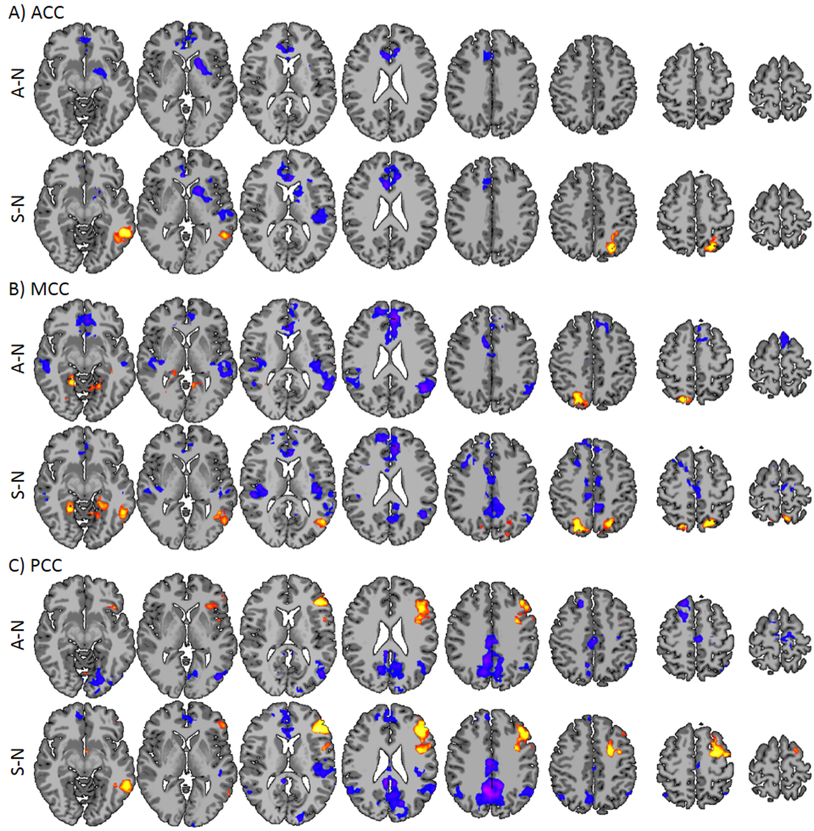
Figure S1: Follow up ROI connectivity analysis for Study 1. Follow up ROI connectivity was preformed for the three regions derived from the ICD analysis. A) ACC, B) MCC, C) PCC show significant differences between the alcohol or stress condition and the netural condition. Comparison between the alcohol and stress conditions showed no significant differences for any of the ROIs.

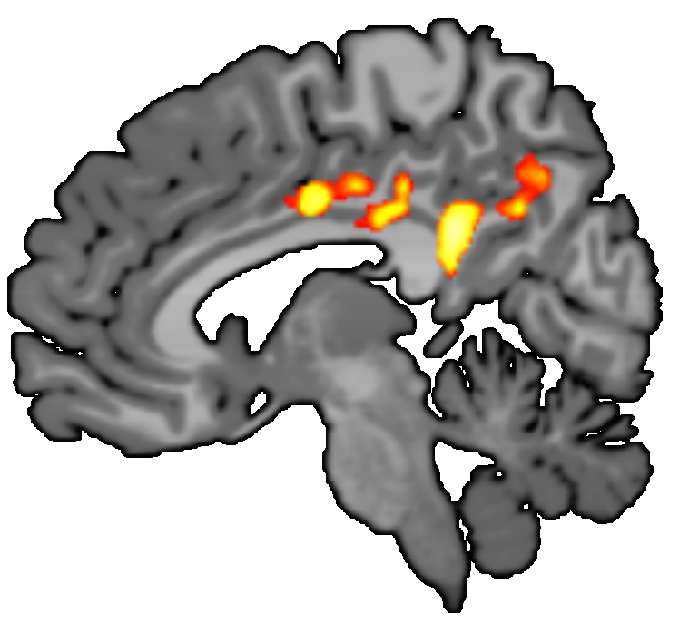
Figure S2: Group comparisons of all AD patients and 30 HC participants. Qualitatively, the cue by group interaction is similar to the one presented in Figure 3. Results are shown at p<0.05, corrected.

Supplemental references

Anticevic A, Hu S, Zhang S, Savic A, Billingslea E, Wasylink S, et al (2013). Global Resting-State Functional Magnetic Resonance Imaging Analysis Identifies Frontal Cortex, Striatal, and Cerebellar Dysconnectivity in Obsessive-Compulsive Disorder. Biol Psychiatry.

Cooney NL, Litt MD, Morse PA, Bauer LO, Gaupp L (1997). Alcohol cue reactivity, negative-mood reactivity, and relapse in treated alcoholic men. J Abnorm Psychol 106(2): 243-250.

Fox H, Seo D, Tuit K, Hansen J, Kimmerling A, Morgan PT, et al (2012). Guanfacine effects on stress, drug craving and prefrontal activation in cocaine dependent individuals: preliminary findings. J Psychopharmacol.

Fox HC, Bergquist KL, Hong KI, Sinha R (2007). Stress-induced and alcohol cue-induced craving in recently abstinent alcohol-dependent individuals. Alcohol Clin Exp Res 31(3): 395-403.

Fox MD, Zhang D, Snyder AZ, Raichle ME (2009). The global signal and observed anticorrelated resting state brain networks. J Neurophysiol 101(6): 3270-3283.

Hommer RE, Seo D, Lacadie CM, Chaplin TM, Mayes LC, Sinha R, et al (2012). Neural correlates of stress and favorite-food cue exposure in adolescents: A functional magnetic resonance imaging study. Hum Brain Mapp.

Jastreboff AM, Potenza MN, Lacadie C, Hong KA, Sherwin RS, Sinha R (2011). Body mass index, metabolic factors, and striatal activation during stressful and neutral-relaxing states: an FMRI study. Neuropsychopharmacology 36(3): 627-637.

Lang PJ, Kozak MJ, Miller GA, Levin DN, McLean A, Jr. (1980). Emotional imagery: conceptual structure and pattern of somato-visceral response. Psychophysiology 17(2): 179-192.

Li CS, Kosten TR, Sinha R (2005). Sex differences in brain activation during stress imagery in abstinent cocaine users: a functional magnetic resonance imaging study. Biol Psychiatry 57(5): 487-494.

McNeil DW, Vrana SR, Melamed BG, Cuthbert BN, Lang PJ (1993). Emotional imagery in simple and social phobia: fear versus anxiety. J Abnorm Psychol 102(2): 212-225.

Mitchell MR, Balodis IM, Devito EE, Lacadie CM, Yeston J, Scheinost D, et al (2013). A preliminary investigation of Stroop-related intrinsic connectivity in cocaine dependence: associations with treatment outcomes. Am J Drug Alcohol Abuse 39(6): 392-402.

Murphy K, Birn RM, Handwerker DA, Jones TB, Bandettini PA (2009). The impact of global signal regression on resting state correlations: are anti-correlated networks introduced? Neuroimage 44(3): 893-905.

Potenza MN, Hong KI, Lacadie CM, Fulbright RK, Tuit KL, Sinha R (2012). Neural correlates of stress-induced and cue-induced drug craving: influences of sex and cocaine dependence. Am J Psychiatry 169(4): 406-414.

Power JD, Mitra A, Laumann TO, Snyder AZ, Schlaggar BL, Petersen SE (2014). Methods to detect, characterize, and remove motion artifact in resting state fMRI. Neuroimage 84: 320-341.

Scheinost D, Papademetris X, Constable RT (2014). The impact of image smoothness on intrinsic functional connectivity and head motion confounds. Neuroimage 95: 13-21.

Seo D, Jia Z, Lacadie CM, Tsou KA, Bergquist K, Sinha R (2011). Sex differences in neural responses to stress and alcohol context cues. Human brain mapping 32(11): 1998-2013.

Sheehan P (1967). A shortened version of the Bett's questionnaire upon mental imagery. Journal of Clinical Psychology 23: 386-389.

Sinha R (2009). Modeling stress and drug craving in the laboratory: implications for addiction treatment development. Addict Biol 14(1): 84-98.

Sinha R, Fox HC, Hong KA, Bergquist K, Bhagwagar Z, Siedlarz KM (2009). Enhanced negative emotion and alcohol craving, and altered physiological responses following stress and cue exposure in alcohol dependent individuals. Neuropsychopharmacology 34(5): 1198-1208.

Sinha R, Fox HC, Hong KI, Hansen J, Tuit K, Kreek MJ (2011). Effects of Adrenal Sensitivity, Stress- and Cue-Induced Craving, and Anxiety on Subsequent Alcohol Relapse and Treatment Outcomes. Arch Gen Psychiatry 68(9): 942-952.

Van Dijk KR, Sabuncu MR, Buckner RL (2012). The influence of head motion on intrinsic functional connectivity MRI. Neuroimage 59(1): 431-438.

Yan CG, Cheung B, Kelly C, Colcombe S, Craddock RC, Di Martino A, et al (2013). A comprehensive assessment of regional variation in the impact of head micromovements on functional connectomics. Neuroimage 76: 183-201.

