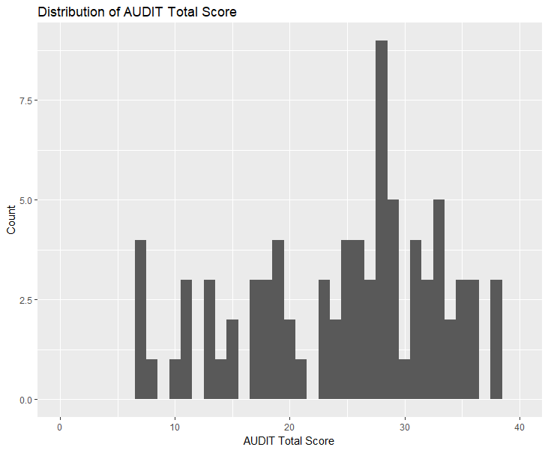
Supplemental Figure 1. Distribution of AUDIT and Fagerstrom Scores
Skewness = -0.478
Kurtosis = -0.773

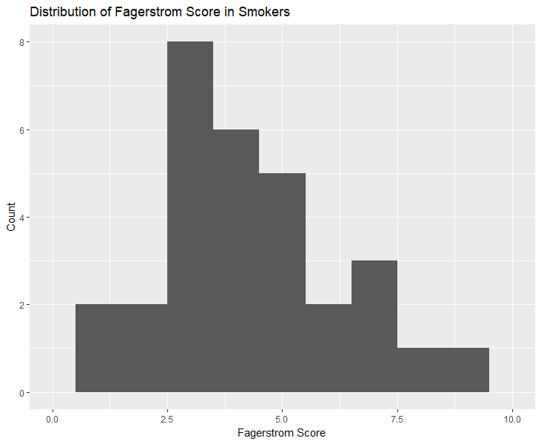
Skewness = 0.216
Kurtosis = -0.407
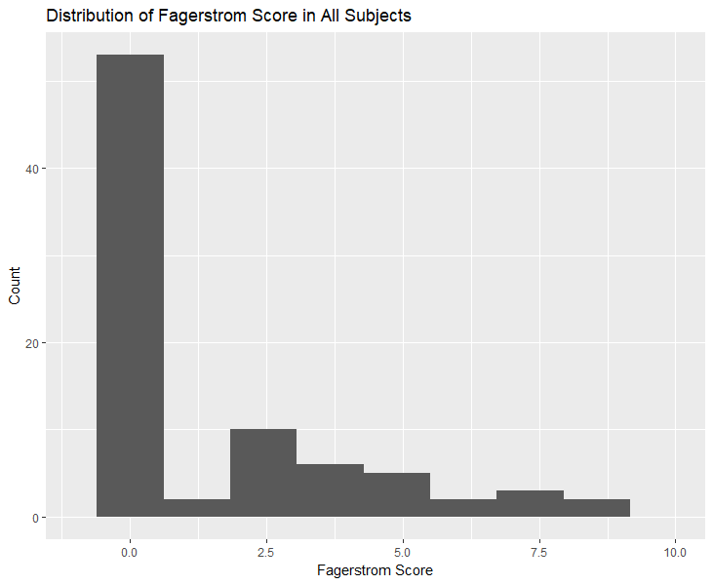
Skewness = 1.295
Kurtosis = 0.530

Supplemental Table 1.
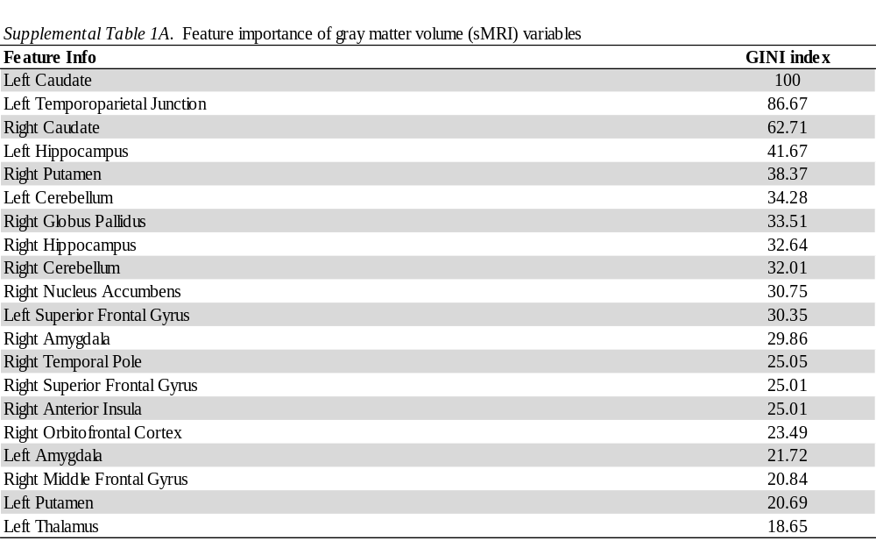
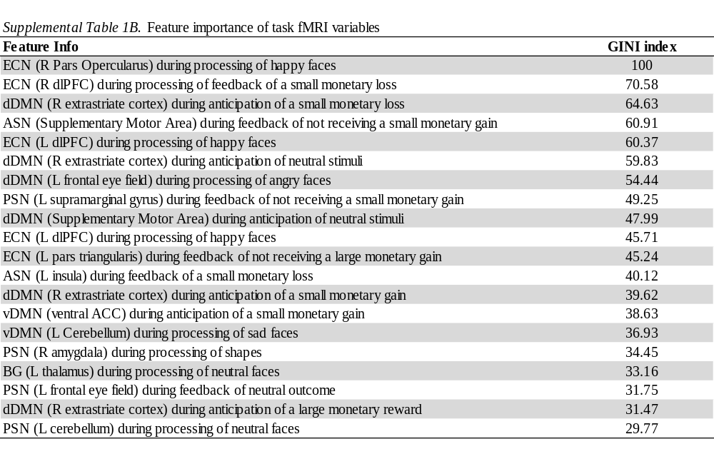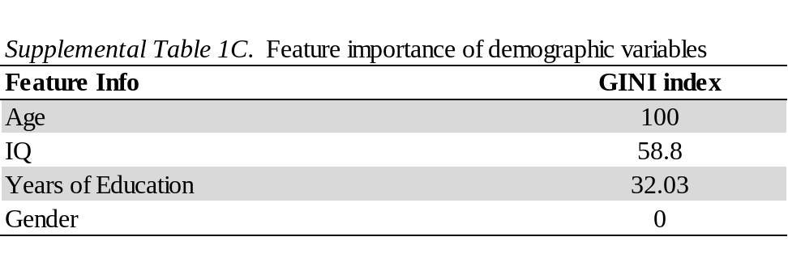
Supplemental Material 1. Resting State Analysis
The relationship between alcohol use severity and resting-state network connectivity was investigated by running a multi-way, multivariate analysis of covariance (MANCOVA). AUDIT total score, age, IQ, gender, and years of education were modeled as independent variables and resting state network features as dependent variables. These analyses were conducted using the MANCOVAN toolbox in GIFT (54); post-processing of the significant findings was done using R and ggplot2 (56).
Individuals with moderate to heavy alcohol use engaged networks of neural activity corresponding to standard resting state networks. Out of the 44 non-noise related ICs, these included the ASN (ICs: 5), PSN (ICs: 5), dDMN (ICs: 5), vDMN (ICs: 6), bilateral ECN (ICs: 2), and BG (ICs: 3; see Figure 1A to see the extent of the combination of these ICs.) Additional components corresponding to Higher Visual, Primary Visual, Visuospatial, Auditory, Language, Precuneus, and Sensorimotor Networks were identified from the rs-fMRI signal.
The MANCOVAN of neural resting state features by AUDIT, age, years of education, and gender was significant for within-network spatial maps and spectra, but not for between-network FNC connectivity. Specifically, AUDIT score was significantly positively related to PSN engagement (i.e., right insula). There was also a significant interaction between AUDIT and age. In older individuals, there was a negative association (but in younger individuals, a positive association) between AUDIT and engagement within hypothesized networks localized in thalamus, insula, putamen, globus pallidus, medial temporal gyrus, visual association, fusiform, and Broca’s areas. There was a positive association in older individuals (but in younger individuals, a negative association) between AUDIT and engagement within hypothesized networks localized in visual association, precuneus, PCC, and cerebellum regions. See Table 2 for statistics.

Supplemental Table 2. Relationship between AUDIT, Age, and Resting Neural Engagement
 |  |  |  |  | Whole Sample |  | Age < 41 | Age > 41
Component IC Number | Location | Coordinates (x y z) |  |  | r_AUDIT | r_Age | r_AUDIT | r_AUDIT
ASN
21 | L Broca's | -35 | 3 | 11 | .16 (ns) | -0.22 (ns) | .50* | -.19 (ns)
 | L SMA | -1 | 0 | 56 | .24⁺ | -.28* | .32 (ns) | .16 (ns)
 | R Primary Motor | 55 | -2 | 13 | -.38** | -.48*** | -.36⁺ | -.41*
73 | Insula | -32 | 2 | -3 | -.09 (ns) | .13 (ns) | 0.38⁺ | -.47*
PSN
29 | R cerebellum | 29 | -52 | -36 | -.20 (ns) | -.32* | -.42* | .22 (ns)
49 | R insula | 38 | -1 | -8 | .52*** | - | - | -
vDMN
36 | L visual association | -8 | -49 | 6 | -.20 (ns) | .07 (ns) | -.55* | .21 (ns)
 | L precuneus | -1 | -54 | 47 | -.38** | .14 (ns) | -.56** | .05 (ns)
 | PCC | 12 | -53 | 12 | -.27⁺ | -.23⁺ | -.60** | .20 (ns)
 | L visual association | -15 | -53 | 0 | -.07 (ns) | .13 (ns) | .18 (ns) | 0.37⁺
dDMN
25 | L visual association | -15 | -61 | 24 | .07 (ns) | -.28* | .53** | 0.07 (ns)
 | L fusiform | -28 | -46 | -2 | .31* | .11 (ns) | .62** | -.29 (ns)
 | R visual association | 9 | -45 | 9 | .13 (ns) | -.12 (ns) | -.23 (ns) | .53**
BG
8 | L putamen | -18 | 7 | 2 | -.05 (ns) | .20 (ns) | .41* | -.38*
 | L globus pallidus | 25 | -6 | 0 | -.02 (ns) | -.16 (ns) | .40* | -.43*
 | R putamen | 29 | -6 | 0 | -.08 (ns) | -.30* | .30 (ns) | -.50**
 | R putamen | 22 | 10 | 5 | -.09 (ns) | .14 (ns) | .32 (ns) | -.43*
37/45 | R thalamus | 1 | -13 | 6 | .22 (ns) | .19 (ns) | .59** | -.35⁺
 | L thalamus | -1 | -13 | 6 | 0.24⁺ | .17 (ns) | .59** | -.30 (ns)
Notes: Values extracted from the MANCOVAN of component spatial maps during resting state fMRI. Components displayed in table are significant in the MANCOVAN analysis (- indicates that the interaction was not significant); correlations represent post-hoc analyses. r_AUDIT indicates correlation between AUDIT and neural engagement in the sample; r_Age indicates correlation between age and neural engagement. p<.10⁺, p<.05*, p<.01**, p<.001***. Coordinates reported in Talairach space.

Supplemental Material 2. Structural Analysis
Gray Matter Volumes (GMV) were analyzed using MANCOVA in R version 3.4 (54), employing Pillai’s Trace as the test statistic. In the overall MANCOVA, AUDIT was not significantly related to gray matter volume in the ROIs ( F[20,29] = 1.346, p = .228, Pillai’s trace = .4814 ) when modeled with age, IQ, gender, and years of education. In exploratory follow up analysis, AUDIT and gray matter volume were significantly negatively correlated in the right NAcc (pearson’s r = -0.268, p = 0.050), right putamen (pearson’s r = -0.328, p = 0.015), and left TPJ (pearson’s r = -0.350, p = 0.009). AUDIT and gray matter volume in the left temporal pole were positively correlated at a trend level (pearson’s r = 0.265, p = .053). The volume of other ROIs did not have a significant or trend-level relationship with AUDIT.

Supplemental Material 3. Task Analysis Results.
In order to limit the whole-mask false positive rate in the unimodal analysis by correcting for multiple comparisons, 3dClustStim was run based on the updated procedure using autocorrelation function (ACF) for spatial correlation of fMRI noise descripted in Cox et al., 2016. Cluster-size thresholds were set based on a per-voxel p-value threshold of p = .001 and whole-mask threshold of α = .05. Minimum cluster size differed by mask (ASN: k = 5, PSN: k = 5, dDMN: k = 5, vDMN: k = 7, ECN: k = 4, BG: k = 4).
- Monetary Incentive Delay:
AUDIT was not significantly associated with task performance in hit percentage for either reward cued targets (Mean: 66.81, SD: 14.31, correlation with AUDIT: r = -0.071, p = 0.607) or loss cued targets (Mean: 64.63, SD: 11.38, correlation with AUDIT: r = 0.154, p = 0.2604). For the neuroimaging analysis, the overall F-tests of AUDIT x condition (covarying for age, IQ, years of education, and gender) were significant in ECN, A/PSN, v/dDMN, and basal ganglia networks. Post-hoc examination of the conditions of interest at each significant cluster in the F-tests indicated that during Loss Anticipation, there was a positive relationship between AUDIT and neural activity in the dDMN, vDMN, and basal ganglia (thalamus, caudate), as well as in some portions of the ASN (temporal pole, pars triangularis), PSN (premotor cortex, supramarginal gyrus), and ECN (right frontal pole, lPFC, mPFC). Also during Loss Anticipation, there was a negative relationship between AUDIT and neural activity in in some portions of the ASN (SMA, pars opercularis), PSN (right dlPFC, cerebellum), and ECN (left frontal pole). During Reward Anticipation, there was a positive relationship between AUDIT and neural activity in the dDMN and basal ganglia (caudate), as well as in some portions of the ECN (pars triangularis, mPFC, lPFC, right frontal pole), vDMN (precuneus, lingual gyrus, and more medial portions of the SPL), PSN (premotor, supramarginal gyrus), and ASN (temporal pole). Also during Reward Anticipation, there was a negative relationship between AUDIT and neural activity in some portions of the ASN (SMA), PSN (dlPFC, cerebellum), vDMN (more lateral portion of the SPL), and ECN (left frontal pole). See Table 3 and Figure 3 for test statistics and a visual representation of these effects. There were no substantive differences in results when smoking as quantified by Fagerstrom Score was included as a covariate in the MVM model.

Supplemental Table 3. Relationship between AUDIT and Neural Activity during Monetary Incentive Delay
 | Lat. | k | Peak Coordinates (x y z) |  |  | F | r_loss | r_rew
ASN
Supplementary Motor Area | R | 199 | 20 | 6 | 62 | 5.38 | -0.204 | -0.181
Pars Opercularis | R | 12 | 50 | 12 | 16 | 4.28 | -0.117 | 0.190
Temporal Pole | R | 11 | 54 | 6 | -4 | 5.9 | 0.348 | 0.190
Pars Triangularis | R | 9 | 40 | 26 | 10 | 4.55 | 0.371 | 0.356
PSN
Premotor Cortex | L | 19 | -20 | 20 | 52 | 3.91 | 0.319 | 0.290
Dorsolateral Prefrontal Cortex | R | 12 | 48 | 38 | 10 | 4.64 | -0.223 | -0.213
Supramarginal Gyrus | R | 8 | 58 | -22 | 30 | 3.75 | 0.266 | 0.259
Vermis (Cerebellum) | L | 7 | -2 | -44 | -32 | 4.69 | -0.107 | -0.143
vDMN
Superior Parietal Lobule | R | 10 | 30 | -60 | 52 | 5.3 | -0.002 | -0.180
Precuneus | L | 9 | -8 | -50 | 58 | 3.42 | 0.354 | 0.304
Lingual Gyrus | L | 8 | -6 | -74 | 0 | 3.92 | 0.257 | 0.068
Superior Parietal Lobule | R | 8 | 20 | -54 | 62 | 3.91 | 0.151 | 0.287
dDMN
Supplementary Motor Area | R | 212 | 16 | 20 | 48 | 5.99 | 0.091 | 0.229
Frontal Eye Fields | L | 27 | -22 | 38 | 42 | 5.04 | 0.353 | 0.174
- | L | 6 | -30 | 20 | 48 | 3.39 | - | -
Medial Prefrontal Cortex | L | 12 | -6 | 44 | 34 | 4.32 | 0.333 | 0.282
- | L | 9 | -8 | 52 | 24 | 4.35 | - | -
Premotor Cortex | R | 8 | 22 | 10 | 52 | 4.02 | 0.110 | 0.123
Pars Opercularis | R | 5 | 54 | 16 | 24 | 4.81 | 0.192 | -0.033
ECN
Pars Triangularis | R | 193 | 50 | 40 | 6 | 6.27 | 0.075 | 0.292
Pars Opercularis | R | 39 | 54 | 12 | 20 | 6.23 | 0.192 | -0.033
Medial Prefrontal Cortex | L | 14 | -26 | 38 | 38 | 4.77 | 0.353 | 0.174
Par Triangularis | R | 13 | 40 | 26 | 10 | 4.56 | 0.371 | 0.356
Supplementary Eye Field | R | 6 | 6 | 40 | 42 | 3.97 | 0.195 | 0.222
Lateral Prefrontal Cortex | R | 5 | 30 | 40 | 14 | 2.96 | 0.211 | 0.306
Frontal Pole | R | 4 | 22 | 52 | 6 | 3.77 | 0.125 | 0.280
Frontal Pole | L | 4 | -20 | 58 | 28 | 3.28 | -0.235 | -0.217
Medial Prefrontal Cortex | L | 4 | -20 | 44 | 24 | 3.16 | 0.317 | 0.085
BG
Putamen/Globus Pallidus | R | 7 | 22 | -8 | 10 | 3.55 | -0.080 | -0.032
Thalamus | L | 6 | -20 | -16 | 14 | 3.71 | 0.280 | 0.072
Caudate | R | 5 | 16 | -2 | 16 | 5.47 | 0.102 | 0.105
Notes: F-statistic reported based on significant multivariate model test, based on maximally complicated model. *indicates that this region was not significant in the maximally complicated model, but was significant in the AUDIT x condtion F test. Pearson's r reported based on correlation between extracted beta-coefficients and AUDIT score; r_loss corresponds to the Anticipation of Loss - Neutral contrast, while r_rew corresponds to the Anticipation of Reward - Neutral contrast. Coordinates reported in Talairach space.
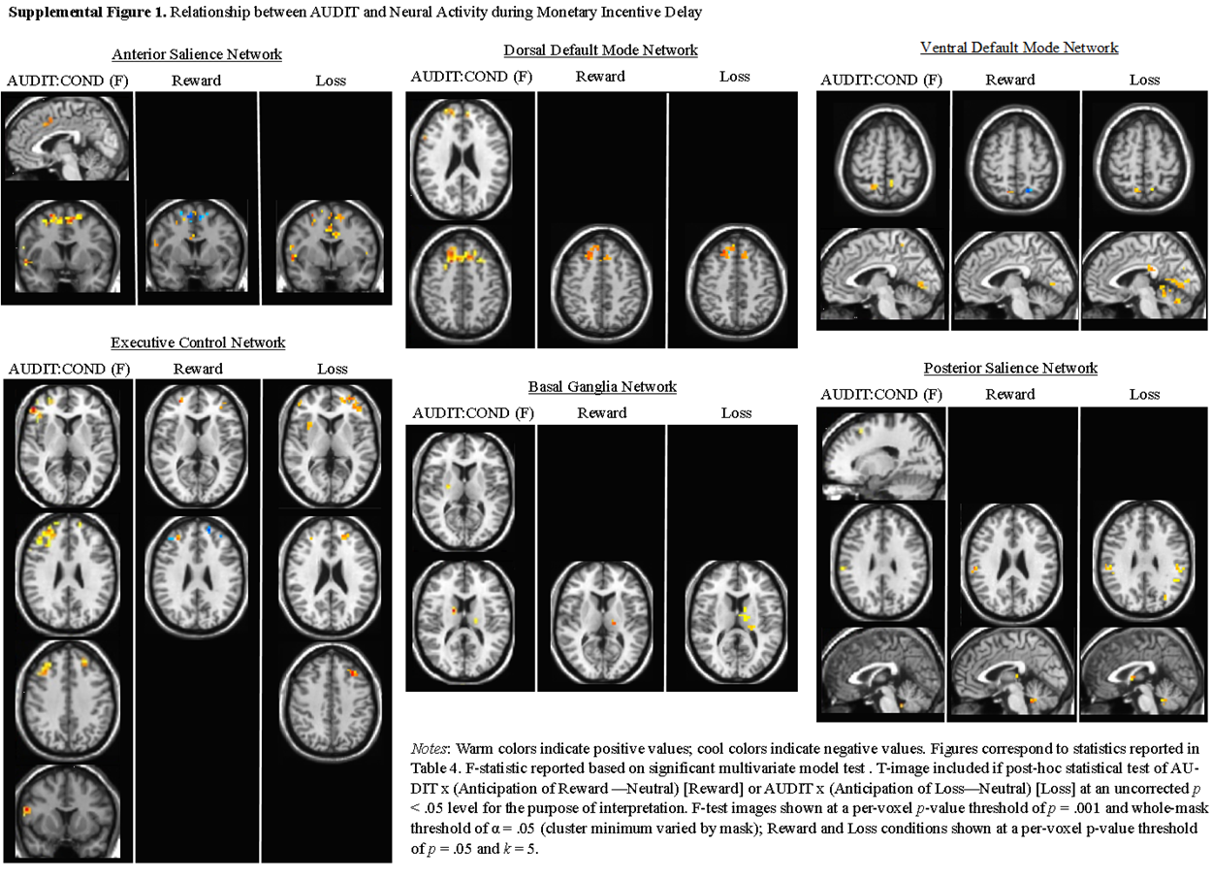

- Face Matching
The overall F-test of AUDIT*condition was significant in the ECN (right dlPFC, x = 54, y = 24, z = 10, F = 5.95, k = 5). There was also a significant t-test of AUDIT score when processing sad faces compared to shapes (left thalamus, x = -20, y = -18, z = 0, F = 4.21, k = 4). In post-hoc examination of these significant clusters, AUDIT was negatively related to processing in the dlPFC of happy faces (r = -0.4689), neutral faces (r = -0.2975), and shapes (r = -0.3888). Processing of angry, fearful, and sad faces was not related to AUDIT total score in the dlPFC. In the thalamus, processing of shapes was also negatively related to AUDIT (r = -0.2014), while processing sad faces was not related to AUDIT (r = 0.0548). Processing of angry, fearful, happy, and neutral faces was also not related to AUDIT in the thalamus. There were no substantive differences in results when smoking as quantified by Fagerstrom Score was included as a covariate in the MVM model.

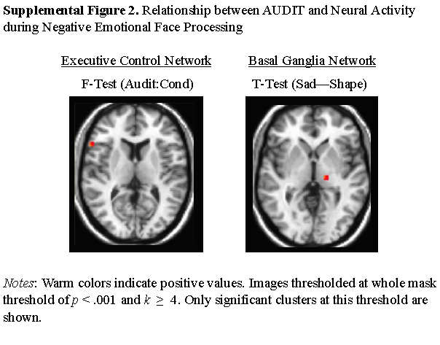
Supplemental Material 4. Discussion of Supplemental Results
The unimodal analyses only partially replicated the results of previous studies. Other work using MID tasks with alcohol use samples found reduced VS engagement, which we did not find here (70-72). However, we did find that AUD severity was related to less dorsal striatum activation during monetary incentive delay. Vollstädt-Klein and colleagues (73) suggest that in heavy compared to light drinkers, cue-induced neural activity shifts from the ventral to dorsal striatum. Previous studies using a face matching task to predict treatment outcomes for AUD found reduced dlPFC, ACC, amygdala/parahippocampal gyrus, and insula activity during negative face processing in AUD patients (74-76). Although we found effects of chronic alcohol use in the dlPFC at a stringent threshold, rostral ACC, amygdala/parahippocampal gyrus, and insula AUDIT effects were only detected at a lower threshold (p < .05, uncorrected). Finally, our brain structure findings suggested that more severe AUD was associated with less GMV in the putamen and left TPJ, consistent with previous work from out lab in a different sample (32), and in the right NAcc (as in Makris et al., 2008). However, we did not find GMV associated with AUD in PFC regions, as other studies found (30, 31).
Supplemental Table 4. Inpatient/Outpatient Demographics Breakdown
 | Inpatient Mean | Outpatient Mean | t | p | Diff (95% CI)
Age | 43.93 | 35.26 | 2.77 | 0.0097 | 8.67 (CI: 2.26, 15.06)
IQ | 100.03 | 99.16 | 0.19 | 0.85 | 0.87 (CI: -8.50, 10.24)
Education | 13.48 | 15 | -2.22 | 0.03 | -1.52 (CI: -2.92, -0.13)
AUDIT | 28.15 | 16.05 | 6.54 | 2.61E-07 | 12.1 (CI: 8.32, 15.87)
Drinks/day | 16.06 | 6.76 | 5.19 | 3.22E-06 | 9.3 (CI: 5.71, 12.89)
Fagerstrom | 2.08 | 1.28 | 1.13 | 0.2647 | 0.8 (CI: -0.63, 2.23)
Gender | male: 65.79% | male: 68.42%
Smoking Status | smoker: 47.37% | smoker: 27.78%

