Appendix – Supplementary Materials
Article: Neural Cognitive Control Moderates the Association between Insular Risk Processing and Risk-taking Behaviors via Perceived Stress
Journal: Developmental Cognitive Neuroscience
Appendix A: List of Items for Risk-taking Behaviors
1. Ridden in a car without a seatbelt
2. Ridden on a bike without a helmet
3. Done something dangerous on a dare
4. Carried a weapon somewhere
5. Threatened to beat up someone to make them do something
6. Taken part in a gang fight
7. Skipped school without permission
8. Had a fist fight with another person
9. Purposely set a fire in a building or in any other place
10. Hurt an animal on purpose
11. Smoked a cigarette or used tobacco
12. Drunk a bottle or glass of beer or other alcohol (not counting having a drink with the family on holidays or religious occasions)
13. Used or smoked marijuana, grass, pot, weed
14. Taken or stolen something not yours worth a lot, like a video game
15. Taken or stolen something not yours worth little, like candy
16. Gotten into someplace like a movie or game without paying
17. Run away from home
18. Broken into a building to take or steal something
19. Purposely damaged or destroyed property that wasn’t yours

Appendix B
List of regions associated with increasing CV during the decision phase for Time 1
T1 Decision Phase: Parametric regressor of CV for chosen options
 |  |  |  | Peak MNI Coordinates
Cluster # |  | Region | Size | x | y | z | T
1 |  | R Insular Cortex | 605 | 30 | 20 | -11 | 8.24
 |  | R Insular Cortex |  | 45 | 17 | -2 | 7.27
2 |  | R Anterior Cingulate Cortex | 1798 | 3 | 35 | 22 | 8.14
 |  | R Anterior Cingulate Cortex |  | 6 | 41 | 4 | 6.25
 |  | R Pallidum |  | 12 | 2 | -5 | 5.91
3 |  | L Insular Cortex | 430 | -30 | 17 | -14 | 7.79
 |  | L Insular Cortex |  | -39 | 17 | -5 | 7.65
4 |  | R Middle Cingulate Cortex | 111 | 3 | -16 | 34 | 4.84
5 |  | L Middle Occipital Lobe | 93 | -36 | -94 | 1 | 4.14
 |  | L Middle Occipital Lobe |  | -27 | -97 | -8 | 4.08
6 |  | R Middle Occipital Lobe | 45 | 24 | -100 | 1 | 4.09
 |  | R Inferior Occipital Gyrus |  | 36 | -88 | -8 | 3.59
7 |  | R Precentral Gryus | 8 | 42 | 5 | 31 | 3.54
8 |  | R Superior Orbitofrontal Cortex | 5 | 21 | 56 | -8 | 3.43
Note: MNI, Montreal Neurological Institute; L, Left; R, right. Size refers to the number of voxels in the cluster. At the subject level, decision and outcome events were included with a duration of 4 and 2 seconds, respectively. Additionally, a parametric regressor of CV-modulated decision phase activity and a parametric regressor of outcome phase activity representing whether the subject received the high or low outcome was received was included in the subject model. All activations reported here survive whole-brain family-wise error multiple comparisons correction at a threshold of p < .05.

List of regions associated with increasing CV during the decision phase for Time 2
T2 Decision Phase: Parametric regressor of CV for chosen options
 |  |  |  |  |  | Peak MNI Coordinates
Cluster # |  | Region | Size |  |  |  |  | x |  | y |  | z |  |  | T
1 |  | R Anterior Cingulate Cortex |  | 2960 |  |  | 6 |  | 38 |  | 22 |  |  | 8.10
 |  | R Insular Cortex |  |  |  |  | 30 |  | 20 |  | -11 |  |  | 8.04
 |  | R Pallidum |  |  |  |  | 12 |  | 5 |  | -2 |  |  | 7.30
2 |  | L Inferior Frontal Gyrus |  | 418 |  |  | -36 |  | 23 |  | -5 |  |  | 7.85
 |  | L Insular Cortex |  |  |  |  | -33 |  | 20 |  | -11 |  |  | 7.51
 |  | L Inferior Frontal Gyrus |  |  |  |  | -42 |  | 14 |  | 10 |  |  | 4.19
3 |  | R Middle Occipital Lobe |  | 569 |  |  | 33 |  | -91 |  | 1 |  |  | 6.60
 |  | R Middle Occipital Lobe |  |  |  |  | 21 |  | -100 |  | 1 |  |  | 6.56
 |  | R Inferior Occipital Lobe |  |  |  |  | 27 |  | -94 |  | -5 |  |  | 6.53
4 |  | L Middle Occipital Lobe |  | 527 |  |  | -33 |  | -91 |  | 1 |  |  | 5.90
 |  | L Inferior Occipital Lobe |  |  |  |  | -21 |  | -97 |  | -5 |  |  | 5.68
5 |  | L Precentral Gyrus |  | 29 |  |  | -51 |  | -1 |  | 49 |  |  | 5.15
6 |  | R Precentral Gyrus |  | 159 |  |  | 45 |  | 2 |  | 46 |  |  | 4.46
 |  | R Precentral Gyrus |  |  |  |  | 48 |  | 5 |  | 34 |  |  | 4.30
7 |  | L Middle Occipital Gyrus |  | 60 |  |  | -24 |  | -73 |  | 31 |  |  | 4.30
 |  | L Superior Occipital Gyrus |  |  |  |  | -18 |  | -67 |  | 37 |  |  | 4.17
8 |  | Vermis |  | 30 |  |  | 0 |  | -52 |  | -29 |  |  | 4.21
9 |  | R Middle Frontal Gyrus |  | 62 |  |  | 30 |  | 56 |  | 28 |  |  | 4.20
 |  | R Middle Frontal Gyrus |  |  |  |  | 21 |  | 50 |  | 25 |  |  | 3.75
10 |  | R Superior Parietal Lobe |  | 41 |  |  | 33 |  | -55 |  | 58 |  |  | 4.05
11 |  | R Superior Occipital Lobe |  | 39 |  |  | 27 |  | -64 |  | 40 |  |  | 4.00
 |  | R Precuneus |  |  |  |  | 12 |  | -70 |  | 40 |  |  | 3.58
 |  | R Middle Occipital Lobe |  |  |  |  | 33 |  | -70 |  | 31 |  |  | 3.53
12 |  | R Middle Frontal Gyrus |  | 20 |  |  | 42 |  | 53 |  | 13 |  |  | 3.99
13 |  | L Inferior Parietal Lobe |  | 26 |  |  | -27 |  | -55 |  | 52 |  |  | 3.97
15 |  | L Cerebellum |  | 12 |  |  | -33 |  | -58 |  | -26 |  |  | 3.80
16 |  | L Superior Frontal Gyrus (orbital) |  | 6 |  |  | 21 |  | 44 |  | -14 |  |  | 3.61
17 |  | R Superior Frontal Gyrus (orbital) |  | 7 |  |  | 21 |  | 56 |  | -11 |  |  | 3.50
Note: MNI, Montreal Neurological Institute; L, Left; R, right. Size refers to the number of voxels in the cluster. At the subject level, decision and outcome events were included with a duration of 4 and 2 seconds, respectively. Additionally, a parametric regressor of CV-modulated decision phase activity and a parametric regressor of outcome phase activity representing whether the subject received the high or low outcome was received was included in the subject model. All activations reported here survive whole-brain family-wise error (FEW) multiple comparisons correction at a threshold of p < .05.

Appendix C: Areas of significant activation for the contrast of Interference minus Neutral blocks of the Multi-Source Interference Task at Time 1
 | Cluster |  |  |  |  |  |  | Peak |  |  |  | MNI Coordinates |  |  |  |  |  | Region
 | k |  |  | p(FWE) |  |  |  | t |  |  |  | x |  | y |  | z
 | 759 |  |  | < .001 |  |  |  | 21.84 |  |  |  | -42 |  | -37 |  | 49 |  | L postcentral gyrus
 |  |  |  |  |  |  |  | 19.61 |  |  |  | -24 |  | -64 |  | 49 |  | L superior parietal lobule
 |  |  |  |  |  |  |  | 18.07 |  |  |  | -30 |  | -55 |  | 52 |  | L inferior parietal lobule
 | 265 |  |  | < .001 |  |  |  | 20.43 |  |  |  | -3 |  | 14 |  | 49 |  | L posterior-medial frontal
 | 506 |  |  | < .001 |  |  |  | 20.42 |  |  |  | -39 |  | -85 |  | -2 |  | L inferior occipital gyrus
 |  |  |  |  |  |  |  | 20.15 |  |  |  | -30 |  | -91 |  | -2 |  | L inferior occipital gyrus
 |  |  |  |  |  |  |  | 19.05 |  |  |  | -39 |  | -73 |  | -8 |  | L fusiform gyrus
 | 654 |  |  | < .001 |  |  |  | 19.21 |  |  |  | 42 |  | -64 |  | -8 |  | R fusiform gyrus
 |  |  |  |  |  |  |  | 19.17 |  |  |  | 42 |  | -82 |  | -2 |  | R inferior occipital gyrus
 |  |  |  |  |  |  |  | 18.46 |  |  |  | 33 |  | -91 |  | 1 |  | R inferior occipital gyrus
 |  |  |  |  |  |  |  | 15.78 |  |  |  | 39 |  | -67 |  | -23 |  | R cerebellum (crus 1)
 |  |  |  |  |  |  |  | 15.24 |  |  |  | 33 |  | -49 |  | -26 |  | R cerebellum (VI)
 | 245 |  |  | < .001 |  |  |  | 19.06 |  |  |  | -24 |  | -4 |  | 55 |  | L middle frontal gyrus
 | 431 |  |  | < .001 |  |  |  | 18.12 |  |  |  | 30 |  | -58 |  | 52 |  | R inferior parietal lobule
 |  |  |  |  |  |  |  | 18.11 |  |  |  | 45 |  | -31 |  | 49 |  | R postcentral gyrus
 |  |  |  |  |  |  |  | 16.52 |  |  |  | 30 |  | -64 |  | 40 |  | R superior occipital gyrus
 | 140 |  |  | < .001 |  |  |  | 17.38 |  |  |  | 27 |  | -4 |  | 55 |  | R superior frontal gyrus
 | 94 |  |  | < .001 |  |  |  | 16.89 |  |  |  | -45 |  | 2 |  | 34 |  | L inferior frontal gyrus (pars opercularis)
 | 46 |  |  | < .001 |  |  |  | 15.01 |  |  |  | -9 |  | -19 |  | 10 |  | L thalamus
 | 24 |  |  | < .001 |  |  |  | 14.50 |  |  |  | 33 |  | 20 |  | 7 |  | R insula lobe
 | 7 |  |  | < .001 |  |  |  | 13.47 |  |  |  | 6 |  | -73 |  | -20 |  | Cerebellar vermis (7)
 | 13 |  |  | < .001 |  |  |  | 13.32 |  |  |  | 48 |  | 8 |  | 31 |  | R inferior frontal gyrus (pars opercularis)
 | 12 |  |  | < .001 |  |  |  | 13.31 |  |  |  | -30 |  | 17 |  | 10 |  | L insula lobe
 | 5 |  |  | < .001 |  |  |  | 12.73 |  |  |  | 9 |  | -19 |  | 10 |  | R thalamus
 | 9 |  |  | < .001 |  |  |  | 12.66 |  |  |  | -27 |  | -55 |  | -23 |  | L cerebellum (VI)
 |  |  |  |  |  |  |  | 12.60 |  |  |  | -27 |  | -64 |  | -23 |  | L cerebellum (VI)
Note. Voxel-wise thresholded at t = 12, equivalent to p = 2.00 x 10⁻²³ uncorrected. k = the number of voxels in each significant cluster; FWE = family-wise error corrected; t = peak activation level in each cluster; x, y, z = MNI coordinates; L = left; R = right. Boldface indicates the regions included in the neural cognitive control factor scores. Reprinted from Kim-Spoon, J., Maciejewski, D., Lee, J., Deater-Deckard, K., & King-Casas (2017). Longitudinal associations among family environment, neural cognitive control, and social competence among adolescents. Developmental Cognitive Neuroscience, 26, 69-76.

Appendix D: Information about factor score calculation
Insular risk processing factor score at Time 1 and Time 2
We conducted confirmatory factor analyses, in which standardized left and right anterior insula activation scores loaded on an overall insula factor score. Factor loadings were constrained to be equal for model identification purposes. In this fully saturated model (χ² = 0, df = 0), both factor loadings were significant (.90 at Time 1, .96 at Time 2, p < .001). The bilateral insula factor scores were used in the analyses as the neural risk processing variable, with higher scores indicating higher BOLD responses in the insula, indicating higher insular risk processing.
Neural cognitive control factor score at Time 1
Among the extracted ROI values during the MSIT task (see Appendix A), variables representing (1) regions known to be engaged by inhibitory control related to interference- and error-processing (Fitzgerald et al., 2010; Koechlin, Ody, & Kouneiher, 2003; Roberts & Hall, 2008) and (2) regions significantly correlated with behavioral performance (i.e., absolute magnitude of correlation > .20 with both behavioral accuracy and reaction time difference scores) were chosen as manifest indicators of the neural inhibitory control factor. The ROIs that were selected as manifest indicators for the neural cognitive control factor score were left posterior-medial frontal cortex, left and right inferior frontal gyrus, left and right inferior parietal lobules, right superior frontal gyrus, and left middle frontal gyrus. Although the right insula lobe was significantly activated during the MSIT task, we did not include this region to avoid conceptual overlap between the neural cognitive control and the insular risk processing factor score. Using these selected indicators, we conducted confirmatory factor analyses, in which the indicators loaded on an overall latent neural cognitive control factor. For model identification, the factor loading of the left posterior-medial frontal cortex was constrained to 1 and its intercept to 0. Based on modification indices, we included residual correlations between left and right inferior parietal lobules, left and right inferior frontal gyrus, right inferior frontal gyrus and left middle frontal gyrus, and left posterior-medial frontal cortex and left inferior frontal gyrus. The final model showed a good fit (χ² = 7.71, df = 10, p = .66, CFI = 1.00, RMSEA = .00). Standardized factor loadings ranged from .53 - .88 (all ps <.001). This neural cognitive control factor score correlated significantly with the accuracy and reaction time difference score (-.40 and .36, ps < .001), indicating that higher activation in these regions was associated with lower behavioral cognitive control. The latent factor score represents the interference-related BOLD signal during the MSIT task and was used in the analyses as the cognitive control variable, with higher scores indicating lower neural cognitive control.

Appendix E: Conceptual Models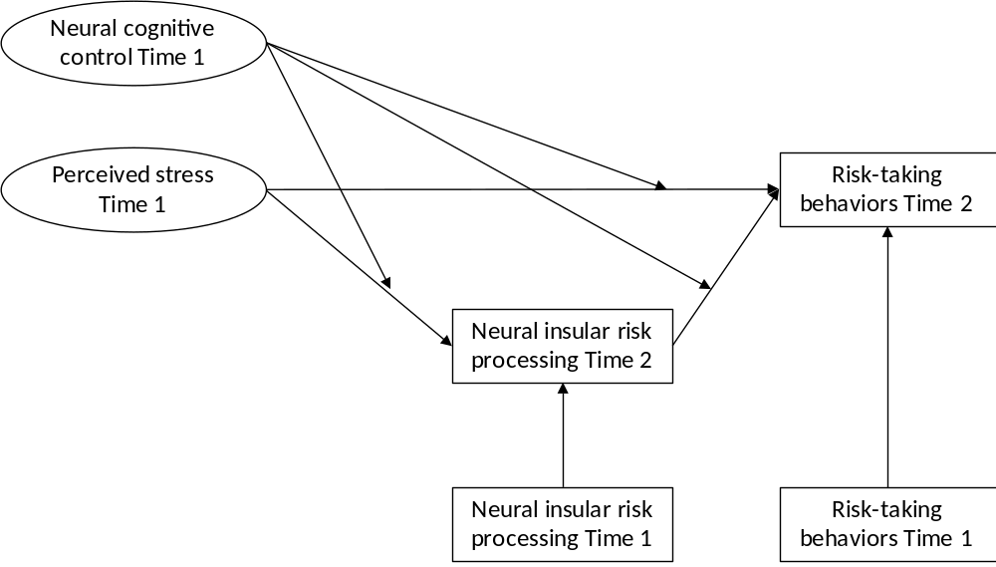
Figure E1. Model a: Conceptual model of the moderating effect of neural cognitive control on the indirect effect from perceived stress to risk-taking behaviors via insular risk processing.

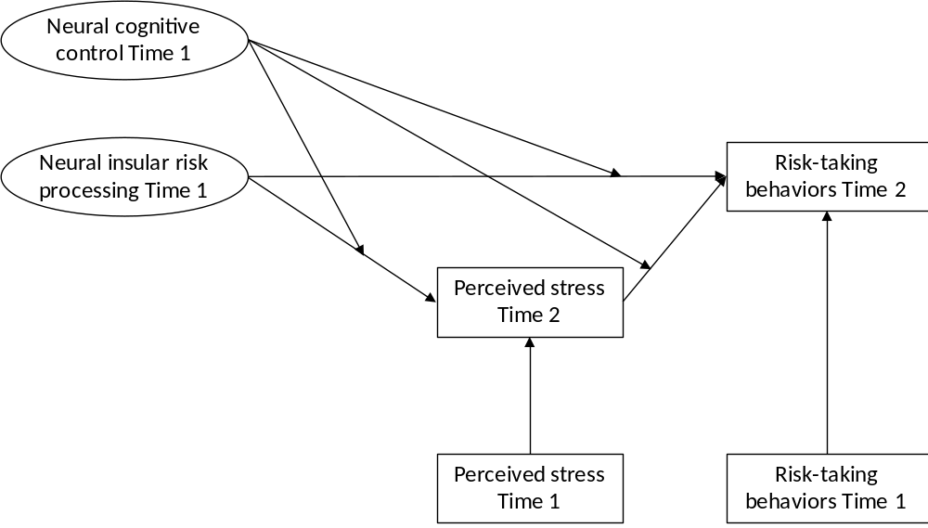
Figure E2. Model b: Conceptual model of the moderating effect of neural cognitive control on the indirect effect from insular risk processing to risk-taking behaviors via perceived stress.

Appendix F: Frequency distribution Perceived Stress and Adolescent Risk-taking Behaviors

Figure F1. Frequency distribution perceived Stress Time 1

Figure F2. Frequency distribution perceived Stress Time 2

Figure F3. Frequency distribution perceived Risk-taking Behaviors Time 1

Figure F4. Frequency distribution perceived Risk-taking Behaviors Time 2

Figure F5.Percentage of adolescents reporting risk-taking behaviors at Time 1. 1 = Ridden in a car without a seatbelt, 2 = Ridden on a bike without a helmet, 3 = Done something dangerous on a dare, 4 = Carried a weapon somewhere, 5 = Threatened to beat up someone to make them do something, 6 = Taken part in a gang fight, 7 = Skipped school without permission, 8 = Had a fist fight with another person, 9 = Purposely set a fire in a building or in any other place, 10 = Hurt an animal on purpose, 11 = Smoked a cigarette or used tobacco, 12 = Drunk a bottle or glass of beer or other alcohol (not counting having a drink with the family on holidays or religious occasions), 13 = Used or smoked marijuana, grass, pot, weed, 14 = Taken or stolen something not yours worth a lot, like a video game, 15 = Taken or stolen something not yours worth little, like candy, 16 = Gotten into someplace like a movie or game without paying, 17 = Run away from home, 18 = Broken into a building to take or steal something, 19 = Purposely damaged or destroyed property that wasn’t yours

Figure F6. Percentage of adolescents reporting risk-taking behaviors at Time 2. 1 = Ridden in a car without a seatbelt, 2 = Ridden on a bike without a helmet, 3 = Done something dangerous on a dare, 4 = Carried a weapon somewhere, 5 = Threatened to beat up someone to make them do something, 6 = Taken part in a gang fight, 7 = Skipped school without permission, 8 = Had a fist fight with another person, 9 = Purposely set a fire in a building or in any other place, 10 = Hurt an animal on purpose, 11 = Smoked a cigarette or used tobacco, 12 = Drunk a bottle or glass of beer or other alcohol (not counting having a drink with the family on holidays or religious occasions), 13 = Used or smoked marijuana, grass, pot, weed, 14 = Taken or stolen something not yours worth a lot, like a video game, 15 = Taken or stolen something not yours worth little, like candy, 16 = Gotten into someplace like a movie or game without paying, 17 = Run away from home, 18 = Broken into a building to take or steal something, 19 = Purposely damaged or destroyed property that wasn’t yours
Appendix G: Scatterplots for main effects
b* = .28***
Figure G1. Scatterplot for the relation between perceived stress Time 2 and risk-taking behaviors Time 2. *** p < .001
b* = -.19*
Figure G2. Scatterplot for the relation between insula risk processing Time 1 and perceived stress Time 2. * p = .03
Appendix H: Parameter Estimates for Testing the Indirect Effect from Perceived Stress Time 1 to Risk-taking Behaviors Time 2 via Insular Risk Processing Time 2
 | B | SE | p | b* (beta)
Perceived stress Time 1 Insular risk processing Time 2 | -0.14 | 0.10 | .17 |  | -.12
Neural cognitive control Time 1 Insular risk processing Time 2 | 0.31 | 0.18 | .09 |  | .15
Perceived stress Time 1 Risk-taking behaviors Time 2 | 0.00 | 0.02 | .94 |  | .01
Neural cognitive control Time 1 Risk-taking behaviors Time 2 | 0.12 | 0.05 | .02 |  | .20
Insular risk processing Time 2 Risk-taking behaviors Time 2 | -0.01 | 0.03 | .62 |  | -.05
Note. Insular risk processing Time 2 was controlled for insular risk processing Time 1 (B = 0.29, SE = 0.10, p = .003, b* = .31). Risk-taking behaviors Time 2 were controlled for risk-taking behaviors Time 1 (B = 0.70, SE = 0.08, p < .001, b* = .62). Insular risk processing was operationalized as BOLD responses in the bilateral insula during a lottery choice task with higher values indicating higher insular risk processing. Neural cognitive control was operationalized as interference-related BOLD responses in cognitive control areas during the MSIT task with higher values indicating lower neural cognitive control.

