Supplementary Information

Methods:
Timeseries extraction. Following the mass univariate GLM analysis, we investigated BOLD timeseries from several regions of interest for a) their ability to predict trial type and b) the causal role they play as part of a Dynamic Causal Model network.

To maximize power and sensitivity in the BOLD timeseries, we used individual subjects’ peaks within significant group mean activation in the premature>correct contrast. The ROIs were located within significant group mean activations and anatomically constrained to facilitate the interpretation of the results. In practice, the mean group activations were masked with anatomical ROIs from the Harvard Oxford atlas: IFC (pars opercularis), dorsal striatum (dStriatum), anterior cingulate (ACC) and parietal operculum. Subject-specific peak was not constrained to either side when group effects were bilateral (e.g. in the IFC for HC and SIB in money incentive context or SDI in drug incentive context).

In order to validate the relatively sparse GLM design, we selected several ROIs (including the ACC, IFC and dorsal striatum) that were associated with the premature>correct contrast. Next, we extracted and pre-processed the timeseries from those ROIs and extracted the activations for correct and premature responses (areas underneath the ROI timeseries highlighted in red and blue). These activations were then used to predict the response type in a logistic regression with subject-level random effects (see main Methods for additional details). This validation analysis revealed a strong discriminative effect of the BOLD activation in the selected ROIs on response type (Figure 1D and Supplementary Figure 3).
The validation analysis also included the parietal operculum when appropriate (for SDI and HC in the money incentive context and SDI in drug incentive context). DCMs used a subset of ROIs from this analysis, which were shown to be predictive of trial type, lending further credibility to the neurobiological data constraining the dynamic causal models.

Firstly, search space ROIs were created by taking the Harvard-Oxford anatomical atlas masks for bilateral inferior frontal cortex (IFC, pars opercularis), striatum (bilateral caudate, nucleus accumbens and putamen), anterior cingulate cortex (ACC) and parietal operculum regions. The anatomical ROI was masked by the group mean activations in the HC, SDI and SIB groups for money and drug incentive conditions, respectively, resulting in distinct search space ROIs for each group, which were then used to extract individual timeseries. Individual contrast parameter estimate maps (premature > correct_{drug} for SDIs; premature > correct_{money} for HCs and SIBs) were masked with the search space ROI, and FSL cluster (https://fsl.fmrib.ox.ac.uk/fsl/fslwiki/Cluster) was used to extract the coordinates of the maximum intensity voxel in the largest cluster for each ROI (IFC, Caudate, ACC, pO). A sphere of 5 mm radius was placed at the maximum intensity voxel and the first Eigenvariate from each ROI was extracted sing fslmeants (https://fsl.fmrib.ox.ac.uk/fsl/fslwiki/Fslutils).
The extracted timeseries were preprocessed using the rsHRF toolbox for SPM (Wu et al, 2013; Wu and Marinazzo, 2016) by deconvolving the timeseries with a canonical HRF with time and dispersion derivatives (TR=2s, length of HRF=32s), bandpass filtering (0.001-0.3Hz) and despiking the timeseries. Subsequently, the timeseries were upsampled by a factor of 100 using spline interpolation (interp1, MATLAB) and the total area for each of the anticipation windows (premature or correct) for the relevant money and drug conditions, were extracted using numerical integration (trapz, MATLAB, Appendix Figure S1, supplementary figure 1).

Driving inputs for the DCM. The driving inputs for the DCM assume that all trials activate the PFC areas including the ACC and IFC. This assumption is justified by other studies employing DCM to investigate stopping impulsivity (Rae et al, 2015, 2016), based on the expectation that impulse control requires top-down inhibition provided by the IFC and the ACC. Furthermore, data-driven experiments show this assumption to be justified in context of response inhibition in the Go/No-Go task (Ma et al, 2015), as DCM discovery studies show that ACC, vlPFC, dlPFC and hippocampus are reliable driving inputs for all Go/No-Go trials, whereas caudate has only been a reliable input for easy Go/No-Go trials.

Analyses results from all reported random effects DCMs (RFX) in the main text were verified and confirmed using fixed effects analyses (FFX).

Results

Inspection of the unaffected sibling group (SIB) revealed several points. Firstly, the SIB winning DCM family was also fully interactive in terms of fixed connections (Family exceedance probability$≈$1). However, the location of task modulation varied substantially across participants (Figure S3). Models placing the modulation location at the ACC, IFC, or the connections between IFC and dStriatum or between the ACC and dStriatum all received some evidence. Bayesian Model Averaging revealed strong effective connectivity between the ROIs in the SIB group, but no significant task modulation inputs were identified due to interindividual variability. Since SIB also showed worse fit of the DCMs to data compared to the other groups, we focused on the more robust DCMs in HC and SDI.
Additionally, we noted that on average SIBS showed lower self-reported money valuations (Table 1). Taken together, attributing lower incentive salience to monetary rewards within the context of this study compared to the other two groups could have been critical in a) eliciting attenuated network activations and b) inter-individual variability in DCM task modulation in the SIB group.
Main effect of condition on target stimulus duration
The target stimulus duration was titrated to achieve 66% accuracy in responding, therefore providing an additional measure of task performance. As shown in Supplementary Figure 5, we report no main effect of the group (HC, SIB, SDI) on mean target duration (F_{2, 129}=1.074, p=0.34). There were no interactive effects of group and condition F_{2, 129}=1.534, p=0.22), although a very small but significant effect of condition was found F_{1, 129}=4.07, p=0.045).

References
Ma L, Steinberg JL, Cunningham KA, Lane SD, Bjork JM, Neelakantan H, et al (2015). Inhibitory behavioral control: A stochastic dynamic causal modeling study comparing cocaine dependent subjects and controls. NeuroImage Clin 7: 837–847.
Rae CL, Hughes LE, Anderson MC, Rowe JB (2015). The prefrontal cortex achieves inhibitory control by facilitating subcortical motor pathway connectivity. J Neurosci 35: 786–94.
Rae CL, Nombela C, Rodríguez PV, Ye Z, Hughes LE, Jones PS, et al (2016). Atomoxetine restores the response inhibition network in Parkinson’s disease. Brain 139: 2235–2248.
Wu GR, Liao W, Stramaglia S, Ding JR, Chen H, Marinazzo D (2013). A blind deconvolution approach to recover effective connectivity brain networks from resting state fMRI data. Med Image Anal 17: 365–374.
Wu GR, Marinazzo D (2016). Sensitivity of the resting-state haemodynamic response function estimation to autonomic nervous system fluctuations. Philos Trans R Soc A Math Phys Eng Sci 374: .

Supplementary Table 1. Whole brain group comparisons for the Premature > Correct response contrast in the drug incentive context.
SDI>HC group comparison
Region (Brodmann Area) | Size | X_{mm} | Y_{mm} | Z_{mm} | Z | P_{FWE-cor}
Primary Motor Cortex (BA6) - Left | 9343 | -52 | 2 | 46 | 4.23 | 6.96E-30
Primary Motor Cortex (BA6) - Right | 1288 | 62 | -10 | 38 | 4.13 | 4.77E-07
Temporal Pole (BA38) - Right | 787 | 40 | 20 | -32 | 4.44 | 0.000103
Angular gyrus (BA39) - Right | 761 | 46 | -50 | 22 | 4.06 | 0.000139
Amygdala - Left | 715 | -20 | -8 | -12 | 3.85 | 0.000241
PCC (BA23) - Right | 591 | 10 | -54 | 8 | 3.31 | 0.00113
PCC (BA31) - Left | 573 | -14 | -44 | 36 | 3.65 | 0.00142
Occipital cortex (BA19) - Right | 362 | 30 | -82 | -12 | 3.97 | 0.0266
OFC/vmPFC (BA11) - Left | 353 | -10 | 34 | -14 | 3.25 | 0.0305
OFC (BA47) - Right | 353 | 32 | 38 | -12 | 4.02 | 0.0305
OFC (BA47) - Left | 333 | -32 | 20 | -22 | 3.94 | 0.0412
Thalamus (BA50) - Right | 338 | 20 | -28 | 8 | 3.6 | 0.0382
Striatum* | 171 |  |  |  |  | 0.0365
WM between Cau and Put |  | -22 | 2 | 18 | 3.31 | 0.0365
Left Cau |  | -12 | 10 | 16 | 3.23 | 0.0365
Left Cau |  | -14 | 8 | 20 | 3.15 | 0.0365
Left anterior Cau |  | -14 | 18 | 12 | 3.12 | 0.0365
WM between Put and Insula |  | -32 | -4 | 12 | 2.8 | 0.0365
Left putamen |  | -22 | 2 | 8 | 2.49 | 0.0365
SDI>SIB group comparison
Region (Brodmann Area) | Size | X_{mm} | Y_{mm} | Z_{mm} | Z | P_{FWE-cor}
Primary Motor Cortex (BA6) - Left | 23758 | -52 | 4 | 46 | 5.1 | <0.0001
Occipital (BA19) - Left |  | -34 | -82 | 16 | 4.66 | <0.0001
Occipital (BA18) – Left |  | -32 | -92 | 10 | 4.29 | <0.0001
Superior temporal gyrus (BA22) – Left |  | -50 | -6 | -14 | 4.33 | <0.0001
Thalamus (BA50) - Left |  | -10 | -20 | 12 | 4.31 | <0.0001
Supramarginal gyrus (BA40) - Right | 1046 | 56 | -44 | 46 | 4.09 | 5.78E-06
IFC (pars opercularis) (BA44) - Right | 646 | 52 | 14 | 32 | 3.8 | 0.000562
Primary Motor Cortex (BA6) - Right | 570 | 46 | -14 | 40 | 3.72 | 0.00148
Temporal lobe (BA21) - Right | 558 | 62 | -26 | -12 | 3.48 | 0.00173
Striatum* | 350 |  |  |  |  | 0.00176
WM between Put and Thal |  | -24 | -26 | 6 | 3.94 | 0.00176
Left Putamen |  | -18 | -6 | 6 | 3.5 | 0.00176
WM between Put and Insula |  | -36 | -2 | 2 | 3.41 | 0.00176
Left dorsal caudate |  | -20 | -4 | 24 | 3.01 | 0.00176
Left dorsal putamen |  | -24 | -4 | 14 | 2.86 | 0.00176
WM between Put and Insula |  | -32 | -24 | 10 | 2.79 | 0.00176

*Striatum clusters were extracted from a 2nd level analysis with a whole striatum mask as shown in Figure 2 rather than the whole brain mask
WM, white matter; PCC, posterior cingulate cortex; OFC, orbitofrontal cortex; Cau, Caudate; Put, Putamen; Thal, thalamus; FWE, family wise error.

Supplementary Table 2. Results from the hierarchical logistic regression analyses with ROI activation as predictors of premature or correct trials.

Healthy Controls (money context) summary
 | Estimate | SE | Z-value | Pr(>|z|)
Intercept | -2.294 | 0.164 | -14.0 | 2E-16 | ***
IFG | 0.005 | 0.005 | 0.9 | 0.352
ACC | 0.018 | 0.005 | 3.3 | 0.001 | ***
CAU | 0.009 | 0.004 | 2.2 | 0.030 | *
PO | 0.007 | 0.005 | 1.4 | 0.149
 |  |  | BIC | 1379.5
Healthy Controls (drug context) summary
 | Estimate | SE | Z-value | Pr(>|z|)
Intercept | -2.294 | 0.164 | -14.0 | 2E-16
ACC | 0.014 | 0.003 | 4.4 | 1E-05 | ***
 |  |  | BIC | 1320.6 | ***
Unaffected Siblings (money context) summary
 | Estimate | SE | Z-value | Pr(>|z|)
Intercept | -2.169 | 0.125 | -17.3 | 2E-16 | ***
IFG | 0.010 | 0.003 | 3.1 | 0.002 | **
ACC | 0.014 | 0.003 | 4.0 | 7E-05 | ***
CAU | 0.001 | 0.003 | 0.3 | 0.77111
 |  |  | BIC | 1418.8
SDIs (money context) summary
 | Estimate | SE | Z-value | Pr(>|z|)
Intercept | -1.916 | 0.135 | -14.2 | 2E-16 | ***
IFG | 0.029 | 0.005 | 6.1 | 1E-09 | ***
ACC | -0.015 | 0.005 | -2.9 | 0.004 | **
PO Left | 0.003 | 0.005 | 0.6 | 0.574
PO Right | 0.013 | 0.005 | 2.5 | 0.011 | *
 |  |  | BIC | 1503.1
Stimulant Dependent Individuals (drug context) summary
 | Estimate | SE | Z-value | Pr(>|z|)
Intercept | -1.830 | 0.111 | -16.4 | 2E-16 | ***
IFG | 0.008 | 0.004 | 1.9 | 0.064
ACC | 0.000 | 0.005 | -0.04 | 0.971
CAU | 0.014 | 0.005 | 3.0 | 0.003 | **
PO | 0.008 | 0.005 | 1.8 | 0.077
 |  |  | BIC | 1553.4
IFG, inferior frontal gyrus; ACC, anterior cingulate cortex; Cau, caudate; PO, parietal operculum; SE, standard error; BIC, Bayesian Information Criterion.
Supplementary Figure 1. Example timeseries from a single participant used in the validation analysis of the fMRI GLM, with correct and premature trials modelled as events of interest.
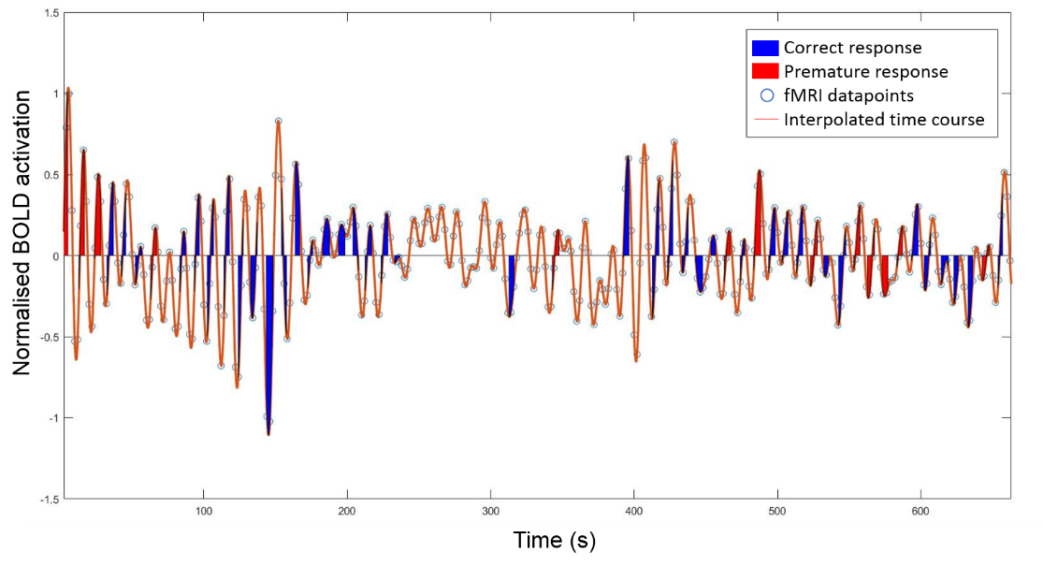

Supplementary Figure 2. Two-way interactions between group and incentive (money versus drug) in the striatum ROI. Differential response to incentives for SDI versus HC are shown in red/orange and for SDI versus SIB in blue. A significant interaction between group (HC vs SDI, SIB vs SDI) and incentive was found in the left caudate and left putamen. Z=[0 -2 4 8 10 14 16 18], (Multiple comparison corrected using FSL randomise and thresholded at p<0.05 FWE).
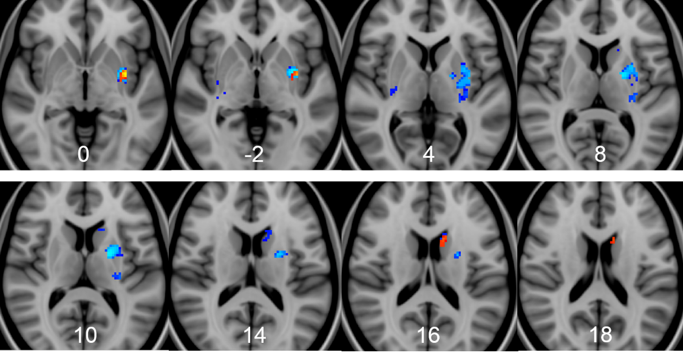

Supplementary Figure 3. ROI placements for each subject and their average time courses with 95% confidence intervals for premature and correct trial types. The first column shows inferior frontal cortex (IFC), dorsal anterior cingulate (dACC) and dorsal striatum (dSTR) spheres from each participant overlaid on the MNI template to illustrate the locations of the ROIs. Individual spheres for SDIs are shown in red and HC spheres are shown in blue. Second column shows average brain activation time courses obtained from deconvolved, denoised and interpolated BOLD signals for HCs in money condition, whereas the third and fourth columns shows average brain activation for each ROI in the SDIs in the money and drug conditions, respectively. The bold portion of the X-axis highlights the anticipation phase during which the premature response was made (premature trials in red), or which was immediately followed by an on-target response (correct trials in black). Anticipation phase duration varied randomly in duration between 3.5 and 5s. Note that these ROIs were used for validation analysis in Figure 1D and DCM analysis in Figure 4. While average SDI drug incentive time courses show overlap between premature and correct trials, this is likely due to high interindividual variability and did not significantly reduce within-subject prediction of trial type from ROI activation levels.
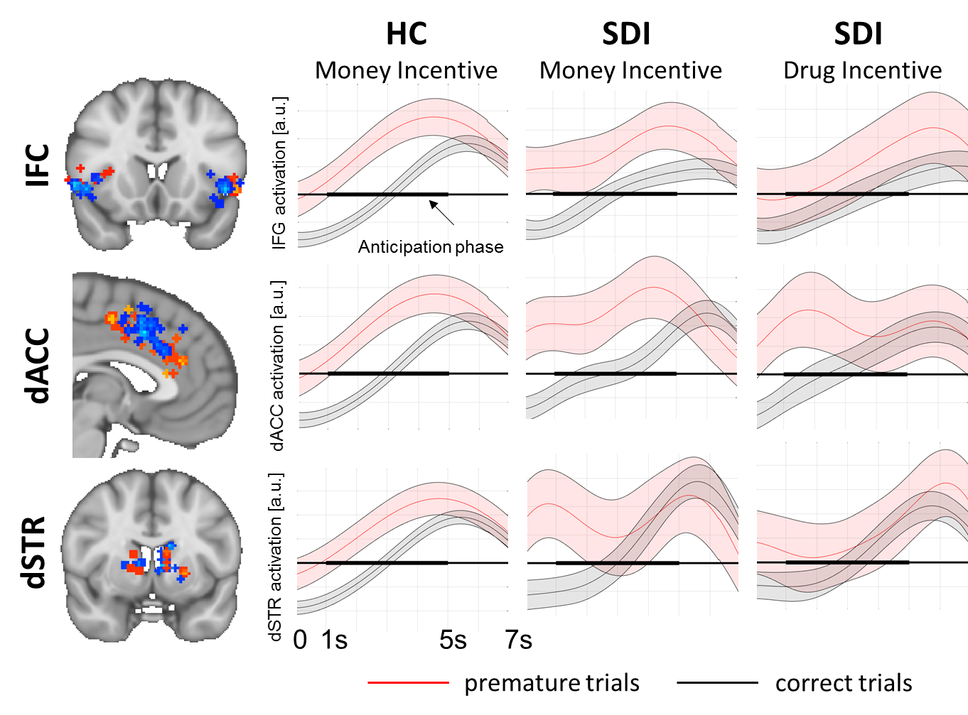
Supplementary Figure 4. DCM results including the SIB group. (A) Similarly to the findings from the SDI and HC groups, the fully interactive model reliably characterises the network connectivity in the unaffected siblings (SIB). (B) In contrast to the SDI and HC, the SIB group showed substantial interindividual variability, mirrored by the lack of a consistently winning model within the winning model family. (C) This was accompanied by an absence of significant modulatory effects as the location of task modulation varied across individuals. (D) Depiction of all models included in the BMS and BMA analyses. The first row contains models 1-3 (left to right), while the second and third rows contain models 4-6 and 7-9, respectively.
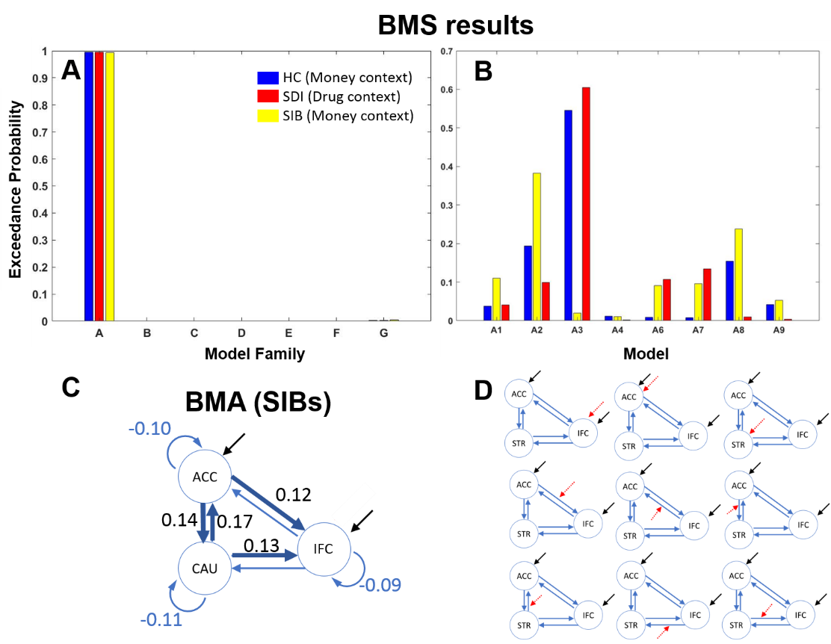

Supplementary Figure 5. Mean target stimulus duration in the HC, SIB and SDI in the drug and money conditions (A) and mean target duration difference between the conditions (B).
