**ESE 519 Project Proposal**

**BrainWAV: Emotive Audio Device**

Pranav Sahay, Shanjit Jajmann, Jared Wilson

Research centered around the analysis of electroencephalogram (EEG) has a wide spectrum of applications particularly in the area of medical and entertainment applications. One such application is emotion recognition using EEG, and in recent years has made many promising advances. Research from the Nanyang Technological University in Singapore (2012), provided a proof of concept study that real-time emotion recognition was possible using surface EEG recordings. To provide a real world application for this technology is an exciting development.

**Goal**:

***Summary***

The goal of this project is to build upon existing research to design a system capable of real-time EEG analysis and emotion classification to suggest or automatically playback songs for the user.

***Project Goals***

1. Design real-time EEG acquisition hardware
2. Train SVM model in MATLAB
3. Classify user emotions in real time (using SVM model)
4. Interface device with audio program API (Song Choice)
5. Implement wireless transmission (Bluetooth)

|  |  |
| --- | --- |
| **Hardware** | **Software** |
| Mbed (for DSP) | Training using MATLAB/Python |
| [ADS1299EEG-FE](http://www.digikey.com/product-detail/en/ADS1299EEGFE-PDK/296-34948-ND/3661882) for (signal acquisition) | Web Application using Youtube API |
| [EEG Electrodes](http://openbci.myshopify.com/collections/frontpage/products/openbci-electrode-starter-kit) | EEG repository |
| Electrode Cap |  |
| Bluetooth Module |  |

***LINKS FOR PARTS ARE PROVIDED***

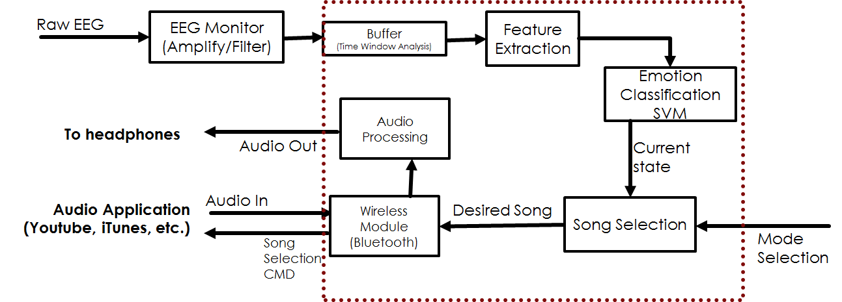

**Timeline**

**Week1 (3/30)**

Acquire EEG emotion classification training data from online resources. Gather hardware resources and begin hardware construction.

**Week 2 (4/6)**

Train SVM/other learning models in Matlab/Python using training data. Complete hardware design including electrodes and show real time recording.

**Week3 (4/13)**

Program microcontroller to be able to extract the desired time windowed features for the SVM model. Interface microcontroller with the web application to take in extracted features and playback appropriate audio.

**Week4 (4/20)**

Implement SVM model on microcontroller (test/debug). If wired connection working properly, implement bluetooth.

**Week5 (4/27)**

Additional time to Test/Debug. Explore extra credit implementation if design is functional.

**Deliverables:**

1. Show device capable of real-time EEG acquisition and feature extraction.
2. Interface the microcontroller with web application using youtube API to enable song selection and streaming.
3. Create a generalized SVM model that is able to accurately classify the emotional state from EEG recordings (show that it can classify better than a random selection process).
4. Enable real-time emotion classification.
5. Implement wireless communication between microcontroller and user device.

*Extra Credit:*

We have two “extra credit” objective that we would like to accomplish if time permits.

1. Enable all audio processing to be done on device without the need of external headphones. More specifically, implement “very good quality” audio playback on device and eliminate the need for external headphones or speakers.
2. Make the device self-learning. While an initial SVM model will be used for each user, the SVM model will be able to adapt to the user over time by the user providing feedback to the device. An example of this implementation would be for the device to prompt the user to describe how they are feeling at a random time, this will guide the device in making future decisions.