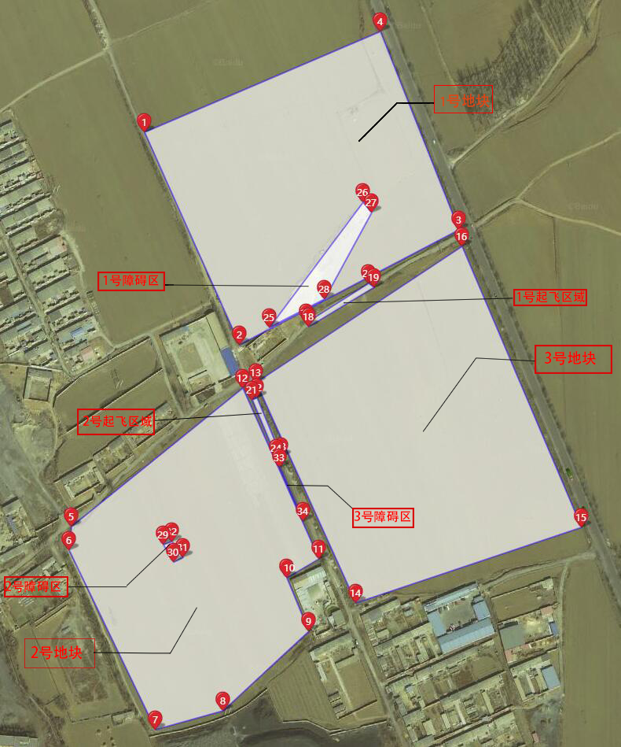

垄的方向为1号点到2号点。

飞机数为8架。

地块区为3个。

障碍区3个。

起飞区2个。

幅宽4米。

1号地块

(1) 118.295759,39.699527

(2) 118.296841,39.69767

(3) 118.299347,39.698684

(4) 118.298449,39.700411

2号地块

(5) 118.294919,39.696067

(6) 118.294892,39.695859

(7) 118.29588,39.694277

(8) 118.296644,39.694443

(9) 118.297623,39.695144

(10) 118.29738,39.695616

(11) 118.297748,39.695783

(12) 118.296877,39.697289

3号地块

(13) 118.29703,39.697337

(14) 118.298162,39.695394

(15) 118.300749,39.69606

(16) 118.299383,39.698538

1号起飞区域

(17) 118.297596,39.697865

(18) 118.297623,39.69783

(19) 118.298373,39.698177

(20) 118.29831,39.698212

2号起飞区域

(21) 118.29698,39.697185

(22) 118.297039,39.697205

(23) 118.297313,39.696685

(24) 118.297263,39.696674

1号障碍区域

(25) 118.297178,39.697826

(26) 118.298243,39.698926

(27) 118.29835,39.698833

(28) 118.297811,39.698076

2号障碍区域

(29) 118.29597,39.695908

(30) 118.296082,39.695758

(31) 118.29619,39.695797

(32) 118.29606,39.695935

3号障碍区（一条线，模拟田边的一排树）

(33) 118.297295,39.696591

(34) 118.297569,39.696119