

A Final Year Internship Report

on

“Web Application”

at

Paila Creation

Submitted To

Office of Dean,

Faculty of Management

Tribhuvan University

In partial fulfillment of the requirement for the Degree of Bachelor of

Information Management (BIM)

Under the Supervision of

Er. Dhiraj Kumar Jha

Project Coordinator

Orchid International College

Submitted By

Bhawana Pathak

TU Registration No:7-2-939-74-2016

TU Exam Roll No: 7416/16

Orchid International College

May 2021

Supervisor’s Recommendation

I hereby recommend that this report has been prepared under my supervision by Bhawana Pathak in partial fulfillment of the requirements for the degree of Bachelor of Information Management (BIM) be processed for evaluation.

……………..........…….

Er. Dhiraj Kumar Jha

Project Coordinator

Department of Information Management

Orchid International College

Bijayachowk, Gaushala

i

CERTIFICATE OF APPROVAL

The undersigned certify that they have read and recommended to the Department of Information Management for acceptance, an internship report submitted by Miss. Bhawana Pathak in partial fulfillment for the degree of Bachelor of Information Management (BIM).

 | ---------------------------- | -------------------------
 | Er. Dhiraj Kumar Jha | Bijay Mishra
 | Internship Supervisor | Program Coordinator
 | Department of Information Management | Department of Information Management
 | Orchid International College | Orchid International College
 | Bijayachowk, Gaushala | Bijayachowk, Gaushala

---------------------------------------------

Prof. Dr. Purushottam Sharma

Internal Examiner

Orchid International College

Bijayachowk, Gaushala

ii

DECLARATION

I, Bhawana Pathak (7416/16), hereby declare this internship report entitled “Web Application Development” in partial fulfillment of the requirement for the degree of Bachelor of Information Management under the Faculty of Management, Tribhuvan University, is my original work and I have not submitted it earlier elsewhere.

…………………………….

Bhawana Pathak

BIM, VIII Semester

iii

ACKNOWLEDGEMENT

I would like to thank the University for including such a wonderful task in the curriculum of BIM. I would like to express my gratitude and appreciation to all those who helped me throughout the internship period. Firstly, I would like to acknowledge the supervising team at Paila Creation- Mr. Sushan Tachamo, Supervisor for giving us special time, effort and guidance throughout the project assigned to me for inspiring, cooperative, helpful and providing such a friendly environment at work..

My special appreciation goes to the Report Supervisiors for their supportive guidance during preparation of this report and his untiring effort of going through the draft reports and providing me valuable suggestions.

Mr. Bidur Dahal, principal of Orchid International College, deserves special thanks for his support and inspiration and encouragement to maintain my internship report in track.

Bhawana Pathak

BIM, VIII Semester

iv

Table of Contents
Supervisor’s Recommendation i

CERTIFICATE OF APPROVAL ii

DECLARATION iii

ACKNOWLEDGEMENT iv

List of Tables vii

List of Figure viii

ABBREVIATIONS ix

CHAPTER 1:INTRODUCTION 10

1.1 Background 10

1.2 Objectives 10

1.3 Methodology 11

1.3.1 Organization Selection 11

1.3.2 Placement 11

1.4 Duration 12

1.5 Activities 13

CHAPTER 2:INTRODUCTION OF INDUSTRY 14

2.1 Introduction of IT Industry 14

2.2 Importance of IT 14

2.3 Scope of IT 15

2.4 History Of IT in Nepal 16

2.5 Opportunities and Challenges 16

CHAPTER 3 :INTRODUCTION OF THE ORGANIZATION 18

3.1 Introduction of Paila Creation 18

3.2 Objective of Paila Creation 18

v

3.3 | Mission of Paila Creation .................................................................................................................... |  | 19
3.4 | Vision of Paila Creation ...................................................................................................................... |  | 19
3.5 | Contact Details .................................................................................................................................... |  | 19
CHAPTER 4:ANALYSIS OF ACTIVITY DONE/ PROBLEM SOLVED ......................................... |  |  | 20
4.1 | Background ......................................................................................................................................... |  | 20
4.2 | Analysis of activities done .................................................................................................................. |  | 20
4.3 | Tools Used .......................................................................................................................................... |  | 20
4.4 | Basic Functionalities of the System .................................................................................................... |  | 20
4.4.1 |  | Use Case ........................................................................................................................................... | 20
4.4.2 |  | ER-Diagram ..................................................................................................................................... | 24
4.4.3 |  | Class Diagram .................................................................................................................................. | 25
4.4.4 |  | Sequence Diagram ............................................................................................................................ | 26
4.4.5 |  | Activity Diagram .............................................................................................................................. | 27
CHAPTER 5 : CONCLUSION ................................................................................................................ |  |  | 28
5.1. Conclusion .......................................................................................................................................... |  |  | 28
5.2 | Lesson Learn ....................................................................................................................................... |  | 28
References .................................................................................................................................................. |  |  | 29
Appendix .................................................................................................................................................... |  |  | 30

vi

List of Tables

Table 1:Internship Duration 12

Table 2:Organization Details 19

Table 3:Admin Login 21

Table 4:Manage Category 21

Table 5:Manage product 22

Table 6:Manage Order 22

Table 7:View Category 22

Table 8:View Product 23

Table 9:Add product to cart 23

Table 10:Order Product 23

vii

List of Figure

Figure 1.1 Organizational Structure 12

Figure 2.1 Organization logo. 18

Figure 4.1 Use Case Diagram 21

Figure 4.2 Er-diagram 24

Figure 4.3 Class Diagram 25

Figure 4.4 Sequence Diagram 26

Figure 4.5 Activity Diagram 27

viii

ABBREVIATIONS

BIM

BPO

CEO

CV

IT

OIC

TU

NTIS

NTA

ITES-BPO

ER-diagram

Bachelor of Information Management

Business Process Outsourcing

Chief Executive Officer

Curriculum Vitae

Information Technology

Orchid International College

Tribhuvan University

Nepal Trade Intergration Strategy

Nepal Telecommunication Authority

Informational Technology Enable Services-Business

Process Outsourcing

Entity-Relationships Diagram

ix

CHAPTER 1:INTRODUCTION

1.1 Background

An internship is an opportunity offered by an employer to potential employees known as interns to work at a firm for a limited period of time for building working experience in real-world scenario. Internship assists the students to use and apply the theoretical knowledge gained form their academics into real world, evaluate the changes they face and learn from it. Therefore, internship plays a vital role in career development of a student. Internships are individual and tailored to the needs and interests of each student in the program. As part of the internship experience, students are expected to take an active role in finding an appropriate internship for themselves.

Internship is done as a partial fulfillment of requirements of the bachelor in information management (BIM), an undergraduate degree awarded by Tribhuvan university (TU), Kirtipur. The internship is assigned six credit hours (minimum of ten weeks or 180 hours long) as a part of the course requirement. The internship scheme is a great way to develop specific skills and knowledge, as well as make contacts and build confidence. More and more, employers assess the skills and abilities of prospective employees by evaluating their previous experiences.

This internship as per the requirement of the TU for the BIM not only fulfils that very requirement but has also developed me personally by getting myself acquainted with how the software industry regulates. This program has enhanced the skill and enthusiasm of the students as they get knowledge of the company environments and to learn different aspects of working mechanism that prevail in the organizations. Every subject learned during the BIM course including Data Structure and Algorithm, Design Analysis and Algorithm, Database Management System, Data Mining and Data Warehouse, Web Technology, Distributed Database and others have been well implemented during this internship program. During this internship period student were introduced to the organizational structure, professional world, ISO standards of the organization.

1.2 Objectives

The main objective of the project report is to know about web application development at Paila Creation. In order to achieve this objective, specific objective of the report are:

10
The specific objectives of internship are:

- To implement MVC pattern in Laravel.

- To design and manage the databases.

- To implement the programming skills to develop web based applications.

1.3 Methodology

1.3.1 Organization Selection

Appropriate selection of organization for the internship is always a crucial task. Being an IT student, I am interested in software development. As an intern, I wanted to be in the organization where my interest will be fully appreciated. So, I selected Paila Creation Nepal as my internship destination.

While selecting this company for my internship, first I started to search the vacancy in various job portal. Then I started to drop my CV (Curriculum Vitae) to my list of suitable organization. Through interview I was selected as a backend laravel developer to my interested organization. Paila Creation was the good choice as it had provided me a very good and cooperative environment to learn.

1.3.2 Placement

In Paila Creation, I was placed in backend developer and given a task to develop a web application of bakery ordering system. I got proposed to engage in back end development. In three months’ period, I was supervised by Team Leader.

11
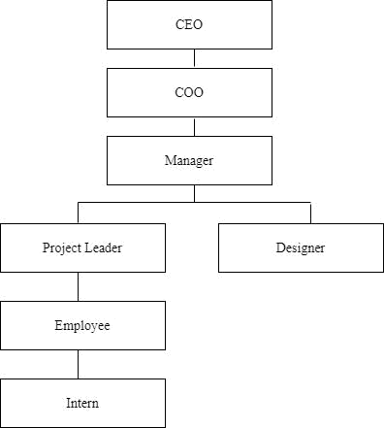

Figure 1.1 Organizational Structure

1.4 Duration

 | Table 1:Internship Duration
Start date |  | 6th October 2020
End Date |  | 10th January 2021
Internship Period |  | 3 months

During the internship period I was assigned various task for the website development. From 6th October to 10th January, I had been involved in various projects, though in this report, introduction is given about the bakery ordering system. During that period, I was supervised by my Supervisor Mr Sushan Tachamo.

12
1.5 Activities

During the period of internship, I was assigned various tasks that were reviewed by supervisor. Most regularly our work was evaluated as per our performance and we were guided and suggested to do if there were any deviation in our work. The task contains the problems that need to be solved or list of activities that need to be done along with the design of it. After the task assigned, we start generating overall idea about task and start to code as per the task requirement. The list of activities done are as follows:

- Design the database

- Implementing database

  - Design backend

- CRUD operation

- Form validation

- XAMPP

- MySql for database design

- PhpStorm

13
CHAPTER 2:INTRODUCTION OF INDUSTRY

2.1 Introduction of IT Industry

The information technology (IT) industry has become one of the most robust industries in the world. IT encompasses all possible aspects of information systems based on computers and telecommunications used often in the context of a business or other enterprise. IT, more than any other industry or economic facet, has an increased productivity, particularly in the developed world, and therefore is a key driver of global economic growth.

Computer Science is the study of principles and practices that underpin an understanding and modelling of computation, and of their application in the development of computer systems. At its heart lies the notion of computational thinking: a mode of thought that goes well beyond software and hardware, and that provides a framework within which to reason about systems and problems. This mode of thinking is supported and complemented by a substantial body of theoretical and practical knowledge, and by a set of powerful techniques for analyzing, modelling and solving problems.

The software industry expanded in the early 1960s, almost immediately after computers were first sold in mass-produced quantities. Universities, government, and business customers created a demand for software. Many of these programs were written in-house by full-time staff programmers. Some were distributed freely between users of a particular machine for no charge. Others were done on a commercial basis, and other firms such as Computer Sciences Corporation (founded in 1959) started to grow. The computer/hardware makers started bundling operating systems, systems software and programming environments with their machines.

The software market in Nepal is experiencing steady growth. Experts and professionals involved in this business are taking this growth as a positive aspect of developing awareness related to information technology in the country.

2.2 Importance of IT

With the introduction of computers, the business world is changing forever. Using computers and software, business use information technology to esure that their departments run smoothly. The importance is listed below:

- Information technology today is essential in ensuring the smooth functioning of all the departments in a company

14

- The manufacturing and production companies, such as those in the automobile sector, uses IT and software products to get rid of any sort of errors or mistakes, in the proper functioning of the tools used for designing and manufacturing purposes.

- It has great use in the automated production of sensitive information, up-gradation of the important business processes, and streaming of the various business processes.

- It helps the managers in adapting to the new business processes, and also for predicting the possible impacts of newer technologies.

- It helps the students as well as the teachers in studying the course materials easily, by enabling faster access to information from across the globe, on a number of different topics.

- Information technology is used for storing, protecting, processing, securing, transmitting, receiving and retrieving information.

2.3 Scope of IT

Career in IT is considered one of the most high-paying jobs and is full of opportunities. We all know that the world has become dependent in Information technology and life without one is beyond our imagination. The technologies are developing day by day. The fast growth in technological field has made the world a better and fast-moving place. The growth is due to the increase in applications of computer in almost every field.

IT graduates can work in different industry like software industry, financial institutions, health, corporate organizations, etc.

The following are the list of common careers for IT graduates:-

- System Analyst

- Project Manager

- Software Developer

- Web Designer

- Database Developer

- QA (Quality Assurance) Officer

- Technical Writer

- Artificial Intelligence

- Ethical Hacking

15

2.4 History Of IT in Nepal

The history of IT in Nepal dates back to not more than a couple of decades. The IT sector is an emerging area in Nepal. The Government of Nepal has identified IT and business process outsourcing (BPO) as one of the 5 priority potential export service sectors in the Nepal Trade Integration Strategy (NTIS) 2010. IT has the potential to generate high growth, investment, and significant profits in the coming years and is expected to be one of the most significant growth contributors to the Nepali economy.

Business process outsourcing is a major emerging area in IT in Nepal. These IT entities are often referred to as ITES-BPO (informational technology enable services-business process outsourcing). The existing players in ITES-BPO in the market serve both the domestic and international market. Three types of companies are involved in the ITES-BPO sector: local solution providers focusing on the local markets, export-oriented providers (e.g. offshore center) and hybrid providers (both local and export-oriented).

An IT park is being established in Banepa, Kavre. The local investment in this venture is estimated to be around NPR 270 million (USD 2.70 million). The government is preparing to give a 50% tax subsidy to companies operating in the park. The park is expected to develop software, promote IT-based business and provide services, as well as promote investors in related fields. The credit for introducing internet among the people mainly goes to the private sector. Although the internet was initially limited only to email services, in 1995, a company Mercantile Communications finally started the internet services in the country. In 1998, Nepal Telecommunications Authority (NTA), a telecommunications regulatory body, was formed as per the Telecommunications Act 1997.

2.5 Opportunities and Challenges

Along with its various usage, if well recognized and properly implemented IT has lots of opportunities as bellows:-

- It is important economic driver in economic world.

- Increasing E-Commerce business

- The whole world is being digitized

- Machine Learning has given a new scope in IT

- Increasing people demand for software and applications

16
- Companies are using technology more intelligently and strategically

Though IT sector has been one of the most requiring sectors of today’s business world, we also have various challenges to face with the use of information technology as:-

- Changing customer’s needs and wants

- Security issues

- Skilled manpower getting outsourced to other countries

- Manage and tame the complexity beast

- Insufficient allocation of budget

- Lacking the knowledge of latest technology

17
CHAPTER 3 :INTRODUCTION OF THE ORGANIZATION

3.1 Introduction of Paila Creation

Paila Creation is a professional web design, web development, web hosting, software development and mobile application company in Nepal. They have a keen sense of their client’s business needs and their services are delivered in accordance with their requirements.

From their small but resolute beginning, they have made major inroads into the IT market, capturing key areas of products and service, and established a track record of success in delivering high quality software engineering innovation, business analytics products and services.

Paila Creation partners with our clients to help them achieve their business and IT needs. They have experience, knowledge and skills to advice, design, engineer and implement solutions to medium to large scale systems that take business to new heights.


Figure 2.1 Organization logo.

3.2 Objective of Paila Creation

The major objectives of Paila Creation are:

- To provide quality customer services.

- Partner with customer to provide best solution.

- To provide most innovative software products.

- To improve technical and analytical skill of the employees.

- To create performance focused culture within an organization.

18
3.3 Mission of Paila Creation

Our aim is to build long-term partnerships with our customers. With their support, we aim to maximize the potential of our traditional business, through a combination of enhanced quality of service, creative marketing, innovative pricing and cost efficiency.

At the same time, we’ll pursue profitable growth by migrating our customer to new wave products and services. We will interlink each and every business people and their customers, in villages and cities with worldwide business people, without categorizing them into classes.

3.4 Vision of Paila Creation

Our goal is to ensure customer satisfaction by developing required applicable technology in sync with trends compatible to everyday changing markets in order to promote, standardize and develop customers' business portfolios as per their needs. The services we provide our clients are always result oriented & primed to perform successfully in highly competitive markets.

3.5 Contact Details

 | Table 2:Organization Details
Location |  | Putalisadak,Kathmandu,Nepal
Phone |  | +977 9843367450
Email |  | mail.pailacreation@gmail.com

19
CHAPTER 4:ANALYSIS OF ACTIVITY DONE/ PROBLEM SOLVED

4.1 Background

The main purpose of the project was the development of a bakery ordering system. This project required adding various validations along with attractive frontend display. The system was divided into two parts as frontend and backend. The frontend part was basically was done with php, css and bootstrap whereas the backend part was developed using php with laravel framework and SQL. I was given the task of doing the backend module of this project.

4.2 Analysis of activities done

During the internship perios, I was hired as an intern in development section and was given task to develop the web application in Laravel.

During this period I performed following activities:

- Get familiar with PHP and Laravel framework

- Designed the database using SQL

- Developed a backend module for bakery ordering system

- Created CRUD operations for this system

4.3 Tools Used

Many tools were used while developing this system. Some of the tools used are listed below:

- XAMPP Server

- PhpStorm

- GIT

- Google Chrome

4.4 Basic Functionalities of the System

4.4.1 Use Case

A use case diagram is a representation of a user’s interaction with the system that shows the relationship between the user and the different use cases in which the user is involved.

20
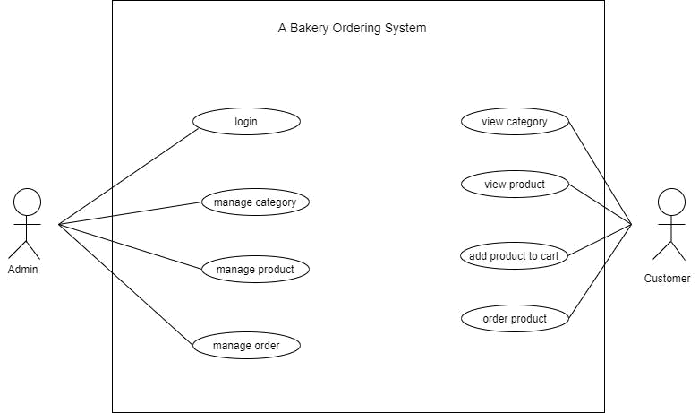

 | Figure 4.1 Use Case Diagram
Explanation of the Use Case
 | Table 3:Admin Login
Use-case Identifier | UC1:Admin Login
Primary Actor | Admin
Secondary Actor | None
Description | The admin logs into the system.
Success Scenario | The admin successfully logged into the system.
Failure Scenario | The admin cannot log into the system if username and password does
 | not match.
 | Table 4:Manage Category
Use-case Identifier |  | UC2:Manage category
Primary Actor |  | Admin
Secondary Actor |  | None
Description |  | The admin keeps the record of the category.
Pre-condition |  | The admin can only view and insert the record
 |  | after logged in.
Post-condition |  | The database must be updated.
 | 21

Success Scenario |  | Category is added into the database.
Failure Scenario |  | The database is not connected.
 | Table 5:Manage product
Use-case Identifier |  | UC3:Manage product
Primary Actor |  | Admin
Secondary Actor |  | None
Description |  | The admin keeps the record of the product.
Pre-condition |  | The admin can only view and insert the record
 |  | after logged in.
Post-condition |  | The database must be updated.
Success Scenario |  | Product is added into the database.
Failure Scenario |  | The database is not connected.
 | Table 6:Manage Order
Use-case Identifier |  | UC4:Manage order
Primary Actor |  | Admin
Secondary Actor |  | None
Description |  | The admin keeps the record of the ordered items.
Pre-condition |  | The admin can only view the record after logged
 |  | in.
Post-condition |  | The database must be updated
Success Scenario |  | Ordered item is added into the database
Failure Scenario |  | The database is not connected.
 | Table 7:View Category
Use-case Identifier |  | UC5:View category
Primary Actor |  | Customer
Secondary Actor |  | None
Description |  | The customer can view the category displayed.
Pre-condition |  | The customer can only view the category which is
 |  | displayed.
Post-condition |  | The customer can view product according to the
 |  | category.
 | 22

Success Scenario |  | Category is displayed to the customer.
Failure Scenario |  | The database is not connected.
 | Table 8:View Product
Use-case Identifier |  | UC6:View product
Primary Actor |  | Customer
Secondary Actor |  | None
Description |  | The customer can view the product.
Pre-condition |  | The customer can only view the product which is
 |  | displayed.
Post-condition |  | The customer can order the product
Success Scenario |  | The customer can view and order the product.
Failure Scenario |  | The database is not connected.
 | Table 9:Add product to cart
Use-case Identifier |  | UC7:Add product to cart
Primary Actor |  | Customer
Secondary Actor |  | None
Description |  | The customer can add product to the cart
Pre-condition |  | The customer can only add product to the cart
 |  | which is displayed.
Post-condition |  | The customer can order the product.
Success Scenario |  | The customer can mange the cart.
Failure Scenario |  | The database is not connected.
 | Table 10:Order Product
Use-case Identifier |  | UC8:Order Product
Primary Actor |  | Customer
Secondary Actor |  | None
Description |  | The customers can order the product.
Pre-condition |  | The admin can order the cart product.
Post-condition |  | The order is placed.
Success Scenario |  | The product is ordered.
Failure Scenario |  | The database is not connected.
 | 23

4.4.2 ER-Diagram

An entity-relationship diagram is data modeling technique that graphically illustrates an information system’s entities and the relationship between those entities.
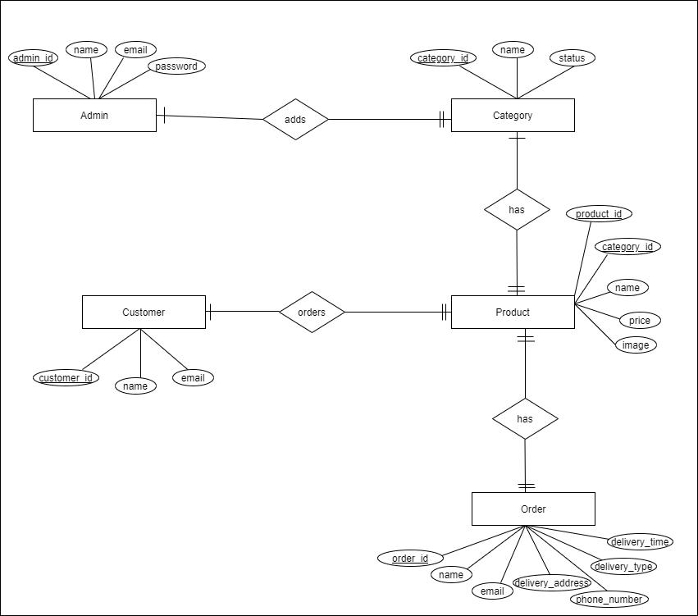

Figure 3.2 Er-diagram

In the above diagrame five entites i.e admin,category,product,customer and order are shown with their attributes and relationship among them. The admin here manages category,product,customer and order. The customer orders the displayed product.

24
4.4.3 Class Diagram

A class diagram is a type of static structure diagram that describes the structure of a system by showing the system’s classes, their attributes, operations or methods and the relationships amomg objects.
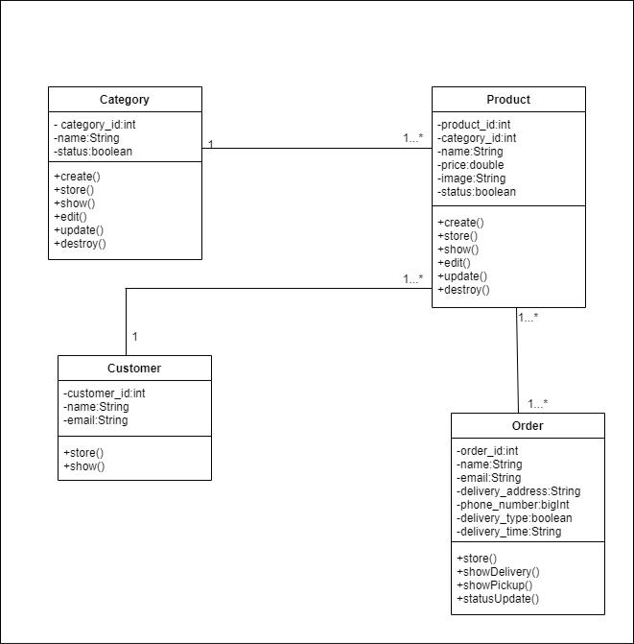

Figure 4.3 Class Diagram

25
4.4.4 Sequence Diagram

A sequence diagram shows the object interactions arranged in time sequence. It depicts the objects and classes involved in the scenario and the sequence of message exchanged between the objects needed to carry out the functionality of the scenario.
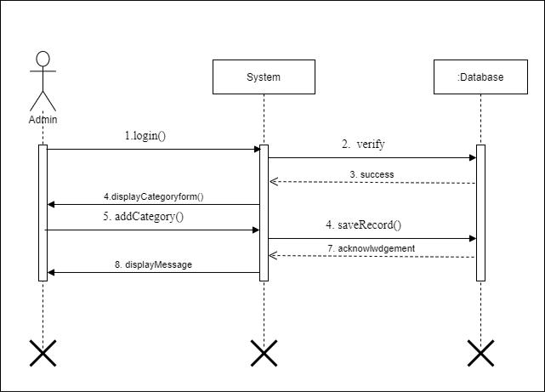

Figure 4.4 Sequence Diagram

26
4.4.5 Activity Diagram

An activity diagram is basically flowchart to represent the flow from one activity to another activity describes as an operation of the system. Activity diagrams are not only used for visualizing the dynamic nature of a system, but they are also used to construct the executable system by using forward and reverse engineering techniques.
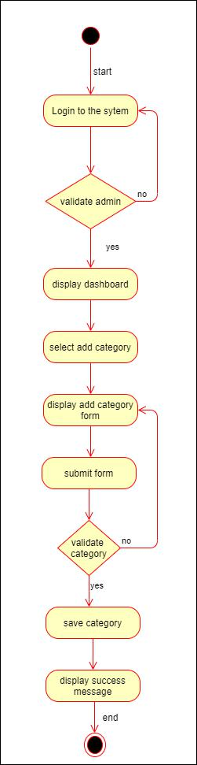

Figure 4.5 Activity Diagram

27
CHAPTER 5 : CONCLUSION

5.1. Conclusion

It was a wonderful experience to work in Paila Creation with highly professional group of people. It was a great opportunity to learn about the professional environment and develop a professional attitude. The way one person helped the other and the whole development functioned together showed how a group of professional work together to meet a desired goal. The importance of good leadership among the managers and discipline among the staffs is must for smooth functioning of any organization or any department within it. Similarly good communication skill among all the staffs is also a necessity for the growth of any organization. It will certainly go as a confidence boosting factor in coming days.

5.2 Lesson Learn

While doing internship in Paila Creation, it was a great platform for me to learn about the professional environment. It had provided me the opportunities to acquire practical knowledge about the working procedures in the organization at a real time. I learnt how the different phases of software development life cycle goes through. I get to know about various tools and techniques used while developing a software.

Some of the important lessons which I learned during my internship period are:

- Writing clean, commented code make programming easier

- Appropriate communication among team members

- Learn Laravel framework

- Learn about database design

- Dedication to work

- Update according to changing environment and use latest technology.

28

References

Laravel.com. 2021. Authentication - Laravel - The PHP Framework For Web Artisans. [online] Available at: <https://laravel.com/docs/8.x/authentication> [Accessed 17 May 2021].

GitHub. 2021. Crinsane/LaravelShoppingcart. [online] Available at:

<https://github.com/Crinsane/LaravelShoppingcart> [Accessed 17 May 2021].

Laravel.com. 2021. Middleware - Laravel - The PHP Framework For Web Artisans. [online] Available at: <https://laravel.com/docs/8.x/middleware> [Accessed 17 May 2021].

Savani, H., 2021. Laravel Many to Many Eloquent Relationship Tutorial. [online]

Itsolutionstuff.com. Available at: <https://www.itsolutionstuff.com/post/laravel-many-to-

many-eloquent-relationship-

tutorialexample.html#:~:text=Many%20to%20many%20relationship%20is,also%20connecte

d%20with%20multiple%20users.> [Accessed 17 May 2021].

29

Appendix


30
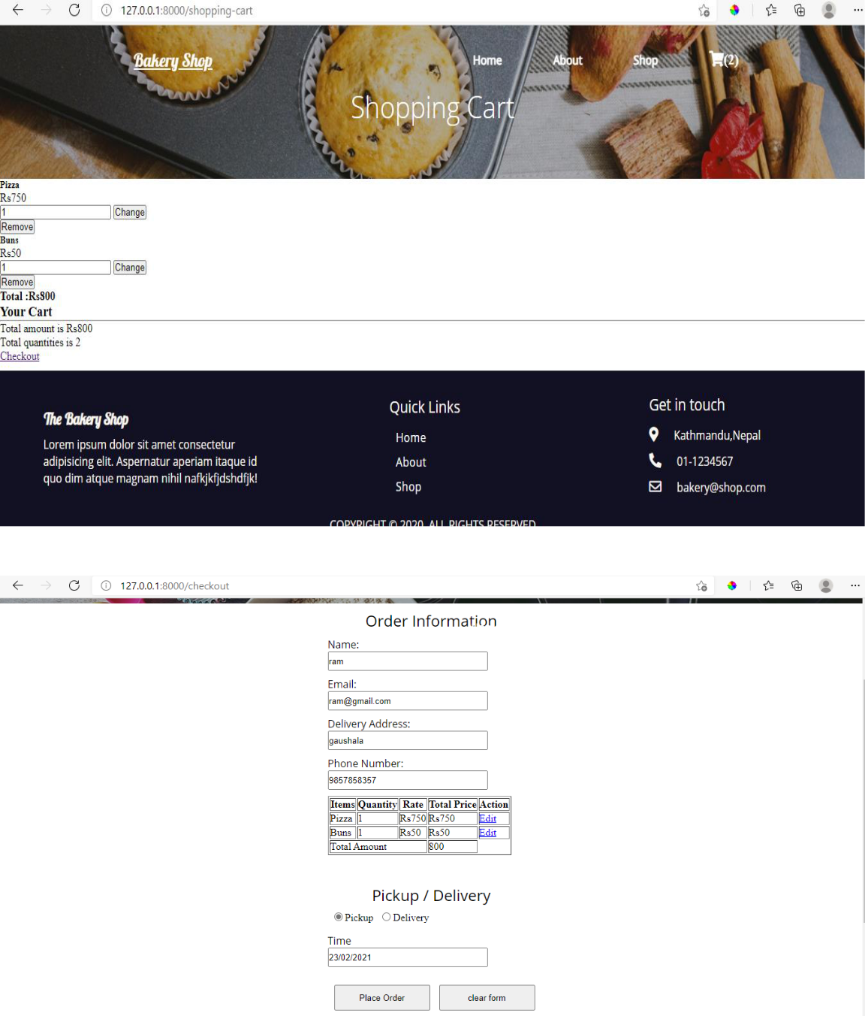

31
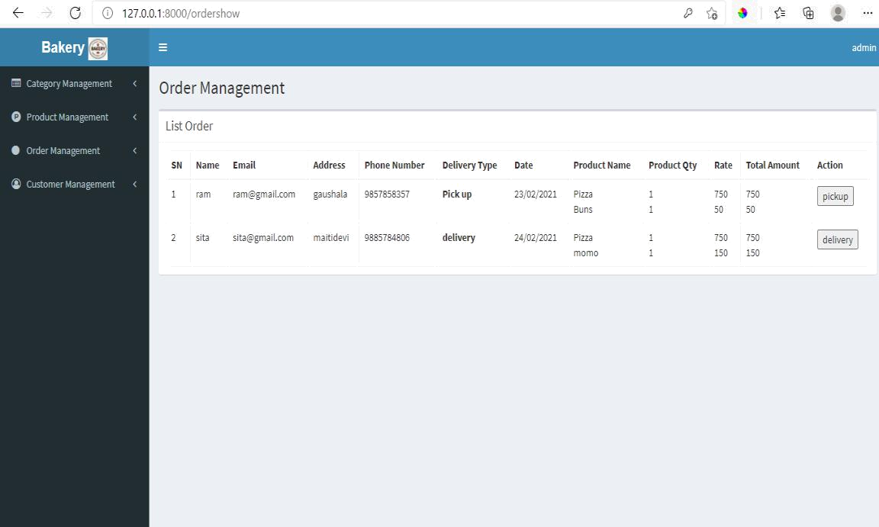

32

