**TRIBHUVAN UNIVERSITY**

**Faculty of Management**



**An Internship Report On**

**Web Development**

**AT**

**Neutroline Pvt. Ltd**

**Under the supervision of Mr. Janak Prasad Timilsina**

**Submitted by**

Dipesh Shrestha

**TU REG NO:** 7-2-25-1176-2016

**Exam Roll no:** 7717/16 **Nepal Commerce Campus** An Internship Report Submitted to

**Faculty Of Management,Tribhuvan University**

**In the partial fulfillment of the requirements for the degree of Bachelor of Information Management**

**Kathmandu, Nepal Jun 2021**

# APPROVAL SHEET

This is to certify that the Internship Report

Submitted By: Dipesh Shrestha

Exam Roll No:- 7717/16

TU Registration No:- 7-2-25-1176-2016

**Entitled**

**FRONTEND DEVELOPMENT ON NEUTROLINE PRIVATE**

**LIMITED**

has been prepared as approved by this campus. This Internship Report is forwarded for an

examination

Mr. Surya Pd. Devkota Director, BIM Program Nepal Commerce

# INTERNSHIP COMPLETION LETTER

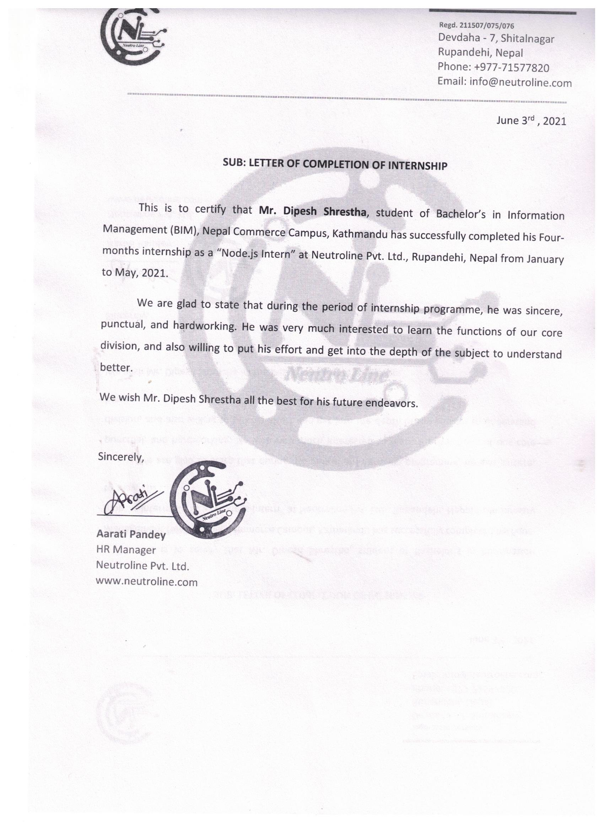

# CERTIFICATE FROM THE SUPERVISOR

This is to certify that the internship project entitled “**Web Development** **on Neutroline Pvt. Ltd**” is an academic work based on an internship done by **Dipesh Shrestha** submitted in the partial fulfillment of the degree of the Bachelor of Information Management at the Faculty of Management, Tribhuvan University under my guidance and supervision. To the best of my knowledge, the information presented by her in the internship report has not been submitted earlier.

…………………………….

Signature of the Supervisor

Mr. Janak Prasad Timilsina

Designation: Deputy Director

Date: May 2021

# STUDENT DECLARATIONS

I hereby declare that the internship report entitled “**Web Development on Neutroline Pvt. Ltd**”, submitted to the Faculty of Management, Tribhuvan University, is an original piece of work under the supervision of **Mr. Janak Prasad Timilsina**, deputy director of Bachelor of Information Management, Nepal Commerce Campus and is submitted in partial fulfillment of the requirements for the award of the degree of **Bachelor of Information Management** **(BIM)**. This internship report has not been submitted to any other university or institution for the award of any degree or diploma.

……………………………

Signature:

Dipesh Shrestha

BIM 8th Semester

Nepal Commerce Campus

Date: May 2021

# ACKNOWLEDGEMENT

An internship report entitled “**An Internship Report on Web Development** “has been prepared in the partial fulfillment of the requirement for the degree of **Bachelor of Information Management**. I would to thank Tribhuvan University for designing the practical based Internship program and giving opportunity for the students to explore the real life situation of the IT sector as well as to insight the theoretical knowledge in the practical field.

First of all, I would like to extend my gratitude to **Mr. Pitambar Pandey** chairman of Neutroline Private Limited for giving me an opportunity to work as an intern in the organization. I feel very fortunate enough to get such an encouraging mentor who continuously counseled me and helped me. I am also grateful to **Mr. Prabin Giri** for his valuable corporation, guidance direction and support throughout the period of internship.

This is a rejoicing moment and privilege for me to take this ample opportunity to express my deep and warmth sense of gratitude and sincere regards to my respected supervisor **Mr. Janak Prasad Timilsina** for his constant encouragement, valuable suggestion, proper guidance of supervision in accomplishing this project work. I am also thankful to **Mr.Surya Prasad Devkota**, BIM director for his generous support.

Dipesh Shrestha

BIM 8th semester

Nepal Commerce Campus

Minbhawan, Kathmandu

Table of Contents

*APPROVAL SHEET i*

*INTERNSHIP COMPLETION LETTER ii*

*CERTIFICATE FROM THE SUPERVISOR iii*

*STUDENT DECLARATIONS iv*

*ACKNOWLEDGEMENT v*

*List of Figures iv*

*List of Table v*

*LIST OF ABBREVIATIONS vi*

CHAPTER I INTRODUCTION 1

1.1 Background 1

1.2 Objectives 1

1.2.1 Broad Objectives 1

1.2.2 Specific Objectives 1

1.3 Methodology 2

1.3.1 Organization Selection 2

1.3.2 Placement 2

1.4 Duration of Internship 2

1.5 Tasks and Activities 3

CHAPTER II INTRODUCTION OF THE INDUSTRY 5

2.1 Introduction to Information technology 5

2.2 History of IT industry of Nepal 5

2.3 Challenges and Opportunities 6

2.3.1 Challenges 6

2.3.2 Opportunities 7

2.4 Scope of Information Technology 7

CHAPTER III Introduction to Organization 8

3.1 Introduction of Neutroline Private Limited 8

3.2 Organization Structure 8

3.3 Vision of the Organization 9

3.4 Mission of the Organization 9

3.5 Goals of the Organization 9

3.6 Services Offered 9

3.7 Contact Details 9

CHAPTER IV Analysis and Activities Done 10

4.1 Analysis of activities performed 10

4.1.1 Getting familiar with html CSS and JavaScript 10

4.1.2 Learned to use GIT and GITHUB 10

4.1.3 Getting familiar with react Js 10

4.1.4 Building website module 11

4.1.5 Learning to create API using node Js with mongoDB 11

4.2 Gant Chart of internship **Error! Bookmark not defined.**

4.3 Role of the intern and fitting in the organization structure 11

4.4 Introduction to Project 12

4.5 Work Division 12

4.6 Tools Used **Error! Bookmark not defined.**

4.7 System Development 13

4.7.1 Use Case Diagram 13

4.7.2 Database Design 14

4.7.3 Activity Diagram of Online Restaurant Website Admin Panel 14

4.7.4 ER-Diagram 15

CHAPTER V CONCLUSIONS/ LESSONS LEARNT 17

5.1 Conclusion 17

5.2 Lesson Learn 17

References Error! Bookmark not defined.

Appendix 19

# List of Figures

Figure 2.1 Organizational Logo 8

Figure 2.2 Organizational Structure 9

Figure 4.3Use Case Diagram 13

Figure 4.4 Schema Diagram 14

Figure 4.5 Activity Diagram 15

Figure 4.6 ER Diagram 16

# List of Table

Table 1.1 Duration of Internship 2

Table 4.2 Work Divisions 12

# LIST OF ABBREVIATIONS

BIM: Bachelor of Information Management

CSS: Cascading Style Sheet

CEO: Chief Executive Officer

COO: Chief Operating Officer

GANTT: Generalized Activity Normalization Time Table

HTML: Hyper Text MarkUp Language

IT: Information Technology

JS: Java Script

TU: Tribhuvan University

# CHAPTER I INTRODUCTION

## Background

This internship report has been prepared as a requirement for the completion of the Bachelor of **Information Management (BIM)** program of **Tribhuwan University**. I started my internship program at **Neutroline Private Limited**. My organizational director is **Mr. Pitambar Pandey** and co-director is **Mr. Krishna Pandey** and my supervisor is **Mr. Prabin Giri.** A choice was given to me to choose the field in which I was interested. As my interest and curiosity was in software and web app development, I choose to work and start with frontend development in React as well as Backend in node JS. I chose development field because it will help me to understand the actual work flow of software development.

## Objectives

### Broad Objectives

* + The main objectives were to study the viability of the proposed system and requirement analysis of the system that is to be developed.
  + To understand the process of web development and database schemas

### Specific Objectives

* + For partial fulfillment of Internship Project as per final year requirement assigned by the university
  + To understand and learn how programs are developed
  + To develop a fully functional web development application
  + To track and regulate office workflow
  + To gain an experience of solving the real-world problems in the real-world environment
  + To understand how APIs are developed

## Methodology

### Organization Selection

Appropriate selection of organization for the internship is always a crucial task. Being an IT student, I am interested in software development. As an intern, I wanted to be in the organization where my interest will be fully appreciated. So, I select Neutroline Pvt. Ltd. as my internship destination.

While selecting this company for my internship, first I started to search the vacancy in various Job portal as well as company’s website. Then I start to drop my CV (Curriculum Vitae) to my list of suitable organization. Through written test and short interview, I was selected as a Web developer to my interested organization. Neutroline was the good choice as it had provided me a very good and cooperative environment to learn.

### Placement

This intern was placed in development section of Neutroline and was given task to develop the web application on react Js as well as node Js.

During the internship tenure, intern was provided with workspace at the organization and has worked as website developer under the supervision of **Mr. Prabin Giri**, with the access to the very information of the organization, its organizational resources, information and equipment’s

## Duration of Internship

Table 1.1 Duration of Internship

|  |  |
| --- | --- |
| Time Period | 30th January 2021- 30th May 2021 |
| Days per week | 6 |
| Hours per day | 8Hrs (10AM to 6PM) |
| Position | Intern |
| Mentor | Mr. Prabin Giri (Supervisor) |

## Tasks and Activities

During my three months of internship project, following activities are done:

* Getting familiar with html CSS and JavaScript
* Learned to use GIT and GITHUB
* Getting familiar with react Js
* Building website module
* Learning to create API using node Js with mongoDB

The tools used to perform the activities are as follows:

* GIT
* Visual Studio Code Editor
* MongoDB Compass
* Edge Browser
* Postman

Gant chart is a graphical tool that is used for planning and scheduling projects. Here is the Gantt chart that shows the activities that were performed as an interne in Neutroline Pvt. Ltd for 16 weeks.

|  |  |  |  |  |  |  |  |  |  |  |  |  |  |  |  |  |
| --- | --- | --- | --- | --- | --- | --- | --- | --- | --- | --- | --- | --- | --- | --- | --- | --- |
| **Activities Performed** | **Weeks of Internship** | | | | | | | | | | | | | | | |
| 1st | 2nd | 3rd | 4th | 5th | 6th | 7th | 8th | 9th | 10th | 11th | 12th | 13th | 14th | 15th | 16th |
| Getting familiar with html CSS and JavaScript |  |  |  |  |  |  |  |  |  |  |  |  |  |  |  |  |
| Learned to use GIT and GITHUB |  |  |  |  |  |  |  |  |  |  |  |  |  |  |  |  |
| Getting familiar with react Js |  |  |  |  |  |  |  |  |  |  |  |  |  |  |  |  |
| Building website module |  |  |  |  |  |  |  |  |  |  |  |  |  |  |  |  |
| Learning to create API using node Js with mongoDB |  |  |  |  |  |  |  |  |  |  |  |  |  |  |  |  |

# CHAPTER II INTRODUCTION OF THE INDUSTRY



## Introduction to Information technology

Information technology refers to the development, maintenance, and use of computer software, systems, and networks. IT refers to the hardware software solution that enable organization to gather organize and analyze all form of electronic data. Information Technology is the application of computers and telecommunication equipment to store, retrieve, transmit and manipulate data, often in the context of a business or other enterprise. Several industries are associated with Information Technology, including computer hardware, software, electronics, semiconductors, internet, e-commerce, telecom equipment computer services.

The digital economy connects people business and organization around the world through IT. Greater use of digital technology can boost productivity, bridge distance extend market reach provide global competitiveness and improve the service delivery and social wellbeing. Some examples of digital technology that helps individual and business use information includes personal computer, laptops, tablets, mobile phones emails etc. It workers can specialize in the fields like software developer, application management hardware or desktop support server or storage. Basically, software development has become an important field in IT because of popularity of handheld device and emergence of e commerce.

## History of IT industry of Nepal

In the earliest period of software development, it was harder to design and develop software. In that period programming had to be done with machine level language which is harder to understand and implement. But now high-level programming language are used which makes easier to understand and easy to learn and to code.

It sector is emerging area in Nepal. The Government of Nepal has identified IT and Business Process Outsourcing as one of the 5 priority export service sectors in Nepal Trade Integration Strategy (NTIS) 2010. IT has the potential to generate high growth, investment, and significant profits in the coming years and is expected to be one of the most significant growth contributors to the Nepali economy. In the early 21st century another service came to new heights, known as Cloud. Cloud service provides a platform for using hosted service, Software as a Service (SaaS). The software industry expanded in the early 1960s, after computers were first sold in mass quantities. Universities, government, and business customers created a demand for software.

An IT Park is being established in Banepa in kavre District. The total investment in this venture is estimated to be around NPR 270 million (USD 2.70 million). The government is preparing to give a 50% tax subsidy to companies operating in the Park. The Park is expected to develop software, promote IT-based business and provide services, as well as promote investors in related fields. Today society is relying much on the use of technology and this has indeed created the demand of experts in the field of Information and technology. As a developing country good policy on software development are to be maintained by the government and also involvement and investment on this field has to be increased.

Since, there are some IT companies that become success to establish their own renowned name in the Nepali IT market. Some of renowned IT companies are as follows:

* F1Soft International Pvt.Ltd
* Deerwalk Services Pvt.Ltd
* Verisk Information Technology Pvt.Ltd
* Leapfrog Pvt.Ltd.
* Logpoints Nepal

## Challenges and Opportunities

There are various challenges that organization has been facing since long time. There are some of the challenges and opportunity that are explained below



### Challenges

Several challenges in IT industry in Nepal though it is one of the industries making progress in Nepal. IT plays a crucial part for the development of a nation; some hindrances make it quite tough too. The certain challenges of IT industry in Nepal. These are:

* Allocation of budget in IT is not sufficient.
* Lack of skilled manpower for developing IT industry.
* No effective cyber law.
* Network security is by far the greatest concern for many companies.

### Opportunities

IT industry in Nepal also creates a great deal of opportunities. This is the only industry that is growing so fast in Nepal. This is very useful way to communicate with the global market of the information technology. Some opportunities of IT in Nepal are as follows:

* Low development costs
* Establishment of international software company
* Increasing trends of using software in the organization
* Investment from government in the field of research and development of IT.

## Scope of Information Technology

Information technology helps in production and manipulation of sensitive information, cultural development and communication and timely upgrading. The common careers of IT graduate’s area as follows:

* Database Developer
* Web Developer
* Quality Assurance
* System Administrator
* Network Engineer
* IT consultant

# CHAPTER III Introduction to Organization



## Introduction of Neutroline Private Limited

Neutroline is established in 2019 with an aim to provide a technology solution to all types of clients including individuals, government, all kind of small business and large organizations. After a successful work in the field of IT Recruiting in United States, our team has come up with an idea to expand the area of work by utilizing the knowledge, experience and technology and provide a software solution to the client in Nepal and Internationally. We believe we should do something to our country and give back to the society. We want our young generations get an opportunity to expose their talent, utilize their knowledge and skills in home country.

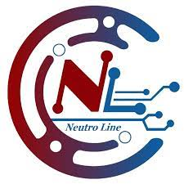

Figure 2.1 Organizational Logo

## Organization Structure

|  |
| --- |
| CEO  COO  Project manager  Backend Developer  Frontend Developer  Intern |

Figure 2.2 Organizational Structure

## Vision of the Organization

* To be the leading software company in the nation and create a brand by providing excellent 'customer's satisfaction that many companies are missing.

## Mission of the Organization

* To be the best IT Solution Provider through our innovative and unique work.
* To turn the life-changing ideas of our customers into awesome software.

## Goals of the Organization

* To expand their workforces in all divisions
* To deliver cost effective and high-quality software solutions for a wide range of industries and domains
* To get the projects done on time and within budget

## Services Offered

Neutroline Pvt Ltd has been offering the various services in the market of Nepal.The services provided by the Neutroline Pvt Ltd are as follows:

* Mobile Development
* Web Development
* Software Testing and Quality Assurance
* Enterprise Software Development
* Recruitment and Workforce Solution

## Contact Details

**Organization**: Neutroline Pvt.Ltd

**Address**: Shitalnagar, Devdaha 7, 32900, Rupandehi, Nepal

**Website**: <https://neutroline.com/>

**Email**: info@neutroline.com

**Phone no**: +977-71-577820

# CHAPTER IV Analysis and Activities Done

**Table 2.1** Users table

**Table 2.3** Country table

**Table 2.4** City table

**Table 2.5** State table

**Table 2.6** Department table

**Table 2.7** Division table



## Analysis of activities performed

During the internship at Neutroline Pvt Ltd I got a chance to learn many things and improve my programming skills. I have learned to develop the website using react and node Js. I was given opportunity to work in the restaurant project. I made a component in react and module. I was given a task to build website module and also provide tips and guidance for doing the assigned tasks.

* Getting familiar with html CSS and JavaScript
* Learned to use GIT and GITHUB
* Getting familiar with react Js
* Building website module
* Learning to create API using node Js with mongoDB

### Getting familiar with html CSS and JavaScript

For at list 1 week, I have learned about HTML CSS form basic. It is necessary to learn and use the visual studio code. As an internee I got familiar with html CSS and JavaScript. I required one weeks for recalling all these as I had studied in previous semester. I was given a study material from my seniors for knowing about the related topics.

### Learned to use GIT and GITHUB

For at list one week, I have learned about git and git hub. I have preferred different tutorial to learned. I have learned to clone, push and merge in the git hub. I have learned to store the project in the git and to share with the team member.

### Getting familiar with react Js

After two weeks of timeframe as an interne I got familiar with react Js. I have learned to build user interface specially for single page applications. I have been familiar with react components, state, hooks and props and use a material UI and styled components for styling the web page.

### Building website module

After working as an intern for 6 weeks task was given to build the website module by using react Js. I have given a task to make some of the module for the restaurant project and code in the restaurant project.

### Learning to create API using node Js with mongoDB

For at list 6 weeks, I have learned about node Js and mongoDB. I have learned express as framework on node Js. I learned to create API using node Js express. For I week I have learned about the mongoDB.

## Role of the intern and fitting in the organization structure

During internship at Neutroline Pvt.Ltd , the task was assigned by the staffs to the internee. As a intern it is necessary to perform the task assigned by the staff seriously and to submit the performed task according to their allotted time. As being web developer intern, it is necessary to perform the task like coding and debugging the software applications and experimenting with design elements.

In each and every organization there are certain rules and regulation that each employee should follow. It is necessary to fulfill the client’s demand and to meet the company goals. As an intern I had to follow all the rules and regulation to fit in the organization. The role of an intern in organization are listed below:

* Maintaining coordination and cooperation with the team members
* Completion of assigned task according to their allotted time.
* Assist in creating user interfaces by using HTML/CSS, JS and react.
* Testing and debugging the website

The organization always used to focus on the intern whether they are showing their interest towards their task or not and give their valuable guidance and suggestions towards the completion of the task. Company always tries to maintain the team coordination and wants that the intern has also maintain the good relationship with their colleagues and their senior staffs. As being an intern in NPT I strictly follow all the rules and regulations and completion of assigned task.

## Introduction to Project

Online Restaurant Website is a web-based application that enables users to reserve the table through online, see the menus of the restaurant, can search the menu item they prefer. This system is developed to automate day to day activity of a restaurant. This restaurant management system can be used by employees in a restaurant to handle the clients, their orders and can help them easily find free tables or place orders. The services that are provided is food ordering and reservation table management by the customer through the system online, customer information management menu information management and report. The restaurant menu is organized by categories (appetizers, soups, salads, entrees, sides and drinks) of menu items. Main objective builds the system this is to provide ordering and reservation service by online to the customer. Each menu item has a name, price and associated recipe. A recipe for a menu item.

People used to spend long time waiting for a table to be ready for them at a restaurant, And after that, they would wait longer time to order their [food](https://www.bartleby.com/topics/food). By using this software customer can book a table faster and order the menu faster.

The project is divided into three layers:

* Developing Restaurant Website using React
* Developing Backend using node.js
* Developing Admin panel using React

## Work Division

Online Restaurant Website is an output of team-effort. It is developed my team of three people. The tasks have been divided into three major divisions. The task division for each of the developer is shown below:

Table 4.2 Work Divisions

|  |  |
| --- | --- |
| **Assignee** | **Work** |
| * Dipesh Shrestha (intern) | * To Build APIs and make connection with database, To Build Admin Panel, Testing of APIs and connection with Admin dashboard. |
| * Pramila Khadka (intern) | * Restaurant website and connection with the Api. |
| * Yamuna Adhikari(intern) | * Restaurant website and connection with the Api. |

## System Development

The development of the system was initiated by designing the system through activity diagram, er-diagram, designing the database for the system. Supervisor and senior developer’s suggestions, guidance and online tutorials provided a great aid in the development of the system. Then the design was followed through coding the system.



### Use Case Diagram

A use case diagram is a representation of a user’s interaction with the system that shows the relationship between the user and the different use cases in which the user is involved.

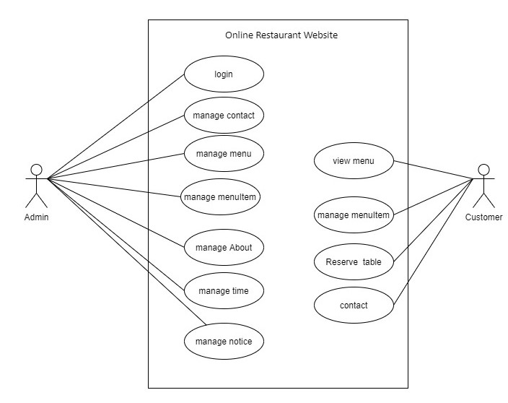

Figure 4.3Use Case Diagram

### Database Design

The database of the system was designed and developed in mongodb. The database consists of 7 collections. These tables are about, contact, menuitem, menus, notices, times, user profile. The database schema for the required system was designed as shown by the following figure:

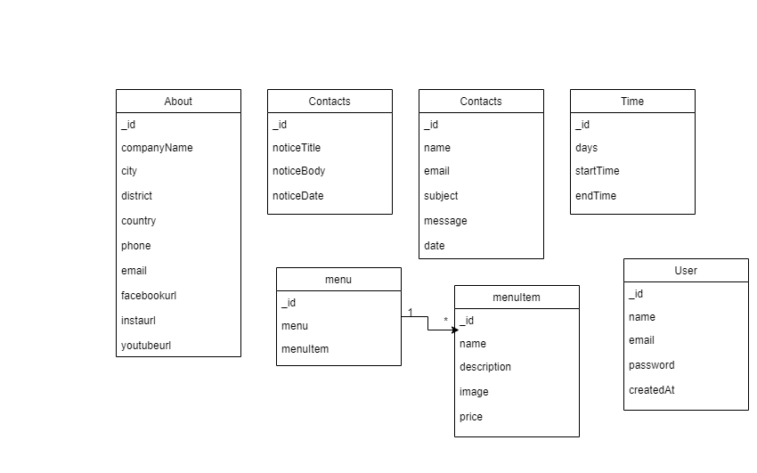

Figure 4.4 Schema Diagram

Figure 3.3: Database Schema Design

### Activity Diagram of Online Restaurant Website Admin Panel

Admin Panel is built using react.js. This is web-based application which can only be accessible by admin or authorized users. Here the management activity is done by the admin.

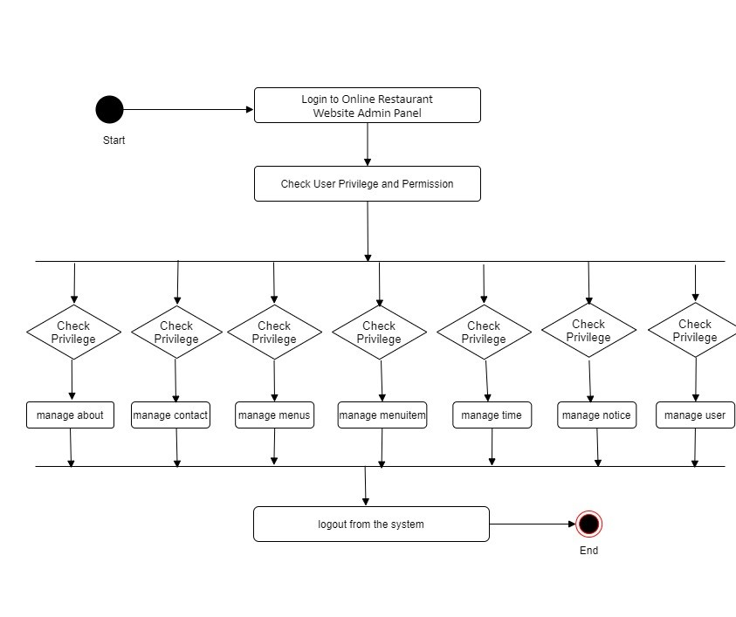

Figure 4.5 Activity Diagram

### ER-Diagram

An entity-relationship diagram is data modeling technique that graphically illustrates an information system’s entities and the relationship between those entities.

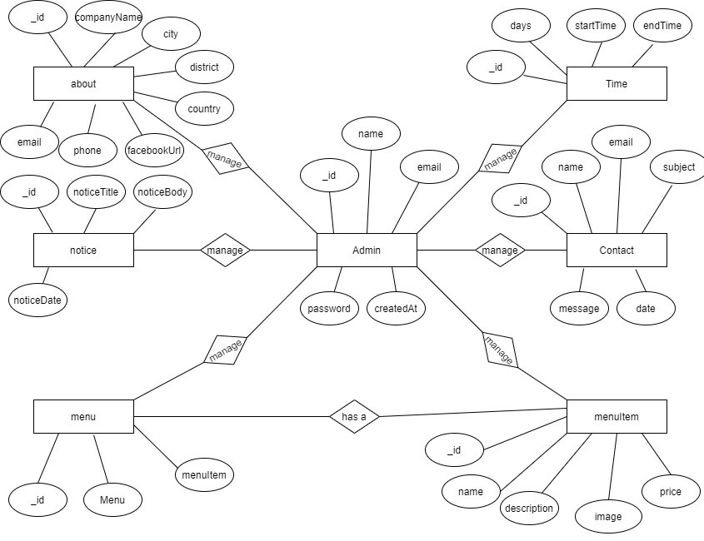

Figure 4.6 ER Diagram

In the above diagram 7 entities i.e., admin, about, time, notice, contact, menu and menuItem are shown with their attributes and relationship among them. The admin here manages about, time, notice, contact, menu and menuItem. Menu has a menuItem.

# CHAPTER V CONCLUSIONS/ LESSONS LEARNT



## Conclusion

It was a wonderful experience to work in Neutroline with highly professional group of people. It was a great opportunity to learn about the professional environment and develop a professional attitude. The way one person helped the other and the whole development functioned together showed how a group of professional work together to meet a desired goal. The importance of good leadership among the managers and discipline among the staffs is must for smooth functioning of any organization or any department within it. Similarly good communication skill among all the staffs is also a necessity for the growth of any organization. It will certainly go as a confidence boosting factor in coming days.

## Lesson Learn

While doing internship in Neutroline, it was a great platform for me to learn about the professional environment. It had provided me the opportunities to acquire practical knowledge about the working procedures in the organization at a real time. I learnt how the different phases of software development life cycle goes through. I get to know about various tools and techniques used while developing a software.

Some of the important lessons which I learned during my internship period are:

* Writing clean, commented code make programming easier
* Appropriate communication among team members
* Learn node JS express framework
* Learn about MongoDB
* Learn about GIT and GitHub
* Learn about React JS
* Learn about Material UI
* Dedication to work
* Update according to changing environment and use latest technology.

# REFERENCES

*About documentation*. (2021, June 8). Retrieved from Node Js: https://nodejs.org/en/docs/

*Build A Restful Api With Node.js Express & MongoDB*. (2021, June 8). Retrieved from Youtube: https://www.youtube.com/watch?v=vjf774RKrLc

*CRUD API with mongoDB*. (2021, June 8). Retrieved from Zellwk: https://zellwk.com/blog/crud-express-mongodb/?fbclid=IwAR061brAuLsWM4hgoW4TmedJk3GpDjlMFOoEQVaOxEX9XODeYIwNnJBYGfU

*Get Started*. (2021, June 8). Retrieved from React Js: https://reactjs.org/docs/getting-started.html

*Node Js RestFul API*. (2021, June 8). Retrieved from Tutorialspoint: https://www.tutorialspoint.com/nodejs/nodejs_restful_api.htm

# Appendix



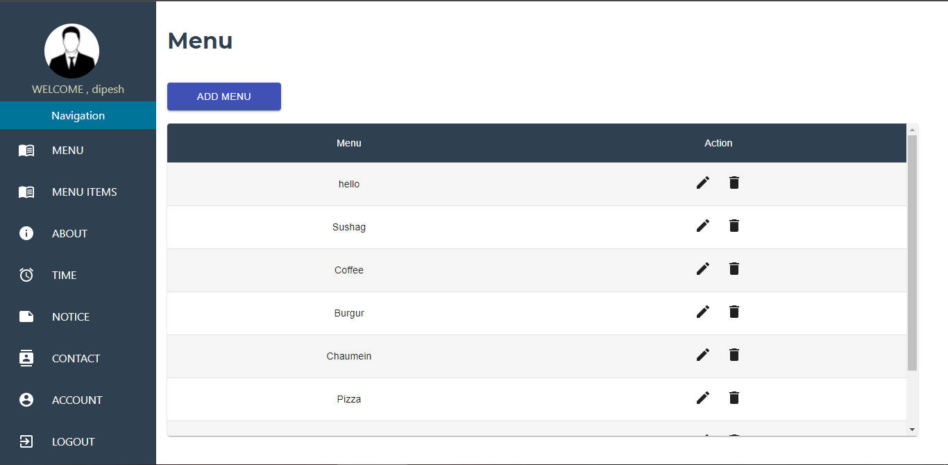

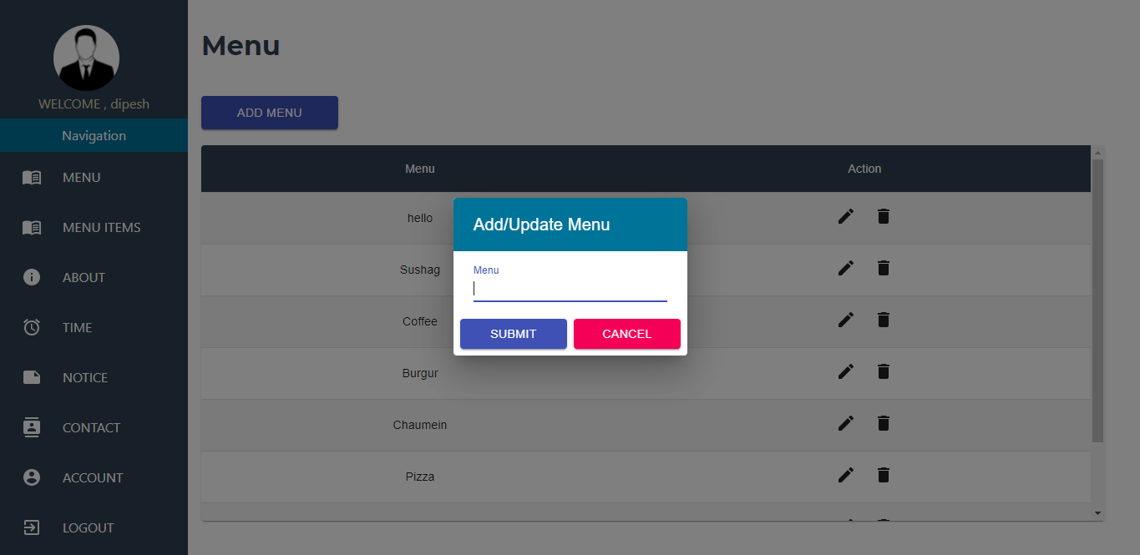

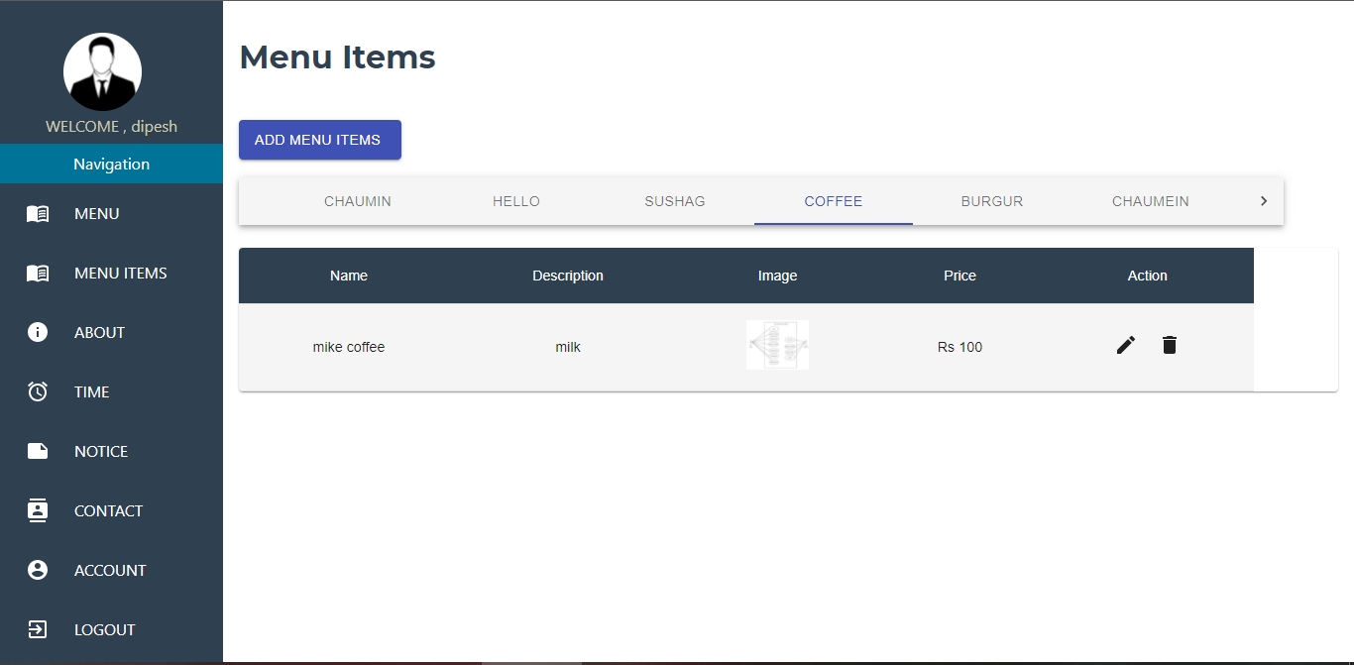**s**

