### Education

**Year of Passing: 2070**

**GLORY ENGLISH SECONDARY SCHOOL – RADHERADHE,**

**BHAKTAPUR - SECONDARY SCHOOL LEVEL (SLC)**

Passed in first division with distinction

Marks Obtained: 80%

**Year of Passing: 2072**

**SUN SHINE HIGHER SECONDARY SCHOOL - THIMI, BHAKTAPUR- HIGHER**

**SECONDARY SCHOOL LEVEL (10+2) - MANAGEMENT STREAM**

Passed in First Division with distinction

Marks Obtained: 75.5%

**Year of Passing: 2078**

**NEPAL COMMERCE CAMPUS-MINBHAWAN KATHMANDU**

**UNIVERSITY LEVEL-BACHELOR IN INFORMATION MANAGEMENT, TRIBHUWAN**

**UNIVERSITY**

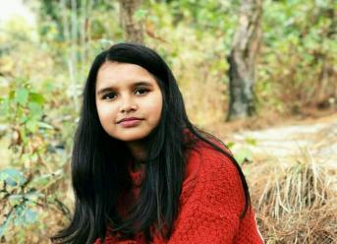

I am dedicated , hardworking and can be able to solve the problem.I thrive on challenge and constantly set goals for myself.I am passionate about my work

### Skills

* Html
* Css
* Javascript
* React Js
* Java

### Project

**Github link:**

* **<https://github.com/pramila123/>**

### Hobbies

* Playing chess - great way to unwind and keep the mind sharp.
* Reading novels
* Love to listen music and travel in new places

### Language

* Nepali
* English

Pramila khadka

9861343628

Khadkapramila1023@gmail.com