# System Overview

The ADARA Processing and Cataloging System (APCS) is implemented as separate services performing the needed work. The major services are:

1. workflow manager
2. permissions
3. cataloging
4. automated reduction
5. reduced data cataloging

Each service communicates with an ActiveMQ Broker as shown in Figure 1.

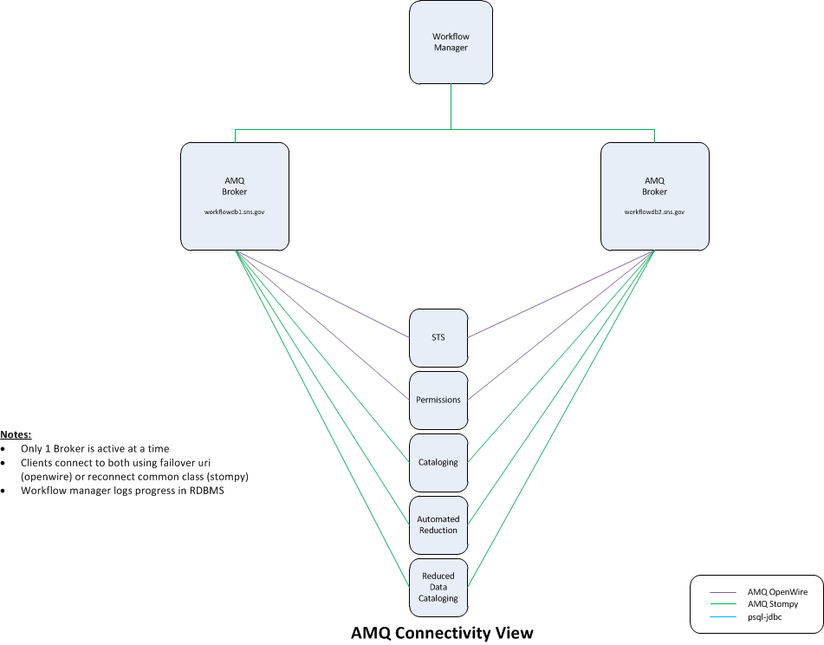

Figure

The ActiveMQ brokers utilize the Postgresql RDBMS for persistent message storage. In the APCS setup, the RDBMS is configured in a Master/Standby configuration with Streaming Replication to the Standby server.

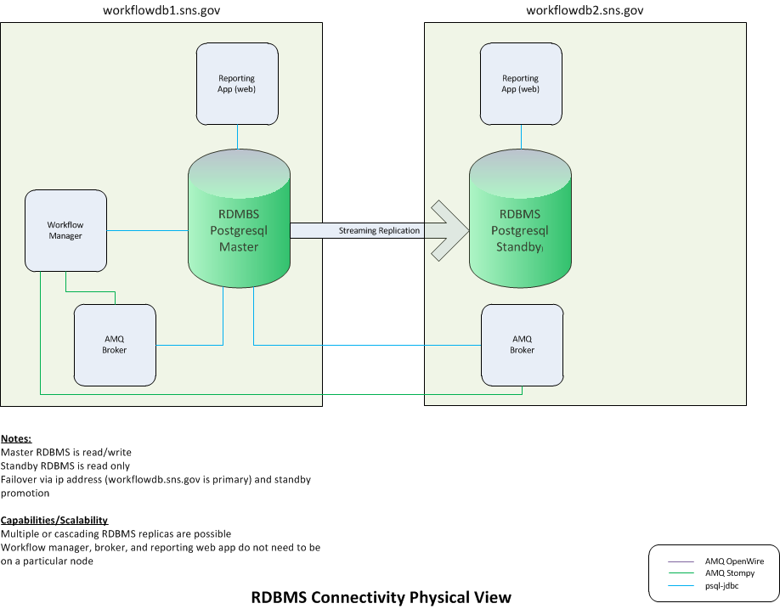

Figure

The Workflow Manager also uses a database in the Postgresql server for storing workflow progress and status. The reporting application in-turn reads data from the database to report a run’s processing/cataloging progress and status. The RDBMS setup is illustrated in Figure 2.

The communication messages and workflow sequence are also defined in the RDBMS. This allows for customization and tailoring per instrument, and it provides the ability to define different workflow types for a particular instrument. The messages from a typical workflow are illustrated in Figure 3.

# 

Figure

# Failover

Quigley – primary workflowdb.sns.gov, ip change, standby database can be promoted with signal (pg_ctl promote). For recovery the formerly standby Postgresql server should remain the master and a new standby setup from the new master.

**Failover Preliminary Outline when Master DB system fails - DRAFT!**

1. Stop activemq brokers
   1. activemq stop
2. Promote standby database
   1. pg_ctl promote
3. Do the ip change for snsworkflowdb.sns.gov (so it is now pointing to snsworkflowdb2.sns.gov server
   1. Note: not sure if postgresql will start accepting connections on the new interface or not (may require restart or something else). If ip address (snsworkflowdb) is the same as a pre-existing interface (snsworkflowdb2) then there should be no problem. Problem may arise if introducing a new interface. --- Needs tested
4. Restart the brokers
5. Carry on

**Restore Preliminary Outline when Master DB system failed and system is now running with the former Standby as Master - DRAFT!**

1. From the former master (or a new server) copy the Master database
   1. Note: the Master is the current master (formerly standby)
   2. pg_basebackup –D ./ –x –P –v –U <username> -h <host>
   3. Place contents under the new Standby data directory
2. Rename recovery.done to recovery.conf
   1. Note: may need to copy recover.done separately (not sure)
3. Start the new Standby server
4. Check logs to see that streaming replication has begun

# Miscellaneous Notes

**Quigley has newer notes with proper users & passwords**

**Streaming Replication**

1. Setup the master database

postgresql.conf (not complete, just some highlighted ones)

* 1. activate_archive_mode = on
  2. wal_keep_segments = 1000

1. Start the master
2. Copy the master to the slave data dir using pg_basebackup
3. Setup recovery.conf
4. Keep recovery.conf as recovery.done on the master

Command to get backup to create standby from (This puts data in the current directory ./. This data needs to go in the Standby’s datadir. So you can execute this command there.)

pg_basebackup –D ./ –x –P –v –U <username> -h <host>

Setting up the master and standby

<http://www.postgresql.org/docs/devel/static/warm-standby.html>

* postgresql.conf (not complete, just some highlighted ones)
  + activate_archive_mode = on
  + wal_keep_segments = 1000

To change so commits block until the replica is written to disk:

Set [synchronous_standby_names](http://www.postgresql.org/docs/devel/static/runtime-config-replication.html#GUC-SYNCHRONOUS-STANDBY-NAMES) to a non-null value. And synchronous_write to ‘on’

Tested and this works. If the standby goes down the db stops until it returns. You can have more than one and only one has to confirm the write. But if sync replication is enabled you cannot continue with a single master server. Async replication may be sufficient for our use.

<http://archives.postgresql.org/pgsql-hackers/2012-07/msg00409.php>

**DB Failover**

<http://www.postgresql.org/docs/devel/static/warm-standby-failover.html>

**Using Postgresql as persistent amq store**

To create a postgres database for activemq

Ref: <http://trenaman.blogspot.com/2008/09/setting-up-postgresql-database-for.html>

**Setup PostgreSQL database for activemq**

1. become user postgres

su - postgres

1. Create a database called activemq-db

$ created activemq-db

1. login to the db as the admin user (i.e. postgres)

psql activemq-db

Note: security needs to be discussed with Quigley so the following should be reviewed and altered as needed

1. set password for user postgres

activemq-db=> alter user postgresql with password 'postgres';

1. create activemq user

activemq-db=> create user activemq with password 'activemq;

1. Exit psql

activemq-db=> \q

1. Edit pg_hba.conf file to allow activemq user acess to the activemq-db

Example

# for streaming replication

host replication replication 172.16.162.1/32 trust

host all postgres 172.16.162.1/32 md5

# for activemq

host activemq-db activemq 172.16.162.1/32 md5

host activemq-db activemq 172.16.162.177/32 md5

local activemq-db all trust

# for reporting_db

host reporting_db icat 172.16.162.177/32 md5

1. Tell server to reload config

$ pg_ctl reload

1. Test login

$ pgsql –U activemq activemq

Type: \copyright for distribution terms  
 \h for help with SQL commands  
 \? for help with psql commands  
 \g or terminate with semicolon to execute query  
 \q to quit  
   
 activemq-db=>

1. The database tables will be created by the broker when it connects

**Configure the ActiveMQ brokers to use the postgresql**

1. Determine path to reporting app (i.e. /opt/ornl/sns/workflow, or /var/www/workflow)
2. /etc/httpd/conf/httpd.conf – setting to get the django config from workflow

reporting/apache/apache_django_wsgi.conf

1. Add PYTHONPATH to django conf

i.e. WSGIPythonPath /var/www/workflow/app

1. Configure activemq config to use postgres persistent store
2. Installation/configuration of workflow manager, tests, etc.

Ref: <http://activemq.apache.org/jdbc-master-slave.html>

1. Add bean for postgres in activemq.xml

<!-- Postgres DataSource Sample Setup -->

<bean id="postgres-ds" class="org.postgresql.ds.PGPoolingDataSource">

<property name="serverName" value="heidelberg"/>

<property name="databaseName" value="activemq-db"/>

<property name="portNumber" value="0"/>

<property name="user" value="activemq"/>

<property name="password" value="activemq"/>

<property name="maxConnections" value="10"/>

</bean>

1. Activemq needs to use postgresql-jdbc.jar

Copy jar file (postgresql-jdbc.jar) into activemq/lib/optional/

(There maybe other ways to set the search path, but this works.)

1. Turn off query timeout (since jdbc class does not implement it )

<broker useJmx="false" brokerName="jdbcBroker" xmlns="http://activemq.apache.org/schema/core">

<persistenceAdapter>

<jdbcPersistenceAdapter dataDirectory="${activemq.data}" dataSource="#postgres-ds">

<databaseLocker>

<database-locker queryTimeout="0" />

</databaseLocker>

</jdbcPersistenceAdapter>

</persistenceAdapter>

The above is for master/slave brokers. You can have multiple slaves. The way it works is the first broker gets a database lock and becomes the master. The remaining brokers block waiting to get the lock. If the master exits or dies, one of the waiting brokers will take over as the master.

For Clustered JDBC database set useDatabaseLock to false. See 20120919 and 20120913 notes. This setting is not recommended due to unreliable failover/handoff.

<jdbcPersistenceAdapter dataDirectory="${activemq.data}" dataSource="#postgres-ds" useDatabaseLock="false">

Ref: <http://fusesource.com/docs/esb/4.3/amq_persistence/FuseMBPersistJDBCNoJournal.html>

The recommended configuration is master/slave brokers using JDBC Persistent store. Ref:

<http://fusesource.com/docs/broker/5.5/clustering/Failover-MasterSlave-JDBC.html>

**WARNING / ISSUES / NOTES**

20120919-1: Tested with C++ client using openwire failover. The client blocks and switches over fine. However, there are issues with dual (or probably more) brokers when not using the useDatabaseLock. There were attempts in the brokers to insert duplicate primary keys in the database after switching over. Had to restart activemq server(s) to remedy. Note: when using master/slave (useDatabaseLock=”true”) the c++ client always switch fine and there were no broker problems detected.

20120913-1. Using cluster db store had three undelivered messages in table. Had to restart a broker for them to be sent. Not sure why or how it got in that condition, but there was a lot of thrashing, heavly load stop & start testing before that. (Update: this may have been with multiple brokers - not master/slave, see 20120919 note)

20120911-1. Had scenario where there were zombie (maybe) connections to the activemq tables and the new activemq could not get the master lock and just stopped there (never created 616xx port openings), and it was not operational.

CONCLUSION: This is how the master/slave broker works. One blocks trying to get the lock until the master releases the lock (or dies). Normal mechanism