MACHINE LEARNING

Midterm Assignment Report
Student Name: Ayşe Neva Ağca
Student Number: 23040102041
Course: Machine Learning
Submission Date: 11 November 2026
Datasets: Breast Cancer Wisconsin and Wine Classification

1. Loading the Datasets
I used two datasets from scikit-learn. The Breast Cancer dataset contains 569 samples and 30 features, with two classes: malignant (0) and benign (1). The Wine dataset contains 178 samples and 13 features, with three classes (0, 1, 2). I separated the features (X) and target labels (y) before starting the analysis.

2. Dataset Quality Checks
I checked both datasets for missing values, duplicates, and outliers. Neither dataset had missing values or duplicate feature rows, and all features were numerical. Using the IQR method, I found 608 potential outlier values in Breast Cancer and 21 in Wine. I kept these values because unusual measurements are not necessarily incorrect.

3. Exploratory Data Analysis (EDA)
I examined the descriptive statistics and created class distribution graphs, correlation heatmaps, and boxplots. In Breast Cancer, the strongest correlations were mean radius–mean perimeter (0.998), worst radius–worst perimeter (0.994), and mean radius–mean area (0.987). This makes sense because larger cell measurements are generally related. The boxplots also showed different feature ranges and possible outliers.

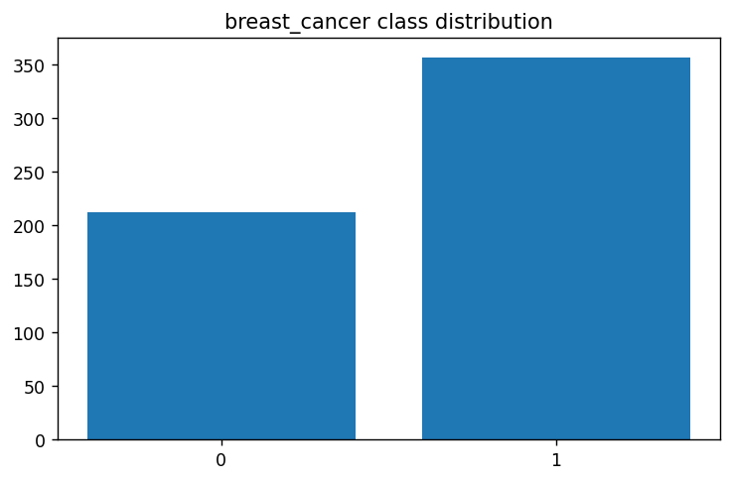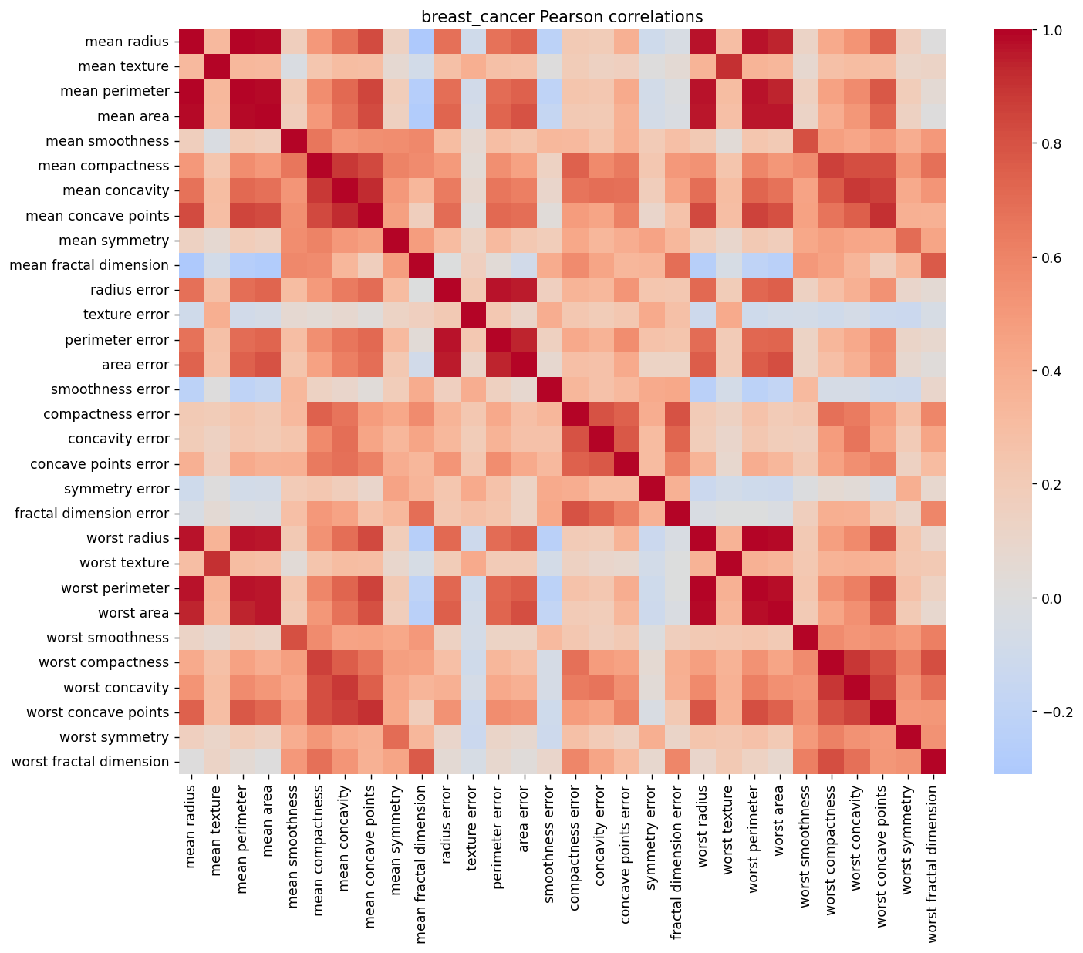

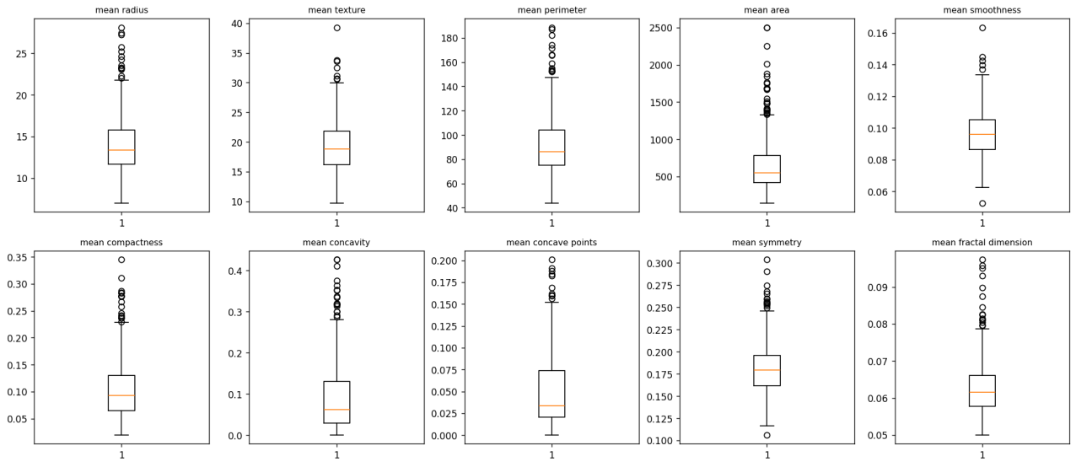
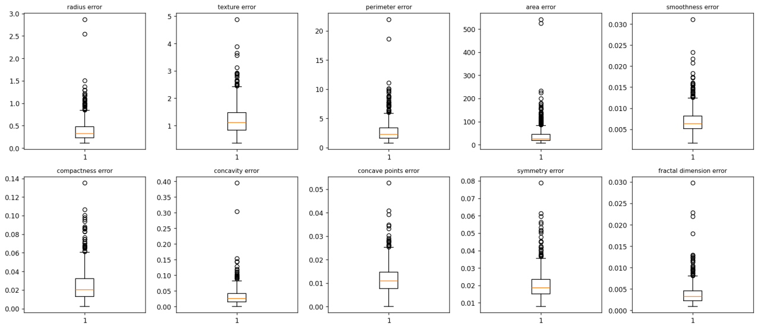
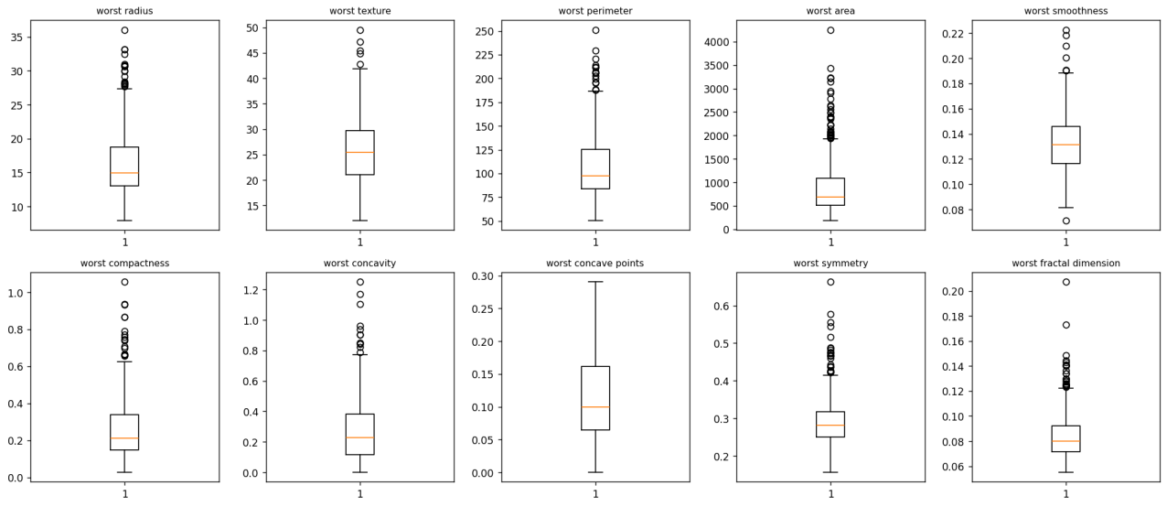

wine — top three unique Pearson correlations: total_phenols / flavanoids: 0.865, flavanoids / od280/od315_of_diluted_wines: 0.787, total_phenols / od280/od315_of_diluted_wines: 0.700. Boxplots show varied scales and potential extremes; these summaries were not used for model selection.

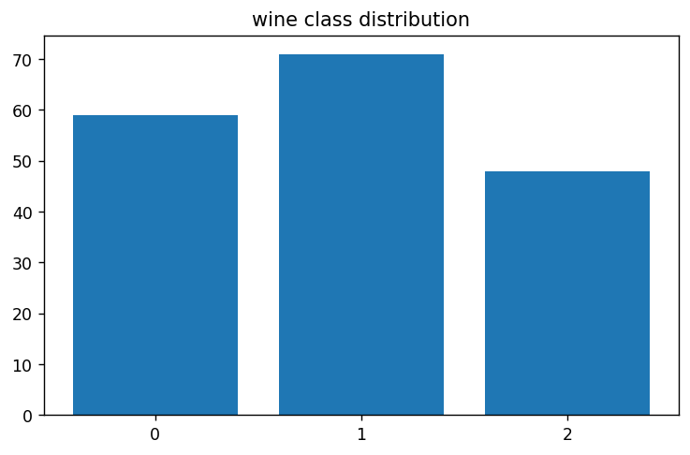
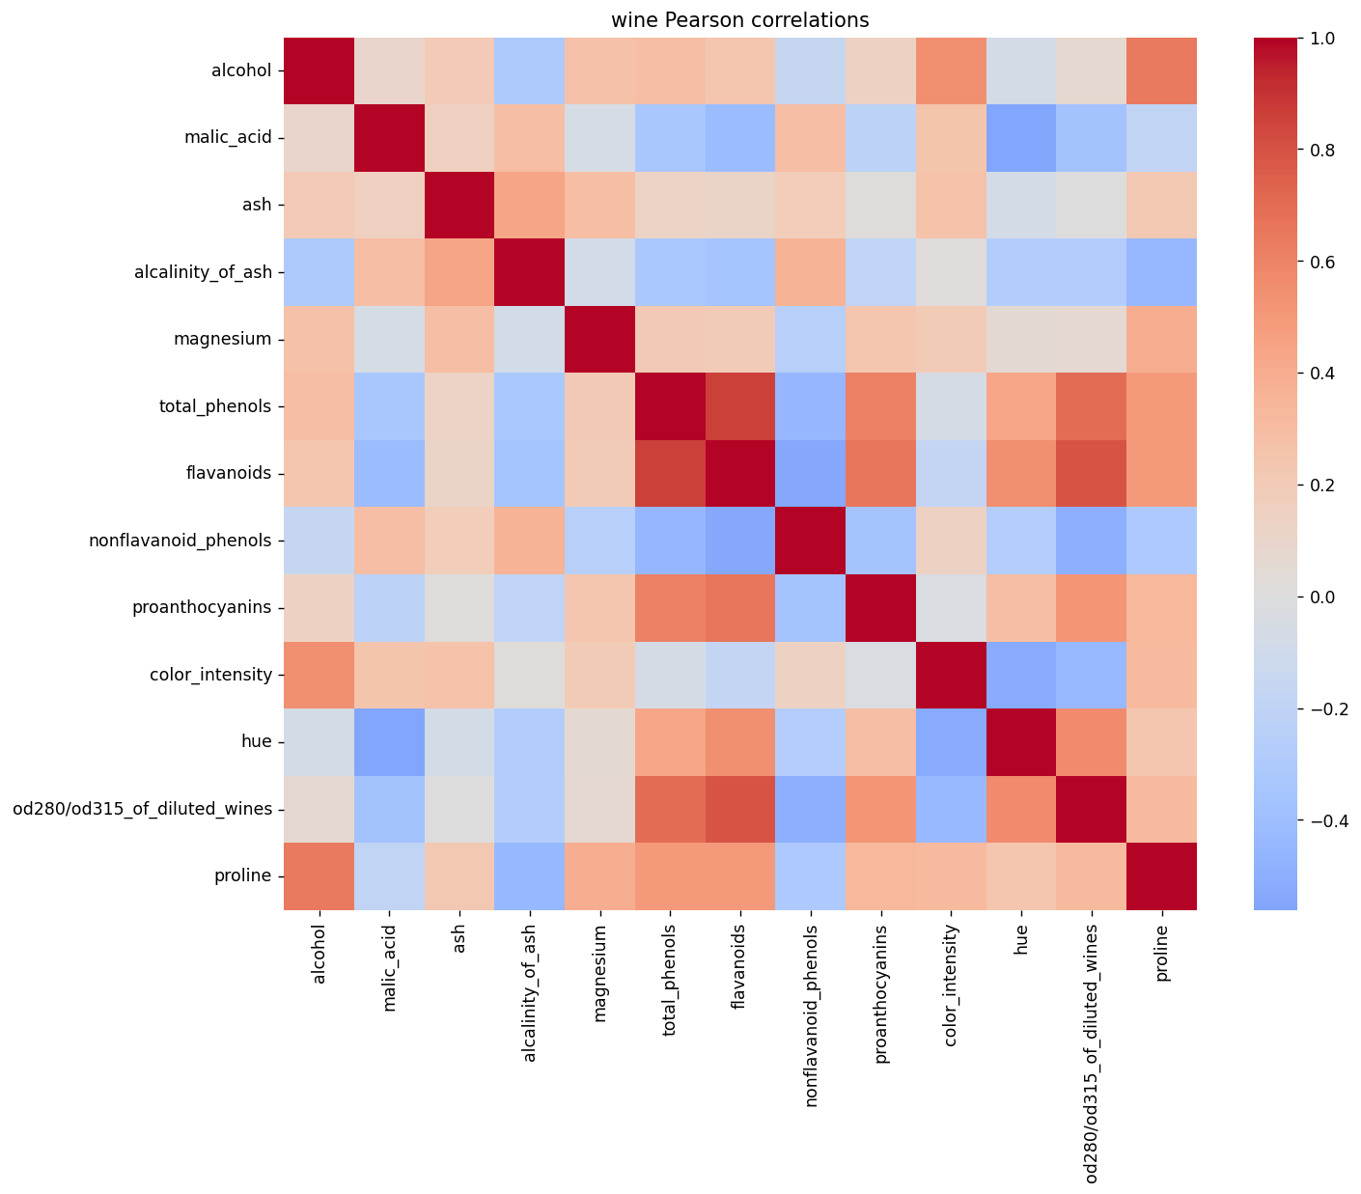

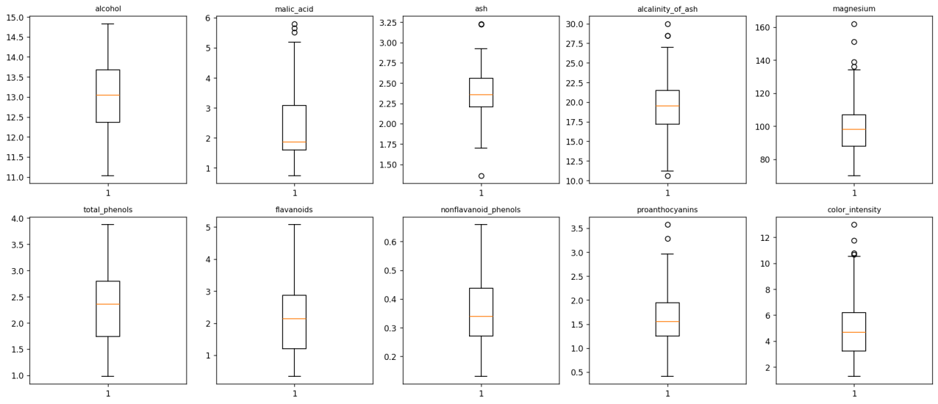
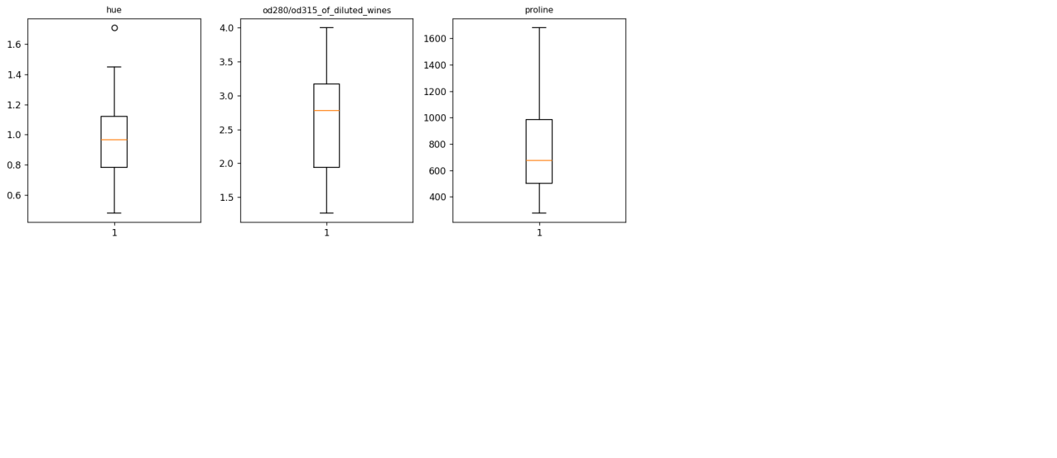

4. Splitting the Datasets
I first separated 20% of each dataset for final testing. Then I divided the remaining data into training and validation sets using three random seeds: 42, 52, and 62. This gave me approximately 70% training, 10% validation, and 20% testing data. I kept the test set unchanged so I could evaluate the final models fairly.

5. Data Preprocessing and Scaling
Neither dataset had missing values, so I did not need to fill in any data. I used StandardScaler to standardize the features. I fitted the scaler only on the training data and then applied it to the validation and test data. This helped me avoid data leakage.

6. Preparing the Two Data Representations
I prepared two versions of each dataset: one with the original feature values and another with scaled values. I used the same samples in both versions to make the comparisons fair.

7. Training the Classification Models
I trained three types of classification models: Decision Tree, KNN, and Gaussian Naive Bayes. I tested different tree depths and KNN neighbor counts, using both scaled and unscaled data. With three random seeds, I completed 66 classifier runs for each dataset, making 132 runs in total.

8. Measuring Validation Performance
I compared the models using accuracy, precision, recall, F1-score, and ROC-AUC. I selected the best configurations mainly based on average validation macro-F1.
For Breast Cancer, the best model was scaled KNN with 7 neighbors, achieving a mean validation F1-score of 0.9677. For Wine, scaled KNN with 11 neighbors performed best, with a score of 0.9814. I noticed that scaling made a big difference, especially for KNN.

breast_cancer — 22 configuration summaries (means and sample SD):
configuration_id | train_f1_mean | val_f1_mean | val_f1_std | val_accuracy_mean | val_auc_mean
breast_cancer_knn_scaled_7 | 0.9702 | 0.9677 | 0.0297 | 0.9708 | 0.9782
breast_cancer_knn_scaled_11 | 0.9694 | 0.9608 | 0.0395 | 0.9649 | 0.9945
breast_cancer_knn_scaled_3 | 0.9793 | 0.9547 | 0.0228 | 0.9591 | 0.9793
breast_cancer_knn_scaled_5 | 0.9721 | 0.9547 | 0.0228 | 0.9591 | 0.9795
breast_cancer_knn_scaled_1 | 1.0000 | 0.9369 | 0.0213 | 0.9415 | 0.9339
breast_cancer_gnb_unscaled_default | 0.9323 | 0.9369 | 0.0226 | 0.9415 | 0.9797
breast_cancer_gnb_scaled_default | 0.9307 | 0.9248 | 0.0201 | 0.9298 | 0.9760
breast_cancer_tree_scaled_10 | 1.0000 | 0.9195 | 0.0112 | 0.9240 | 0.9266
breast_cancer_tree_scaled_none | 1.0000 | 0.9195 | 0.0112 | 0.9240 | 0.9266
breast_cancer_tree_unscaled_10 | 1.0000 | 0.9195 | 0.0112 | 0.9240 | 0.9266
breast_cancer_tree_unscaled_none | 1.0000 | 0.9195 | 0.0112 | 0.9240 | 0.9266
breast_cancer_tree_scaled_5 | 0.9946 | 0.9188 | 0.0227 | 0.9240 | 0.9301
breast_cancer_tree_unscaled_5 | 0.9946 | 0.9188 | 0.0227 | 0.9240 | 0.9301
breast_cancer_tree_scaled_3 | 0.9739 | 0.9177 | 0.0304 | 0.9240 | 0.9414
breast_cancer_tree_unscaled_3 | 0.9739 | 0.9177 | 0.0304 | 0.9240 | 0.9414
breast_cancer_knn_unscaled_11 | 0.9404 | 0.9155 | 0.0113 | 0.9240 | 0.9605
breast_cancer_tree_scaled_2 | 0.9527 | 0.9117 | 0.0236 | 0.9181 | 0.9220
breast_cancer_tree_unscaled_2 | 0.9527 | 0.9117 | 0.0236 | 0.9181 | 0.9220
breast_cancer_knn_unscaled_5 | 0.9469 | 0.9107 | 0.0297 | 0.9181 | 0.9480
breast_cancer_knn_unscaled_7 | 0.9442 | 0.9040 | 0.0013 | 0.9123 | 0.9581
breast_cancer_knn_unscaled_3 | 0.9558 | 0.8910 | 0.0449 | 0.9006 | 0.9299
breast_cancer_knn_unscaled_1 | 1.0000 | 0.8786 | 0.0566 | 0.8889 | 0.8757

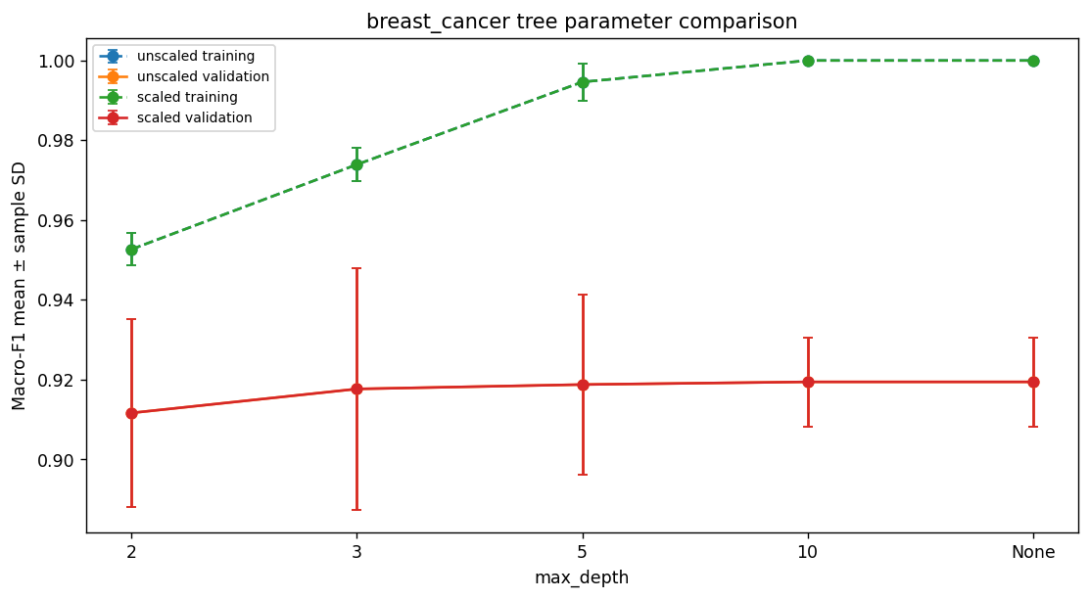
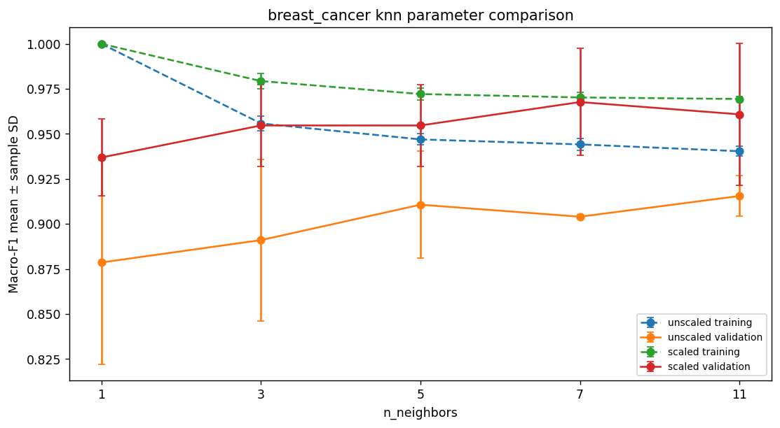

Selected: breast_cancer_knn_scaled_7; mean validation macro F1=0.9677, SD=0.0297. Tree-depth and neighbour-count figures show that higher complexity is not guaranteed to improve validation performance. KNN distances are especially sensitive to feature scaling; compare corresponding scaled/unscaled rows.

wine — 22 configuration summaries (means and sample SD):
configuration_id | train_f1_mean | val_f1_mean | val_f1_std | val_accuracy_mean | val_auc_mean
wine_knn_scaled_11 | 0.9656 | 0.9814 | 0.0323 | 0.9815 | 1.0000
wine_knn_scaled_5 | 0.9762 | 0.9814 | 0.0323 | 0.9815 | 1.0000
wine_knn_scaled_7 | 0.9603 | 0.9814 | 0.0323 | 0.9815 | 1.0000
wine_knn_scaled_1 | 1.0000 | 0.9658 | 0.0296 | 0.9630 | 0.9749
wine_gnb_scaled_default | 0.9840 | 0.9638 | 0.0314 | 0.9630 | 1.0000
wine_gnb_unscaled_default | 0.9840 | 0.9638 | 0.0314 | 0.9630 | 1.0000
wine_tree_scaled_10 | 1.0000 | 0.9462 | 0.0545 | 0.9444 | 0.9552
wine_tree_scaled_3 | 0.9926 | 0.9462 | 0.0545 | 0.9444 | 0.9611
wine_tree_scaled_5 | 1.0000 | 0.9462 | 0.0545 | 0.9444 | 0.9552
wine_tree_scaled_none | 1.0000 | 0.9462 | 0.0545 | 0.9444 | 0.9552
wine_tree_unscaled_10 | 1.0000 | 0.9462 | 0.0545 | 0.9444 | 0.9552
wine_tree_unscaled_3 | 0.9926 | 0.9462 | 0.0545 | 0.9444 | 0.9611
wine_tree_unscaled_5 | 1.0000 | 0.9462 | 0.0545 | 0.9444 | 0.9552
wine_tree_unscaled_none | 1.0000 | 0.9462 | 0.0545 | 0.9444 | 0.9552
wine_knn_scaled_3 | 0.9687 | 0.9457 | 0.0558 | 0.9444 | 1.0000
wine_tree_scaled_2 | 0.9365 | 0.8481 | 0.0365 | 0.8519 | 0.9050
wine_tree_unscaled_2 | 0.9365 | 0.8481 | 0.0365 | 0.8519 | 0.9050
wine_knn_unscaled_1 | 1.0000 | 0.6714 | 0.0226 | 0.7037 | 0.7654
wine_knn_unscaled_5 | 0.7739 | 0.6667 | 0.0399 | 0.7037 | 0.8645
wine_knn_unscaled_3 | 0.8294 | 0.6456 | 0.0429 | 0.6667 | 0.8333
wine_knn_unscaled_7 | 0.7804 | 0.6356 | 0.0316 | 0.6667 | 0.8459
wine_knn_unscaled_11 | 0.7309 | 0.6005 | 0.0010 | 0.6296 | 0.8216

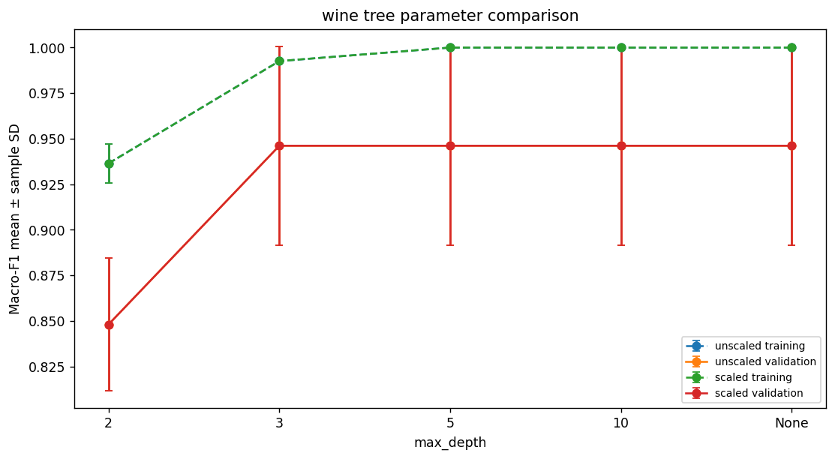

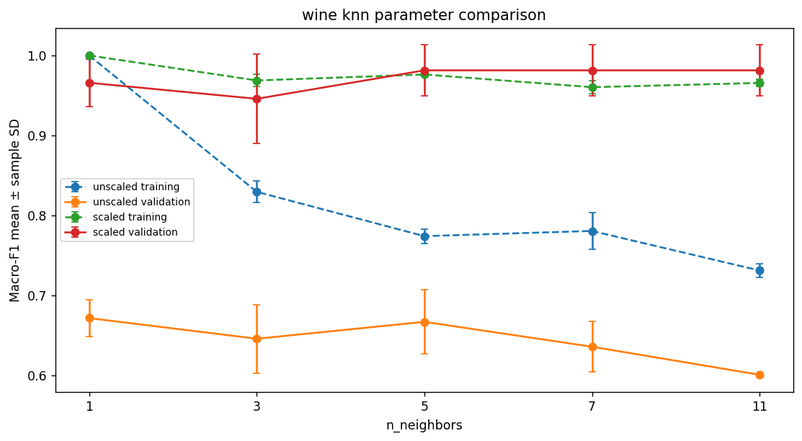

Selected: wine_knn_scaled_11; mean validation macro F1=0.9814, SD=0.0323. Tree-depth and neighbour-count figures show that higher complexity is not guaranteed to improve validation performance. KNN distances are especially sensitive to feature scaling; compare corresponding scaled/unscaled rows.

Evaluating the Selected Models on the Test Sets
After selecting the models, I tested them on the fixed test sets. The Breast Cancer model achieved 97.37% accuracy and a macro-F1 score of 0.9713. The Wine model achieved 100% accuracy and a macro-F1 score of 1.0000.
I also examined confusion matrices and ROC curves to understand the predictions and possible errors. These results were obtained without using the test sets to choose the models.

dataset | configuration_id | evaluation_seed | val_f1_mean | val_f1_std | test_accuracy | test_precision | test_recall | test_f1 | test_auc
breast_cancer | breast_cancer_knn_scaled_7 | 42 | 0.9677 | 0.0297 | 0.9737 | 0.9800 | 0.9643 | 0.9713 | 0.9888
wine | wine_knn_scaled_11 | 42 | 0.9814 | 0.0323 | 1.0000 | 1.0000 | 1.0000 | 1.0000 | 1.0000

Breast Cancer: The selected scaled KNN (k=7) achieved 97.37% test accuracy, 0.9713 macro-F1 and 0.9888 ROC-AUC. Its mean validation macro-F1 was 0.9677. This means the test result was close to what we observed during validation. There were 3 incorrect predictions out of 114 test samples. Since class 0 means malignant, errors involving this class are especially important.

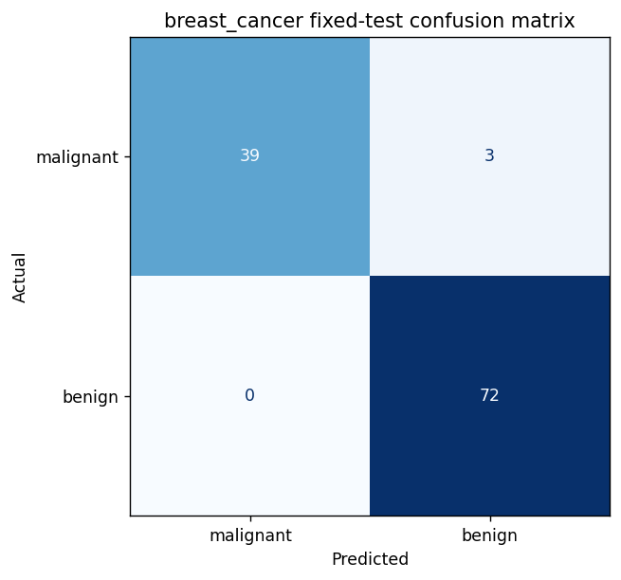
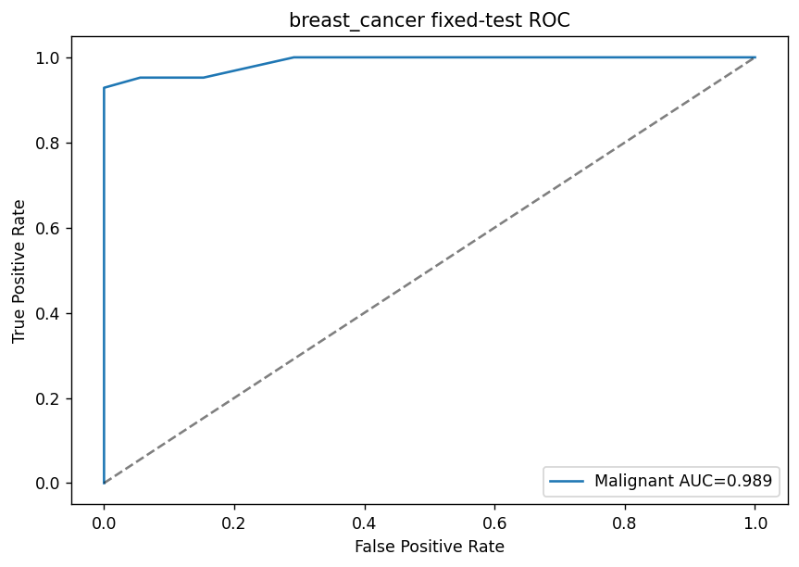

Wine: The selected scaled KNN (k=11) achieved 100% test accuracy, 1.0000 macro-F1 and 1.0000 multiclass ROC-AUC on the 36 test samples. Its mean validation macro-F1 was 0.9814. This is a strong result for this particular split, but it does not mean the model will always be perfect on new data.
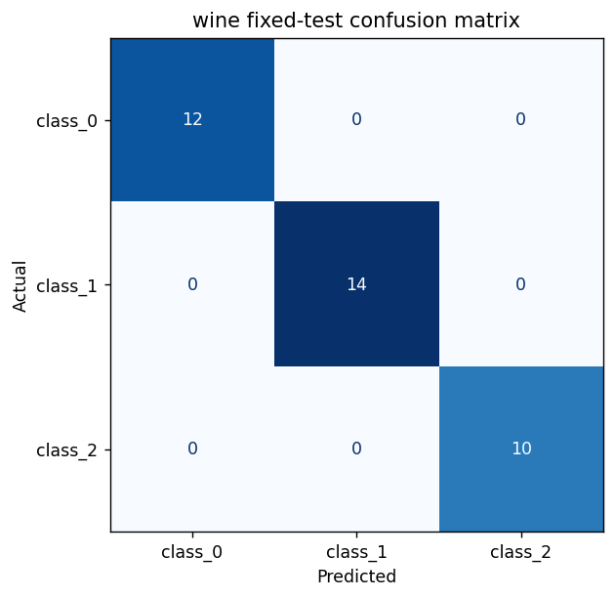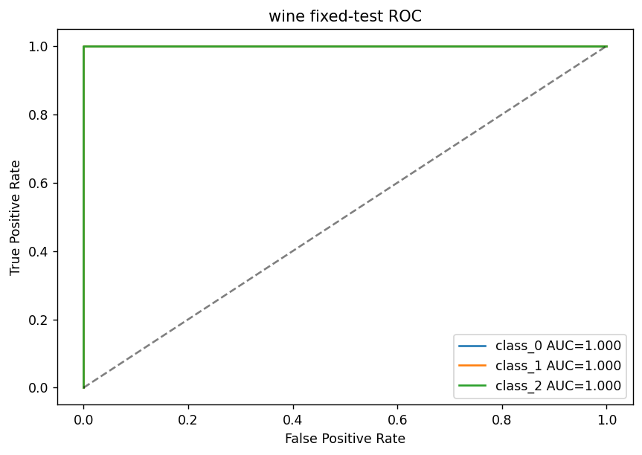

The confusion matrices show which classes were predicted correctly and incorrectly. The ROC plots show how true-positive and false-positive rates change at different thresholds. I did not choose a threshold using the test set. Because the validation splits overlap and the datasets are fairly small, these results should be interpreted carefully.

K-Means Clustering
I also tested K-Means clustering without using class labels during training. I used two clusters for Breast Cancer and three for Wine, with scaled and unscaled data.
Scaling improved the test ARI score from 0.5585 to 0.7354 for Breast Cancer and from 0.3733 to 0.9088 for Wine. This showed me that scaling can also affect clustering results.
For the two-dimensional graphs, I selected worst area and mean area for Breast Cancer, and proline and magnesium for Wine, using training-data variance. K-Means itself still used all features.

dataset | representation |  | val_ari_mean |  | val_ari_std |  | val_silhouette_mean |  | valid_seed_count
breast_cancer | scaled |  | 0.5813 |  | 0.1424 |  | 0.3121 |  | 3
breast_cancer | unscaled |  | 0.5043 |  | 0.1064 |  | 0.6773 |  | 3
wine | scaled |  | 1.0000 |  | 0.0000 |  | 0.2751 |  | 3
wine | unscaled |  | 0.3613 |  | 0.0680 |  | 0.5765 |  | 3
dataset |  | representation |  | test_cluster_counts |  | test_ari |  | test_silhouette
breast_cancer |  | unscaled |  | {0: 86, 1: 28} |  | 0.5585 |  | 0.7120
breast_cancer |  | scaled |  | {0: 74, 1: 40} |  | 0.7354 |  | 0.3251
wine |  | unscaled |  | {0: 14, 1: 10, 2: 12} |  | 0.3733 |  | 0.4929
wine |  | scaled |  | {0: 13, 1: 13, 2: 10} |  | 0.9088 |  | 0.2711

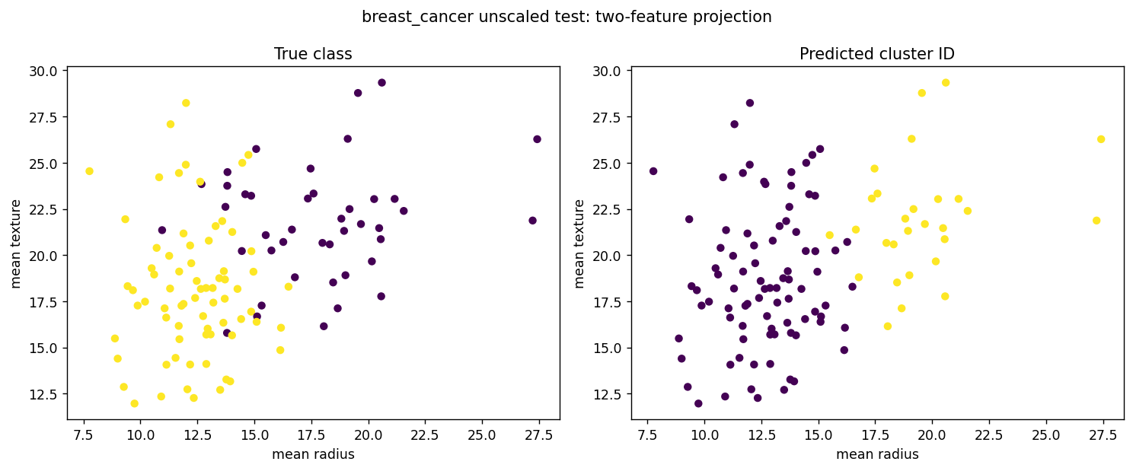
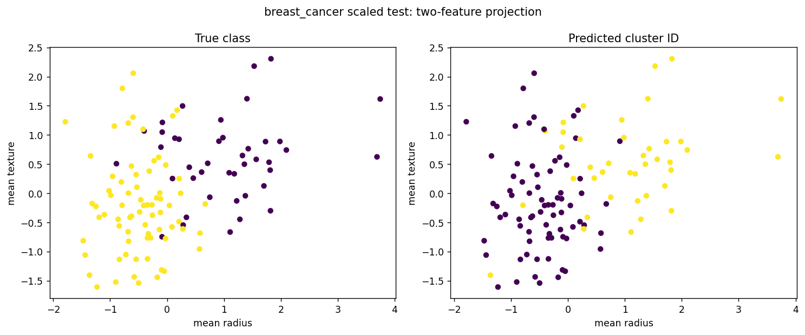
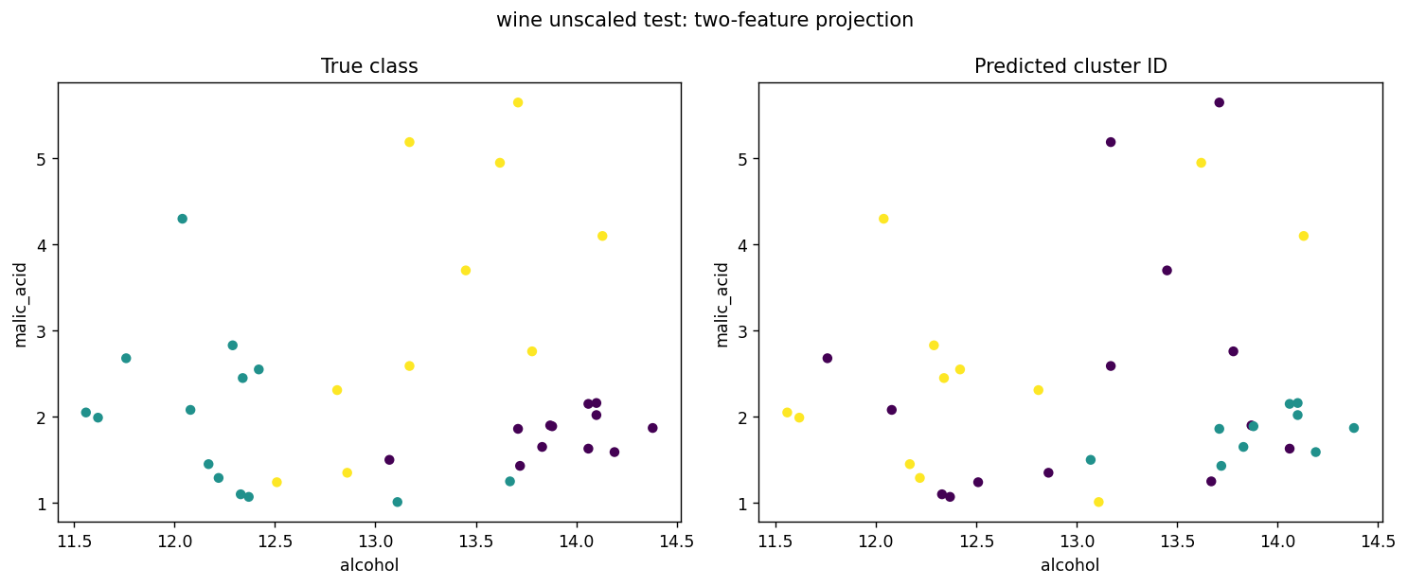
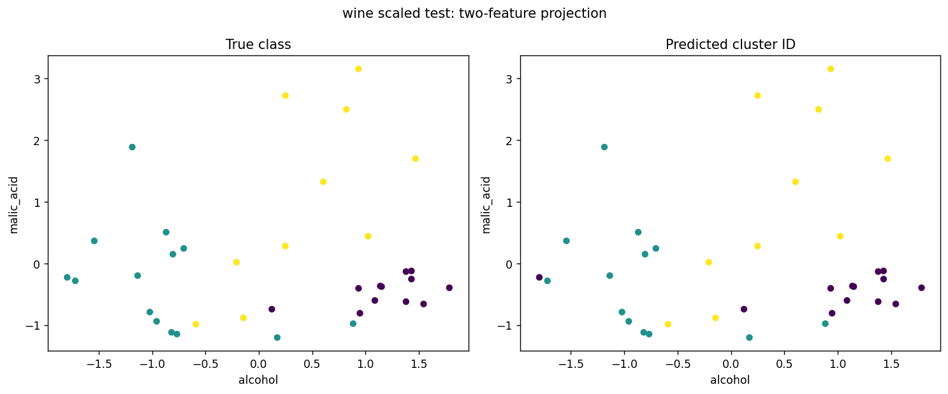
The notebooks include contingency tables comparing the true classes and predicted cluster IDs. Cluster numbers are not class labels. For the 2D scatterplots, I chose two original features using the highest raw variance in the seed-42 training data: worst area and mean area for Breast Cancer, and proline and magnesium for Wine. This choice is affected by measurement units and is only for plotting. K-Means itself was trained using every original feature.

11. Comparing the Two Datasets
breast_cancer: selected breast_cancer_knn_scaled_7, mean validation macro F1 0.9677, fixed-test macro F1 0.9713.
wine: selected wine_knn_scaled_11, mean validation macro F1 0.9814, fixed-test macro F1 1.0000.
Breast Cancer K-Means: Test ARI increased from 0.5585 without scaling to 0.7354 with scaling. However, silhouette decreased from 0.7120 to 0.3251. This shows that different clustering metrics can give different impressions.
Wine K-Means: Test ARI increased from 0.3733 without scaling to 0.9088 with scaling. Silhouette decreased from 0.4929 to 0.2711. Scaling improved agreement with the known wine classes, but not the silhouette score.
breast_cancer: KNN validation macro F1 ranged from 0.8786 (breast_cancer_knn_unscaled_1) to 0.9677 (breast_cancer_knn_scaled_7); variation and depth/neighbor trends appear in Section 8 figures.
wine: KNN validation macro F1 ranged from 0.6005 (wine_knn_unscaled_11) to 0.9814 (wine_knn_scaled_11); variation and depth/neighbor trends appear in Section 8 figures.
I learned that scaling is especially useful for KNN and distance-based clustering. I would like to try a larger dataset or more repeated splits in future work to see whether the results stay similar.

12. Required Run and Output Inventory
In total, I completed 132 classification runs and 12 K-Means runs, making 144 model fits. I saved the results in CSV files and included the graphs and executed notebooks in the project folder. These files make it possible to review the experiments and their results.

Submission Details
GitHub Repository:
https://github.com/neva4434/ML_Midterm_Project

Presentation Video:
https://youtu.be/Xi4llmR6L9s

