Pseudocode
Algorithm: Print binary digits using repeated division by 2

- Display: Enter a non-negative integer:
- Read number
- If number < 0 then
a. Display: Invalid input. Please enter a non-negative integer.
b. Stop
- Display: Binary digits (least significant to most significant):
- If number == 0 then
a. Display 0
b. Stop
- While number > 0 do
a. digit = number % 2
b. Display digit
c. number = number / 2
- Stop

Hand-Trace Table (Test input = 21)

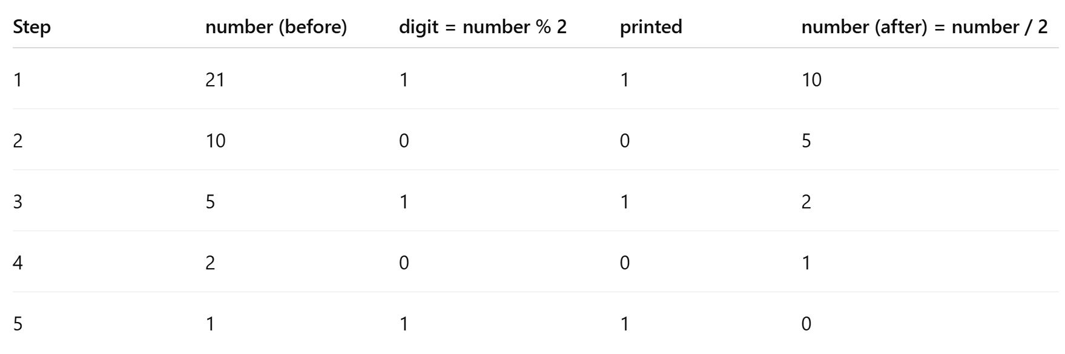

Output:
1
0
1
0
1

