TTi Current State of Play (April/May)
Alva Gosson 5/6/2018

Logger c#

There are 2 existing Git branches.
- The version (binary on NAS) is working (March). Jim has git source code.
Sample Trigger/Timing is in development so the program may need trivial updates as any changes: the wrapper MyAIO.cs is our wrapper for the Contec file Caio.cs which wraps the C calls to the Contec driver. Our function SetupTimedSample(…) contains the instructions to set the driver for a sampling event including how it triggers and what timer to use. (The function name is legacy from when it was timed and needs refactoring.)
- The development branch (April) is not tested and contains a number of major but incomplete architectural changes. Data is stored in ‘jjd’ format. “Monitor” can now open/view existing ‘jjd’ files, and utilises the fastest available C library to process data into frequency domain. This branch aimed ultimately to mirror the processing currently developing in Matlab and test code that will eventually be reused in an unrelated new program to accompany the final product. A move to c++ may be desirable for that final distribution.

TODO
- A kernel mode driver for the digital transducers will be needed eventually.
- Continue finding/developing signal processing code in C for future use.

GPU Expansion

Phoebe has Z10PE-D8 WS motherboard with 2 CPU sockets and 7 PCIe slots. The first 4 attach to the first socket and the last 3 to the second socket. She has 1x mid range CPU with 2x 1080Ti GPU attached to it in slots 1,3 (2,4 are hidden by the double spaced cards). By adding a second CPU core PCIe slots 5,7 can be used to add 4x GPU to the system. However a power upgrade [(nGPUs + 1) x 300)W (currently 900W) and improved cooling would be needed. There has been a report that the original Z10PE bios firmware had some difficulty seeing all 80 lanes in a dual cpu system – worth bearing in mind if problems are encountered attaching a second core. Given this possibility another option if one CPU is proving sufficient would be to swap the motherboard for the X99-E WS. This would be the same cost as a new CPU and would place all PCIe slots under the control of one CPU. Improved power and cooling could then be added for a total of 4 GPU in Phoebe’s chassis.

The original expansion plan was to create standalone external boxes attached by ethernet Cat5e cables. POGO is not bottlenecked by GPU connection bandwidth so external boards can be run off x8, x4, x2 or even x1 lane. However external boxes seem very expensive £1000 per specialist external board (excluding the £900 GPU price). GPUs are double spaced and boards with double spaced slots, or large single spaced boards are apparently specialist and expensive. Under investigation.

A cheaper alternative may be GPU splitters as used on mining rigs. These digitally divide the lanes down Cat5e cables. It is unknown whether Phoebe’s Bios will detect them. Pogo needs them to be detectable in bios. They are very cheap so an experiment would be financially trivial. This may prove the best way to expand.

POGO

Work flow is demonstrated in exampleGen.m which comes with POGO. In summary:

1. Matlab (ours is in Windows so files need be swapped between environments)
savePoly( 'filename.poly', points, edges, holes );

takes simple matrices and combined into a basic text file (.poly format)

2. Linux
pogoMesh filename.poly -s dx

[dx is the required element length (metres)]

Generates a file in ‘.vtu’ format.

3. Matlab
m = loadVtuMesh('filename.vtu');

‘m’ here will be referred to henceforth as a Pogo Mesh. It is the precursor to savePogoInp(…).

Add model parameters to ‘m’. (details in Jimrail example to follow).

savePogoInp('filename.pogo-inp',m);

4. Linux
pogoBlock filename //Looks for filename.pogo-inp
pogoBlockGreedy3d filename //3d version

Generates filename.pogo-block file.

pogoSolve filename //Looks for filename.pogo-block

This generates ‘.pogo-field’ and ‘.pogo-hist’ files.

Matlab
Finally move files back into Windows environment. 2 Matlab functions that generate basic graphics are described in the manual.pdf.

Jimrail example

Using Jim’s existing code as a starting point the following scripts demo an interface with pogo. Assumes triangular plane strain CPE3 elements in 2D models.

1. saveJMeshToPoly.m
Takes a rail mesh e.g. MESH_RAIL_56_1.mat and generates pogo ‘.poly’ file. Uses Jim’s get_edge_and_node_props(…) to decompose full mesh to find edges. This plugs into the flow at 2 above to generate a ‘.vtu’ file. Enables using Pogo meshing tool.

2. convertJMesh2DPogoMesh(jmesh)
Takes the mesh component from a Jim mesh (using his algorithm) and generates a Pogo Mesh (m) see step 3 above.

3. saveJMeshToPogoInp.m
Takes a 2D rail mesh e.g. MESH_RAIL_56_1.mat (currently using method 2 above to generate the 2D Pogo Mesh) extrudes it using Pogo function extrudePogo(…) to generate a 3D rail. It then adds a model to it with signal source on the rail top at one end and the receiver on top at the other end. So far only tested with the Hann windowed signal from exampleGen.m.

- Note how CPE3 element types are automatically upgraded to C3D6R by extrudePogo()
- Have copied the Isotropic steel parameters from the exampleGen.m
- Note how matTypes{1} is referenced by the 1 in the elTypeRefs(1) in the Pogo Mesh struct and .matTypeRefs
- Signal is force (not displacement) in this demo.
- Copied the Courant-Friedrichs-Lewy (CFL) condition (0.3) from the demo to ensure ~30% element per time step.

Estimates of GPU requirements from Jimrail example results.
The simple model below with 45820/66882 node/elements uses 201.06MB of GPU space or 0.9% of our 2xGPU memory. This has a mean element size of 6.3mm in a rail of height 158.7mm. Scaling up by 2^2 we can only increase mesh density by 5^2 with the current GPUs (i.e. 1.2mm element size). For denser models we will need more GPUs.

Post-Processing

Pogo simulation generates 2 files types: ‘.pogo-field’ and ‘.pogo-hist’. These are discussed in the manual.

‘.pogo.hist’ contains continuous time-series for selected nodes.

‘.pogo-field’ contains all nodes for selected slices of time.

See figures for example output.

TODO
- Establish size limits of the model. 22GB exists on the 2 GPUs. It appears that we will need more GPUs for element sizes < 1mm.
- Explore applying static tension to the model. In Pogo this is done by applying a gradually applied signal and allowing reverberations to die away.
- Section 3.3.3 of manual: default model boundary is “Sound Soft” (in a vacuum). Explore setting degrees of freedom of some nodes to 0 to model sleepers etc.
- 3.3.3.1 Using pogo addAbsBound(…) function to add absorbing boundaries to rail ends.
- Write code to convert ‘.pogo-field’ file type to ‘.xdmf’ which can be opened in Paraview. This is consider a faster and superior means of visualizing than matlab.

Network Setup
  - There is a NAS. It is old so needs to have SMB1.0 set on in Windows Features. We don’t have server enforced network security anyway so security hazard is none. However turn off when joining networks outside. Incorporating NAS public folder into work flow is the easiest way to swap data between machines and out to public.
  - NAS is accessible online via http://buffalonas.com/werethesas. Username/Password is still default which means that anyone who finds our no-ip static address can dump files on the Public folder of NAS. Be careful what you click on in the Public folder here! Password needs to be improved, and possibly account settings employed.
  - Fixed IP Address. Scarlet runs the no-ip app which periodically updates our external ip with no-ip server. The free account needs to be logged into once a month to reactivate.
  - On the local net Remote Desktop is set up on Scarlet/Phoebe. They are also SSH servers (this can be disabled via Manage Optional Features on Scarlet/ Terminal “sudo systemctl disable ssh;” in Phoebe). 2x Random Ports are open in the BT Firewall which map to SSH ports on these machines. 13 character password is the security. It will be cracked fairly quickly if someone wants a way in. Remote accounts use the same password so that is the only protection. The system is for convenience at the moment but not long term security. Upgrading to keys* is needed in long run.

*keys means RSA public/private 2048bit key pairs – currently not known to be breakable. While SSH is already an encrypted layer a password must be sent to the server. Using key pairs means that a public key (which is safe for anyone to know) is held on the server, but the client retains the private key which unlike a password is never distributed during authentication. Private keys are locally encrypted and so a password is still needed locally to unencrypt but it is all local. A hacker cannot get into the middle and must have authorised access to the local machine.

saveJMeshToPoly.m

%saves a jmesh object into POGO .poly format

//Example usage:

OUTPATH = strcat('POGO_SCRIPTS\','raildemo.poly');
JIM_DATA_INPATH = 'JIM\meshes\MESH_RAIL_56_1.mat';
jmesh = load(JIM_DATA_INPATH);

saveJMeshToPoly(jmesh, OUTPATH)

//Source

function saveJMeshToPoly(jmesh, OUTPATH)

edge_and_node_props = get_edge_and_node_props(jmesh.mesh,0);
points = edge_and_node_props.ordered_outside_node_co_ord.';

plot(points(1,:),points(2,:),'.')

nPointsOuter = length(points);
segs = [ (1:nPointsOuter).' [2:nPointsOuter 1].'].';

savePoly( OUTPATH, points, segs, [] );

end
convertJMesh2DPogoMesh(jmesh)

%maps a jmesh object to Pogo Mesh object

function n = convertJMesh2DPogoMesh(jmesh)

mesh = jmesh.mesh;

n.nodePos = mesh.nd.pos';
n.elNodes = mesh.el.nds';
%CPE3 = plane strain triangle
n.elTypes = { struct('name','CPE3', 'paramsType', 0) };
n.nDims = 2;
n.nDofPerNode = 2;
%material type 1 (user defined elsewhere)
n.elTypeRefs = ones(1,size(mesh.el.nds,1 ))';

end
saveJMeshToPogoInp.m

Note: Demo model is hard coded

//Example usage:

PATH = 'POGO_SCRIPTS\';
OUTFILE = '3Djimrail.pogo-inp';
OUTPATH = strcat(PATH, OUTFILE)

JIM_DATA_INPATH = 'JIM\meshes\MESH_RAIL_56_1.mat';
jmesh = load(JIM_DATA_INPATH);

saveJMeshToPogoInp(OUTPATH, jmesh)

//Source (adapted from exampleGen.m)

function saveJMeshToPogoInp(jmesh)

%define element size (was dx = 0.2e-3;)
%take mean from mesh
ed = get_element_details(jmesh.mesh);
dx = ed.mean_edge_length;

jm = convertJMesh2DPogoMesh( jmesh );

%This gets to same place as CreateMesh.m/Meshing and loading POGO generated VTU

%get point on top
top_value = max(jm.nodePos(2,:));
top_point = find(jm.nodePos(2,:) == top_value)

figure
plot(jm.nodePos(1,:),jm.nodePos(2,:),'k.')
hold on
plot(jm.nodePos(1,top_point),jm.nodePos(2,top_point),'ro')

z_length = 1; %rail length metres (for demonstration)
n_slices = floor(z_length/dx); %duplicate in z direction n times

m = extrudePogo(jm, n_slices, dx);
%C3D6R (triangle extruded to trianglular prism)

%sit source on top point on slices 3
top_point_10_slice = (10 - 1) * size(jm.nodePos,2) + top_point;
%sit receiver on top of mid slice
mid_slice = floor((n_slices + 1)/ 2)
top_point_mid_slice = (mid_slice - 1) * size(jm.nodePos,2) + top_point;

%MODEL VARIABLES

%source and receiver points
sPoint = top_point_10_slice;
rPoint = top_point_mid_slice;
%crude display rail nodes. Source node red. Receiver green.
figure
rotate3d on
scatter3(m.nodePos(1,:),m.nodePos(2,:),m.nodePos(3,:), 'b.')
hold on
scatter3(m.nodePos(1,sPoint),m.nodePos(2,sPoint),m.nodePos(3,sPoint), 'ro', 'MarkerFaceColor', 'r')
scatter3(m.nodePos(1,rPoint),m.nodePos(2,rPoint),m.nodePos(3,rPoint), 'go', 'MarkerFaceColor', 'g')

%define material properties (material Isotropic)
E = 210e9;
G = 80e9;
nu = E/2/G-1;
rho = 8000;

%Courant-Friedrichs-Lewy (CFL) condition (#elements / timestep)
courant = 0.3; % mix of sizes so be conservative with stability

%define frequency
freq = 60;
%number of cycles in toneburst
nCyc = 3;
%sound speeds
c0 = sqrt(E*(1-nu)/(rho*(1+nu)*(1-2*nu)));
cSh = sqrt(E/(2*rho*(1+nu)));

%get wavelengths
lambda = c0/freq;
lambdaSh = cSh/freq;

%Add model variable to model

%set dt and nt
m.dt = dx/c0*courant;
%want 5 s long simulation
duration_secs = 5
m.nt = round(duration_secs/m.dt);

%get number of elements
nEls = size(m.elNodes,2);
%define the material references (set them all to material 1)
m.matTypeRefs = ones(nEls,1);
%then define material 1 with the properties from before
%Type 0 = Isotropic (Parameters: E, nu, rho, [alpha (damping) optional])
m.matTypes{1}.paramsType = 0;
m.matTypes{1}.paramValues = [E, nu, rho];

%SIGNAL

%put a Hann signal on sig 1, frame 1
m = genPogoHannSignal(m,nCyc,freq,1,1);

%say what nodes to apply it to
m.frames{1}.sigs{1}.nodeSpec = [sPoint sPoint sPoint];

%and which degrees of freedom
m.frames{1}.sigs{1}.dofSpec = [1 2 3];

%set the signal amplitudes in directions x,z
m.frames{1}.sigs{1}.sigAmps = [-0.3 0 0.6];
%set the type to 0, for force
m.frames{1}.sigs{1}.sigType = 0;

%define the measurement frequency and start time
m.measFreq = 2;
m.measStart = 1;

%define the measurement sets
m.measSets{1}.name = 'main';
m.measSets{1}.measNodes = [rPoint, rPoint, rPoint];
m.measSets{1}.measDof = [1 2 3];
%only receiving in x,z for demo simplicity

%calculate time increments to store the field at
gap = round(m.nt/80); % do at around 80 time steps
if gap < 1
gap = 1;
end

m.fieldStoreIncs = 1:gap:m.nt;

savePogoInp(OUTPATH,m);

end

Figures

Cross Section of jmesh (top node identified)
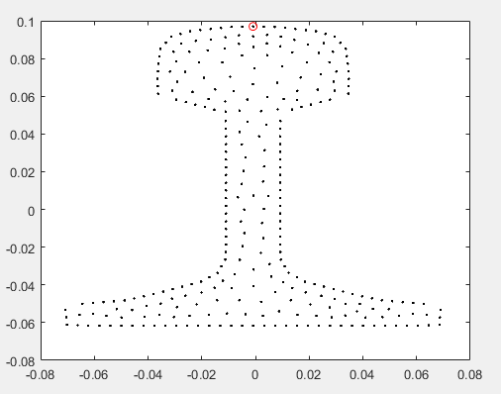

Extruded model with source (red) and receiver (green)

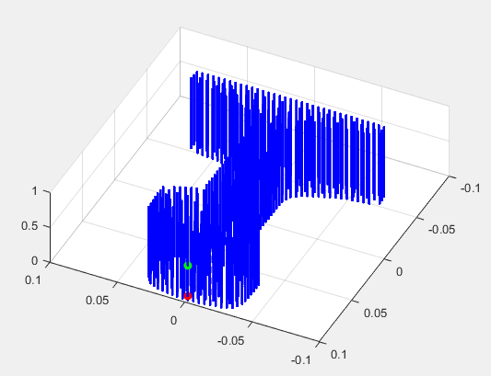

Final frame of Jimrail example after 0.03ms. Displaying longitudinal plane through middle of rail.

Matlab commands:
f = loadPogoField ('3Djimrail.pogo-field');
viewPogoField(f,100,96,0,3,0,cm);

Y is the rail height.
Z is 1.0m length of rail

Note: this is less impressive that the following image because the scale is 10x
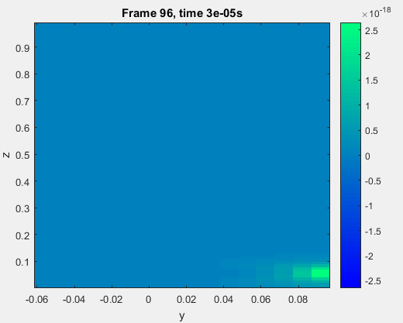

Transverse plane at signal source after 0.03ms.

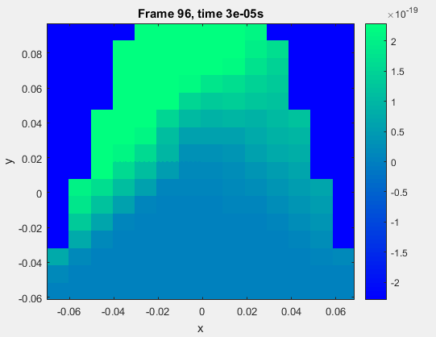

Plot of all History traces for the jimrail example.

Matlab instructions copied from manual.

Magnitude is plotted against time for 3 nodes.

