Generated Images Report
This document contains images generated using Google's Nano Banana Pro API (gemini-3-pro-image-preview) based on the provided prompts.

Image 1: "A beautiful sunset over mountains"
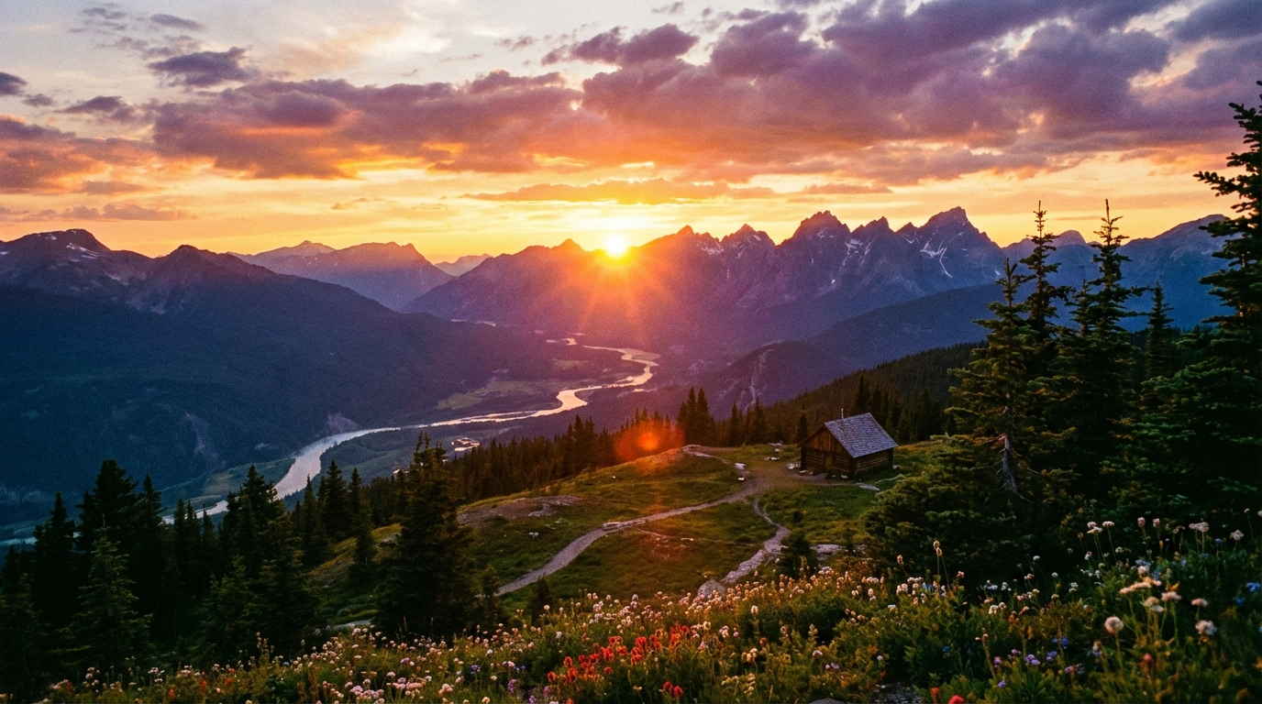

Image 2: "A futuristic city skyline at night"
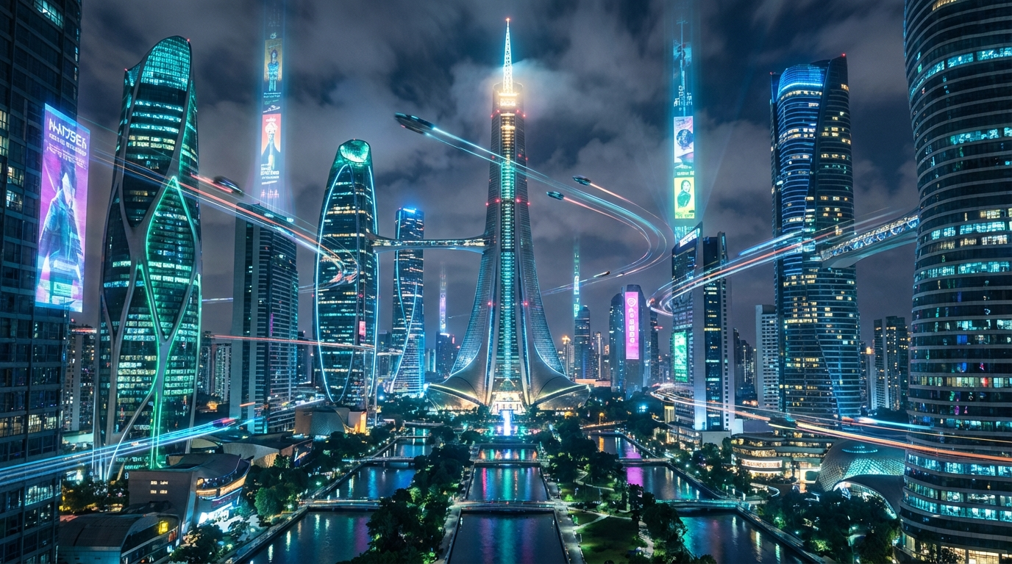

Image 3: "A red rose flower with dewdrops"
