Atomic philology and parallel philology -
some implications of CITE architecture
Neven Jovanović, Zagreb - neven.jovanovic@ffzg.hr
Digital Classics. Re-thinking Text Analysis. Heidelberger Akademie der Wissenschaften, May 2017.
Slides: croala.ffzg.unizg.hr/atomic-parallel/
Open Science Framework (OSF) repository for this talk: osf.io/dbf73

Christopher Blackwell, Neel Smith. Homer Multitext / OGL Analytical Exemplars. Use Cases & Infrastructure: Analytical Editions. May, 2015. Internet. Accessed 11 May, 2017.
CITE Architecture (Smith & Blackwell, 2001-): cite-architecture.github.io
Perseus Latin texts repository: github.com/PerseusDL/canonical-latinLit
Croatiae auctores Latini (CroALa): croala.ffzg.unizg.hr

Theses

We do not design for books. We design to make knowledge explicit.

We design objects that will be manipulated.

The unreachable is unusable. The uncitable is unreachable.

The editor decides (and is responsible for) what to make citable in the text.

The editor is responsible for separating concerns, by organizing various categories of knowledge into separate documents.

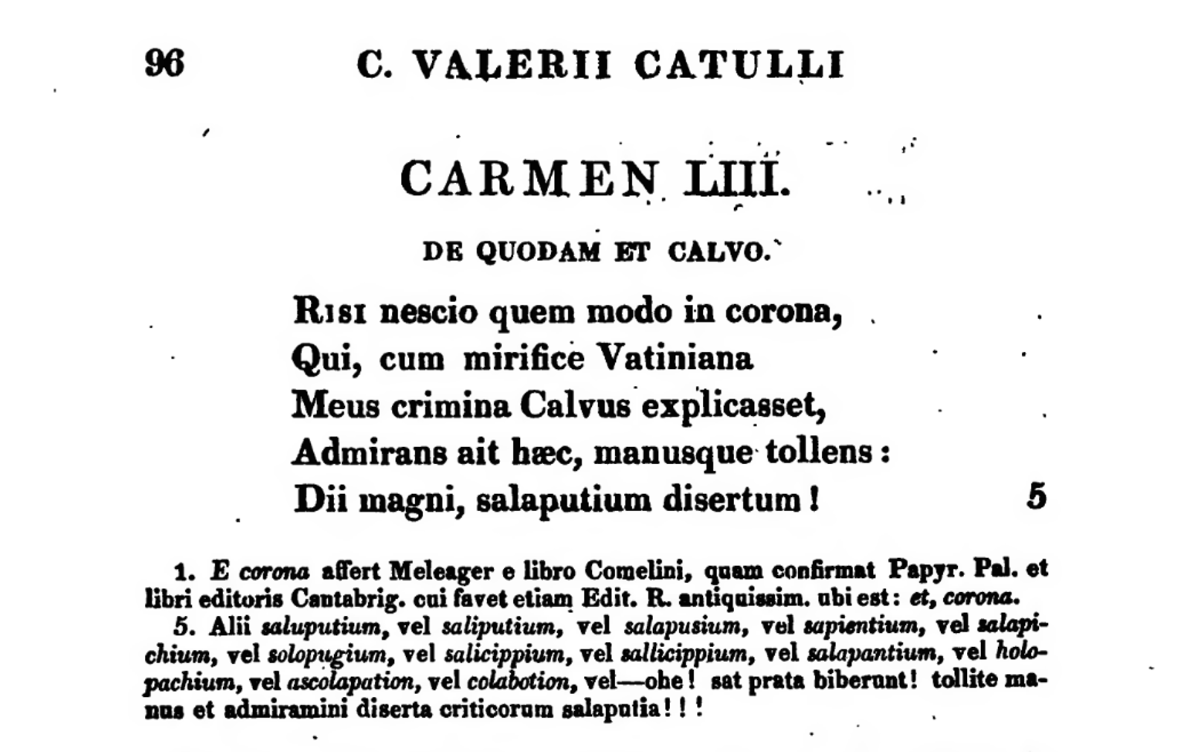
Catullus, ed. Doering, 1820.

