Task1:

**design pattern** is a general repeatable solution to a commonly occurring problem in software design. A design pattern isn't a finished design that can be transformed directly into code. It is a description or template for how to solve a problem that can be used in many different situations.

Benefits of Design Patterns

1. Foresee and rectify future problems easily.
2. Helps in maintaining binary compatibility with subsequent releases.
3. Just by following [SOLID Principles](http://www.vishalchovatiya.com/single-responsibility-principle-in-cpp-solid-as-a-rock/) helps greatly in agile or adaptive software development.
4. The solution facilitates the development of highly [cohesive](https://en.wikipedia.org/wiki/Cohesion_(computer_science)) modules with minimal coupling. Thus, increasing extensibility and reusability.
5. There are some patterns like Facade, Proxy, etc which encapsulates the complexity in itself to provide easy and intuitive interface to the client. Thus, making the overall system easier to understand and reduce learning curve.
6. Design Patterns make communication between designers and developers more crystal and precise. A developer can immediately picture the high-level design in their heads when they refer to the name of the pattern used to solve a particular issue when discussing software design.

Task2:

Z-test

* Your sample size is greater than 30. Otherwise, use a t test.
* Data points should be independent from each other. In other words, one data point isn’t related or doesn’t affect another data point.
* Your data should be normally distributed. However, for large sample sizes (over 30) this doesn’t always matter.
* Your data should be randomly selected from a population, where each item has an equal chance of being selected.
* Sample sizes should be equal if at all possible.

T-test

* A t-test is used when the population parameters (mean and standard deviation) are not known.

Paired T-Test

* A paired t-test is used when we are interested in the difference between two variables for the same subject.

Independent T-test

* You want to know if two groups are different on your variable of interest
* Your variable of interest is continuous
* You have two and only two groups
* You have independent samples
* You have a normal variable of interest

One sample t-test

* The one-sample t-test is used when we want to know whether our sample comes from a particular population but we do not have full population information available to us. For instance, we may want to know if a particular sample of college students is similar to or different from college students in general. The one-sample t-test is used only for tests of the sample mean. Thus, our hypothesis tests whether the average of our sample (M) suggests that our students come from a population with a know mean (m) or whether it comes from a different population.

ANOVA Test

use ANOVA to help you understand how your different groups respond, with a null hypothesis for the test that the means of the different groups are equal. If there is a statistically significant result, then it means that the two populations are unequal (or different).

Non parametric statistical test

Non parametric tests are used when your data isn’t normal. Therefore the key is to figure out if you have normally distributed data. For example, you could look at the distribution of your data. If your data is approximately normal, then you can use parametric statistical tests.

Chi-square test

A chi-square test is a statistical test used to compare observed results with expected results. The purpose of this test is to determine if a difference between observed data and expected data is due to chance, or if it is due to a relationship between the variables you are studying. Therefore, a chi-square test is an excellent choice to help us better understand and interpret the relationship between our two categorical variables.

Task3:

NFT stands for 'non-fungible token'. When something is fungible, like a dollar bill, it is equivalent to, and can thus be exchanged for, any other dollar bill. In contrast, a non-fungible token is a unique asset in digital form that cannot be exchanged for any other NFT. This means that every NFT is a 'one-of-a-kind' item. NFTs are transferred from own owner to another using blockchain technology, which creates a digital trail from seller to buyer that verifies the transaction. This encodes the unique ownership rights to the buyer (new owner).

Task4:

1.Qualitative data

is a bunch of information that cannot be measured in the form of numbers. It is also known as categorical data. It normally comprises words, narratives, and we labelled them with names.

2. Quantitative data

is a bunch of information gathered from a group of individuals and includes [statistical data analysis](https://www.analyticssteps.com/blogs/introduction-statistical-data-analysis). Numerical data is another name for quantitative data

3. Nominal data

is used just for labeling variables, without any type of quantitative value. The name ‘nominal’ comes from the Latin word “nomen” which means ‘name’.

4. Ordinal data

shows where a number is in order. This is the crucial difference from nominal types of data.

5. Discrete data

is a count that involves only integers. The discrete values cannot be subdivided into parts.

6. Continuous data

is information that could be meaningfully divided into finer levels. It can be measured on a scale or continuum and can have almost any numeric value

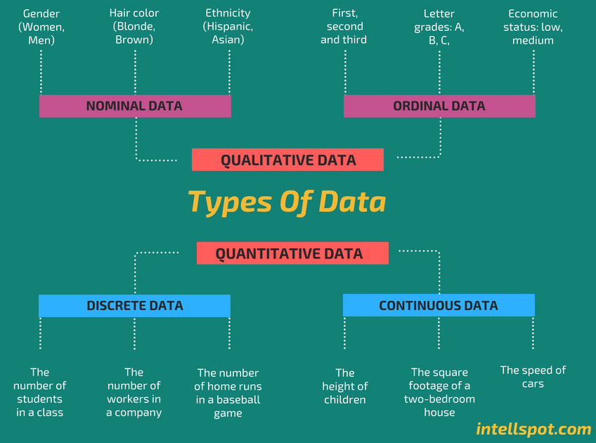

Task6:

Sampling – Dealing with non-deterministic processes

Pattern recognition

Training – use in Maximum likelihood estimation

Developing specific algorithms

Hyperparameter optimization

Model evaluation

Task7:

Our World in Data

Worldometer – real time world statistics

World Bank Open Data | Data

[The World Economic Forum](https://data.worldbank.org/)

National Statistical Agencies of Other Countries

Task8:

The term predictive analytics refers to the use of [statistics](https://www.investopedia.com/terms/s/statistics.asp) and modeling techniques to make predictions about future outcomes and performance. Predictive analytics looks at current and historical data patterns to determine if those patterns are likely to emerge again. This allows businesses and investors to adjust where they use their resources to take advantage of possible future events. Predictive analysis can also be used to improve [operational efficiencies](https://www.investopedia.com/terms/o/operationalefficiency.asp) and reduce [risk](https://www.investopedia.com/terms/r/risk.asp).