程序代码：
import cv2
import numpy as np
import matplotlib.pyplot as plt
import os

# 读取原始图像
image = cv2.imread('Photo/537.png')

# 获取图像尺寸
rows, cols = image.shape[:2]

def rotate_forward_and_mark_holes(img, angle_deg=30.0, save_path='output_picture/Figure_rotated_holes.png'):
"""
使用前向映射将图像绕中心旋转 angle_deg 度。
对目标坐标取整(round)，统计目标图像中没有被映射到的像素点（空洞），
并在输出图像中用白点标注这些空洞。返回 (dest_marked, holes_count, total_pixels)
"""
rows, cols = img.shape[:2]
cx, cy = (cols - 1) / 2.0, (rows - 1) / 2.0

theta = np.deg2rad(angle_deg)
cos_t = np.cos(theta)
sin_t = np.sin(theta)

# 先计算旋转后四个角的坐标以确定新的画布大小与偏移
corners = np.array([
[0 - cx, 0 - cy],
[cols - 1 - cx, 0 - cy],
[0 - cx, rows - 1 - cy],
[cols - 1 - cx, rows - 1 - cy],
], dtype=float)

rot_corners = np.empty_like(corners)
for i, (dx, dy) in enumerate(corners):
rx = cos_t * dx - sin_t * dy
ry = sin_t * dx + cos_t * dy
rot_corners[i, 0] = rx + cx
rot_corners[i, 1] = ry + cy

min_x = rot_corners[:, 0].min()
max_x = rot_corners[:, 0].max()
min_y = rot_corners[:, 1].min()
max_y = rot_corners[:, 1].max()

new_cols = int(np.ceil(max_x - min_x + 1))
new_rows = int(np.ceil(max_y - min_y + 1))

# 偏移量：将原始坐标系平移到新画布中
offset_x = -min_x
offset_y = -min_y

# 目标图像（初始化为黑色）和映射标记（使用更大的画布）
if img.ndim == 2:
dest = np.zeros((new_rows, new_cols), dtype=img.dtype)
else:
dest = np.zeros((new_rows, new_cols, img.shape[2]), dtype=img.dtype)
mapped = np.zeros((new_rows, new_cols), dtype=bool)

# 前向映射：遍历源像素 -> 计算目标位置（包含偏移） -> 取整 -> 赋值
for y in range(rows):
for x in range(cols):
dx = x - cx
dy = y - cy
x_rot = cos_t * dx - sin_t * dy
y_rot = sin_t * dx + cos_t * dy

x_new = x_rot + cx + offset_x
y_new = y_rot + cy + offset_y

xi = int(round(x_new))
yi = int(round(y_new))

if 0 <= xi < new_cols and 0 <= yi < new_rows:
dest[yi, xi] = img[y, x]
mapped[yi, xi] = True

total_pixels = rows * cols
holes_count = int(np.count_nonzero(~mapped))

# 将空洞位置设为白点（RGB 白）以便可视化
dest_marked = dest.copy()
# 对于单通道或三通道都适用的赋值方式
if dest_marked.ndim == 2:
dest_marked[~mapped] = 255
else:
dest_marked[~mapped] = [255, 255, 255]

# 确保输出目录存在
out_dir = os.path.dirname(save_path)
if out_dir and not os.path.exists(out_dir):
os.makedirs(out_dir, exist_ok=True)

cv2.imwrite(save_path, dest_marked)

return dest_marked, holes_count, total_pixels

if __name__ == '__main__':
import sys, os

if image is None:
print("无法读取图像 'Photo/537.png'，请检查路径。")
sys.exit(1)

# 允许从命令行传入角度（度）
angle = 30.0
if len(sys.argv) > 1:
try:
angle = float(sys.argv[1])
except ValueError:
print('传入的角度无效，使用默认 30 度。')

out_img, holes, total = rotate_forward_and_mark_holes(image, angle_deg=angle)
print(f"角度 {angle}° -> 空洞数量: {holes} / {total} ({holes/total:.2%})")

# 显示原图与结果
fig, axes = plt.subplots(1, 2, figsize=(12, 6))
axes[0].set_title('Original')
axes[0].axis('off')
# Matplotlib expects RGB
axes[0].imshow(cv2.cvtColor(image, cv2.COLOR_BGR2RGB))

axes[1].set_title(f'Forward mapping rotation {angle}° (holes white)')
axes[1].axis('off')
axes[1].imshow(cv2.cvtColor(out_img, cv2.COLOR_BGR2RGB))

plt.tight_layout()
# 同步保存一份可视化大图
vis_path = 'output_picture/Figure_rotated_holes_vis.png'
fig.savefig(vis_path)
print(f'已保存结果: output_picture/Figure_rotated_holes.png 和 {vis_path}')
plt.show()

程序运行图像：
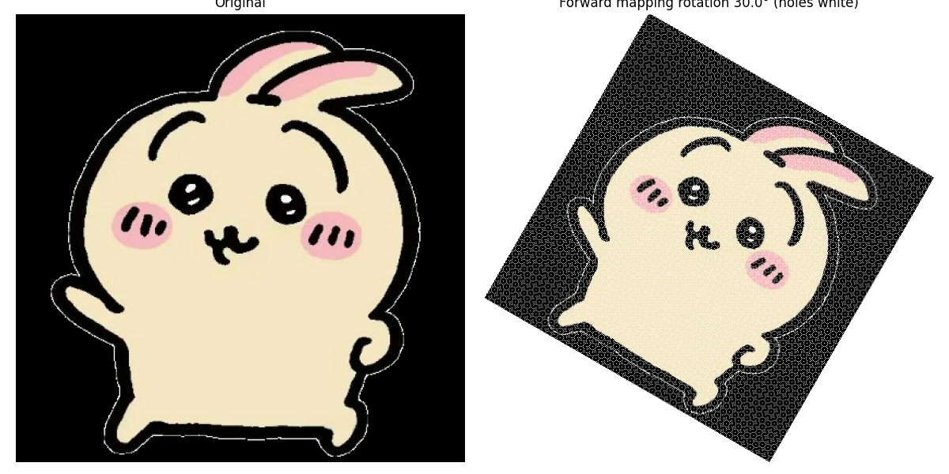

结论：
缩放或者旋转在取整过程中会导致空白点的出现

