程序代码：
import cv2
import numpy as np
import matplotlib.pyplot as plt
import os

def make_scale(sx, sy, cx, cy):
T1 = np.array([[1, 0, -cx], [0, 1, -cy], [0, 0, 1]], dtype=float)
S = np.array([[sx, 0, 0], [0, sy, 0], [0, 0, 1]], dtype=float)
T2 = np.array([[1, 0, cx], [0, 1, cy], [0, 0, 1]], dtype=float)
return T2 @ S @ T1

def make_rotate(angle_deg, cx, cy):
theta = np.deg2rad(angle_deg)
c = np.cos(theta)
s = np.sin(theta)
T1 = np.array([[1, 0, -cx], [0, 1, -cy], [0, 0, 1]], dtype=float)
R = np.array([[c, -s, 0], [s, c, 0], [0, 0, 1]], dtype=float)
T2 = np.array([[1, 0, cx], [0, 1, cy], [0, 0, 1]], dtype=float)
return T2 @ R @ T1

def make_translate(tx, ty):
T = np.array([[1, 0, tx], [0, 1, ty], [0, 0, 1]], dtype=float)
return T

def apply_transform(img, M3, output_size=None):
rows, cols = img.shape[:2]
if output_size is None:
output_size = (cols, rows)
M2 = M3[:2, :]
dst = cv2.warpAffine(img, M2, output_size, flags=cv2.INTER_LINEAR, borderMode=cv2.BORDER_CONSTANT, borderValue=(0,0,0))
return dst
def compare_images(a, b):
if a.shape != b.shape:
raise ValueError('shape mismatch')
diff = cv2.absdiff(a, b)
if diff.ndim == 3:
gray = cv2.cvtColor(diff, cv2.COLOR_BGR2GRAY)
else:
gray = diff
nonzero = int(np.count_nonzero(gray))
mse = float(np.mean((gray.astype(np.float32)) ** 2))
return nonzero, mse, diff
def main():
src = 'Photo/537.png'
img = cv2.imread(src)
if img is None:
print(f"Cannot read image: {src}")
return

rows, cols = img.shape[:2]
cx, cy = (cols - 1) / 2.0, (rows - 1) / 2.0

# transformation parameters
sx, sy = 0.8, 0.8
angle = 30.0
tx, ty = 40, -20

S = make_scale(sx, sy, cx, cy)
R = make_rotate(angle, cx, cy)
T = make_translate(tx, ty)

orders = [
('S_then_R_then_T', [S, R, T]),
('T_then_R_then_S', [T, R, S]),
('R_then_S_then_T', [R, S, T]),
('S_then_T_then_R', [S, T, R]),
]

out_dir = 'output_picture/text5_order'
os.makedirs(out_dir, exist_ok=True)

results = {}
for name, mats in orders:
M = np.eye(3)
for A in mats:
M = A @ M
dst = apply_transform(img, M)
path = os.path.join(out_dir, f'{name}.png')
cv2.imwrite(path, dst)
results[name] = dst
print(f'Saved {path}')

# pairwise comparisons
pairs = [(orders[i][0], orders[j][0]) for i in range(len(orders)) for j in range(i+1, len(orders))]
comparisons = []
for a, b in pairs:
nz, mse, diff = compare_images(results[a], results[b])
comparisons.append((a, b, nz, mse))

print('\nComparison summary (nonzero pixel diff, MSE):')
for a, b, nz, mse in comparisons:
print(f'{a} vs {b} -> nonzero: {nz}, mse: {mse:.2f}')

# visualization
fig, axes = plt.subplots(2, max(4, len(orders)), figsize=(16, 8))
for i, (name, _) in enumerate(orders):
axes[0, i].imshow(cv2.cvtColor(results[name], cv2.COLOR_BGR2RGB))
axes[0, i].set_title(name)
axes[0, i].axis('off')

k = 0
for a, b, nz, mse in comparisons:
if k >= axes.shape[1]:
break
diff = cv2.absdiff(results[a], results[b])
axes[1, k].imshow(cv2.cvtColor(diff, cv2.COLOR_BGR2RGB))
axes[1, k].set_title(f'{a}\nvs\n{b}\nnonzero={nz}\nmse={mse:.1f}')
axes[1, k].axis('off')
k += 1

for j in range(k, axes.shape[1]):
axes[1, j].axis('off')

plt.tight_layout()
vis_path = os.path.join(out_dir, 'order_comparison_text5.png')
fig.savefig(vis_path)
print(f'Visualization saved to {vis_path}')
plt.show()

if __name__ == '__main__':
main()

程序运行图像：
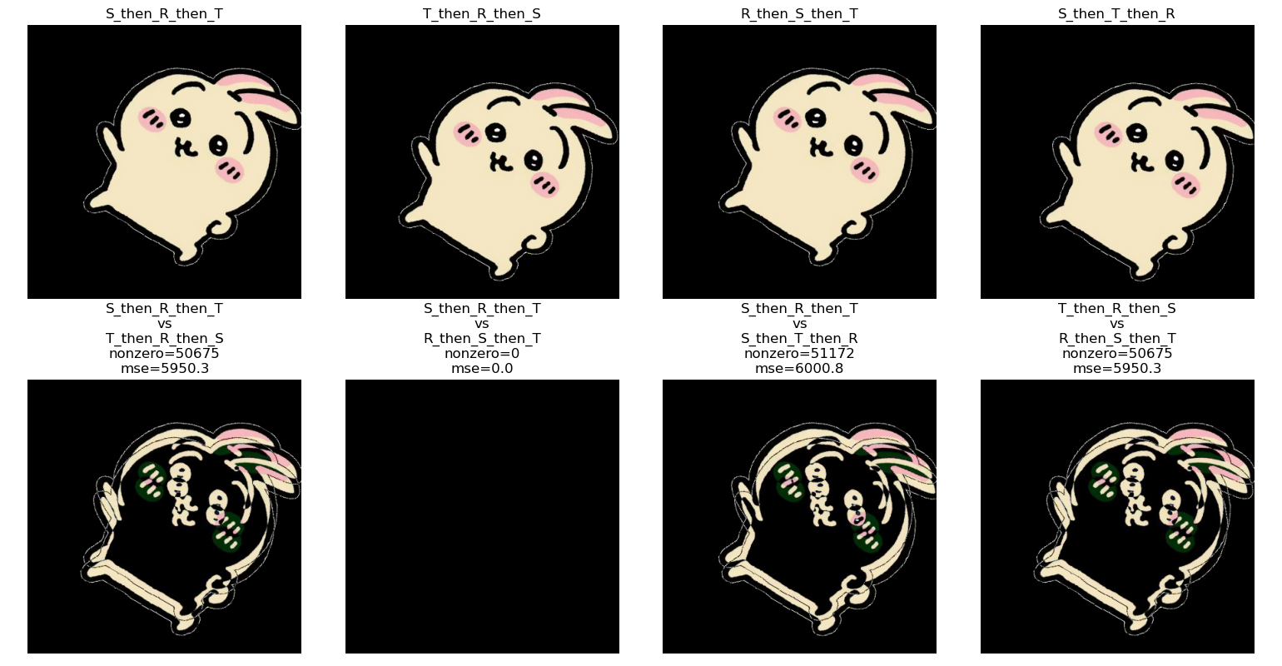

结论：
图像的几何操作（缩放、旋转、平移）与顺序是有关的

