1. 边缘检测
Roberts算子：
import cv2
import numpy as np
import os
def main():
# 尝试读取原始图像（优先使用相对路径 Photo/picture1.jpg）
img_path = 'Photo/picture1.jpg'
image = cv2.imread(img_path)
# 如果直接读取失败，尝试基于脚本目录的备选路径
if image is None:
script_dir = os.path.dirname(__file__)
alt_path = os.path.normpath(os.path.join(script_dir, '..', 'Photo', 'picture1.jpg'))
image = cv2.imread(alt_path)
if image is None:
print(f"无法读取图像，尝试的路径: {img_path} 和 {alt_path}")
return

# 获取图像尺寸
rows, cols = image.shape[:2]
# 转为灰度用于边缘检测
gray = cv2.cvtColor(image, cv2.COLOR_BGR2GRAY)
# 改进的处理管线：去噪 -> Roberts 梯度 -> 二值化 -> 细化骨架化
# 1) 提升局部对比度（CLAHE）并去噪（双边滤波保边缘）
clahe = cv2.createCLAHE(clipLimit=2.0, tileGridSize=(8, 8))
gray_clahe = clahe.apply(gray)
denoised = cv2.bilateralFilter(gray_clahe, d=9, sigmaColor=75, sigmaSpace=75)
# 2) Roberts 交叉算子 — 在每个颜色通道上计算并取最大值以保留颜色边缘
kx = np.array([[1, 0], [0, -1]], dtype=np.float32)
ky = np.array([[0, 1], [-1, 0]], dtype=np.float32)
channel_grads = []
for c in range(3):
ch = image[:, :, c]
# 在单通道上做去噪以保留通道边缘
ch_denoised = cv2.bilateralFilter(ch, d=9, sigmaColor=75, sigmaSpace=75)
gx = cv2.filter2D(ch_denoised.astype(np.float32), -1, kx)
gy = cv2.filter2D(ch_denoised.astype(np.float32), -1, ky)
grad_c = np.sqrt(gx * gx + gy * gy)
channel_grads.append(grad_c)

# 堆叠并取最大值（保留任一通道的强边缘）
grad = np.max(np.stack(channel_grads, axis=-1), axis=-1)
# 归一化
if grad.max() > 0:
grad_n = np.clip((grad / grad.max()) * 255, 0, 255).astype(np.uint8)
else:
grad_n = np.zeros_like(gray, dtype=np.uint8)
# 3) 使用 Otsu 得到初步二值图
_, mask_rob = cv2.threshold(grad_n, 0, 255, cv2.THRESH_BINARY + cv2.THRESH_OTSU)
# 4) 使用 Canny 作为补充（基于 CLAHE+去噪 的灰度图自适应阈值），融合可抑制噪声并增强连续性
# Canny 阈值基于中值法
median_val = np.median(denoised)
sigma = 0.33
lower = int(max(0, (1.0 - sigma) * median_val))
upper = int(min(255, (1.0 + sigma) * median_val))
mask_canny = cv2.Canny(denoised, lower, upper)
# 合并 Roberts 和 Canny 结果
mask_combined = cv2.bitwise_or(mask_rob, mask_canny)
# 5) 去噪和细化：先做开运算移除小噪点
kernel = cv2.getStructuringElement(cv2.MORPH_RECT, (3, 3))
mask_clean = cv2.morphologyEx(mask_combined, cv2.MORPH_OPEN, kernel, iterations=1)

def skeletonize(bin_img: np.ndarray) -> np.ndarray:
# Zhang-Suen style skeleton via morphological operations
img = bin_img.copy()
img[img != 0] = 255
skel = np.zeros(img.shape, np.uint8)
element = cv2.getStructuringElement(cv2.MORPH_CROSS, (3, 3))
while True:
eroded = cv2.erode(img, element)
dilated = cv2.dilate(eroded, element)
temp = cv2.subtract(img, dilated)
skel = cv2.bitwise_or(skel, temp)
img = eroded.copy()
if cv2.countNonZero(img) == 0:
break
return skel

# 优先使用 opencv_contrib 的 ximgproc.thinning (如果可用)，否则使用本地 skeletonize 函数
try:
from cv2 import ximgproc as xip
mask_skel = xip.thinning(mask_clean)
except Exception:
mask_skel = skeletonize(mask_clean)

# 6) 最终边缘掩码：可以再次做小范围膨胀以保证可见性
mask_final = cv2.dilate(mask_skel, cv2.getStructuringElement(cv2.MORPH_RECT, (1, 1)), iterations=1)

# 将边缘以红色叠合回原图，但做 alpha 混合以保留原始细节
alpha = 0.75 # 红色强度（0-1，越大红色越明显）
red_img = np.zeros_like(image)
red_img[:, :] = (0, 0, 255)
blended = cv2.addWeighted(image, 1.0 - alpha, red_img, alpha, 0)
overlay = image.copy()
overlay[mask_final == 255] = blended[mask_final == 255]

# 保存结果到同目录下的 output_picture，并保存中间调试图像以便进一步调参
script_dir = os.path.dirname(__file__)
out_dir = os.path.join(script_dir, 'output_picture')
os.makedirs(out_dir, exist_ok=True)
out_path = os.path.join(out_dir, 'edges_overlay.jpg')
cv2.imwrite(out_path, overlay)

# 保存调试图像：梯度图、合并掩码与最终掩码
debug_grad_path = os.path.join(out_dir, 'debug_grad.jpg')
debug_mask_path = os.path.join(out_dir, 'debug_mask.jpg')
debug_mask_final = os.path.join(out_dir, 'debug_mask_final.jpg')
cv2.imwrite(debug_grad_path, grad_n)
cv2.imwrite(debug_mask_path, mask_combined)
cv2.imwrite(debug_mask_final, mask_final)
print(f"边缘叠合图已保存: {out_path}")

if __name__ == '__main__':
main()
运行图像：
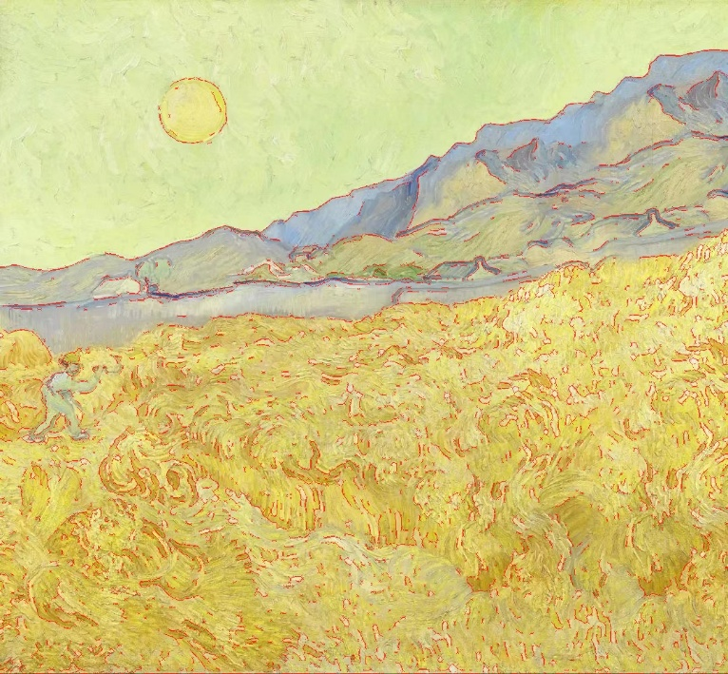
Prewitt算子
import cv2
import numpy as np
import os

def main():
# 读取图像
img_path = 'Photo/picture1.jpg'
image = cv2.imread(img_path)
if image is None:
script_dir = os.path.dirname(__file__)
alt_path = os.path.normpath(os.path.join(script_dir, '..', 'Photo', 'picture1.jpg'))
image = cv2.imread(alt_path)
if image is None:
print(f"无法读取图像，尝试的路径: {img_path} 和 {alt_path}")
return

# 灰度并增强对比
gray = cv2.cvtColor(image, cv2.COLOR_BGR2GRAY)
clahe = cv2.createCLAHE(clipLimit=2.0, tileGridSize=(8, 8))
gray_clahe = clahe.apply(gray)
# 去噪
denoised = cv2.bilateralFilter(gray_clahe, d=9, sigmaColor=75, sigmaSpace=75)
# Prewitt 算子核心（水平和垂直）
px = np.array([[ -1, 0, 1], [ -1, 0, 1], [ -1, 0, 1]], dtype=np.float32)
py = np.array([[ 1, 1, 1], [ 0, 0, 0], [ -1, -1, -1]], dtype=np.float32)
# 在每个颜色通道上计算梯度并取最大
channel_grads = []
for c in range(3):
ch = image[:, :, c]
ch_d = cv2.bilateralFilter(ch, d=9, sigmaColor=75, sigmaSpace=75)
gx = cv2.filter2D(ch_d.astype(np.float32), -1, px)
gy = cv2.filter2D(ch_d.astype(np.float32), -1, py)
grad_c = np.sqrt(gx * gx + gy * gy)
channel_grads.append(grad_c)

grad = np.max(np.stack(channel_grads, axis=-1), axis=-1)
# 归一化
if grad.max() > 0:
grad_n = np.clip((grad / grad.max()) * 255, 0, 255).astype(np.uint8)
else:
grad_n = np.zeros_like(gray, dtype=np.uint8)
# 二值化（Otsu）
_, mask_prew = cv2.threshold(grad_n, 0, 255, cv2.THRESH_BINARY + cv2.THRESH_OTSU)
# 可选：用 Canny 加强连续性
median_val = np.median(denoised)
sigma = 0.33
lower = int(max(0, (1.0 - sigma) * median_val))
upper = int(min(255, (1.0 + sigma) * median_val))
mask_canny = cv2.Canny(denoised, lower, upper)

mask_combined = cv2.bitwise_or(mask_prew, mask_canny)
# 开运算去噪
kernel = cv2.getStructuringElement(cv2.MORPH_RECT, (3, 3))
mask_clean = cv2.morphologyEx(mask_combined, cv2.MORPH_OPEN, kernel, iterations=1)
# 骨架化（简单形态学）
def skeletonize(bin_img: np.ndarray) -> np.ndarray:
img = bin_img.copy()
img[img != 0] = 255
skel = np.zeros(img.shape, np.uint8)
element = cv2.getStructuringElement(cv2.MORPH_CROSS, (3, 3))
while True:
eroded = cv2.erode(img, element)
dilated = cv2.dilate(eroded, element)
temp = cv2.subtract(img, dilated)
skel = cv2.bitwise_or(skel, temp)
img = eroded.copy()
if cv2.countNonZero(img) == 0:
break
return skel

try:
from cv2 import ximgproc as xip
mask_skel = xip.thinning(mask_clean)
except Exception:
mask_skel = skeletonize(mask_clean)

mask_final = cv2.dilate(mask_skel, cv2.getStructuringElement(cv2.MORPH_RECT, (1, 1)), iterations=1)

# alpha 混合红色叠合
alpha = 0.75
red_img = np.zeros_like(image)
red_img[:, :] = (0, 0, 255)
blended = cv2.addWeighted(image, 1.0 - alpha, red_img, alpha, 0)
overlay = image.copy()
overlay[mask_final == 255] = blended[mask_final == 255]

# 保存
script_dir = os.path.dirname(__file__)
out_dir = os.path.join(script_dir, 'output_picture')
os.makedirs(out_dir, exist_ok=True)
out_path = os.path.join(out_dir, 'prewitt_edges_overlay.jpg')
cv2.imwrite(out_path, overlay)
# 保存调试图
cv2.imwrite(os.path.join(out_dir, 'prewitt_debug_grad.jpg'), grad_n)
cv2.imwrite(os.path.join(out_dir, 'prewitt_debug_mask.jpg'), mask_combined)
cv2.imwrite(os.path.join(out_dir, 'prewitt_debug_mask_final.jpg'), mask_final)
print(f"Prewitt 边缘叠合图已保存: {out_path}")

if __name__ == '__main__':
main()

运行图像：
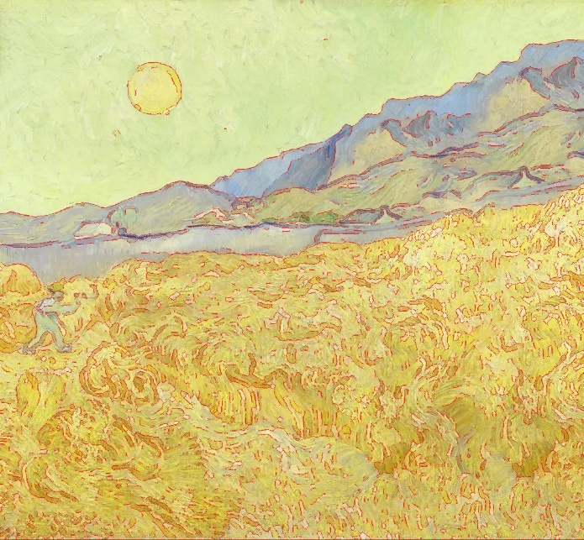

2. 差分运算
Roberts算子：
import cv2
import numpy as np
import os

def main():
# 读取图像（若为彩色则转换为灰度）
img_path = 'Photo/picture2.jpg'
img = cv2.imread(img_path)
if img is None:
script_dir = os.path.dirname(__file__)
alt = os.path.normpath(os.path.join(script_dir, '..', 'Photo', 'picture2.jpg'))
img = cv2.imread(alt)
if img is None:
print(f"无法读取图像，尝试路径: {img_path} 和 {alt}")
return

if img.ndim == 3:
gray = cv2.cvtColor(img, cv2.COLOR_BGR2GRAY)
else:
gray = img.copy()

# Roberts 算子核
kx = np.array([[1, 0], [0, -1]], dtype=np.float32)
ky = np.array([[0, 1], [-1, 0]], dtype=np.float32)
# 计算 Gx, Gy
gx = cv2.filter2D(gray.astype(np.float32), -1, kx)
gy = cv2.filter2D(gray.astype(np.float32), -1, ky)
# 梯度幅值
mag = np.sqrt(gx * gx + gy * gy)
# 归一化用于可视化
if mag.max() > 0:
mag_viz = np.clip((mag / mag.max()) * 255, 0, 255).astype(np.uint8)
else:
mag_viz = np.zeros_like(gray, dtype=np.uint8)
# 二值化（Otsu）得到边缘图
_, edge_bw = cv2.threshold(mag_viz, 0, 255, cv2.THRESH_BINARY + cv2.THRESH_OTSU)
# 保存原灰度、梯度可视化与二值化边缘图
out_dir = os.path.join(os.path.dirname(__file__), 'output_picture')
os.makedirs(out_dir, exist_ok=True)
cv2.imwrite(os.path.join(out_dir, 'text4_gray.jpg'), gray)
cv2.imwrite(os.path.join(out_dir, 'text4_roberts_magnitude.jpg'), mag_viz)
cv2.imwrite(os.path.join(out_dir, 'text4_roberts_edge.jpg'), edge_bw)
# 合并三张图：先转换为 BGR，确保相同高度，然后横向拼接，加入白色间隔并写入标签
h, w = gray.shape[:2]
gap = 10
spacer = 255 * np.ones((h, gap, 3), dtype=np.uint8)
gray_bgr = cv2.cvtColor(gray, cv2.COLOR_GRAY2BGR)
mag_bgr = cv2.cvtColor(mag_viz, cv2.COLOR_GRAY2BGR)
edge_bgr = cv2.cvtColor(edge_bw, cv2.COLOR_GRAY2BGR)

combined = np.hstack([gray_bgr, spacer, mag_bgr, spacer, edge_bgr])

# 添加简短标签
font = cv2.FONT_HERSHEY_SIMPLEX
font_scale = max(0.5, w / 800)
thickness = 1
cv2.putText(combined, 'Original', (10, 25), font, font_scale, (0, 0, 255), thickness, cv2.LINE_AA)
cv2.putText(combined, 'Roberts magnitude', (w + gap + 10, 25), font, font_scale, (0, 0, 255), thickness, cv2.LINE_AA)
cv2.putText(combined, 'Edges (binary)', (2 * (w + gap) + 10, 25), font, font_scale, (0, 0, 255), thickness, cv2.LINE_AA)

combined_path = os.path.join(out_dir, 'text4_combined.jpg')
cv2.imwrite(combined_path, combined)
print(f"已保存: {out_dir}/text4_gray.jpg, text4_roberts_magnitude.jpg, text4_roberts_edge.jpg")
print(f"合并图已保存: {combined_path}")

if __name__ == '__main__':
main()

运行图像：
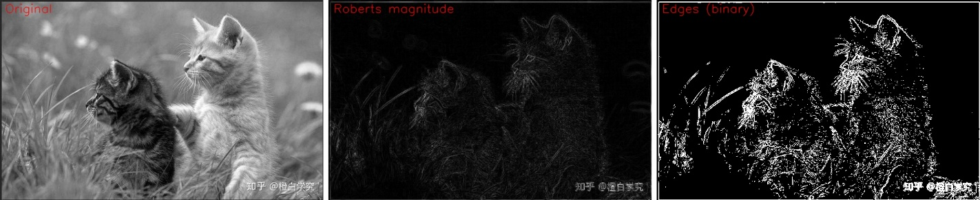

Prewitt算子
import cv2
import numpy as np
import os

def main():
# 读取图像（若为彩色则转换为灰度）
img_path = 'Photo/picture2.jpg'
img = cv2.imread(img_path)
if img is None:
script_dir = os.path.dirname(__file__)
alt = os.path.normpath(os.path.join(script_dir, '..', 'Photo', 'picture2.jpg'))
img = cv2.imread(alt)
if img is None:
print(f"无法读取图像，尝试路径: {img_path} 和 {alt}")
return

if img.ndim == 3:
gray = cv2.cvtColor(img, cv2.COLOR_BGR2GRAY)
else:
gray = img.copy()

# Prewitt 算子核
px = np.array([[-1, 0, 1], [-1, 0, 1], [-1, 0, 1]], dtype=np.float32)
py = np.array([[1, 1, 1], [0, 0, 0], [-1, -1, -1]], dtype=np.float32)
# 计算 Gx, Gy
gx = cv2.filter2D(gray.astype(np.float32), -1, px)
gy = cv2.filter2D(gray.astype(np.float32), -1, py)
# 梯度幅值
mag = np.sqrt(gx * gx + gy * gy)
# 归一化用于可视化
if mag.max() > 0:
mag_viz = np.clip((mag / mag.max()) * 255, 0, 255).astype(np.uint8)
else:
mag_viz = np.zeros_like(gray, dtype=np.uint8)
# 二值化（Otsu）得到边缘图
_, edge_bw = cv2.threshold(mag_viz, 0, 255, cv2.THRESH_BINARY + cv2.THRESH_OTSU)
# 保存原灰度、梯度可视化与二值化边缘图
out_dir = os.path.join(os.path.dirname(__file__), 'output_picture')
os.makedirs(out_dir, exist_ok=True)
cv2.imwrite(os.path.join(out_dir, 'text5_gray.jpg'), gray)
cv2.imwrite(os.path.join(out_dir, 'text5_prewitt_magnitude.jpg'), mag_viz)
cv2.imwrite(os.path.join(out_dir, 'text5_prewitt_edge.jpg'), edge_bw)
# 合并三张图：先转换为 BGR，确保相同高度，然后横向拼接，加入白色间隔并写入标签
h, w = gray.shape[:2]
gap = 10
spacer = 255 * np.ones((h, gap, 3), dtype=np.uint8)
gray_bgr = cv2.cvtColor(gray, cv2.COLOR_GRAY2BGR)
mag_bgr = cv2.cvtColor(mag_viz, cv2.COLOR_GRAY2BGR)
edge_bgr = cv2.cvtColor(edge_bw, cv2.COLOR_GRAY2BGR)

combined = np.hstack([gray_bgr, spacer, mag_bgr, spacer, edge_bgr])

# 添加简短标签
font = cv2.FONT_HERSHEY_SIMPLEX
font_scale = max(0.5, w / 800)
thickness = 1
cv2.putText(combined, 'Original', (10, 25), font, font_scale, (0, 0, 255), thickness, cv2.LINE_AA)
cv2.putText(combined, 'Prewitt magnitude', (w + gap + 10, 25), font, font_scale, (0, 0, 255), thickness, cv2.LINE_AA)
cv2.putText(combined, 'Edges (binary)', (2 * (w + gap) + 10, 25), font, font_scale, (0, 0, 255), thickness, cv2.LINE_AA)

combined_path = os.path.join(out_dir, 'text5_combined.jpg')
cv2.imwrite(combined_path, combined)
print(f"已保存: {out_dir}/text5_gray.jpg, text5_prewitt_magnitude.jpg, text5_prewitt_edge.jpg")
print(f"合并图已保存: {combined_path}")

if __name__ == '__main__':
main()

运行图像：
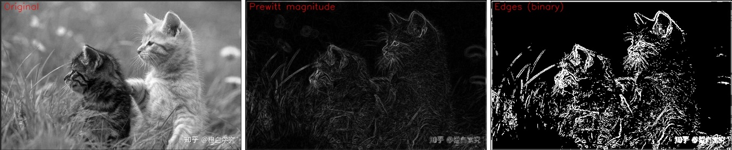

拉普拉斯算子：
import cv2
import numpy as np
import os

def main():
# 读取图像（若为彩色则转换为灰度）
img_path = 'Photo/picture2.jpg'
img = cv2.imread(img_path)
if img is None:
script_dir = os.path.dirname(__file__)
alt = os.path.normpath(os.path.join(script_dir, '..', 'Photo', 'picture2.jpg'))
img = cv2.imread(alt)
if img is None:
print(f"无法读取图像，尝试路径: {img_path} 和 {alt}")
return

if img.ndim == 3:
gray = cv2.cvtColor(img, cv2.COLOR_BGR2GRAY)
else:
gray = img.copy()

# Laplacian 检测
lap = cv2.Laplacian(gray, ddepth=cv2.CV_32F, ksize=3)
lap_abs = np.abs(lap)
# 归一化用于可视化
if lap_abs.max() > 0:
lap_viz = np.clip((lap_abs / lap_abs.max()) * 255, 0, 255).astype(np.uint8)
else:
lap_viz = np.zeros_like(gray, dtype=np.uint8)
# 二值化（Otsu）得到边缘图
_, edge_bw = cv2.threshold(lap_viz, 0, 255, cv2.THRESH_BINARY + cv2.THRESH_OTSU)
# 保存单独图像
out_dir = os.path.join(os.path.dirname(__file__), 'output_picture')
os.makedirs(out_dir, exist_ok=True)
cv2.imwrite(os.path.join(out_dir, 'text6_gray.jpg'), gray)
cv2.imwrite(os.path.join(out_dir, 'text6_laplacian_viz.jpg'), lap_viz)
cv2.imwrite(os.path.join(out_dir, 'text6_laplacian_edge.jpg'), edge_bw)
# 合并三张图并添加标签
h, w = gray.shape[:2]
gap = 10
spacer = 255 * np.ones((h, gap, 3), dtype=np.uint8)
gray_bgr = cv2.cvtColor(gray, cv2.COLOR_GRAY2BGR)
lap_bgr = cv2.cvtColor(lap_viz, cv2.COLOR_GRAY2BGR)
edge_bgr = cv2.cvtColor(edge_bw, cv2.COLOR_GRAY2BGR)

combined = np.hstack([gray_bgr, spacer, lap_bgr, spacer, edge_bgr])

font = cv2.FONT_HERSHEY_SIMPLEX
font_scale = max(0.5, w / 800)
thickness = 1
cv2.putText(combined, 'Original', (10, 25), font, font_scale, (0, 0, 255), thickness, cv2.LINE_AA)
cv2.putText(combined, 'Laplacian magnitude', (w + gap + 10, 25), font, font_scale, (0, 0, 255), thickness, cv2.LINE_AA)
cv2.putText(combined, 'Edges (binary)', (2 * (w + gap) + 10, 25), font, font_scale, (0, 0, 255), thickness, cv2.LINE_AA)

combined_path = os.path.join(out_dir, 'text6_combined.jpg')
cv2.imwrite(combined_path, combined)
print(f"已保存: {out_dir}/text6_gray.jpg, text6_laplacian_viz.jpg, text6_laplacian_edge.jpg")
print(f"合并图已保存: {combined_path}")
if __name__ == '__main__':
main()
运行图像：
