Problem Chosen  E | 2025  MCM/ICM  Summary Sheet | Team Control Number  2511572
Animals or Chemicals? The Future of Agriculture
Summary
在世界人口总数日益增长的当下，粮食危机成为世界性难题，守护国家粮食安全至关重要，实行推林还耕增加耕地面积是一项重要举措。但从森林生态系统到农业生态系统的转变过程中土地变得枯竭，原生物种被驱逐，新的生态系统面临生态结构脆弱易被外界因素影响而破坏的问题。本文针对农业生态系统中的问题，考虑自然过程和人类决策对生态系统的影响，通过模拟物种间相互关系、人类活动、物种变化、环境影响来分析农业生态系统的变化及其稳定性。
针对问题一：问题一为对当前农业生态系统的建模(Model 1)。我们通过构建食物网模型，分析了在茂密森林被新农业生态系统取代后的生态系统动态。通过使用Lotka-Volterra方程组，我们模拟不同物种之间的相互作用以及化学剂的使用对各物种的影响。考虑到季节因素和农业周期，我们将部分参数设置为适当的函数来模拟现实情况。
针对问题二：问题二在模型1基础上纳入新的物种建立成熟农业生态系统模型(Model 2)。随着时间的推移，边缘栖息地逐渐成熟，原生物种回归。我们选择了两种不同生态位的物种，将它们纳入模型并确定它们的影响。通过调整Lotka-Volterra模型参数及引入新的种群动态方程，我们模拟了这些物种的重新出现对现有农业生态系统的影响。
针对问题三：问题三探讨了农民选择有机农业的可行性。我们去除了除草剂和杀虫剂的相关参数模拟了在去除化学剂后的生态系统变化。引入蝙蝠作为生态系统的一部分，有助于控制害虫种群并促进植物的繁殖。蝙蝠通过捕食昆虫和充当授粉者，显著增强了生态系统的稳定性。同时，我们还引入了一种能够恢复生态平衡的另一物种蜜蜂，结果显示，蝙蝠对生态系统的正面影响更为显著,但两者协同工作能够进一步提高生态系统的稳定性，增加农业的经济效益。
最后我们对现有模型进行了灵敏度分析，得到了一些重要参数对生态系统稳定性影响程度。根据灵敏度分析结果，我们总结出增强农业生态系统稳定性，提高农作物产量的几条策略。
在文章的最后我们为有意选择有机农业的农民写了封信，为他提供相关建议并告知相关的政策支持。
综上所述，本文围绕探讨农业生态系统中的生态平衡问题展开，涉及物种间相互关系、化学物质影响、农业周期和季节性变化等多个方面。通过综合运用Lotka-Volterra模型等数学模型和优化算法，对农业生态系统中的生态平衡问题进行了深入探讨，从而为农业生态系统的可持续发展，有机农业的运行模式提供了理论依据。本文通过建立一系列的数学模型和算法，深入分析了生态系统中的复杂关系和影响因素。这些模型不仅揭示了农业生态系统的动态平衡，还为未来的农业管理和生态保护策略提供了科学支撑。

Keywords : Lotka-Volterra model ; Logistic增长模型 ; 农业生态系统

Contents
1 Introduction 4
1.1 Problem Background 4
1.2 Restatement of the Problem 4
1.3 Our Work 4
2 Assumptions and Justifications 5
3 Notations 5
4 Food Web Model of The Original Agricultural Ecosystem 6
4.1 The Establishment of Model 1 6
4.1.1 建立食物网结构 6
4.1.2 各种群数目变化的增长公式 6
4.1.3 其他因素的实现方法 8
4.2 结果展示与分析 8
4.2.1 各物种曲线变化 8
4.2.2 结论 12
5 Natural Processes:Model of The Mature Agricultural Ecosystem 13
5.1 模型的改进 13
5.1.1 食物网结构的变化 13
5.1.2 部分增长公式的调整 13
5.2 结果展示与分析 14
5.2.1 各物种曲线变化及前后对比 14
5.2.2 结论 15
6 Human Decisions：Model of The Green Agricultural Ecosystem 15
6.1 模型3的建立 15
6.1.1 化学剂的去除与蝙蝠的引入 15
6.1.2 结果展示与分析 17
6.2 蜜蜂vs蝙蝠 17
7 Sensitivity Analysis 19
8 Model Evaluation and Further Discussion 19
8.1 Strengths 19
8.2 Weaknesses 20
9 A Letter to The Farmer 20
References 20
Appendices 21

Introduction

Problem Background
近年来，人类人口总数不断上升，为应对人口上涨带来的粮食危机，部分国家选择退林还耕，在扩大耕地面积的同时提高农作物产量[1]。从森林生态系统到农业生态系统的过程中，原有生态结构被打破，新建立的农业生态系统结构单一较脆弱，受环境变化和人类活动影响较大[2]。
随着时间的推移，自然演化过程会逐渐使得农业生态系统趋于丰富和稳定。我们认为这就是农业生态系统逐渐变得成熟。成熟的农业生态系统具有更复杂的食物网结构以及更高的粮食产量[3]。
随着人类生活品质的逐渐提高，除了吃饱，人们更追求食物的健康与品质，绿色蔬菜也备受追捧[4]。与此同时，农民也倾向于尝试将农田运作模式转向绿色农业，减少化学剂的使用，引入如蝙蝠这类生物，用生物防治代替化学防治，在二者之间评估最优方案降本增效

Restatement of the Problem
Considering the background information and restricted conditions identified in the problem statement, we need to solve the following problems:
Problem 1：建立刚取代森林生态系统的农业生态系统食物网模型，分析各成分（主要包括生产者和消费者）之间的相互作用，同时考虑农业周期、季节性和化学剂的使用对系统的影响，建立数学模型分析各个种群种群数目的动态变化。
Problem 2：随时间推移原生物种逐渐回归，农业生态系统趋于稳定且不断丰富，建立新的模型考虑新的物种的加入又会对生态系统的稳定产生的影响
Problem 3：建立恰当的数学模型分析当农民考虑转向有机农业模式而减少化学剂的使用并引入蝙蝠这一特殊的新物种提高农作物产量时，生态系统的稳态发生的变化，同时考虑引入除蝙蝠外的第二种生物来达到与蝙蝠类似的效果。

Our Work

          - Our Work

Assumptions and Justifications
- Assumptions 1 :刚完成转化的农业生态系统中暂时不存在三级及以上的消费者，经过时间的推移以后，逐渐成熟的农业生态系统中会出现更高级的消费者
- Justifications :在初期实现从森林到农业的生态系统转变后，肉食动物大多被驱逐，出于食物、天性等因素的考量，它们很难在短时间内很难返回并重新建立在农业生态系统中的生态地位。而成熟的农业生态系统中，充足且稳定的食物来源则会吸引肉食动物返回捕猎。

- Assumptions 2 :在模型所建立的农业生态系统中各物种之间的关系主要表现为捕食关系，竞争关系主要集中在农作物与杂草之间，其余竞争关系可以忽略不计。
- Justifications :农业生态系统中，人工干预下，农作物处于绝对的主导地位且资源充足，作物与作物之间的竞争几乎不存在，只有以作物为食的昆虫和与作物竞争资源的杂草对其影响最大，于此同时对与初级消费者而言，食物来源充足，种间竞争基本可以忽略不计，次级消费者同理。

- Assumptions 3 :生态系统中所有的生物不会出现变异，表现为杂草、昆虫不会出现耐药性。
- Justifications :建立的模型预测时间周期较短，动植物变异出现耐药性的演化周期较长，因此基本可以认为所有生物都不会发生变异。

- Assumptions 4 :农业生态系统中分解者存在且发挥作用，但基本不会直接影响各个种群数目，可以忽略不计。
- Justifications :分解者主要作用是分解有机物成为无机盐为农作物提供养料，在我们建立的农业生态系统模型中，由于人的作用，生产者的资源是充足的，由此覆盖了分解者的作用，我们便忽略不计。

- Assumptions 5 :环境的总容纳量有限，系统中各个物种受环境影响，其对应的环境容纳量有限且保持不变。
- Justifications :在现实中，环境总承载量有限，尽管植物营养资源充足但受制于气候、空间等因素，所有物种均不能无限繁殖，都有容纳上限。在短期内环境不会发生巨变，其环境容纳量基本稳定，因此可以被视为保持不变。

Notations
The key mathematical notations used in this paper are listed in Table 1.
        - Notations used in this paper
Symbol | Description
r | 物种的增长率
K | 物种的环境容纳量
$$P_{i}$$ | 第i种植物的种群数目
$$I_{i}$$ | 第i种昆虫的种群数目
$$C_{i}$$ | 第i种捕食者的种群数目
$$ε_{i3}$$ | 杂草对第i种农作物的竞争系数
$$α_{ij}$$ | 第i种植物对第j种昆虫的抗性系数
$$β_{ij}$$ | 第j种昆虫对第i种植物的食害系数
$$η_{i}$$ | 第i种捕食者对昆虫的捕食系数
$$δ_{i}$$ | 第i种昆虫的自然死亡率
$$μ_{C_{i}}$$ | 第i种捕食者的自然死亡率
$$γ$$ | 化学剂导致物种死亡的死亡率
$$S$$ | 除草剂的浓度
C | 杀虫剂的浓度

Food Web Model of The Original Agricultural Ecosystem

The Establishment of Model 1

建立食物网结构
基于我们先前的假设，我们分析了原始农业生态系统的食物网结构[5]并进行简化得到如图所示结构：

          - 原始农业生态系统食物网结构
下面是对我们所建立食物网结构的详细阐述：
生产者：考虑到在现代农业种植间作、套作的模式逐渐成熟在农业中通常种植两种及以上的作物，因此我将其归类为作物1和作物2。作为作物的主要竞争物种，杂草也被纳入其中编号为3。
初级消费者：在农业生态系统的初级消费者群体主要由昆虫组成，为便于建模我们将其归纳为三类：(1)昆虫1：只吃农作物的害虫、（2）昆虫2：既吃农作物又吃杂草、（3）昆虫3：只吃杂草的益虫。
次级消费者：为保证模型丰富度，我们在模型中设立了捕食者1和捕食者2，确保它们对初级消费者的捕食力度。

各种群数目变化的增长公式
为研究在上述食物网中各个种群的种群数目随时间的变化了，并分析各个营养级之间的相互作用，我们引入了Logistic增长模型并列出了各种群的数目增长的微分方程：
- 农作物：
$$\frac{dP_{i}}{dt}=r_{p_{i}}P_{i}\left(1-\frac{P_{i}}{K_{P_{i}}}\right)-\sum_{j=1}^{2}{α_{ij}P_{i}I_{j}}-ε_{i3}P_{i}P_{3}$$ | ()
以下是对各个参数的意义的解释：
$r_{p_{i}}$：第i种作物的增长率
$P_{i}$：第i种农作物的种群数量
$I_{j}$：第j种昆虫的种群数量
$K_{P_{i}}$：第i种作物的环境容纳量(资源的最大承载能力)..
$α_{ij}$：第i种植物对第j种昆虫的抗性系数
$ε_{i3}$：杂草对第i种农作物的竞争系数
- 杂草：
$$\frac{dP_{3}}{dt}=r_{p_{3}}P_{3}⋅\left(1-\frac{P_{3}}{K_{P_{3}}}\right)-\sum_{j=1}^{2}{α_{3j}P_{3}I_{j}-\sum_{i=1}^{2}{ε_{3i}P_{i}P_{3}}-}γ_{P_{3}}⋅S$$ | ()
对部分参数解释如下：
$γ_{P_{3}}$: Mortality of weeds caused by different concentrations of herbicides
$S$: Herbicide concentration
- Primary consumers：
$$\frac{dI_{i}}{dt}=r_{I_{i}}I_{i}\left(1-\frac{I_{i}}{K_{I_{i}}}\right)+\sum_{j=1}^{3}{β_{ij}I_{j}}-δ_{i}I_{i}-γ_{I_{i}}⋅C-\sum_{j=1}^{2}{η_{ij}I_{i}C_{j}}$$ | ()
Some parameters are explained as follows：
$β_{ij}$: The damage coefficient of the i-th insect on the j-th plant
$δ_{i}$: The natural mortality rate of the i-th insect
$γ_{I_{i}}$: Mortality rate caused by different concentrations of pesticides
C ：Pesticide concentration
- Secondary consumers:
$$\frac{dC_{i}}{dt}=r_{C_{i}}C_{i}\left(1-\frac{C_{i}}{K_{C_{i}}}\right)+\sum_{j=1}^{3}{η_{j}I_{j}C_{i}}-μ_{C_{i}}C_{i}$$ | ()
$C_{i}$：The population size of the i-th predator
$η_{i}$：Predation coefficient of the i-th predator on insects
$μ_{C_{i}}$：The natural mortality rate of the i-th predator
After listing the above mathematical formulas, we have completed the mathematical modeling of the food web structure based on the hypothesis, that is, the original agricultural food web model（Lotka-Volterra Model），In the above formula we have taken the use of chemicals into account。

Implementation methods of other factors
In actual agricultural ecosystems, factors that affect the number of various populations are not only the food web relationship between organisms, but also seasonal changes and agricultural cycles. In order to take these factors into account in our model and implement the code, we make the following processing to achieve modeling of these factors:
(1) Seasonal changes
In actual agricultural ecosystems, the impact of seasonal changes on the system is mainly reflected in producers. The growth rate of producers is different in different seasons, so the population of producers shows a trend of periodic changes with the change of seasons, and the change of the population of producers will affect the population of consumers. In this way, seasonal changes have an impact on agricultural ecosystems.
By searching for information, we concluded that the impact of seasonal changes on plant growth rates is mainly reflected in the following: the growth rate gradually increases in spring, the growth rate is the highest in summer, the growth rate decreases in autumn, and the plants hardly grow or even disappear in winter, with a growth rate less than 0.
From this rule, we can conclude that the growth rate of plants is more in line with the change law of the sine function. Therefore, Therefore, we define the growth rates $r_{p_{i}}$ of the three producers as different periodic functions $A\sin{t}$,and implemente modeling of seasonal variations.
(2) Agricultural cycle
In agricultural production, the regular sowing and harvesting of crops are essential links, and the impact of these behaviors on the agricultural ecosystem cannot be ignored. The performance of these behaviors in data is also relatively simple, that is, the sudden rise and fall of the crop population.
In the model, we can achieve mathematical simulation of agricultural cycle factors by regulating the population size at a fixed time point.

Results presentation and analysis
In order to obtain the solution of the above differential equation, we use the 'BDF' method to solve the differential equation and obtain the change curve of each population number. The horizontal axis represents the change in time t, and the vertical axis represents the population number. In order to intuitively show the impact of various factors on the population number, we use the control variable method to discuss them one by one.

Curve changes of each species
(1) Changes in the number of various populations under ideal states:
Ideally, the population size of each species is only constrained by the relationship in the food web, and eventually each population will reach a stable level and remain unchanged.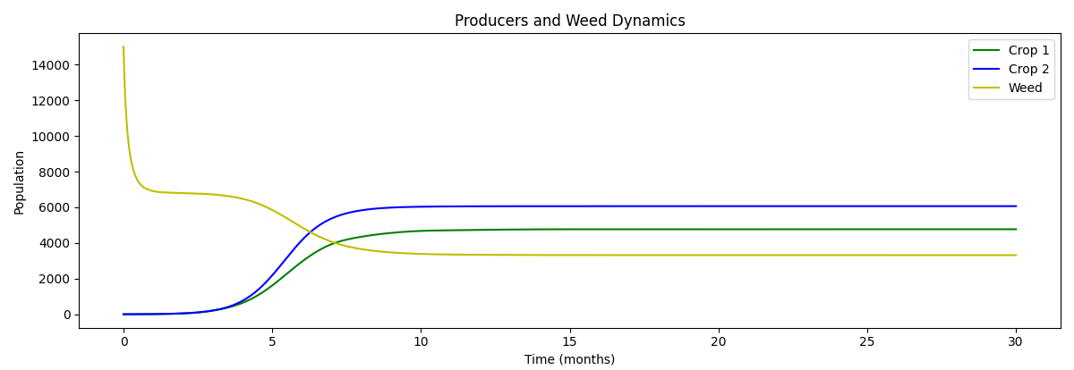
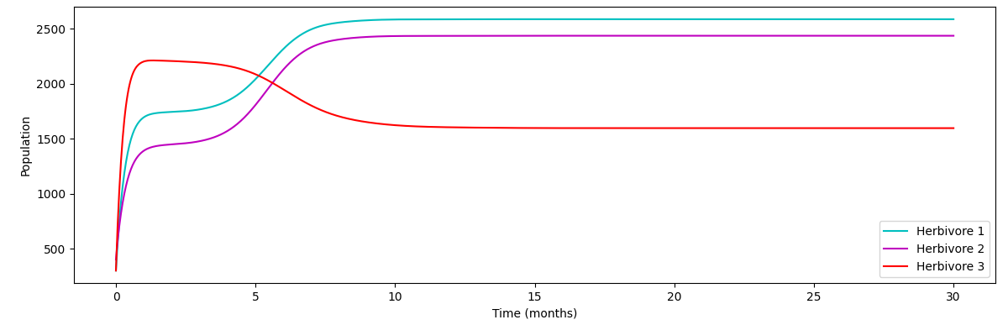
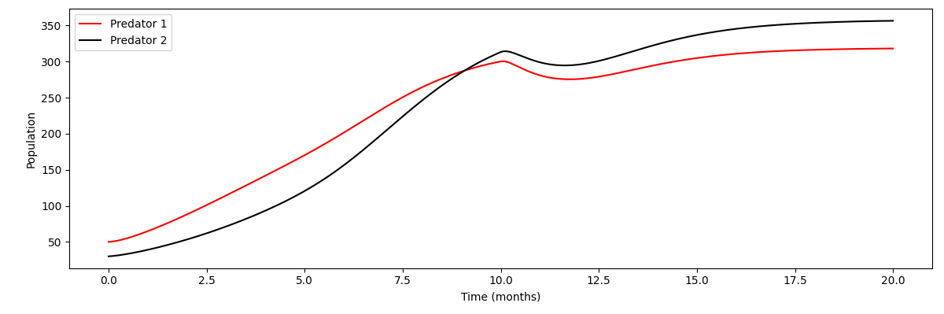
          - Ideal State
We analyze and explain the trend of the curve in the figure:
- Overall, crop 1 and crop 2 are in a dominant position among producers, and their growth curves conform to the ‘S’-shaped growth. Compared with the weed curve, it can also be seen that they conform to the competitive relationship of one increasing while the other decreases.
- When the ecosystem changes from forest to agriculture, the weed population is larger than the environmental carrying capacity, because the environmental carrying capacity of weeds in forest ecosystems is much higher than that in agricultural ecosystems; due to the dramatic change in environmental carrying capacity, the weed population drops sharply. Subsequently, due to the disadvantage in the competition with crops, the weed population drops again, and finally reaches stability.
- Among primary consumers, insects 1 and 2 mainly feed on crops, so they are positively correlated with the growth curves of Crop1 and Crop 2. Similarly, insects 3, which mainly feed on weeds, are positively correlated with the growth curve of weeds.
- Among secondary consumers, their growth curves are mainly related to the total number of primary consumers. Through their growth curves, we can know the overall changing trend of primary consumers.
- Use of chemicals：
In the original agricultural ecosystem, weeds and pests have a great impact on the growth of crops. In order to prevent and control weeds and pests, farmers usually use herbicides and pesticides to achieve the purpose. In the model, we introduce Gaussian functions to simulate the use of chemicals and get the following results.
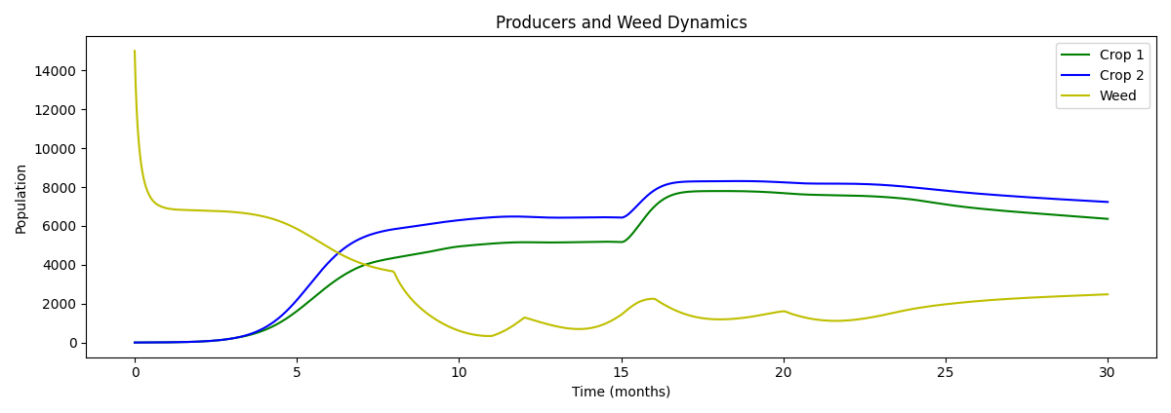
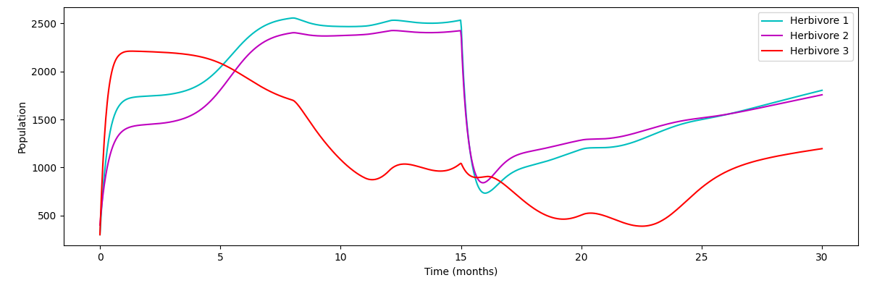
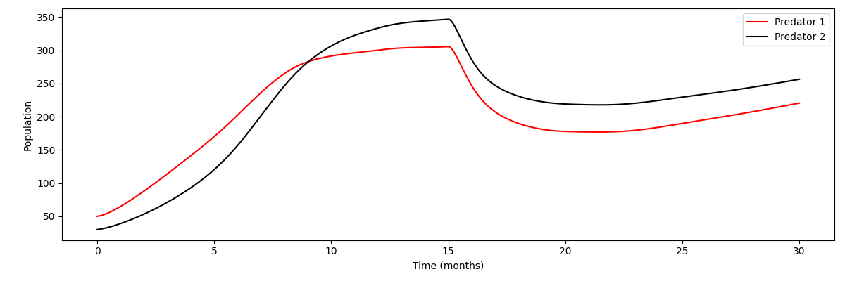
          - Effects of ChemicalsⅠ
Herbicides: It can be clearly seen from the figure that after the first introduction of herbicides at time 8, the weed population decreased significantly, and the growth of crops also increased in a step-by-step manner. As the effect of the herbicide dissipated, the weed population gradually recovered and the growth of crops slowed down. However, due to the periodic spraying of herbicides, the number of weeds was suppressed to fluctuate at a lower level, and the total number of crops was maintained at a relatively high level. Correspondingly, due to the different consumer populations in the food web relationship, there were also positively correlated changes.
Insecticides: In the model, we introduced the effect of pesticides at the 15th time point. We can see that the pesticides have a greater impact on pests (insects 1 and 2) and a smaller impact on beneficial insects (insect 3). After the pesticides were applied, the populations of the three types of insects decreased, with 1 and 2 fluctuating most significantly and 3 fluctuating less. With the reduction of pests, the number of crops increased in a step-by-step manner, and the number of weeds, which were at a disadvantage in competition, decreased.
- Impact of seasonal changes: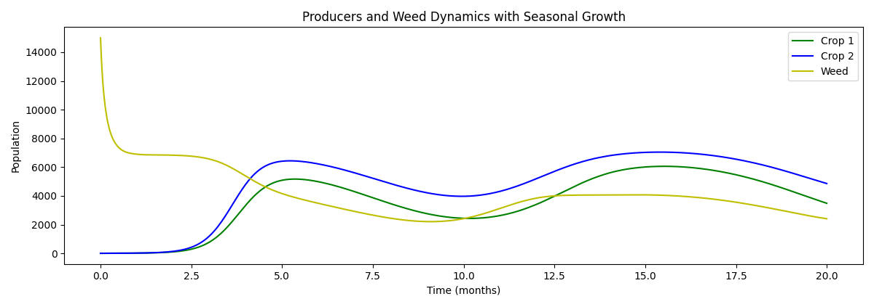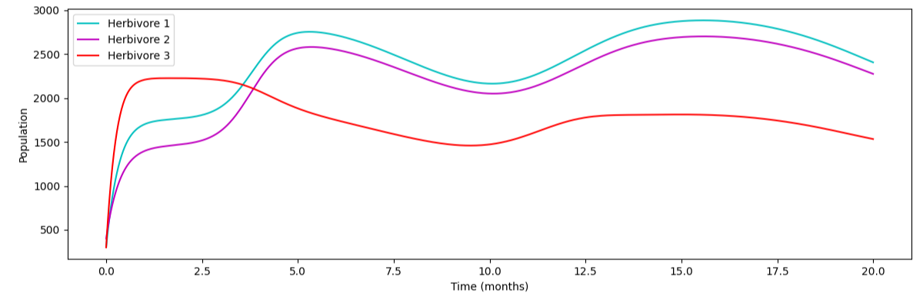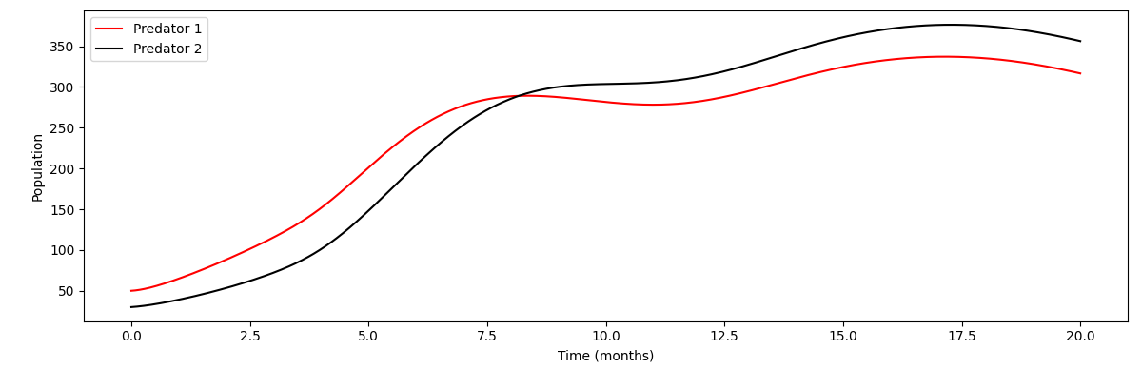
          - Seasonal changes
From the figure we can see that due to seasonal changes, the growth rate of plants shows a fluctuating curve of a sine function. Each producer fluctuates over time but ultimately maintains a relatively stable level.
Due to the effect of predator-prey relationship, the number of consumers at all levels fluctuates accordingly with the changes in their prey species.
- The role of agricultural cycles:

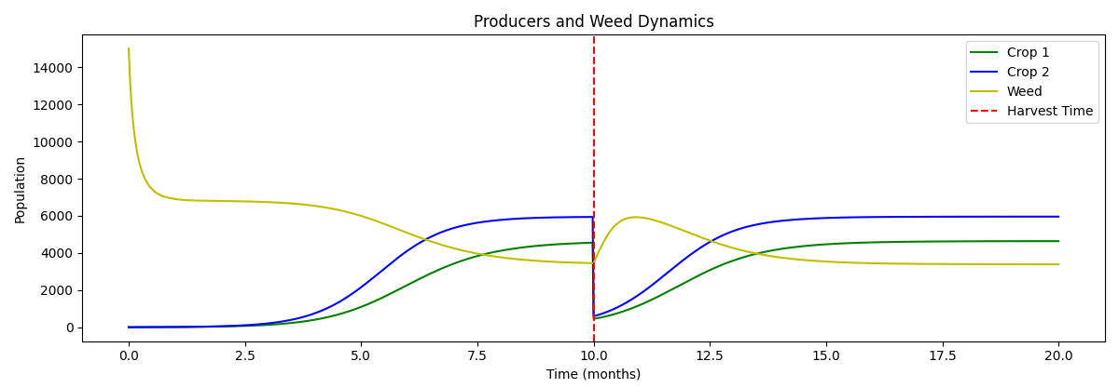
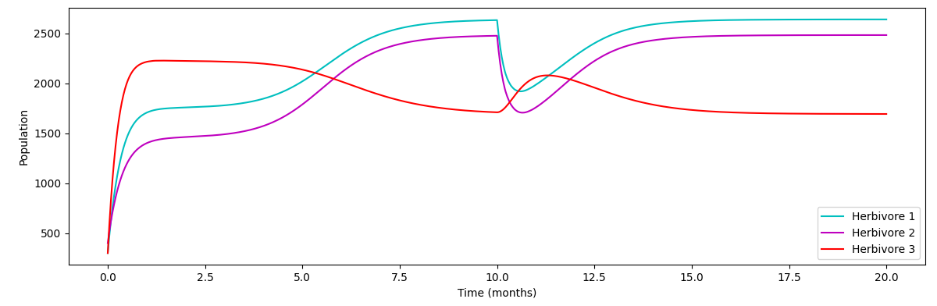

          - Agricultural cycles
It is obvious from the above figure that agricultural ecosystems are greatly affected by human activities. After the harvest, the number of crop populations suddenly drops and weeds quickly gain the upper hand. However, with the passage of time and the sowing of humans, the number of crop populations quickly rebounds and takes the lead, and the ecosystem returns to a stable state.

Conclusion
Through data comparison, we draw the following conclusions:
- The original agricultural ecosystem still has complete ecosystem functions, but due to its relatively simple structure, the system is relatively fragile and easily affected by the environment.
- In current agricultural ecosystems, crops can dominate and rely solely on artificial fertilization to provide sufficient resources to maintain the stability of the system.
- To increase crop yields, farmers need to control weeds and pests. In the current agricultural ecosystem, the prevention of weeds and pests is highly dependent on herbicides and pesticides.
- Human activities have a significant impact on the current eco-agricultural ecosystem, from which it can be inferred that the maintenance cost of agriculture is high and the overall economic benefits are low.

Natural Processes:Model of The Mature Agricultural Ecosystem

Model Improvement

Changes in food web structure
As time goes by, the original agricultural ecosystem gradually stabilizes, the original species begin to return, the species of the ecosystem gradually become richer, the number of consumers gradually increases, higher-level consumers appear, and the composition of producers remains basically unchanged. Therefore, we have established a mature agricultural ecosystem food web based on the original agricultural ecosystem food web as shown in the figure:

          - Food web of a mature agro-ecosystem
As can be seen from the figure, we have introduced a new secondary consumer Predator 3 and a tertiary consumer Predator 4. By adding Predator 3, we have enriched the diversity of secondary consumer predation, while still satisfying Assumption 2 without considering the competitive relationship between secondary consumers. The newly added Predator 4 simulates the complexity of a mature ecosystem well.

Adjustment of some growth formulas
- Predator 1,2,3 growth formula:
$$\frac{dC_{i}}{dt}=r_{C_{i}}C_{i}\left(1-\frac{C_{i}}{K_{C_{i}}}\right)+\sum_{i=1}^{3}{η_{i}I_{i}C_{i}}-μ_{C_{i}}C_{i}-{σ_{i}C}_{i}T_{1}$$ | (5)
Parameter explanation and changes:
$σ_{i}$: Predation coefficient of Predator 4 against Predator i
$C_{i}$: Predator i population size
$T_{1}$: Predator 4 population size
Added$-{σ_{i}C}_{i}T_{1}$ indicate the impact of Predator 4 on Predator i
- Predator 4 growth formula:
$$\frac{dT_{1}}{dt}=r_{T_{1}}T_{1}\left(1-\frac{T_{1}}{K_{T_{1}}}\right)+\sum_{i=1}^{3}{σ_{i}C_{i}T_{1}}-μ_{T_{1}}T_{1}$$ | (6)
Parameter explanation:
$σ_{i}$: Predation coefficient of Predator 4 against Predator i
$C_{i}$: Predator i population size
- Adjustment of the primary consumer growth formula:
$$\frac{dI_{i}}{dt}=r_{I_{i}}I_{i}\left(1-\frac{I_{i}}{K_{I_{i}}}\right)+\sum_{j=1}^{3}{β_{ij}I_{j}}-δ_{i}I_{i}-γ_{I_{i}}⋅C-\sum_{j=1}^{3}{η_{ij}I_{i}C_{j}}$$ | (7)

Results presentation and analysis

Curve changes of each species and comparison before and after
（1）Changes in the number of species under ideal states
In an ideal state, the population of each species is only constrained by the relationship in the food web, and each population will eventually reach a stable level. The solid line in the figure below is the population change curve of each species in the original food web before the introduction of the two new species, and the dotted line is the population change curve of each species in the new food web after the addition of predator 3 and predator 4.
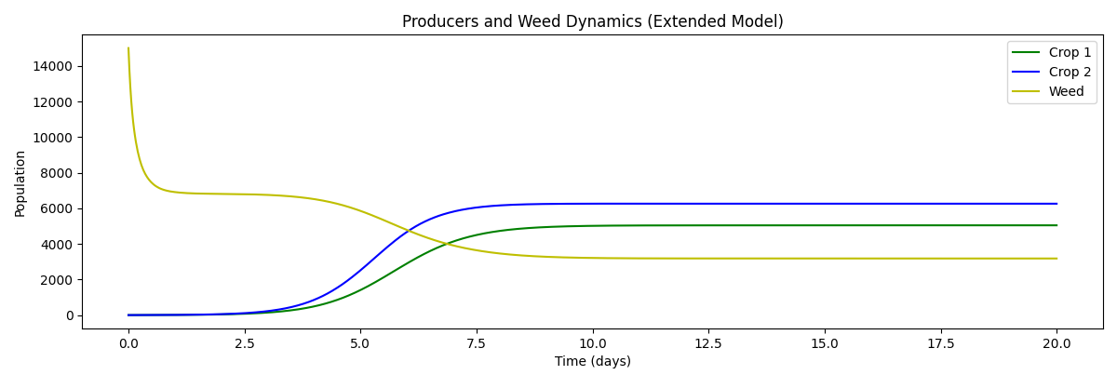
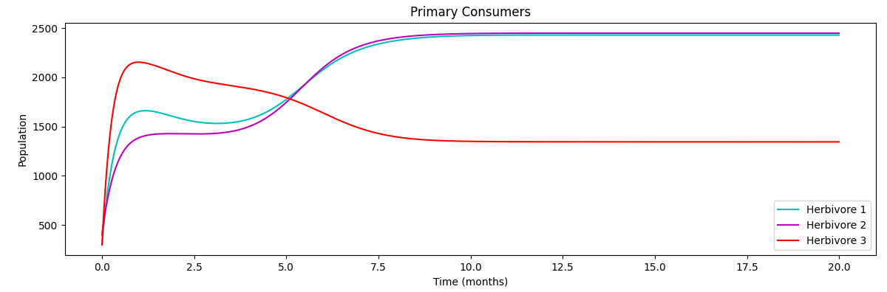
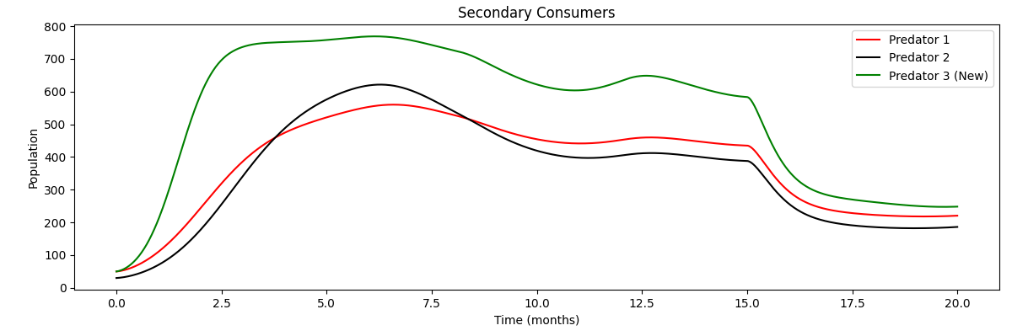
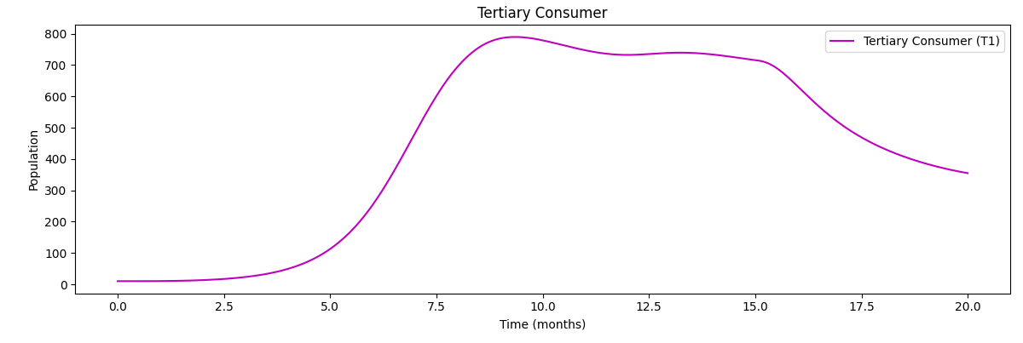
          - Mature agricultural ecosystem
By comparing before and after, we can find that:
- The growth trend of producers remains unchanged, still an "S"-shaped growth curve, and the number of Crop1 and Crop2 increases slightly in the stable state. This is due to the low efficiency of energy transfer and the negative feedback mechanism in the ecosystem. The impact of the newly introduced species on the original species will gradually decrease along the food chain.
- The change degree of primary consumers is more obvious than that of producers. Under the influence of the newly introduced predator 3, the number of insects 1 and 3 in the stable state will decrease. The introduction of predator 4 also greatly reduces the number of predators 1 and 2, weakening the decrease in the number of insects 1 and 3 caused by predator 3. Insect 2 is not affected by the newly introduced predator 3, and the change degree is smaller than that of insects 1 and 3.
- The change in the secondary consumers is the most obvious. Under the influence of the newly introduced predator 4, the number of predators 1 and 2 decreased significantly in the stable state. The decline of predators 1 and 2 is also positively correlated with $σ_{1}$ and $σ_{2}$.
- Compared with primary consumers and secondary consumers, the relationship between tertiary consumers and other species in the food web is relatively simple, conforming to the S-shaped growth curve.
（2）Use of Chemicals
In the original agricultural ecosystem, farmers usually spray herbicides and pesticides to prevent weeds and pests. In this model, we also choose to introduce Gaussian functions to simulate the use of chemicals and obtain the following results:
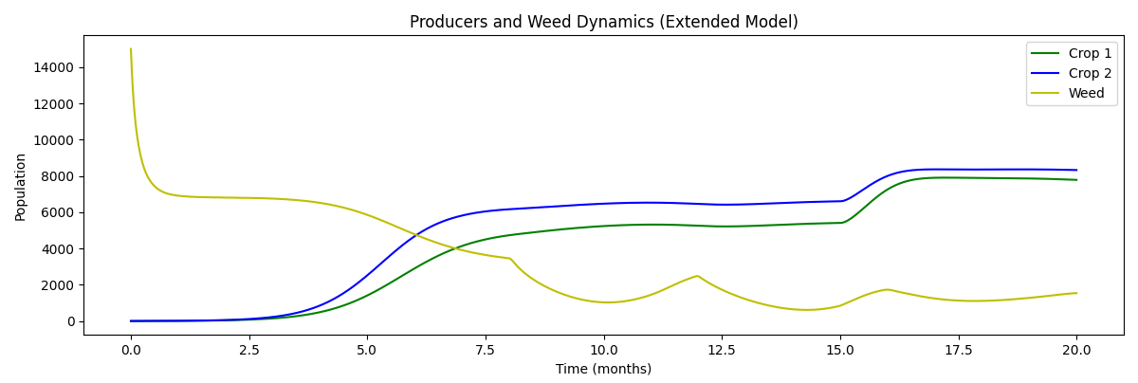
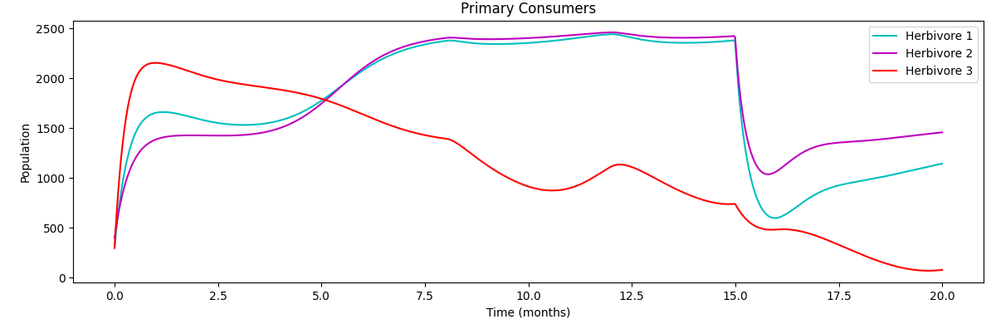

          - Effects of ChemicalsⅡ
Herbicides: Herbicides were applied at time points 8, 12, and 16. The number of weeds decreased after application and began to rise again after a period of time. Herbicides were applied again before the peak value was reached to ensure that the number of weeds remained at a low number. The competition between weeds and crops was reduced, and crop yields were increased.
Insecticides: When the insecticide was applied at time point 15, the number of insects 1 and 2 dropped sharply. The number of secondary consumers that feed on primary consumers also dropped. At the same time, the number of crops at time point 15 increased, and the crop yield was improved.

Conclusion
- The introduction of the tertiary consumer Predator 4 resulted in a significant decrease in the number of secondary consumers
- The introduction of secondary consumer Predator 3 reduces the number of insects, and the crop yield will increase slightly. However, the introduction of Predator 4 reduces the number of secondary consumers, which reduces the predation of secondary consumers on primary consumer insects. Under their combined effects, the increase in crop yield is not significant.
- The introduction of new species should take into account their interactions with other species in the food web.

Human Decisions：Model of The Green Agricultural Ecosystem

模型3的建立
尽管使用化学剂会抑制杂草和害虫的生长从而提高农作物的产量，但是长期使用化学剂本身有较高成本，且会对农业生态系统造成破坏而使其变得脆弱，增加了农田的维护成本。
因此选择有机农业模式，建立绿色农业生态系统是十分必要的。在有机农业运作模式下农民能够减少对杀虫剂、除草剂的使用依赖，同时为确保粮食产量又引入其它生物如蝙蝠等对杂草、害虫进行防治，减少防治成本的同时又增加了生态系统得稳定性和长期可持续性。
所以，在成熟农业生态系统的基础上，我们建立模型3绿色农业生态系统。

化学剂的去除与蝙蝠的引入
- 去除化学剂影响：
为模拟农民开始相除对化学剂的使用依赖而不使用化学剂时，生态系统的变化，我们将模拟使用两类杀虫剂的高斯函数的峰值置零来表示暂停使用农药。
- 引入蝙蝠：
蝙蝠的引入给农业生态系统带来了许多益处：
- 它们能够防治害虫，减少虫害对农作物的影响；
- 它们也能给植物授粉，提高农作物的产量
去除化学剂并引入蝙蝠这一新的物种后食物网结构再次发生改变，记为食物网3，其具体结构如图示：

          - 食物网3
- 相关公式
- 蝙蝠的增长公式：
$$\frac{dB}{dt}=r_{B}B\left(1-\frac{B}{K_{B}}\right)+\sum_{j=1}^{3}{η_{jB}I_{j}B}-μ_{B}B$$ | (8)
参数解释：
B：蝙蝠的种群数目
$η_{jB}$：蝙蝠对第j种昆虫的捕食率
$μ_{B}$：蝙蝠的自然死亡率
- Crop 1,Crop 2的公式调整：
$$\frac{dP_{i}}{dt}=r_{p_{i}}P_{i}\left(1-\frac{P_{i}}{K_{P_{i}}}\right)-\sum_{j=1}^{2}{α_{ij}P_{i}I_{j}}-ε_{i3}P_{i}P_{3}+σ_{i}P_{i}B$$ | (9)
更改说明及参数解释：
$σ_{i}$：蝙蝠授粉对植物i生长的促进系数
新增 $+σ_{i}P_{i}B$部分表示蝙蝠授粉对农作物生长的促进作用

- 昆虫1，2的公式调整：
$$\frac{dI_{i}}{dt}=r_{I_{i}}I_{i}\left(1-\frac{I_{i}}{K_{I_{i}}}\right)+\sum_{j=1}^{3}{β_{ij}I_{j}}-δ_{i}I_{i}-\sum_{j=1}^{3}{η_{ij}I_{i}C_{j}}-η_{iB}I_{i}B$$ | (0)

模型的求解：
为了帮助农民确定在何时引入蝙蝠以及引入多少蝙蝠可以得到尽量多的作物产量，我们通过分段模拟得到了在不同时刻(t_b)以不同的初始蝙蝠数量(B0)引入模型后的曲线，并且记录下此时最终稳定时的作物P1与作物P2的数量之和，以此作为我们的目标函数。结合实际情况分析，我们希望找到一个满意解，得到尽量大的目标函数。因此使用网格搜索法，将时间区间与初始蝙蝠数量区间分割，遍历所有取值点找到最大目标函数值并记录下此时的引入策略，以及目标函数值作为我们的满意解。

结果展示与分析

          - 绿色农业生态系统(蝙蝠)
图中实线为采取最佳引入策略时各物种的变化曲线，虚线为不引入蝙蝠时各物种的变化曲线。
通过对比可以发现：
初级消费者的数目得到了显著降低。这是因为蝙蝠对初级消费者昆虫1、2的捕食导致其增长速度减缓，最终稳定时的数目明显低于不引入蝙蝠时的数目。
生产者的数目有更为明显的提高。由于初级消费者的减少，昆虫1、2对作物的食害作用得到有效抑制。同时，蝙蝠还可以帮助作物完成授粉，作物增长速率提升。综合来看，蝙蝠的引入可以让作物产量得到极大的提升。
次级消费者的数目也有所降低。由于蝙蝠对初级消费者的捕食，以初级消费者为食的次级消费者食物来源减少，数目相较于不引入蝙蝠时的数目有所降低。三级消费者同理。
结论：
去除除草剂并引入蝙蝠可以提高作物产量，蝙蝠的引入帮助作物完成授粉并抑制昆虫对作物的食害作用。同时节约耕作成本。通过网格搜索算法，我们为农民找到了引入蝙蝠的最佳策略，帮助农民最大化作物产量。

蜜蜂vs蝙蝠
蝙蝠能够显著提高农作物的产量，主要原因在于它即能消灭害虫又能为植物传粉。在原有农业生态系统模型中已经存在了以害虫为食的昆虫1，所以我们决定引入蜜蜂这一新物种。
蜜蜂能够为农作物传粉从而提高农作物产量， 与农作物之间是合作共生的关系，在模型中我们主要考虑其对农作物的促进作用而忽略了与其他物种之间的联系。
这是模型运行的结果：

          - 绿色农业生态系统(蜜蜂)
从图中我们可以蜜蜂对农作物的生长有着明显的促进作用，农作物也在与杂草的竞争中取得了更多的优势。对于消费者而言整体变化较小，这与忽略蜜蜂的生态位有关。
与蝙蝠的作用相比，蜜蜂对系统整体的影响较小，这是因为蜜蜂对害虫没有负面影响没有防治虫害的功能。但是蜜蜂生产的蜂蜜能为农民创造额外收入，经济效益巨大。
因此在选择有机农业运作模式是，可以尝试同时引入蝙蝠于蜜蜂，既减少杀虫剂和除草剂使用而降低了成本，又抑制了虫害、杂草增加农作物产量，同时也增加农民收入来源，将本增效，收益巨大。

Sensitivity Analysis
- 参数的选取及变化
基于实际情况并结合模型设置，我们选取了以下参数进行检验：
参数 | 说明 | 基值 | 变化幅度 | 新值
$$r_{P_{3}}$$ | 杂草的自然增长率 |  | +10%
$$r_{P_{1}}$$ | 作物1的自然增长率 |  | +10%
$$r_{P_{3}}$$ |  |  | +10%
$$r_{P_{3}}$$ |  |  | +10%
$$r_{P_{3}}$$ |  |  | +10%

- 结果及分析
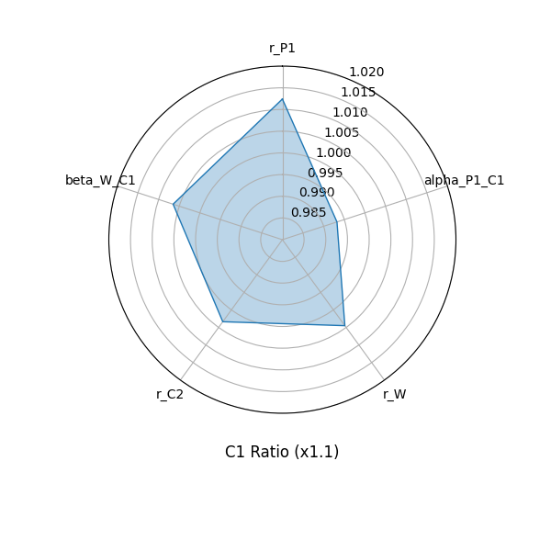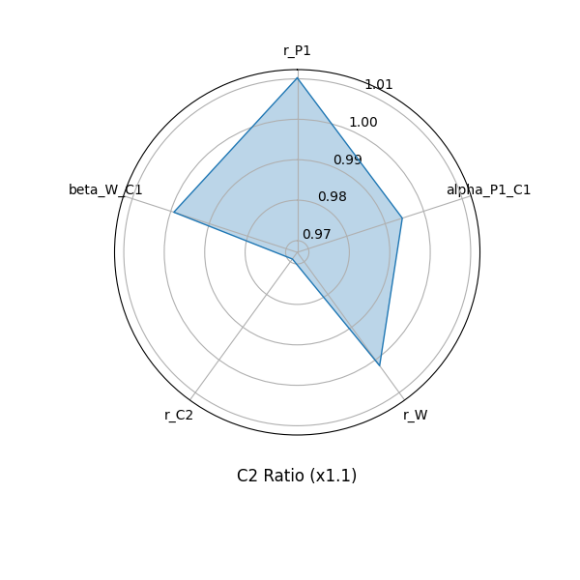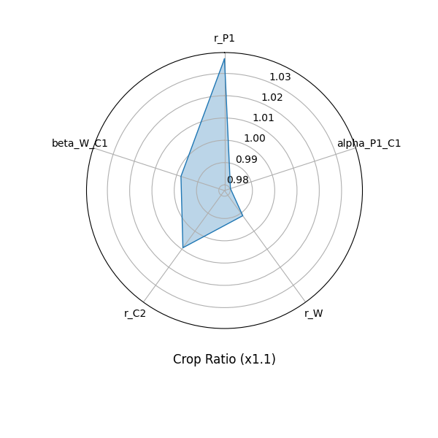
          - 模型灵敏度分析
通过对模型的关键参数逐一进行灵敏度分析，我们能够直观地对比出不同参数对于作物与初级消费者种群动态的影响大小，而且验证了模型对小幅参数扰动的整体响应。
从雷达图可见：
- $r_{P_{1}}$对农作物产量的正向贡献最为显著，说明加快主要作物生长速率可显著提升整体产量；
- 在初级消费者方面，$r_{P_{3}}$的变动对昆虫2的影响更为明显，凸显了杂草在与作物和草食动物互作中起到的重要调节作用。
- 至于其他参数，其变化对害虫数量变化以及作物产量的影响相对平缓，意味着在当前模型设置下，这些相互作用系数的扰动对系统整体稳态的冲击较小。
更宏观地看，这种“单参数增幅”方法能帮助我们识别在短期管理或长期规划中最值得优先干预或关注的关键生态因子：
若要进一步提高产量，可以从优化作物生长速率（例如改良品种或提升生长条件）入手；若要稳定初级消费者或控制害虫，则需特别关注杂草生长及与作物间的竞争关系。通过定量评估各参数的敏感度，我们得以在模型框架下判明哪些生态过程最能左右系统的稳定与高产，为后续更复杂的生态管理策略（如调整耕作制度或引入生物防治）提供了理论依据和决策思路。

Model Evaluation and Further Discussion

Strengths
- 在我们的模型中各营养级的物种数目足够丰富，物种之间的相互关系也足够多样，各级参数设置合理，能够较好地反应现实农业生态系统的食物网结构，这使得我们的模型贴近现实，有一定参考意义。
- 在模拟季节变化带来的影响时，我们使用正弦函数进行模拟；在模拟除草剂的使用时，我们使用高斯函数进行模拟，这些模拟在足够简洁时又符合客观规律变化，具有现实指导意义。
- 模型的求解效率高、结果稳定，在轻微环境变化下模型结果不会出现大幅偏移，说明模型具有一定的普适性。

Weaknesses
- 在考虑环境因素时，只考虑了季节变化带来的增长率改变，未能考虑天气异常、土壤条件等其他因素变化对系统的影响，这使得模型与实际结果存在出入。
- 在实际中化学物质的长期积累以及土壤中微生物活动等都会对动植物生长产生影响，我们在建立模型时将这些因素忽略，这使得模型在对未来的长期模拟上表现较差。

A Letter to The Farmer
Dear Farmer Friends:
Hello! We are Consideration of Mature Agricultural Practices (COMAP) group. Traditional agriculture has become increasingly dependent on chemicals, breaking the intricate grid of life that thrives in nature. Organic farming can protect biodiversity and adhere to the sustainable development of agriculture, but it will increase costs. I hope my suggestions can help you balance costs and sustainability.
Economic trade-offs and sustainability analysis:The upfront shift to organic farming costs more due to the need to use more organic fertilizers and biological control methods, and the cumbersome and expensive certification process for organic farming. However, we must also recognize that organic farming products are sold at a higher price, so it brings greater profits. At the same time, as the ecological environment of organic farming gradually stabilizes, soil fertility and the ability of crops to resist pests and diseases will gradually increase, and we will no longer need to use herbicides and insecticides. In addition, the market potential of organic farming is huge, which will further increase the later benefits of organic farming. So although the short-term cost of organic farming is greater, in the long run, organic farming brings us considerable benefits while ensuring the sustainability of the industry.
To strike the right balance between cost and sustainability, I offer the following advice to farmers:
- Take a gradual transition. Farmers can use part of the land as an experimental field for organic farming, and gradually increase the proportion of organic farming by combining the cost and benefits.
- Adopt scientific farming methods. Such as crop rotation, intercropping, interplanting, etc. These methods can effectively improve soil fertility, balance soil nutrients, and reduce excessive consumption of specific nutrients .
- Resource conservation and recycling. For example, the use of terraces, composting, anaerobic fermentation and renewable energy.
- Technological innovation and application. For example, the Internet of Things, big data, artificial intelligence, etc.,are used to achieve precision agricultural production and management.
Government advocacy and incentive policies:
- Financial support: The government has set up a special fund to support farmers, and encouraged financial institutions to create relevant insurance products.
- Technical support: Provide planned training and technical guidance to farmers.
- Brand and market support: Help farmers sell organic produce.
- Supervision and management: Promote the revision of relevant laws and increase the punishment of illegal acts.
The development of organic farming can not only help farmers obtain long-term and stable income, but also play an important role in environmental protection. I hope my suggestions can help you.

Consideration of Mature Agricultural Practices
2025.1.27

References
            - Foley, J. A., DeFries, R., Asner, G. P., et al. Solutions for a cultivated planet. Nature, 2011, 478(7369): 337–342.
            - Matson, P. A., Parton, W. J., Power, A. G., & Swift, M. J. Agricultural intensification and ecosystem properties. Science, 1997, 277(5325): 504–509.
            - Tscharntke, T., Tylianakis, J. M., Rand, T. A., et al. Global food security, biodiversity conservation and the future of agricultural intensification. Biological Conservation, 2012, 151(1): 53–59.
            - Reganold, J. P., & Wachter, J. M. Organic agriculture in the twenty-first century. Nature Plants, 2016, 2: 15221.
            - Macfadyen, S., Paull, C., Boyle, R., et al. Successful restoration of invertebrate biological control in agricultural landscapes. Biological Control, 2015, 87: 1–7.

Appendices
Appendix 1
Introduce: 这里我们给出模型的主要代码并对一些关键数据进行展示
# Parameters for the model
r_P = 0.1 # Growth rate of plants
K_P = 500 # Carrying capacity of plants
alpha_P = 0.005 # Effect of insects on plant population insects on plant population
r_I = 0.2 # Growth rate of insects
K_I = 200 # Carrying capacity of insects
beta_P = 0.05 # Effect of plants on insect population
delta_I = 0.1 # Natural mortality rate of insects
gamma_I = 0.1 # Death rate of insects due to pesticide
r_C = 0.1 # Growth rate of birds/bats
K_C = 100 # Carrying capacity of birds/bats
eta_I = 0.1 # Efficiency of insect consumption by birds/bats
mu_C = 0.05 # Natural mortality rate of birds/bats
# Create a figure with subplots # Create a figure with subplots
plt.figure(figsize=(10, 6))
# Parameters for the model
r_P = 0.1 # Growth rate of plants
K_P = 500 # Carrying capacity of plants
alpha_P = 0.005 # Effect of insects on plant population
r_I = 0.2 # Growth rate of insects
K_I = 200 # Carrying capacity of insects
beta_P = 0.05 # Effect of plants on insect population
delta_I = 0.1 # Natural mortality rate of insects
gamma_I = 0.1 # Death rate of insects due to pesticide
r_C = 0.1 # Growth rate of birds/bats
K_C = 100 # Carrying capacity of birds/bats
eta_I = 0.1 # Efficiency of insect consumption by birds/bats
mu_C = 0.05 # Natural mortality rate of birds/bats
# Model function
def model(y, t, r_P, K_P, alpha_P, r_I, K_I, beta_P, delta_I,gamma_I, r_C, K_C, eta_I, mu_C):
P, I, C = y # P: Plants, I: Insects, C: Birds/Bats
# Plant growth (Logistic growth and insect effect)
dPdt = r_P * P * (1 - P / K_P) - alpha_P * P * I
# Insect population dynamics (Logistic growth, plant consumption, pesticide effect)
dIdt = r_I * I * (1 - I / K_I) + beta_P * P - delta_I * I - gamma_I * I
# Birds/Bats population dynamics (Logistic growth, insect consumption)
return [dPdt, dIdt, dCdt]
# Initial populations
P0 = 100 # Initial plant population
I0 = 50 # Initial insect population
C0 = 10 # Initial bird/bat population
y0 = [P0, I0, C0] # Initial conditions for the populations

