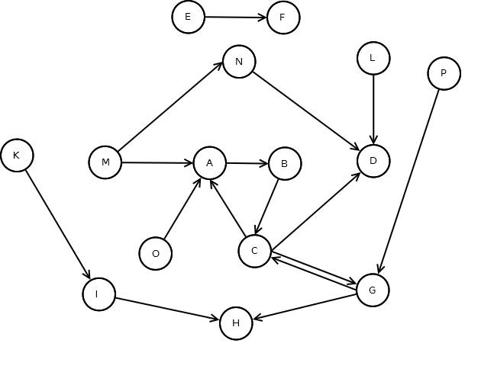
IN: M, I
SCC: A, B, C, G
OUT: D, H
Tubes: N
Tendrils: K, L, O, P
Disconnected: E, F

