Exercise 1: Lists and Arrays
Task: Create a list and an array, perform some basic operations, and print the results (list 1 contains numbers 1 to 5 and list 2 contains numbers from 6 to 10)
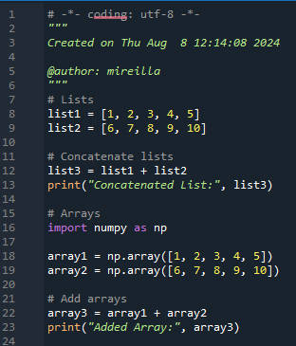

Exercise 2: Loading Data from Files
Task: Load data from a CSV file and print the first few rows.
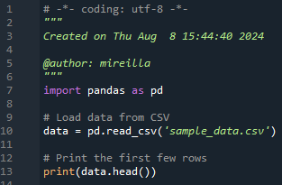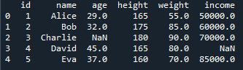

Exercise 3: Numpy and Array Indexing
Task: Create a numpy array and perform indexing and slicing operations.
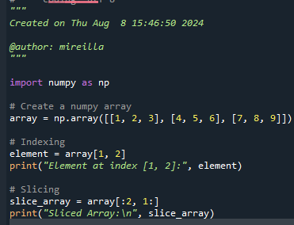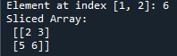

Exercise 4: Creating and Indexing Numpy Arrays

Task 1: Create a 1D Numpy Array and Access Elements
- Create a 1D numpy array with values from 0 to 9.
- Access the 5th element of the array.
- Access the last element of the array.
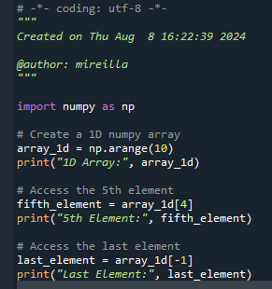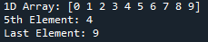

Task 2: Create a 2D Numpy Array and Access Elements
- Create a 2D numpy array with shape (3, 3) containing values from 1 to 9.
- Access the element at the 2nd row and 3rd column.
- Access the first row.
- Access the first column.
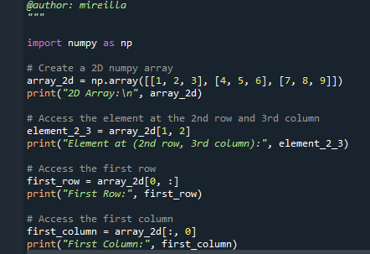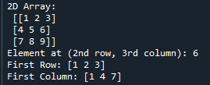

Exercise 2: Slicing and Advanced Indexing

Task 1: Slice a 1D Numpy Array
- Create a 1D numpy array with values from 10 to 19.
- Slice the array to get elements from index 3 to 7.
- Slice the array to get every second element.
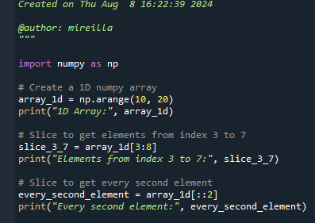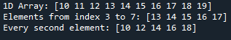

Task 2: Slice a 2D Numpy Array
- Create a 2D numpy array with shape (4, 4) containing values from 1 to 16.
- Slice the array to get the sub-array from rows 1 to 2 and columns 2 to 3.
- Slice the array to get the last two rows.
- Slice the array to get the first two columns.
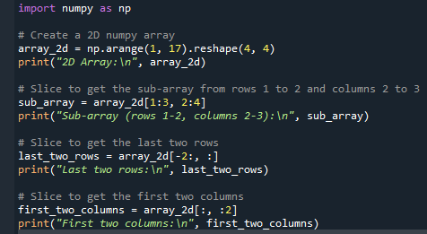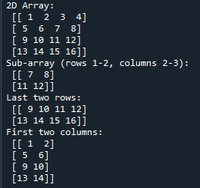

Exercise 3: Boolean Indexing and Fancy Indexing

Task 1: Boolean Indexing
- Create a 1D numpy array with values from 0 to 9.
- Use boolean indexing to get elements greater than 5.
- Use boolean indexing to get elements that are even.
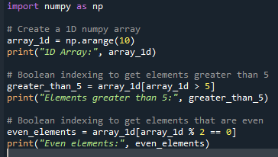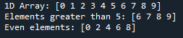

Task 2: Fancy Indexing
- Create a 2D numpy array with shape (4, 4) containing values from 1 to 16.
- Use fancy indexing to get the elements at positions (0, 0), (1, 2), (2, 3), and (3, 1).
