Team Application Exercises (tAPP-5)

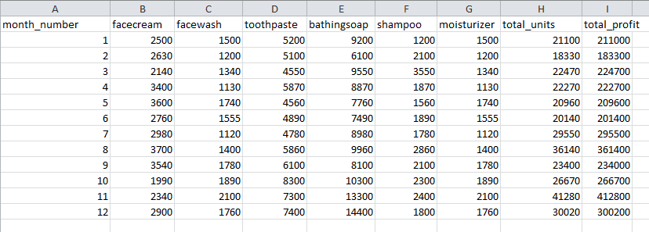
File name: company_sales_data.csv
Task 1: Write a program that reads the "Total profit" of all months and shows it using a line plot.
Total profit data provided for each month. Generated line plot must include the following properties:
- X label name = Month Number
- Y label name = Total profit
The line plot graph should look like this if run.
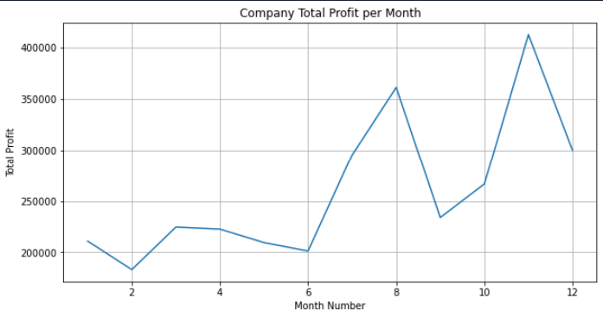

Task 2:
Create a program that will get Total profit of all months and show line plot with the following Style properties.
Generated line plot must include following Style properties: –
- Line Style dotted and Line-color should be red
- Show legend at the lower right location.
- X label name = Month Number
- Y label name = Total Profit
- Add a circle marker.
- Line marker colour as red
- Line width should be 3
The line plot graph should look like this.
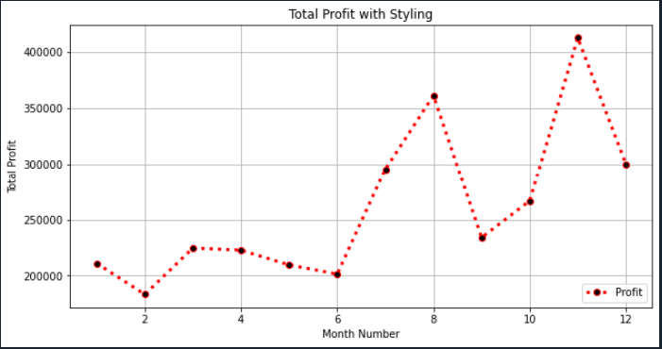

Task 3: Write a program that will read toothpaste sales data of each month and show it using a scatter plot. Also, add a grid in the plot. gridline style should be “–“
The graph should look like this when the program is run.
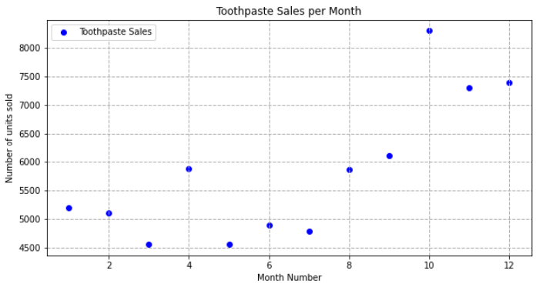

Task 4: A Python program should display a horizontal bar chart of the popularity of programming Languages. However, after running the program, the current output does not look like the intended output.
Current output | Intended output
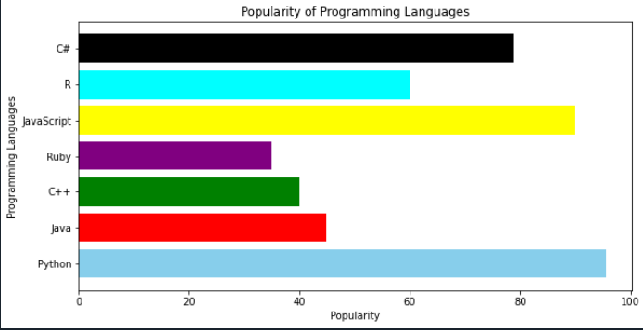 | 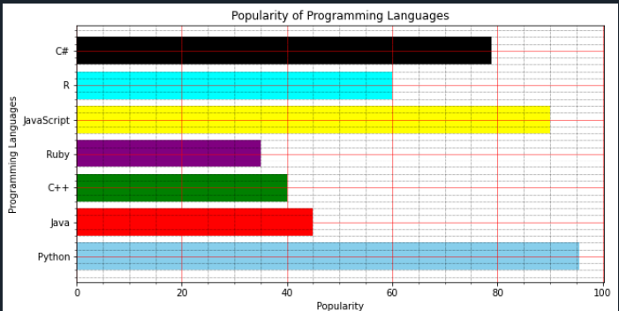

Identify the issue in the code?
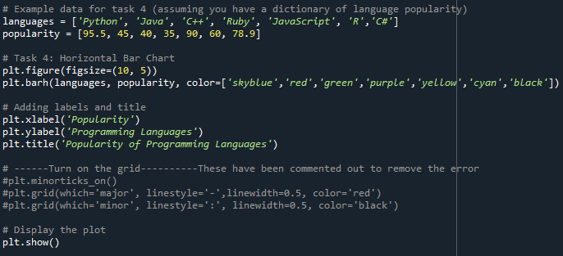
Task 5
What would be the output of this code?
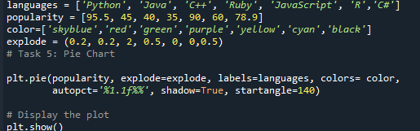

a)
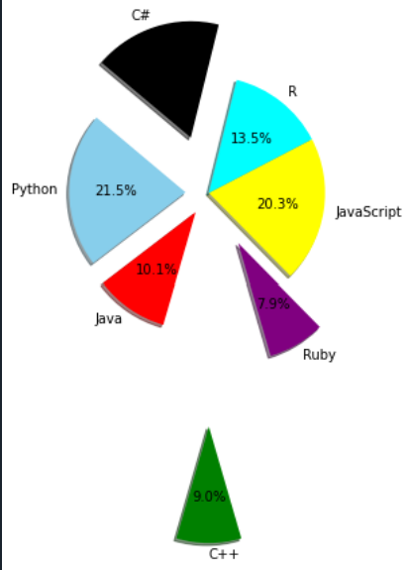
b)
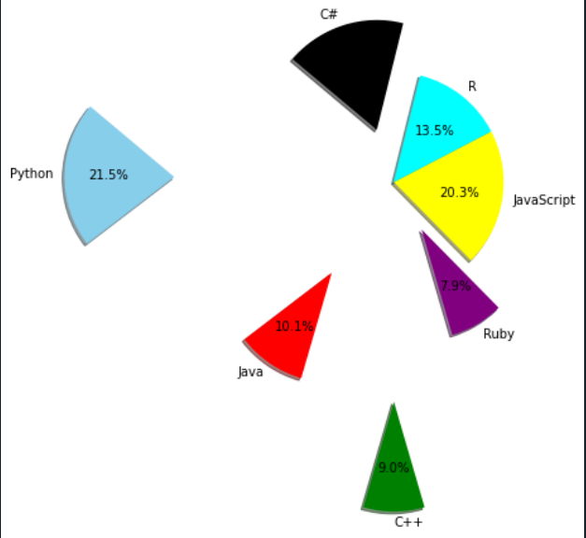
c)
