Team Application Exercises (tAPP-3)
Problem 1
Write a code that creates a database called employees. That database contains a table called contactDetails. The following output will be produced when the program is executed.
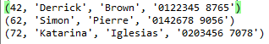

Problem 1 Solution
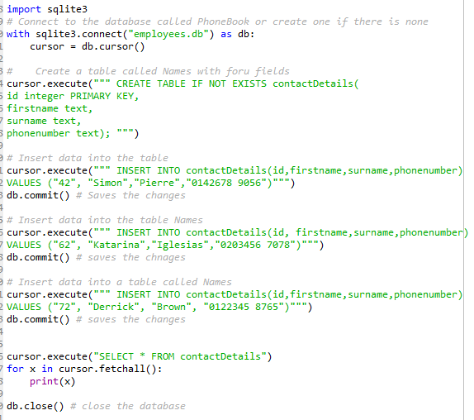

Problem 2 - Debugging code
A user has written a Python script that is supposed to create a new CSV file, ask the user to input the name and age of a person, and then add this information to the end of the file. The script is also supposed to allow multiple records to be added in one session. However, when running the code, it does not execute due to some errors.
Task 1: Identify the errors (making sure you indicate the line number) and how many errors have you found?
Code with errors
Line 14: csv and “w” instead of “m”
Line 22: mode should be a
Line 29: it should be age =
Line 42: it should be create_csv_file
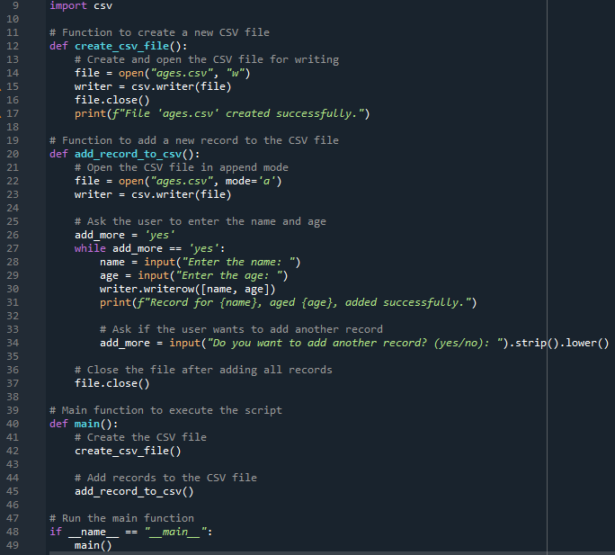
Problem 3 - Parsons puzzle
Task:
Problem 3 Solution
1
2
3
4 | 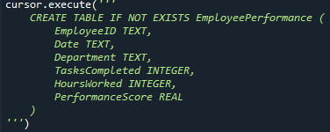
5
6 | 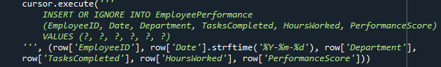
7
8

Problem 4:
This program below should allow the user to convert between miles and kilometres. 1 kilometre = 0.6214 miles and 1 mile = 1.6093 kilometres.
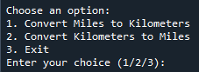
Task: Using a pen and paper, complete the code (with correct indentation).
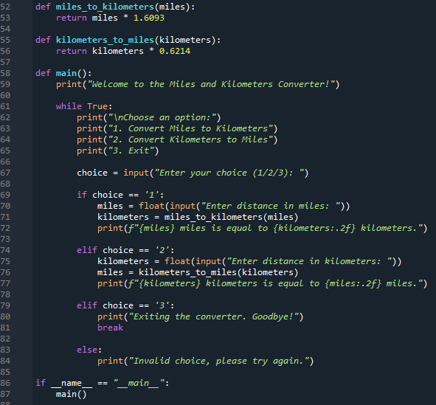

Problem 5
The following code is intended to load a CSV file and filter data by the most recent year. However, it throws an error when trying to access the ‘Date’ column. Debug the code to fix the issue.
Solution
The error occurred because the 'Date' column was not parsed as a datetime object. The correct approach is to use the parse_dates parameter in pd.read_csv() to ensure the 'Date' column is correctly parsed.
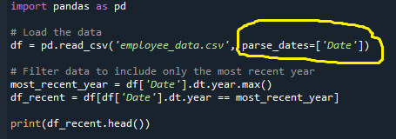

Problem 6 - Debugging
Which of the following codes intended to create a PyTorch tensor and apply the ReLU activation function will throw an error? What is the error?
(1) 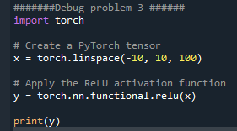 (2)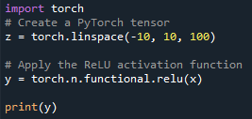

Solution
(2)
AttributeError: module 'torch' has no attribute 'n'.
