HCIDE AE1 Report Template | LB0X Group X
Student 1 Name – GUID; Student 2 Name – GUID; Student 3 Name – GUID; Student 4 Name – GUID; Student 6 Name – GUID; Student 6 Name - GUID
Product Description (1 paragraph)
This document reports on a heuristic evaluation of the XXXX website, specifically its YYY feature. The scope of analysis covers the registration page (URL), the form ZZZ (URL), and…

Usability Issues Master List (0.5-2 pages)
Issue ID | Description | Usability Principle | Criticality | Group Members
1 | Registration form does not provide feedback on error type | 9: Help Users Recognize, Diagnose, and Recover from Errors | Medium | Student 2, Student 4
2 | Complex menu system makes common actions hard to locate | 6: Recognition Rather than Recall | Low | Student 1, Student 2, Student 3, Student 6
3 | No progress or success indicator is provided upon form registration | 1: Visibility of System Status | High | Student 4, Student 5, Student 6
…
…
…
…

Usability Diagram
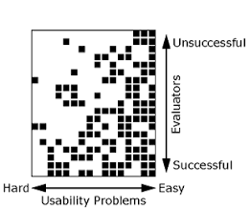
Note: you may use any image creation tool to create this usability diagram. Please refer to the lecture and lab sheet contents for guidelines on the usability diagram purpose and interpretation.

Commentary (2-3 paragraphs)
This evaluation campaign identified xxx issues, of which yyy are considered to be of high importance. As can be shown in the diagram, issue zzz is very frequent, and…

