

Section A 10 marks
A.1. $(".dogs").dblclick( )
A.2. {"employees":[{"firstName":"John", "lastName":"Doe"},
{"firstName":"Anna", "lastName":"Smith"}]}
A.3. Lightning Gonzales 2013
A.4. Control over client application version, easy to update the application, performance issues, and needs to handle a variety of browser/devices.
A.5. DOM builds a hierarchical model of XML elements in memory, whilst SAX provides an event-driven parser.

Section B 30 marks
B.1
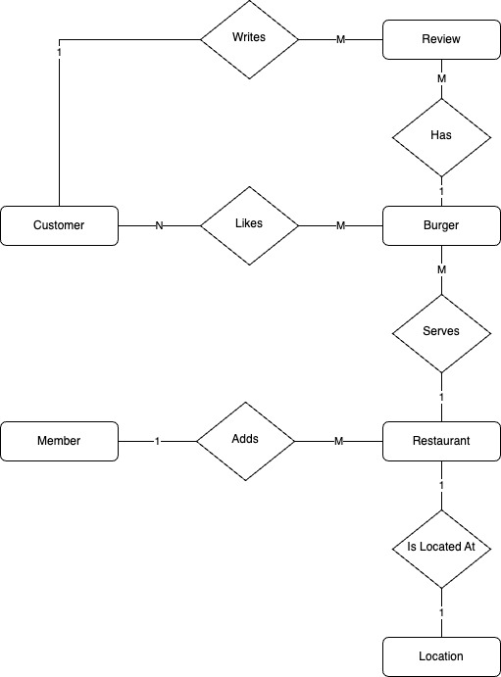
A) 1; (B) M or N; (C) Likes; (D) Location; (E) Review

B.2

class Restaurant(models.Model):
…
location = models.OneToOneField(Location, on_delete=models.CASCADE)
# 1:1 relationship

class Burger(models.Model):
…
restaurant = models.ForeignKey(Restaurant, on_delete=models.CASCADE, related_name="burgers")
# 1:M relationship

B.3
from django.urls import path
from .views import add_burger

urlpatterns = [
path('add_burger/', add_burger, name='add_burger'),
]

B.4
{% for comment in reviews %}

B.5
{{ comment.user.picture }}

B.6
</div>

