**Simulating ChatGPT Locally**

**Building a Simple Simulation**

The aim here is to create a basic function that emulates a chatbot's response mechanism using conditional statements.

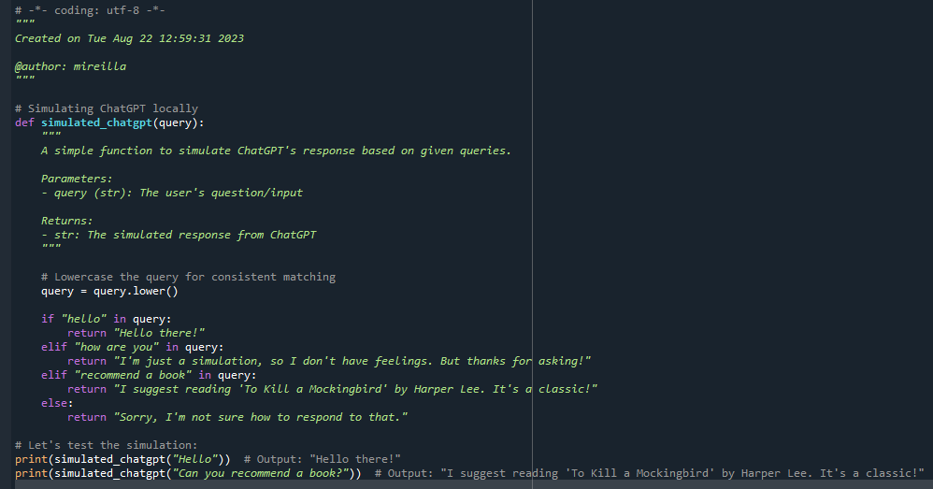

**Exercise 1**: **Problem**: Expand the **simulated_chatgpt** function to handle questions about the weather, e.g., "How's the weather today?". It should return a random weather condition from a list, like ["sunny", "cloudy", "rainy"].

**Exercise 2**: **Problem**: Enhance the **simulated_chatgpt** function so that when asked, "Tell me a joke", it responds with a random joke from a predefined list of jokes.