Amphora product selection brief · first pass · 16 Sep 2026 · for the management team
Five products, one engine: what we should pursue first
Built from every recent deck and brief — the Amphora candidate screen and human + animal portfolio, the Amphora seed deck and its lane decision, the seed-sufficiency stress test, and Sunday's reformulation atlas — and re-scored against two questions only: is the FDA pathway clear and fast, and does a buyer need it? The Kiral engine is assumed throughout: it is what finds the formulation, so "engine leverage" is a third, tie-breaking criterion, not the first.
Prepared by Alex Riley · Evidence: REAL sourced MODELED judgment ABSENT not yet known
The decision
Three human products and two veterinary products, all on one PLGA-and-oral-matrix search loop. Ranked by pathway first: (1) a generic dexamethasone intravitreal implant, the only complex product in our universe FDA will approve on in-vitro data alone; (2) a generic-equivalent goserelin implant, thirty-seven years without a generic and a single parallel PK study to file; (3) once-daily buspirone by 505(b)(2), a PK bridge on a molecule prescribed 16.7 million times a year. Then the two Elanco-shaped animal products: (4) a multi-week post-surgical analgesia depot for dogs and cats, extending a category Elanco already licenses in, and (5) a long-acting small-molecule injectable for canine osteoarthritis, the gap Zoetis's three-month antibody has just opened and Elanco has nothing to fill.
What moved. Octreotide LAR stays the calibration reference but drops off the product list — two generics already exist. Leuprolide is held as the goserelin follow-on rather than a lead: formulation patents run to 2028/2031 and its guidance asks for two PK studies, goserelin's asks for one. Cysteamine, the canine GnRH depot and ceftiofur go to the watch list. Remediation services (nitrosamines, propellants) are revenue, not products, and are handled in the atlas.
MODELED The honest caveat. Four of the five are polymer-release physics. Buspirone is on the list partly because it is the only pick that tests something else. If the PLGA readout fails, four fail together — the management team should choose the list knowing that.
The five at a glance
Pathway is the sort key. Reference markets are the originator's most recent disclosed revenue, not our forecast.
Product | Species · route | What we must show to file | Reference market | Partner / Elanco fit | Earliest filing
1 · Dexamethasone 0.7 mg intravitreal implant (Ozurdex generic) | Human · ANDA | Q1/Q2 sameness + in-vitro release (f2) + physicochemical characterization on 3 batches. No human study (PSG Nov 2025). | $493m 2025, flat (−0.7%); no Orange Book patents, no generic ever | ANI/Alimera, Harrow, Bausch + Lomb | 2028
2 · Goserelin 3.6 mg implant (Zoladex generic-equivalent) | Human · ANDA (CGT eligible) | One single-dose parallel PK study in patients (PSG Nov 2022); no PD endpoint. Single strength. | $1.15bn 2025 ex-US (AZ, +6%); US via TerSera; no generic since 1989 | Teva, Amneal, Cipla; fine-needle/6-month upside to originator | 2029
3 · Buspirone once-daily ER + GRAS first-pass modulator | Human · 505(b)(2) | PK bridge to immediate-release (base case); one efficacy study is the downside case. Non-depot physics. | 16.7m US Rx, #39 drug, 3.7m patients (2024); #95 → #39 in a decade | Azurity, Zydus, specialty CNS; royalty model | 2029
4 · Multi-week post-surgical analgesia depot (dogs, cats) | Animal · NADA (CVM) | Target-animal safety + one field effectiveness study per species; CMC technical section banked early via phased review. | Longest approved: Nocita 72 h (Elanco), Zorbium ~4 d (cats); no multi-week product exists | Elanco is the incumbent licensee of this exact category (Pacira → Aratana → Elanco) | 2030
5 · Canine OA long-acting small-molecule injectable (1–3 mo) | Animal · NADA (CVM); equine second | TAS + field effectiveness in dogs; expanded conditional approval (GFI #261) is a live option for an unmet need. | ~40% of dogs have OA pain (Zoetis); Librela declining after 2025 safety label; Lenivia 3-mo mAb launched EU/CA 2026 | Elanco has Galliprant (daily oral) and no long-acting OA injectable; Virbac, Dechra as alternates | 2030–31

The matrix
Horizontal axis: how clear and how fast the FDA route is. Vertical axis: how badly a buyer needs the product. Marker size: how much of the problem the engine solves. The shaded quadrant is where a seed-stage company should spend. Runner-ups are hollow.
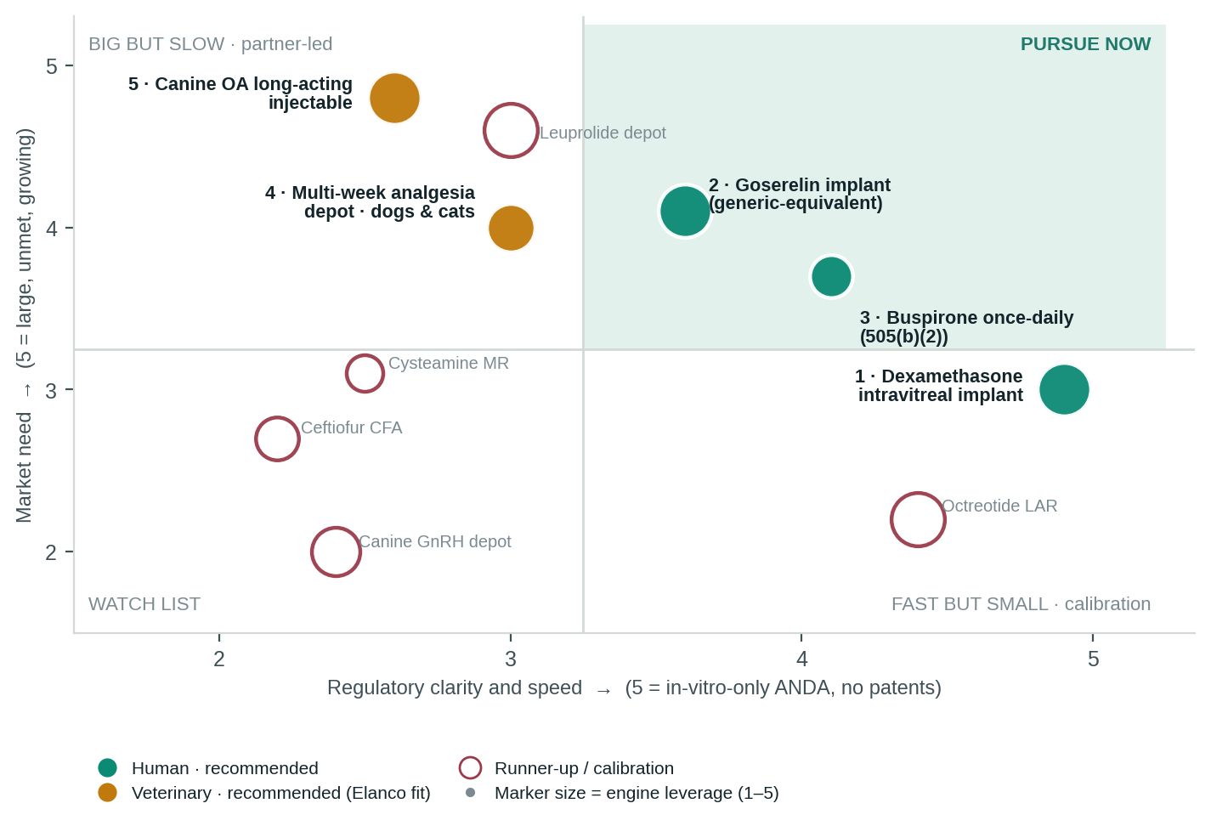
Scorecard. Scores 1–5; weights in the header. Regulatory clarity and speed together carry half the weight because that is the brief. Capital-to-readout is scored inversely (5 = cheapest).
Candidate | Regulatory clarity ·25% | Speed to filing ·25% | Market need ·20% | Engine leverage ·10% | Partner / Elanco fit ·10% | Capital to readout ·10% | Score
1 · Dexamethasone intravitreal implant | 5 | 5 | 3 | 5 | 3 | 4 | 4.3
2 · Goserelin implant | 4 | 3 | 4 | 5 | 3 | 3 | 3.6
3 · Buspirone once-daily | 4 | 4 | 4 | 3 | 3 | 4 | 3.8
4 · Multi-week analgesia depot (vet) | 3 | 3 | 4 | 4 | 5 | 3 | 3.5
5 · Canine OA long-acting injectable (vet) | 3 | 2 | 5 | 5 | 5 | 2 | 3.5
Octreotide LAR (calibration; 2 generics) | 4 | 3 | 1 | 5 | 3 | 3 | 3.0
Leuprolide depot (goserelin follow-on) | 4 | 2 | 5 | 5 | 3 | 3 | 3.6
Cysteamine once-daily MR | 3 | 2 | 3 | 2 | 3 | 3 | 2.7
Canine GnRH sterilisation depot | 3 | 2 | 2 | 4 | 2 | 3 | 2.5
Ceftiofur crystalline free acid | 2 | 3 | 3 | 3 | 3 | 3 | 2.8
MODELED Reading it. Product 1 wins on pathway alone and is the reason the list can promise a filing inside the seed window. Product 5 scores highest on need and lowest on speed — it is on the list because the Elanco fit and the literal reuse of the human triamcinolone dataset make it cheap to start and expensive to skip. Leuprolide out-scores goserelin on market and loses on patents and study count; it becomes the second peptide filing from the same rod-extrusion process, not a separate bet.
What the engine does across the five. One search loop: Products 1 and 2 share a rod-extrusion process; 2, 4 and 5 share depot release kinetics; 4 and 5 share species safety data; 3 stands alone and is the hedge. Every batch, including the failures, is labelled formulation data the public commons does not have — the asset the seed buys.

Why each one, in four lines
1 · Dexamethasone intravitreal implant — the fastest route in our universe REAL
Problem. Ozurdex (NDA 022315) has been on the market since 2009 with no patents and no generic; $493m and flat. The reason is capability, not law: a melt-extruded PLGA rod whose release depends on polymer grade, architecture and process.
Play. FDA's November 2025 guidance asks for Q1/Q2 sameness, comparative in-vitro release (f2) and characterization across three batches — no patient study. Q1/Q2 fixes the recipe, so the whole search is process and polymer: exactly the constraint-first problem the engine is built for. ANI (Alimera's ocular franchise) is the natural filer.
Gate. Day-30: sterile ocular-implant CMO quote. If implant COGS cannot clear generic-erosion pricing, that is the answer to why no generic exists, and we stop.
2 · Goserelin implant — one PK study, thirty-seven years of white space REAL
Problem. Zoladex 3.6 mg has no generic anywhere in the US since 1989. AstraZeneca booked $1.15bn ex-US in 2025, up 6%; TerSera holds the US. Single API source, 16-gauge needle, solid PLGA rod.
Play. Generic-equivalent for a generics partner (Teva, Amneal, Cipla), filed as an ANDA with CGT eligibility. Guidance (Nov 2022) asks for one single-dose parallel PK study in patients; no PD arm. The same extrusion process serves Product 1, and the same peptide-in-PLGA data serves the leuprolide follow-on and, later, a canine GnRH depot.
Gate. Rod-extrusion release match to the reference at pilot scale, with the 50-gram scale-change prediction registered in advance (the seed stress-test's one fix).
3 · Buspirone once-daily — the PK-bridge product that diversifies the physics REAL
Problem. 16.7 million US prescriptions in 2024 for a drug with 4% bioavailability taken three times a day; rank has climbed from #95 to #39 in ten years as prescribers move away from benzodiazepines. An ER version reached PK data in 2001 and was never launched.
Play. ER matrix plus a GRAS first-pass modulator, filed 505(b)(2) on a PK bridge; royalty to a specialty CNS company (Azurity, Zydus). It is the atlas's Program B and the only pick whose physics is not a depot.
Gate. Human PK: once-daily AUC within the IR range with acceptable variability. If FDA signals an efficacy study at the pre-IND meeting, the product moves to the watch list.
4 · Multi-week analgesia depot for dogs and cats — Elanco's own category, extended MODELED
Problem. The longest approved veterinary analgesic runs about four days (Zorbium, cats). Nocita — Elanco's liposomal bupivacaine, licensed from Pacira via Aratana for $1m upfront, $42.5m in milestones and a double-digit royalty — covers 72 hours. Recovery from orthopaedic surgery takes two to three weeks.
Play. A 7–14 day local-anaesthetic or NSAID depot, in-situ or microsphere, as a full NADA. CVM's phased review banks the CMC technical section years before filing. Elanco is both the obvious licensee and the reason to open Virbac and Dechra before any substantive disclosure.
Gate. CVM presubmission conference on whether the engine's release model can be qualified as a validated model under 514.4. A yes is a regulatory position no competitor holds.
5 · Canine OA long-acting injectable — the gap Zoetis just opened and Elanco cannot fill MODELED
Problem. Roughly 40% of dogs carry OA pain. Zoetis's Librela declined through 2025 after a US safety-label update and Zoetis has answered with Lenivia, a three-month anti-NGF antibody launched in Europe and Canada in July 2026. Elanco's OA product, Galliprant, is a daily tablet; Elanco has no long-acting injectable.
Play. A one-to-three-month small-molecule depot — intra-articular triamcinolone PLGA (Zilretta physics, with published canine data) or a systemic NSAID depot — as a full NADA, with expanded conditional approval (GFI #261) as the accelerant if CVM agrees the need is unmet. Equine intra-articular use is the second market. Veterinary royalties run double-digit, two to three times human platform rates.
Gate. Zilretta's $116.6m plateau is the ceiling datum; the day-60 question is whether an Elanco-scale sales force changes it. A steroid depot must show joint-safety data early — Librela's label is the warning.
First ninety days
- Quote the two CMOs — sterile ocular implant and PLGA rod extrusion — and buy Ozurdex and Zoladex reference units. Gate 1 answers itself here.
- Book the CVM presubmission conference on the validated-model question; brief Scott Galasinski on Products 4 and 5 before any Elanco disclosure, and open Virbac and Dechra in parallel.
- Run in-vitro release on the Ozurdex reference against engine-predicted compositions; register the goserelin scale-change prediction before the first batch.
- Hold the buspirone pre-IND request until the PK-bridge design is written; a one-page FDA question costs nothing and settles Gate 3.
Sources
FDA draft PSG dexamethasone intravitreal implant 0.7 mg, Nov 2025 (in-vitro only; Q1/Q2, IVRT f2, 3 batches) · FDA draft PSG goserelin acetate implant, rev. Nov 2022 (single-dose parallel PK) · FDA draft PSG leuprolide acetate, rev. Aug 2021 (two parallel PK studies) · AbbVie FY2025 results, 4 Feb 2026 (Ozurdex $493m, −0.7% op.) · AstraZeneca FY2025 results (Zoladex $1,150m, +6% CER) · Drugs.com generic Lupron Depot (no generic; patents to Mar 2028 / Feb 2031) · ClinCalc DrugStats, buspirone 2024 (16.7m Rx, #39, 3.7m patients) · Elanco Q4 2025 call, 24 Feb 2026 ($4.7bn revenue; Galliprant; innovation $1.15bn 2026 target) · Zoetis FY2025 results, Feb 2026 (Librela/Solensia decline; Lenivia, Portela approvals; ~40% of dogs with OA pain) · MyVetCandy, 16 Jul 2026 (Lenivia three-month launch EU/Canada) · FDA GFI #261 expanded conditional approval (up to 5 years; unmet need + complex study) · Internal: Kiral atlas 14 Sep; seed deck v2 + lane decision 12 Sep; Amphora candidate screen, human + animal portfolio, seed-sufficiency analysis 12 Sep (Nocita deal terms, Zilretta $116.6m, CVM 514.4, vet royalty premium).

