ENTERPRISE HYDRAULIC ENGINEERING SUITE • WWW.PUMPMASTERPRO.COM
PUMP MASTER PRO™
Next-Generation Industrial Pump Sizing, CAD Pipe Network Modeling, Projects & Submittal Automation
[✓] ISO 9906:2012 (Grade 1 & 2) [✓] ANSI/HI 14.6 Test Methods [✓] API 610 (11th/12th Edition) [✓] Pipe Network Solvers [✓] Pixel-Perfect PDF Reports Engine [✓] Highly customizable to suit your organisation
“From Raw Operating Duty Point to Publication-Grade Customer Submittal in Under 3 Minutes.”
Pump Master Pro is the cloud-native hydraulic sizing, curve-fitting, project management, and pipe network analysis platform built specifically for Pump Manufacturers (OEMs), EPC Contractors, Consulting Engineers, and Heavy Industrial Plants (Mining, Water & Slurry). Designed for complete flexibility, users can add their own pump models and test bench curves, organize tender quotations into dedicated project folders, customize PDF submittal templates with corporate branding, and execute complex hydraulic friction solving with zero desktop installations.

1. Target Audiences & Value Delivered
Industry / Stakeholder | Traditional Bottleneck | Pump Master Pro Solution
Pump OEMs & Sales Distributors | Slow quotation turnaround (2–4 hours per quote) and risk of sales reps recommending off-design pumps. | Instant duty point matching, automated impeller trims, branded submittal generation, and multi-tenant catalog hosting.
EPC & Consulting Engineers | Error-prone spreadsheet friction formulas, lost project files, and tedious manual NPSHa safety margin checks. | Interactive orthogonal CAD pipe network modeling, automated Colebrook-White friction solving, and project versioning.
Mining & Slurry Plants | Unpredicted pipe sanding, line blockage, or catastrophic pump wear due to incorrect slurry settling physics. | Native Durand critical deposition velocity (Vc) and Ferguson & Church particle settling velocity algorithms.
Water & Wastewater Utilities | Operating off Best Efficiency Point (BEP), uncontrolled energy waste, and cavitation damage in parallel pumps. | Comprehensive POR/AOR envelope visualization, VFD speed affinity curves, and multi-pump side-by-side comparison.

2. 100% Customizable: Add Your Own Pumps & Catalogues
Unlike rigid legacy tools that lock you into static third-party databases, Pump Master Pro is built to be fully customizable by the user. Whether you are an equipment manufacturer introducing a new product line, or an engineering consultancy managing bespoke client assets, you have full ownership of your data.
✔ Add & Manage Your Own Pumps: Easily register any centrifugal or slurry pump model. Define pump family, series, discharge/suction flange ratings, impeller trim diameter ranges (min, rated, max), design speeds, and motor configurations.
✔ Automated Test Bench Curve Fitting: Simply enter discrete performance test points (Flow, Head, Efficiency, Power, NPSHr). The system's mathematical engine automatically generates high-order polynomial regression curves (R² > 0.998) and affinity law speed/trim variations.
✔ Custom Branding & White-Labeling: Fully customize PDF datasheets and client proposals with your corporate logo, custom primary banner colors, report headers, engineering notes, and warranty disclaimers.
✔ Custom Fluid, Slurry & Pipe Profiles: Create bespoke fluid libraries: define custom slurry specific gravities, d50 particle sizes, non-Newtonian viscosities, pipe materials, roughness factors (ε), and proprietary fitting K-values.

3. Core Engineering Modules & Software Walkthrough
■ Module 1: Intelligent Pump Sizing & BEP Operating Envelope
Filters pump models by target Flow (Q), Head (H), and available NPSH. Ranks selections by proximity to Best Efficiency Point (BEP), displaying Preferred Operating Regions (POR) and Allowable Operating Regions (AOR) with automated Karassik trim corrections and multi-speed affinity law scaling.
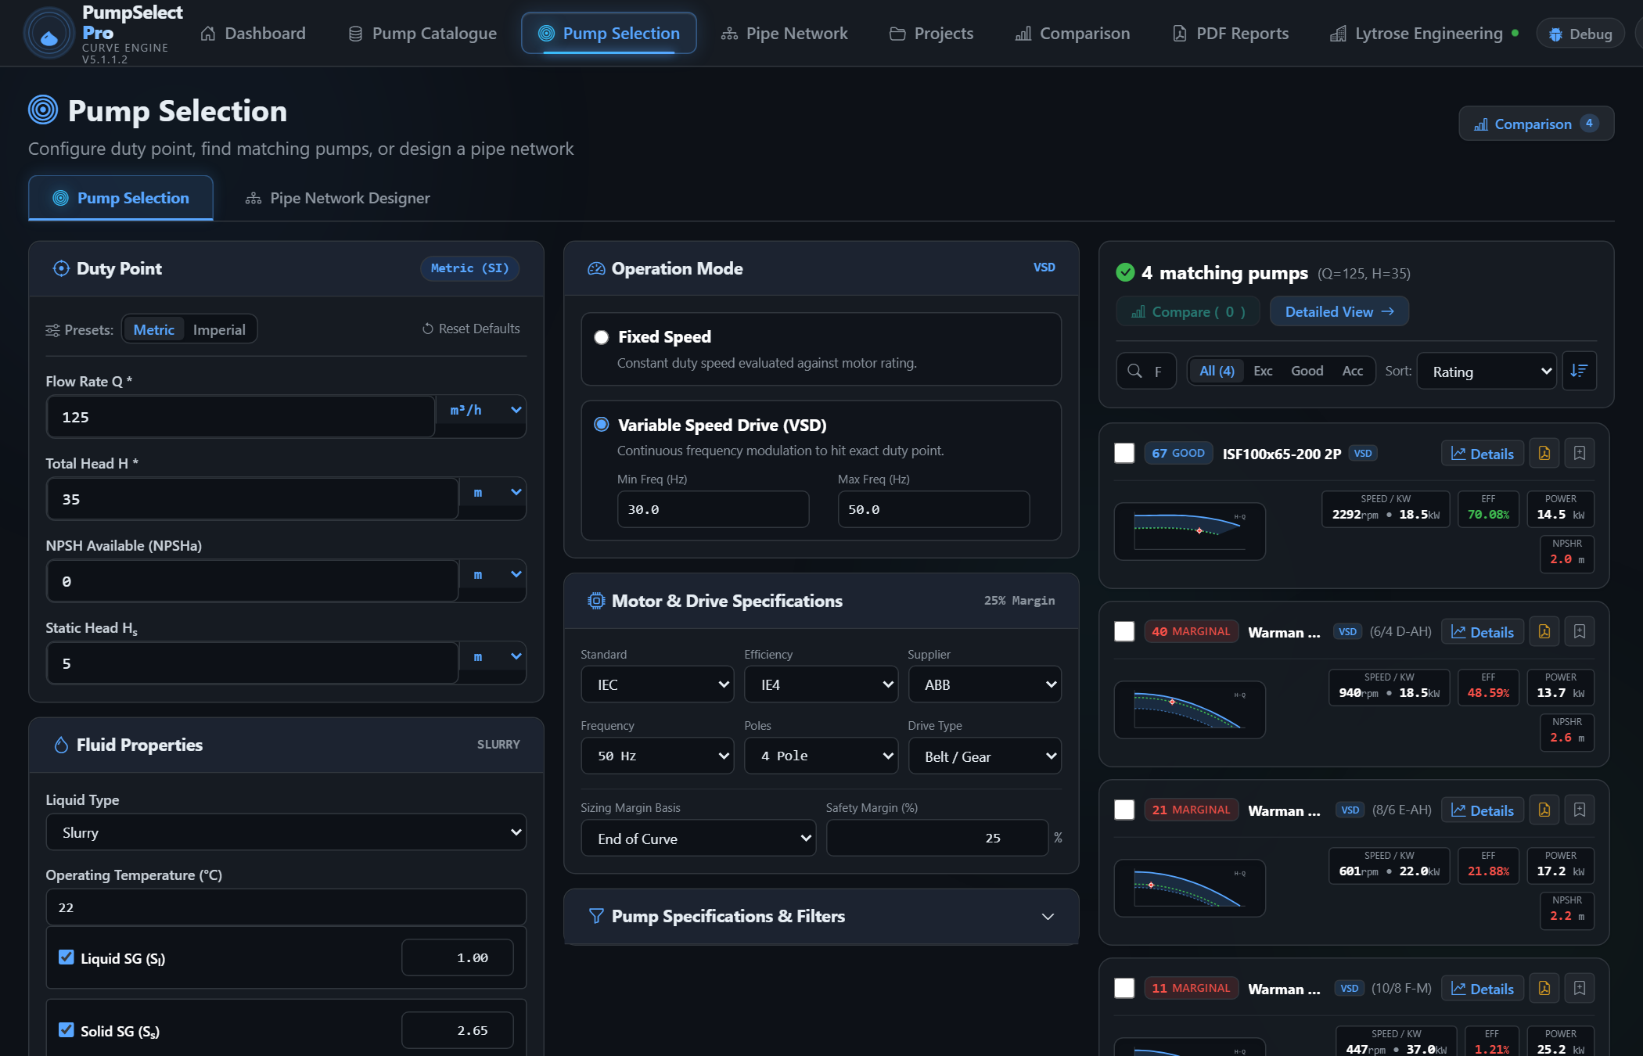
▲ Figure 1: Pump Selection & Sizing Tool — Interactive duty point matching showing superimposed Head (H-Q), Efficiency (η-Q), Power (P-Q), and NPSHr curves with BEP proximity rating.

■ Module 2: Interactive CAD Pipe Network Designer
Full orthogonal pipe routing with integrated elbows, check valves, foot valves, and inline fittings. Iteratively solves Darcy-Weisbach head loss using Colebrook-White friction factors and automatically computes the parabolic system curve (Hsys = Hstatic + k·Q²) overlaid onto pump performance curves.
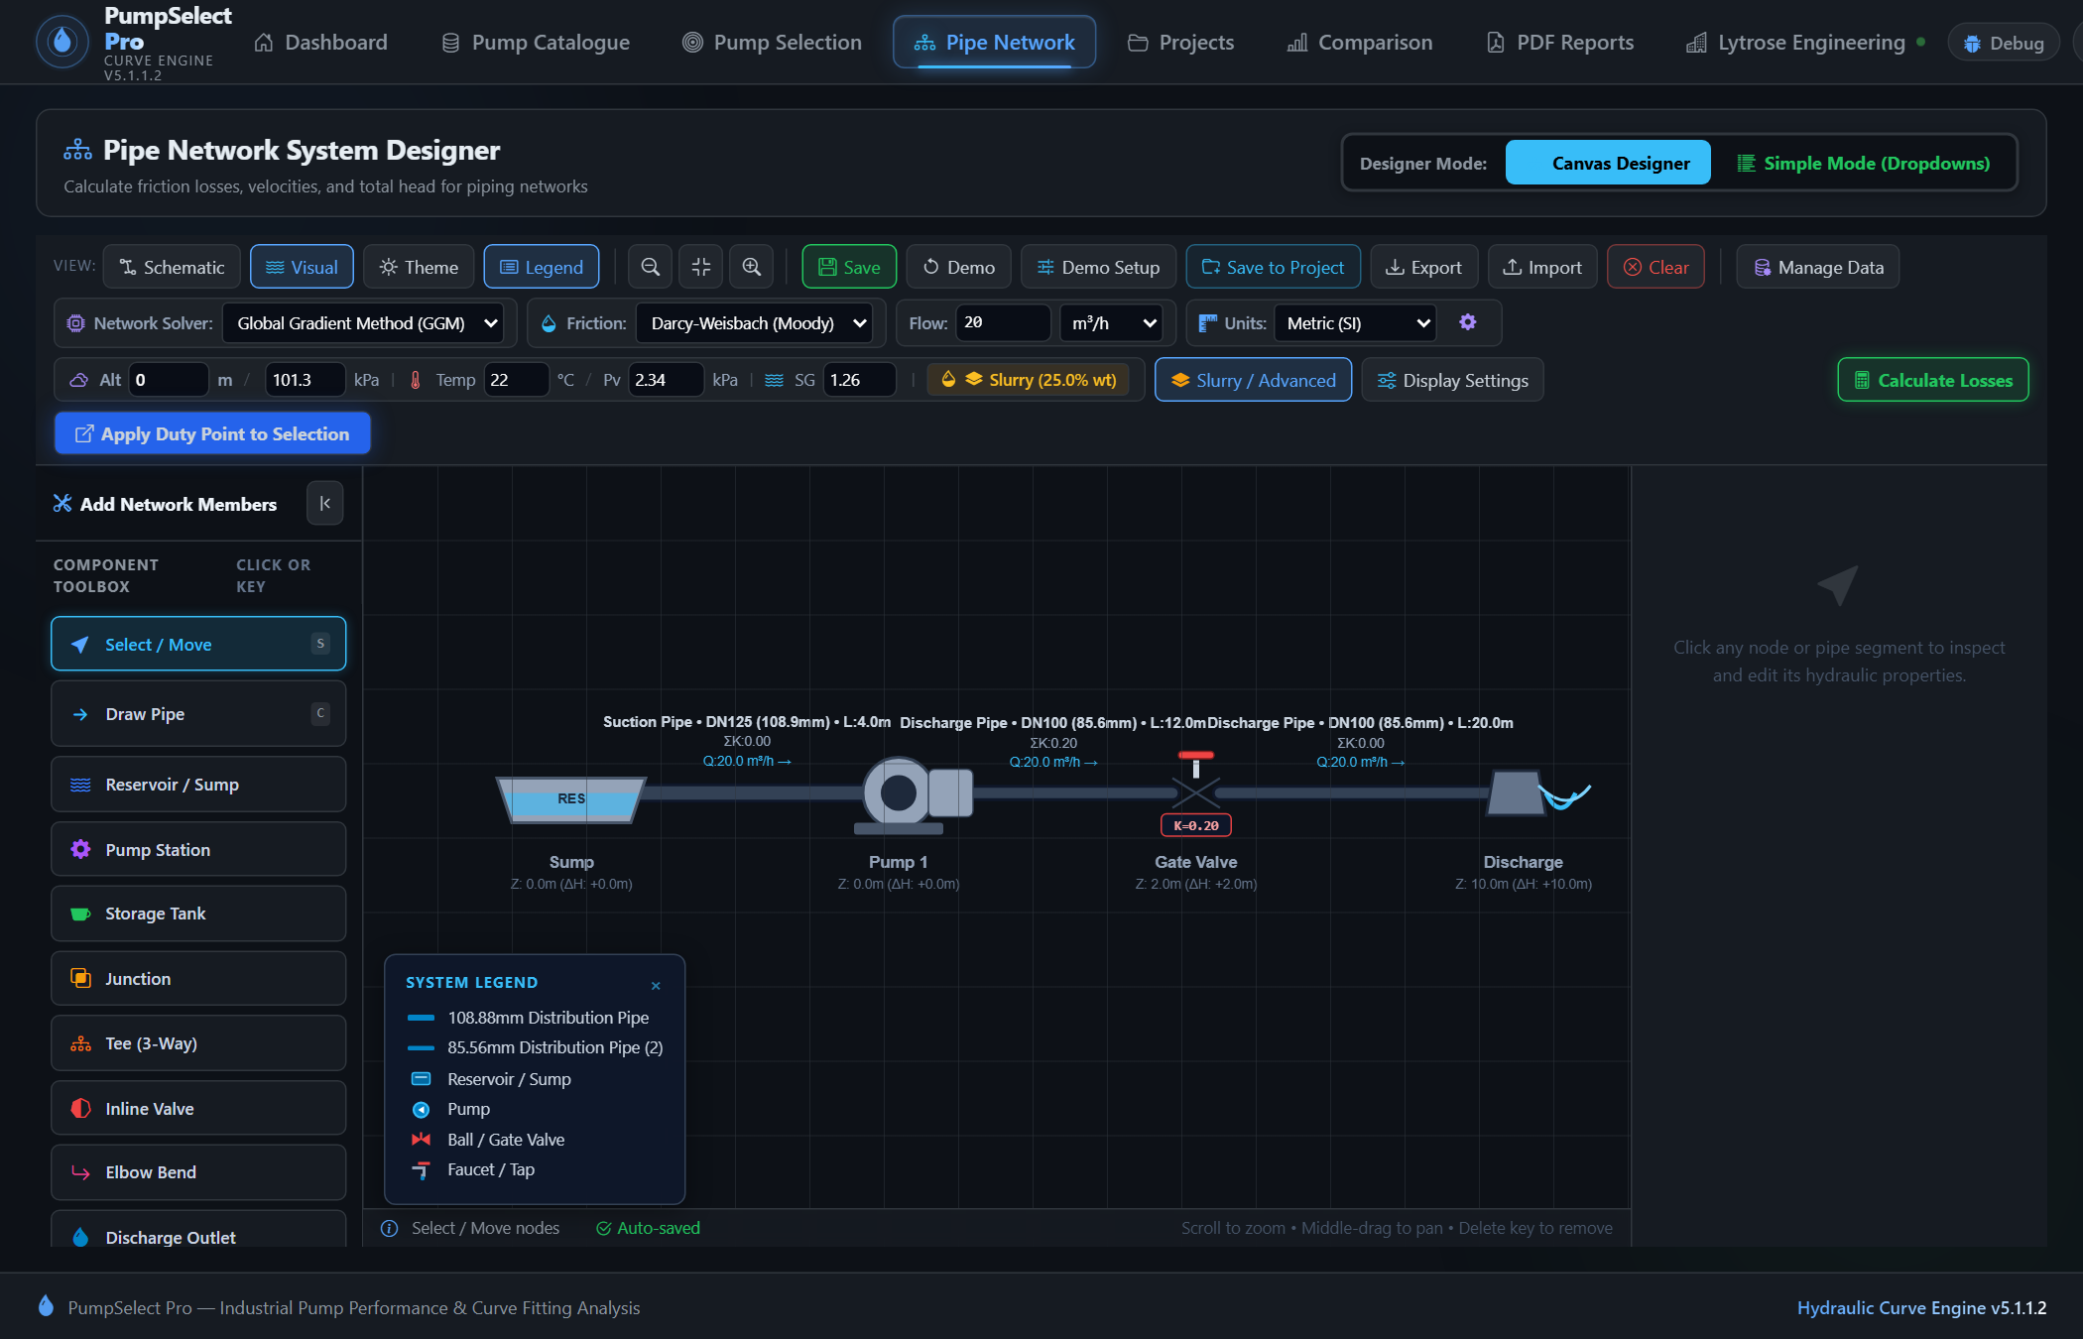
▲ Figure 2: Interactive CAD Pipe Network Designer — Orthogonal pipe layout canvas with hydraulic solver method (GGM / Newton-Raphson), fluid settings, and real-time friction calculations.

■ Module 3: Custom Pump Builder — Add Your Own Proprietary Pumps
Add custom pump models with ease. Input raw manufacturer test bench points, specify impeller trim diameter ranges, define motor ratings and flange ratings, and preview fitted curves in real-time.

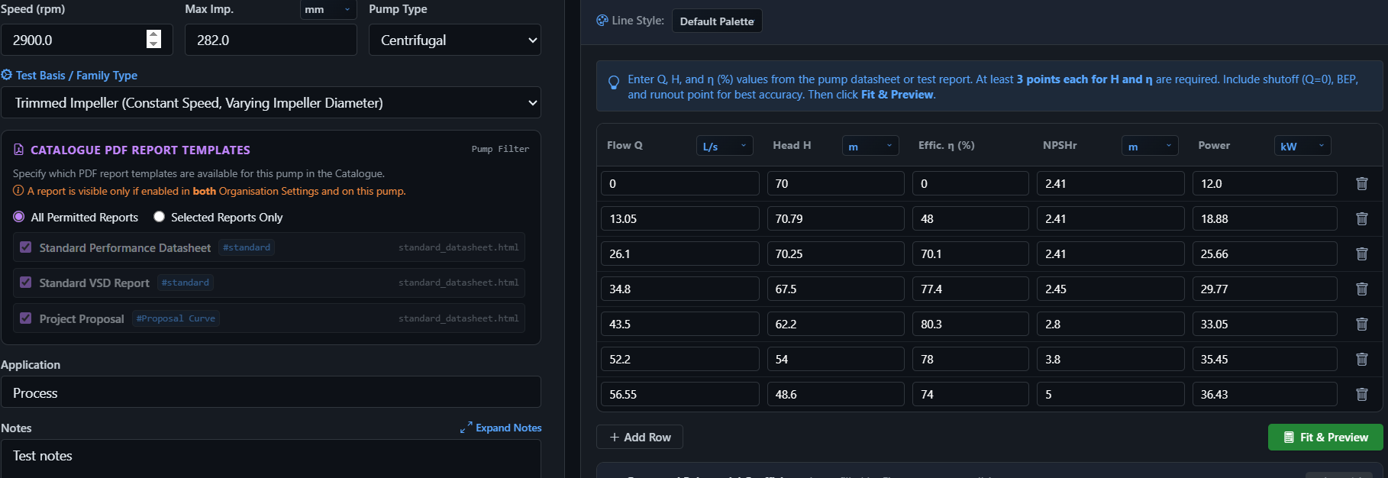
▲ Figure 3: Custom Pump Data Entry & Curve Fitting Form — Add new pump models with live interactive curve fitting, operating limits, and motor specifications.

■ Module 4: Centralized Pump Data Catalogue & Inventory
Manage your complete inventory of pumps, series, and multi-speed curves. Search, filter, and organize by manufacturer, application category, and impeller trim configurations.
■ Module 5: Projects & Saved Selections Management
The Projects module serves as the commercial and engineering repository for all client tenders and quotations. Key capabilities include:
• Complete Selection Snapshot: In a single click, save the selected pump model, operating duty point (Q, H, η, P, NPSHr), fluid rheology, and the COMPLETE CAD pipe network topology directly into a project record.
• Up to 10 Custom Organization Attributes: Configure bespoke metadata per organization (e.g. Plant Area, Mine Site, Fluid Stream, Piping Class, Lead Engineer, Tender Reference, Budget Code).
• Instant Workspace Reload: Any team member can reopen a past saved selection with 1 click directly back into the live selection tool or CAD pipe canvas to re-simulate, modify parameters, or regenerate updated submittals without re-typing data.
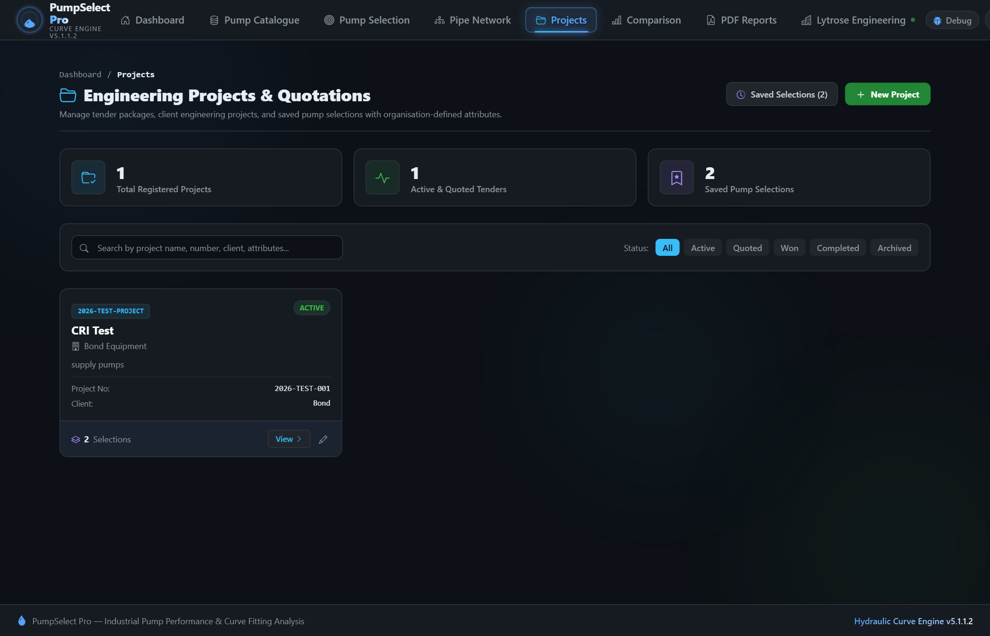
▲ Figure 5: Projects Directory & Saved Selections Management — Centralized project repository displaying client details, tender references, custom metadata attributes, and saved pump selection histories.

■ Module 6: Technical Reports & PDF Submittal Engine
Generate publication-grade engineering submittals and tender datasheets in seconds. Key capabilities include:
• Pixel-Perfect Vector PDF Generation: Utilizes a dedicated Headless Chromium engine to render razor-sharp vector PDF files matching the on-screen browser preview 100% identically—eliminating blurry canvas captures or broken print layouts.
• Flexible 1 to 4 Graph Stacking: Configure 1, 2, 3, or 4 stacked performance charts (H-Q, Efficiency, Power, NPSHr) with customizable display sequence and height percentage splits.
• Comprehensive Technical Sections: Includes operating duty point badges, rated curve overlays, speed/trim isolines, complete construction & materials specification table, hydraulic design specs, and engineering approval remarks.
• Multi-Supplier White-Labeling: Customize header banners, footer notices, corporate logos, and primary brand theme colors per manufacturer or distributor.
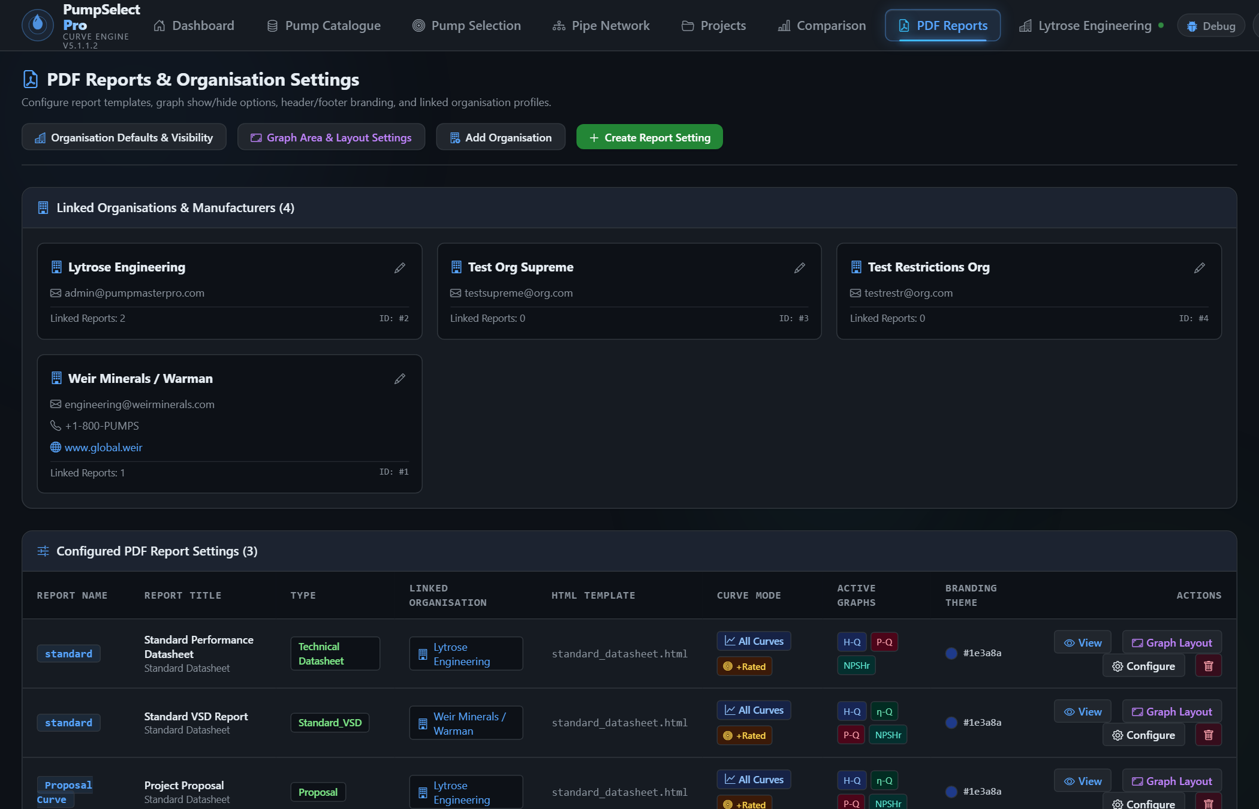
▲ Figure 6: PDF Report Configuration & Graph Layout Settings — Customizable report builder allowing multi-chart sequence ordering, height splits, isoline styling, and corporate white-label branding.

4. Business Impact & Return on Investment (ROI)
Key Performance Metric | Traditional Method (Excel / Desktop) | With Pump Master Pro | Net Impact / ROI
Quotation Turnaround Time | 2 to 4 hours per complex pump quotation. | Under 3 minutes end-to-end. | 90% Time Savings
Project Archiving & Traceability | Scattered Excel files across local drives; impossible to audit. | Centralized database with custom attributes and 1-click reload. | 100% Traceability
Submittal Deliverable Quality | Fragmented screenshots, manual copy-pasting, and uneven styling. | Publication-grade vector PDF datasheets with corporate branding. | Professional Brand Edge
Calculation & Unit Accuracy | Manual formulas prone to broken cells and unit conversion errors. | Automated server-side Python engineering solvers. | Zero Math Errors
Field Cavitation & Reliability | Improper NPSHa safety margins leading to early impeller wear. | Explicit POR/AOR checks and NPSH margin validation. | Fewer Warranty Claims

Ready to Modernize Your Pump Sizing & Quotation Workflow?
Experience automated pump curves, CAD pipe network analysis, project tracking, and instant engineering submittals today.
🌐 Website: https://pumpmasterpro.com | ✉ Contact & Access: admin@pumpmasterpro.com

