ENTERPRISE HYDRAULIC ENGINEERING SUITE • WWW.PUMPMASTERPRO.COM
PUMP MASTER PRO™
Next-Generation Industrial Pump Sizing, Schematic Pipe Network Modeling, Fire Protection & Submittal Automation
[✓] ISO 9906:2012 (Grade 1 & 2) [✓] ANSI/HI 14.6 Test Methods [✓] API 610 (11th/12th Edition) [✓] NFPA 20 / 13 / 14 & EN 12845 Fire [✓] Pipe Network Solvers [✓] Pixel-Perfect PDF Engine [✓] Highly Customizable
“From Raw Operating Duty Point to Publication-Grade Customer Submittal in Under 3 Minutes.”
Pump Master Pro is the cloud-native hydraulic sizing, curve-fitting, project management, and pipe network analysis platform built specifically for Pump Manufacturers (OEMs), EPC Contractors, Consulting Engineers, Fire Protection Designers, and Heavy Industrial Plants (Mining, Water & Slurry). Designed for complete flexibility, users can add their own pump models and test bench curves, organize tender quotations into dedicated project folders, customize PDF submittal templates with corporate branding, and execute complex hydraulic friction and code compliance solving with zero desktop installations.
1. Target Audiences & Value Delivered
Industry / Stakeholder | Traditional Bottleneck | Pump Master Pro Solution
Pump OEMs & Sales Distributors | Slow quotation turnaround (2–4 hours per quote) and risk of sales reps recommending off-design pumps. | Instant duty point matching, automated impeller trims, branded submittal generation, and multi-tenant catalog hosting.
EPC & Consulting Engineers | Error-prone spreadsheet friction formulas, lost project files, and tedious manual NPSHa safety margin checks. | Interactive orthogonal CAD pipe network modeling, automated Colebrook-White friction solving, and project versioning.
Mining & Slurry Plants | Unpredicted pipe sanding, line blockage, or catastrophic pump wear due to incorrect slurry settling physics. | Native Durand critical deposition velocity (Vc) and Ferguson & Church particle settling velocity algorithms.
Water & Wastewater Utilities | Operating off Best Efficiency Point (BEP), uncontrolled energy waste, and cavitation damage in parallel pumps. | Comprehensive POR/AOR envelope visualization, VFD speed affinity curves, and multi-pump side-by-side comparison.
Fire Protection & MEP Engineers | Manual NFPA 20 curve tolerance verification, cumbersome NFPA 13/14 hazard calculations, and disconnected jockey pump sizing. | Dedicated NFPA 20 / EN 12845 / AS 2941 modules with certified curve envelope checks, automated jockey pump & tank duration sizing.

2. 100% Customizable: Add Your Own Pumps & Catalogues
Unlike rigid legacy tools that lock you into static third-party databases, Pump Master Pro is built to be fully customizable by the user. Whether you are an equipment manufacturer introducing a new product line, or an engineering consultancy managing bespoke client assets, you have full ownership of your data.
✔ Add & Manage Your Own Pumps: Easily register any centrifugal or slurry pump model. Define pump family, series, discharge/suction flange ratings, impeller trim diameter ranges (min, rated, max), design speeds, and motor configurations.
✔ Automated Test Bench Curve Fitting: Simply enter discrete performance test points (Flow, Head, Efficiency, Power, NPSHr). The system's mathematical engine automatically generates high-order polynomial regression curves (R² > 0.998) and affinity law speed/trim variations.
✔ Custom Branding & White-Labeling: Fully customize PDF datasheets and client proposals with your corporate logo, custom primary banner colors, report headers, engineering notes, and warranty disclaimers.
✔ Custom Fluid, Slurry & Pipe Profiles: Create bespoke fluid libraries: define custom slurry specific gravities, d50 particle sizes, non-Newtonian viscosities, pipe materials, roughness factors (ε), and proprietary fitting K-values.
3. Core Engineering Modules & Software Walkthrough
■ Module 1: Intelligent Pump Sizing & BEP Operating Envelope
Filters pump models by target Flow (Q), Head (H), and available NPSH. Ranks selections by proximity to Best Efficiency Point (BEP), displaying Preferred Operating Regions (POR) and Allowable Operating Regions (AOR) with automated Karassik trim corrections and multi-speed affinity law scaling.
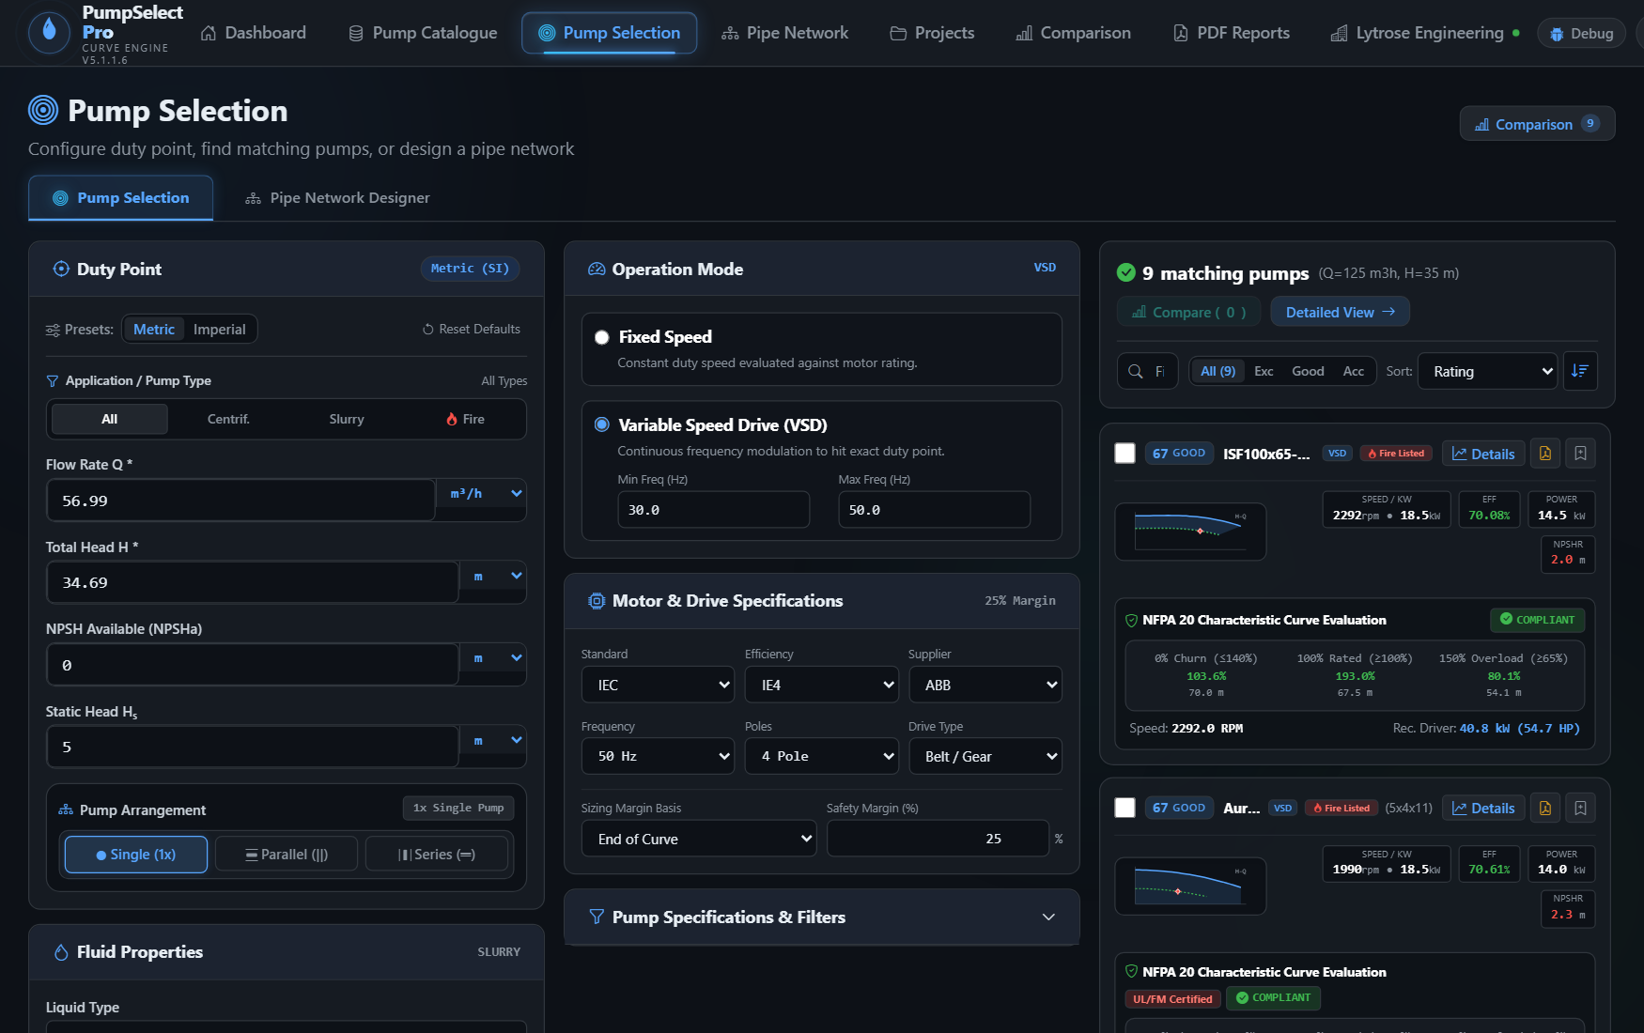
▲ Figure 1: Pump Selection & Sizing Tool — Interactive duty point matching showing superimposed Head (H-Q), Efficiency (η-Q), Power (P-Q), and NPSHr curves with BEP proximity rating.

■ Module 2: Interactive CAD Pipe Network Designer & Schematic Solver
Design full hydraulic circuits with orthogonal pipe routing, integrated elbows, check valves, foot valves, and inline fittings. The software provides dual canvas perspectives: an Orthogonal Physical CAD layout and an intuitive Schematic Circuit View. It iteratively solves Darcy-Weisbach head loss using Colebrook-White friction factors and automatically computes the parabolic system curve (Hsys = Hstatic + k·Q²) overlaid onto pump performance curves for instant duty intersection verification.
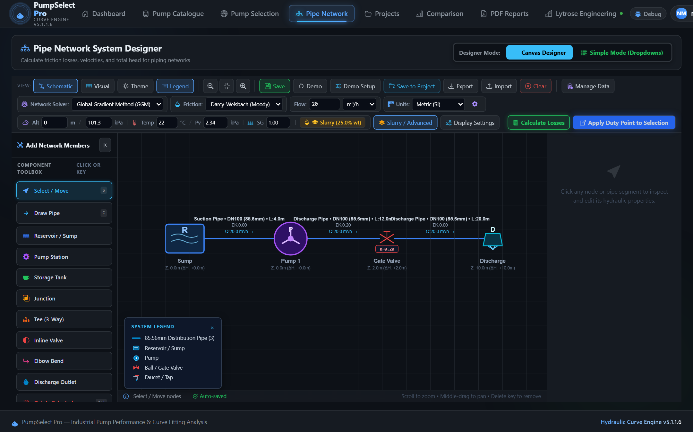
▲ Figure 2: Interactive CAD Pipe Network Designer — Schematic View — Schematic canvas view displaying hydraulic circuit symbols, node elevations, Darcy-Weisbach / Colebrook-White friction factors, and system curve overlays.

■ Module 3: Fire Protection Pump Sizing & NFPA 20 Code Compliance Engine
A dedicated, code-certified engineering module for fire protection systems supporting NFPA 20, NFPA 13, NFPA 14, EN 12845 (LPC), and AS 2941 (AU) standards. Key capabilities include:
• Hazard Classification Demand: Automated hydraulic calculation for light, ordinary, and extra hazard occupancies with design density, operating area, and inside/outside hose stream allowances.
• NFPA 20 Certified Curve Boundaries: Instant evaluation of mandatory fire curve thresholds: 100% rated duty point, minimum 65% rated head at 150% overload test flow, and maximum 140% shutoff (churn) head limit.
• Auxiliary System Sizing: Automated pressure-maintenance jockey pump flow and cut-in/cut-out pressure settings, dedicated fire water storage tank duration volume calculations (30 to 120 min), and code pipe schedules.
• Driver Power Sizing: Electric motor and diesel engine driver power sizing with mandated safety overload margins.
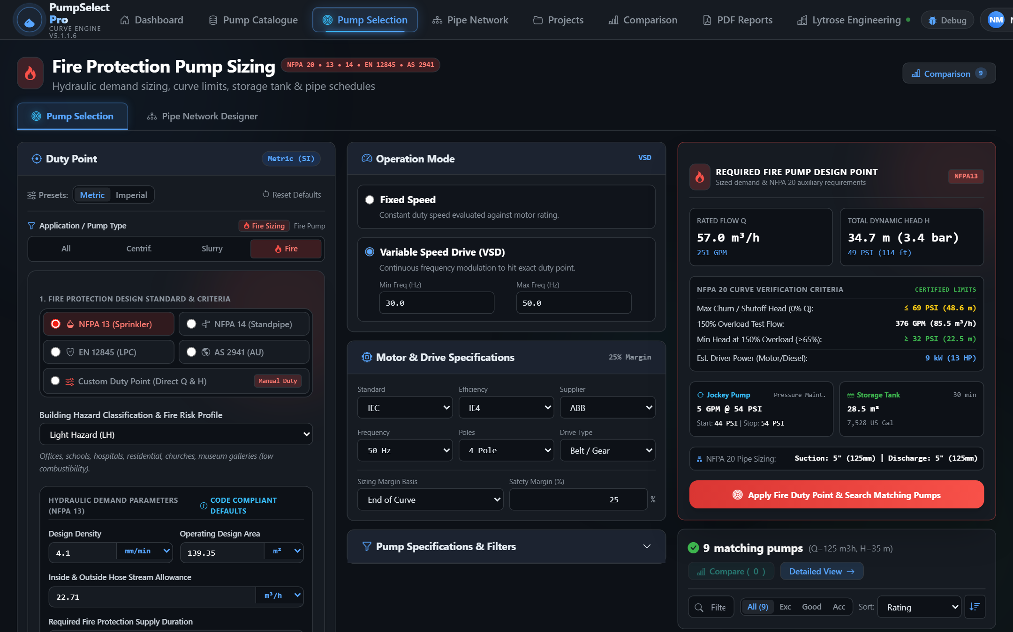
▲ Figure 3: Fire Protection Pump Sizing & Code Compliance Tool — Automated hazard demand sizing (NFPA 13/14, EN 12845, AS 2941), certified NFPA 20 curve boundaries (140% shutoff, 150% overload), auxiliary jockey pump & tank calculations, and duty matching.

■ Module 4: Custom Pump Builder — Add Your Own Proprietary Pumps
Add custom pump models with ease. Input raw manufacturer test bench points, specify impeller trim diameter ranges, define motor ratings and flange ratings, and preview fitted curves in real-time with automated regression.
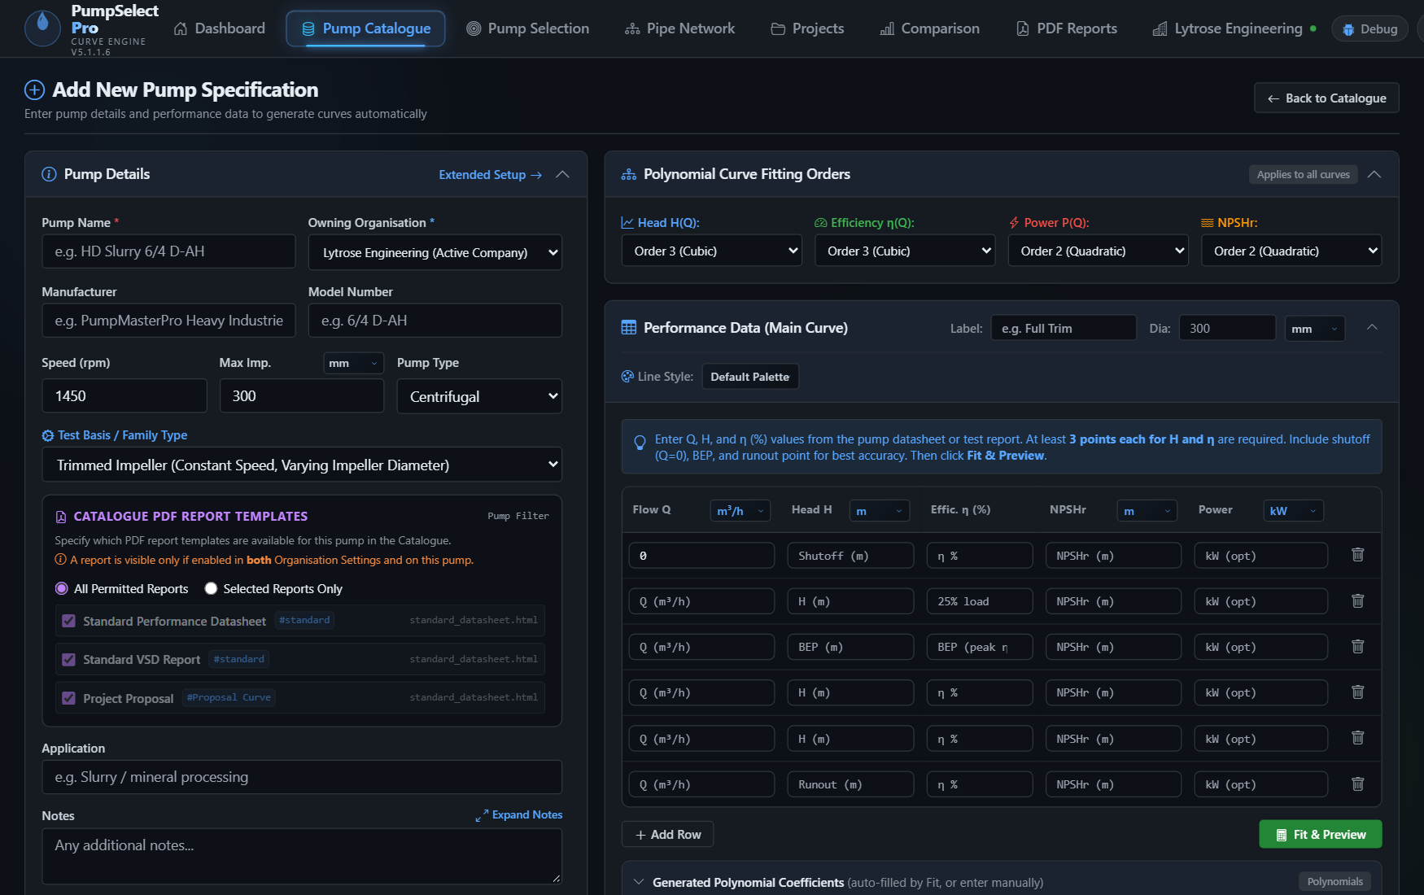
▲ Figure 4: Custom Pump Data Entry & Curve Fitting Form — Add new pump models with live interactive curve fitting, operating limits, and motor specifications.

■ Module 5: Centralized Pump Data Catalogue & Inventory
Manage your complete inventory of pumps, series, and multi-speed curves. Search, filter, and organize by manufacturer, application category (Clean Water, Slurry, Fire Protection, Chemical), and impeller trim configurations. Perform instant multi-pump comparisons and manage organization-wide equipment permissions across engineering and sales divisions.

■ Module 6: Projects & Saved Selections Management
The Projects module serves as the commercial and engineering repository for all client tenders and quotations. Key capabilities include:
• Complete Selection Snapshot: In a single click, save the selected pump model, operating duty point (Q, H, η, P, NPSHr), fluid rheology, and the COMPLETE CAD pipe network topology directly into a project record.
• Up to 10 Custom Organization Attributes: Configure bespoke metadata per organization (e.g. Plant Area, Mine Site, Fluid Stream, Piping Class, Lead Engineer, Tender Reference, Budget Code).
• Instant Workspace Reload: Any team member can reopen a past saved selection with 1 click directly back into the live selection tool or CAD pipe canvas to re-simulate, modify parameters, or regenerate updated submittals without re-typing data.
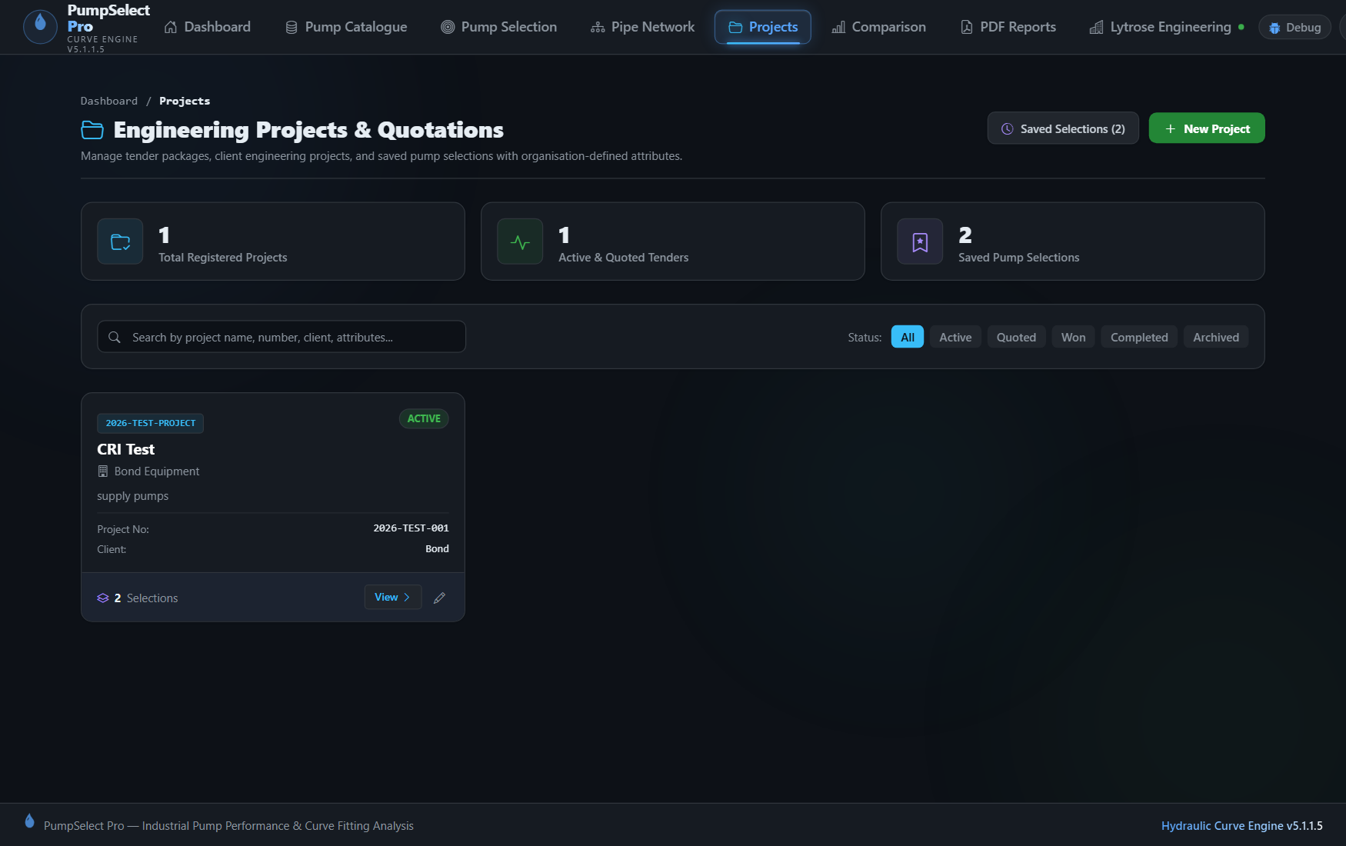
▲ Figure 5: Projects Directory & Saved Selections Management — Centralized project repository displaying client details, tender references, custom metadata attributes, and saved pump selection histories.

■ Module 7: Technical Reports & PDF Submittal Engine
Generate publication-grade engineering submittals and tender datasheets in seconds. Key capabilities include:
• Pixel-Perfect Vector PDF Generation: Utilizes a dedicated Headless Chromium engine to render razor-sharp vector PDF files matching the on-screen browser preview 100% identically—eliminating blurry canvas captures or broken print layouts.
• Flexible 1 to 4 Graph Stacking: Configure 1, 2, 3, or 4 stacked performance charts (H-Q, Efficiency, Power, NPSHr) with customizable display sequence and height percentage splits.
• Comprehensive Technical Sections: Includes operating duty point badges, rated curve overlays, speed/trim isolines, complete construction & materials specification table, hydraulic design specs, and engineering approval remarks.
• Multi-Supplier White-Labeling: Customize header banners, footer notices, corporate logos, and primary brand theme colors per manufacturer or distributor.
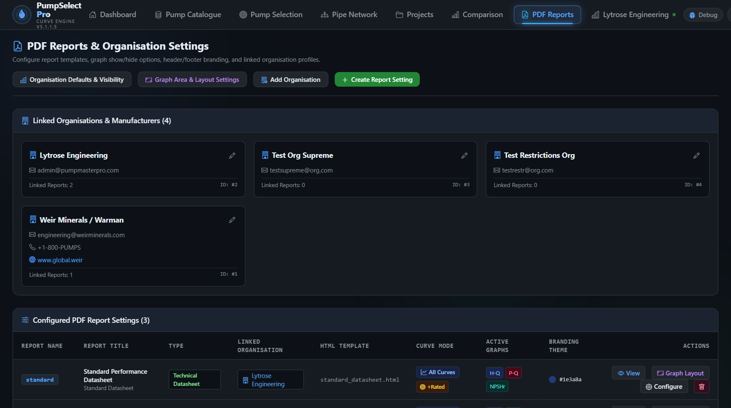
▲ Figure 6: PDF Report Configuration & Graph Layout Settings — Customizable report builder allowing multi-chart sequence ordering, height splits, isoline styling, and corporate white-label branding.

4. Business Impact & Return on Investment (ROI)
Key Performance Metric | Traditional Method (Excel / Desktop) | With Pump Master Pro | Net Impact / ROI
Quotation Turnaround Time | 2 to 4 hours per complex pump quotation. | Under 3 minutes end-to-end. | 90% Time Savings
Fire Protection Compliance | Manual NFPA 20 curve tolerance verification and separate spreadsheet sizing for jockey pumps. | Instant NFPA 13/14/20, EN 12845 & AS 2941 automated verification. | 100% Code Compliance
Project Archiving & Traceability | Scattered Excel files across local drives; impossible to audit. | Centralized database with custom attributes and 1-click reload. | 100% Traceability
Submittal Deliverable Quality | Fragmented screenshots, manual copy-pasting, and uneven styling. | Publication-grade vector PDF datasheets with corporate branding. | Professional Brand Edge
Calculation & Unit Accuracy | Manual formulas prone to broken cells and unit conversion errors. | Automated server-side Python engineering solvers. | Zero Math Errors
Field Cavitation & Reliability | Improper NPSHa safety margins leading to early impeller wear. | Explicit POR/AOR checks and NPSH margin validation. | Fewer Warranty Claims

Ready to Modernize Your Pump Sizing & Quotation Workflow?
Experience automated pump curves, schematic pipe network analysis, fire protection code compliance, project tracking, and instant engineering submittals today.
🌐 Website: https://www.pumpmasterpro.com | ✉ Contact & Access: admin@pumpmasterpro.com

