***Do Read***

Now let’s get into program functioning:

1. Once you run the program you will get this screen

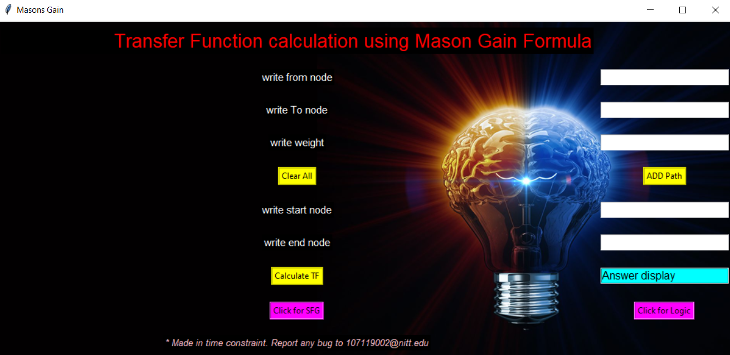

Here you can input all your nodes.

1. After adding one path click on ‘Add path’ button. (It is a necessary task to save that path.)
2. Now for next input, do not append on previous input.
3. Now add all the path by step 2.
4. In case you entered something wrong then click on ‘Clear all’ and start entering nodes from starting.
5. Once you are finished with path adding, enter starting and ending nodes in the next section.
6. Then click on ‘calculate TF’ button to get transfer function.
7. To know logic of code, click on ‘Click for Logic’ Button
8. To see SFG of entered nodes click on ‘Click For SFG’ button.
9. Check the console for more Information.

Now you are good to go >>>>>>

Test my code.

Regards

Abhinav Agrawal