**SEQUENCER (CONTEXT)**

**SPRINT 1**

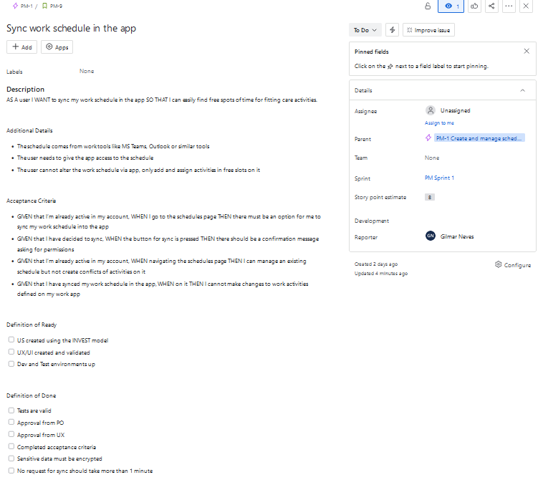

**SPRINT 2**

**BOARD**

