Project Report
Hindi Playfair Cipher

A Specialized Cryptographic Tool for Devanagari Script

1. Introduction

In the contemporary digital landscape, cryptography is a cornerstone of information security. While traditional methods often focus on Latin-based scripts, there is a growing need for security tools that accommodate linguistically diverse systems. This project presents a specialized adaptation of the Playfair Cipher, a symmetric encryption technique that processes pairs of characters (digraphs).

The Hindi Playfair Cipher is specifically engineered to address the phonetic and structural complexities of the Devanagari script, providing a robust framework for securing Hindi text.

2. System Architecture

The application utilizes a sophisticated full-stack architecture designed for scalability, performance, and a clear separation of concerns between the user interface and the core cryptographic logic.

Frontend Layer: Developed using React, Vite, and TypeScript, the frontend offers a high-performance environment. It features a real-time, animated interface that allows users to visualize the encryption and decryption processes instantaneously.

Backend Layer: A Python Flask server serves as the engine of the application. It manages all cryptographic operations and exposes them to the frontend via a secure RESTful API.

UI/UX Design: To ensure a premium and responsive experience across all devices, the interface is styled with TailwindCSS and enhanced with Framer Motion for fluid transitions.

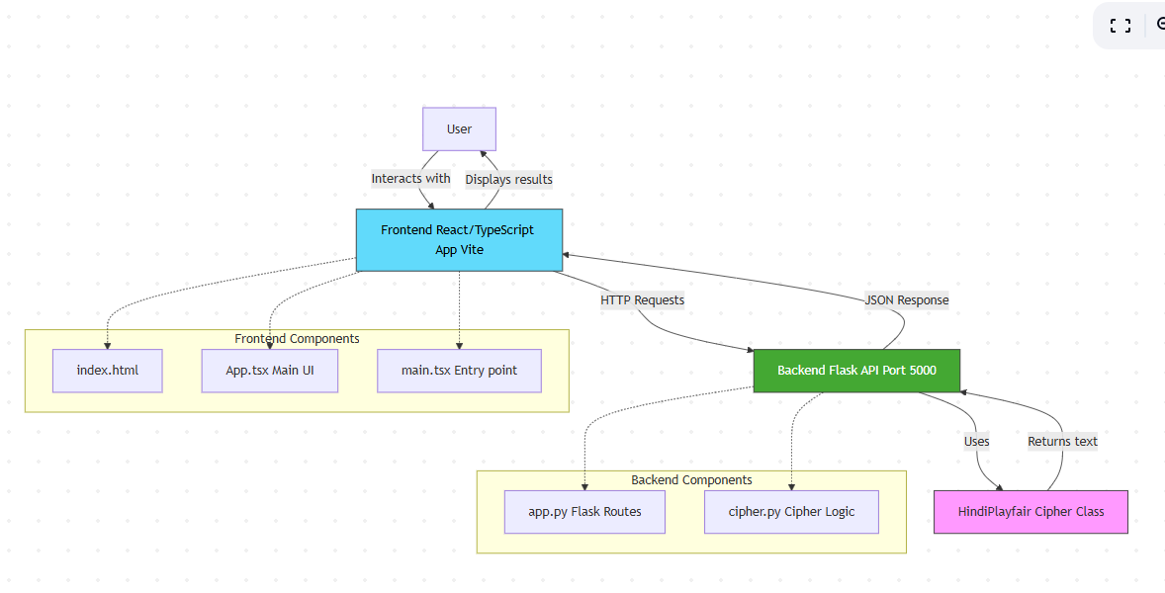

3. The 7x7 Hindi Grid Algorithm

A significant innovation of this project is the expansion of the traditional $5 \times 5$ English Playfair grid into a 7x7 matrix. This modification provides 49 distinct slots, which is essential for capturing the expansive character set of the Devanagari script:
Category | Characters Included
Vowels (11) | अ, आ, इ, ई, उ, ऊ, ऋ, ए, ऐ, ओ, औ
Consonants (33) | क through ह
Special Characters (5) | अं, अः, ् (Halant), क्ष, ज्ञ

Padding Logic: The character 'क्ष' serves as the designated filler, used for padding odd-length strings and handling double-letter occurrences within a digraph.

4. Operational Logic

The system adheres to three primary geometric rules for character transformation within the 7x7 grid:

Same Row Rule: Characters are replaced by the neighbor to their immediate right, with horizontal wrap-around.

Same Column Rule: Characters are replaced by the neighbor immediately below, with vertical wrap-around.

Rectangle Rule: For characters forming a rectangle, each is swapped with the corner character occupying the same row within that rectangle.

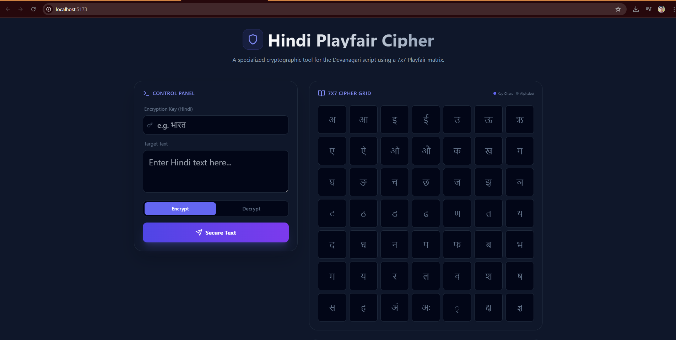

5. Technical Stack Summary

The following table outlines the specialized technologies integrated into this solution:
Category | Technology Used
Frontend Framework | React (Vite) + TypeScript
Styling & Animation | TailwindCSS + Framer Motion
Backend Environment | Python (Flask)
Cryptographic Core | Custom 7x7 Playfair Algorithm

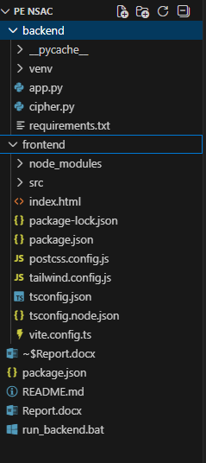

6. EXAMPLES:-

The Hindi Playfair Cipher successfully bridges the gap between classic cryptographic principles and linguistically complex scripts.
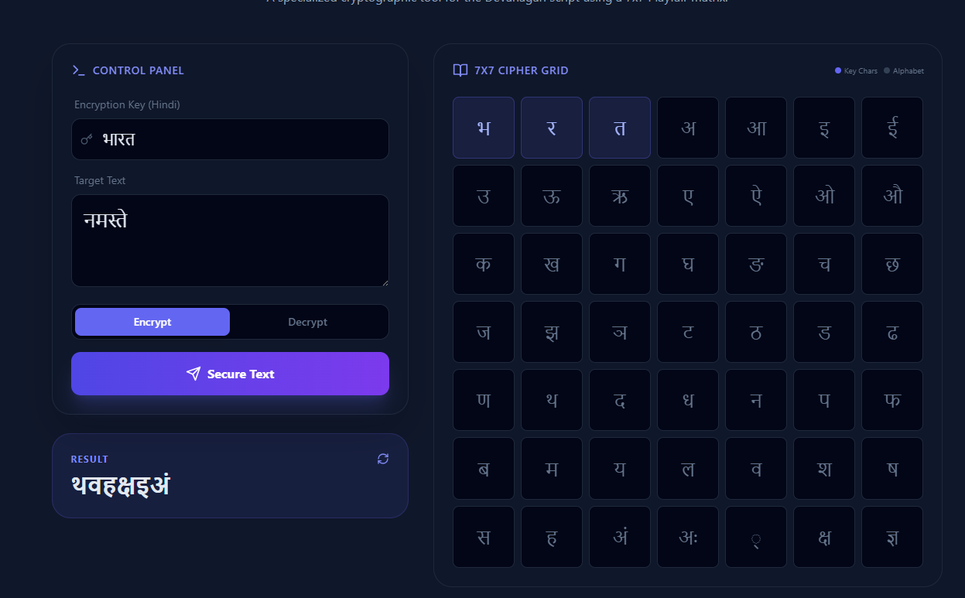 | 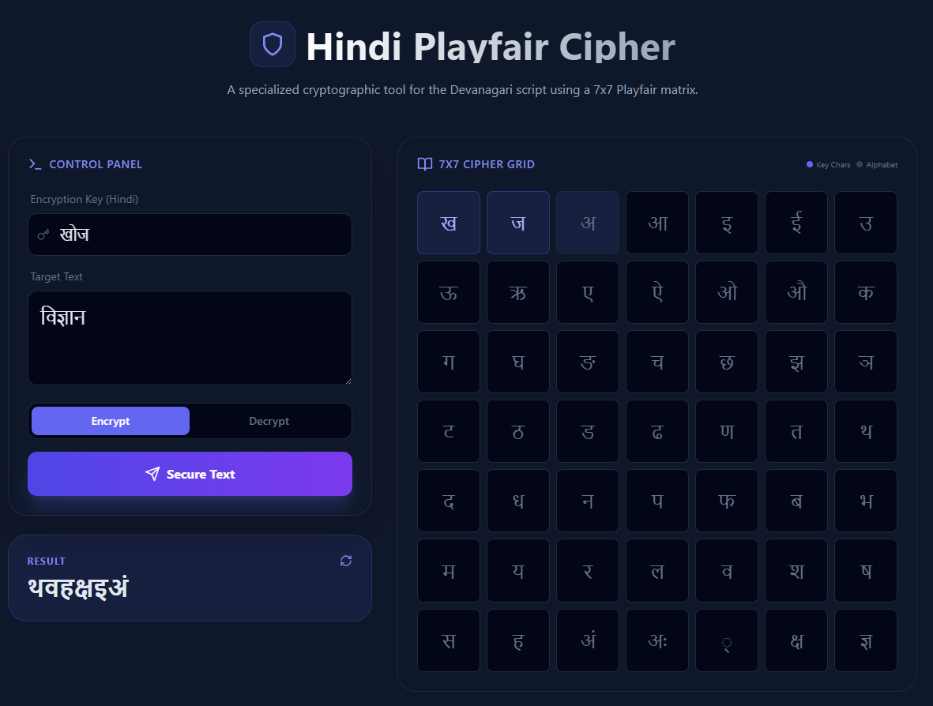
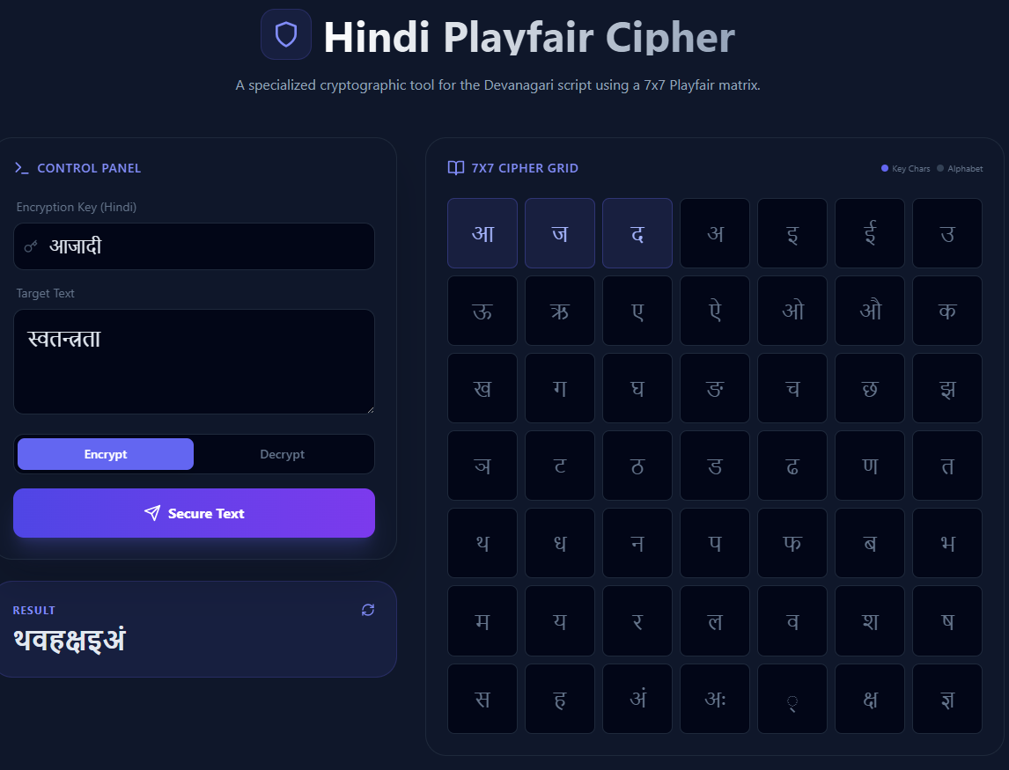 | 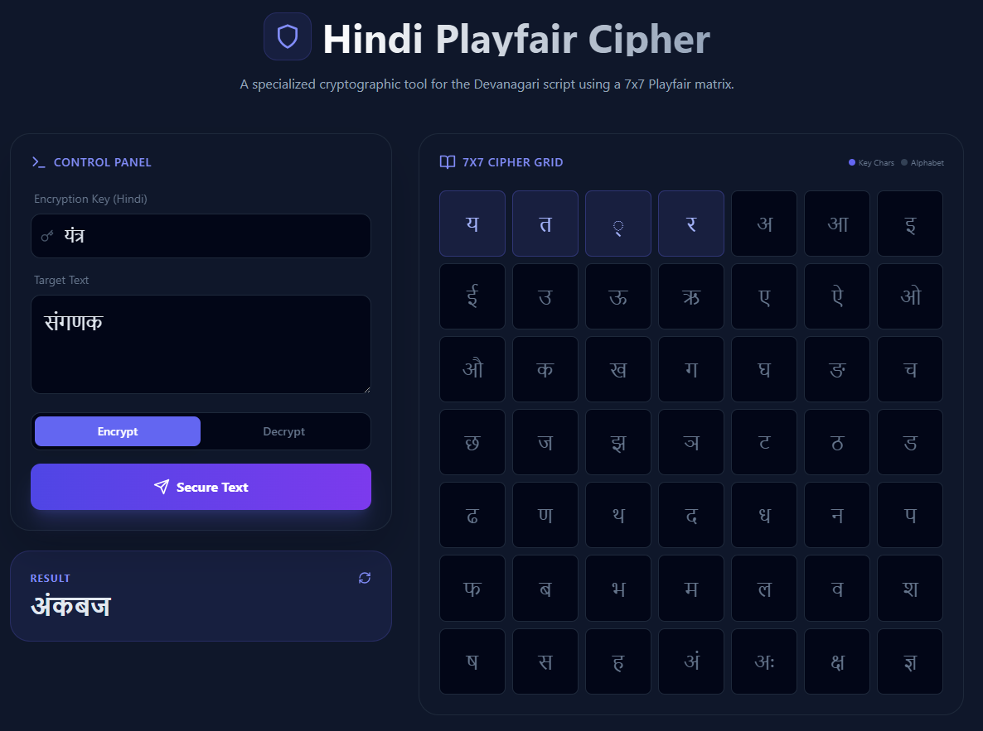

6. Conclusion

The Hindi Playfair Cipher successfully bridges the gap between classic cryptographic principles and linguistically complex scripts. By leveraging a modern, modular tech stack, the project provides a secure, user-friendly, and highly efficient method for processing Devanagari text, demonstrating that traditional ciphers can be effectively modernized for global languages.

