<https://github.com/nevets-steven/fitnesscenter.git> (our code)

Inputs

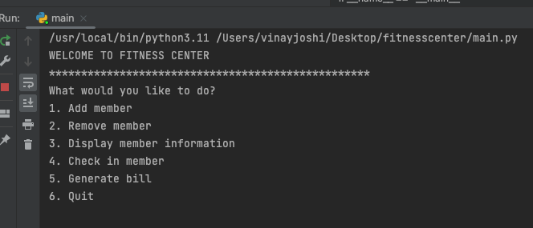

1Add Members(Single Club)

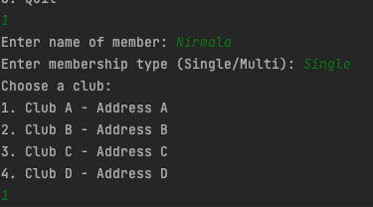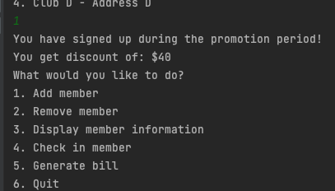

1Add Members(Multi Club)

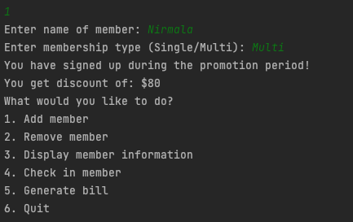

2 Remove member

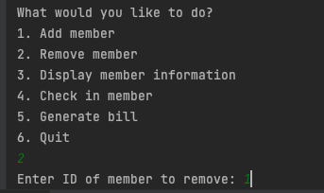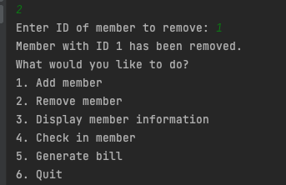

3.Display member information (In case member deleted)

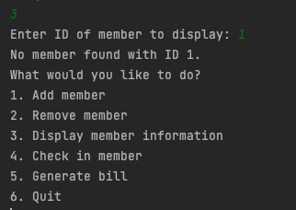

4. Display member information (In case member present)

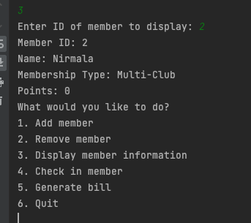

Fitness Center Documentation

5 Classes

* Member()
* SingleClubMember(Member())
* MultiClubMember(Member())
* Club()
* FitnessCenter() // main class

========================================================================

Class Member:

Variables:

* Member_id
* name

Methods:

__Init__(self, member_id, name)

Check_in(Club club):

Returns void

========================================================================

Class Single Club Member:

-**child class** of parent class Member()

Variables:

* Member_id
* Name
* club name

Methods:

__init__(self, member_id, name, club_name)

Check_in(self, name, club_name):

* calls club class -> checks if club is correct -> if correct, assign club,   
  Incorrect show correct club or cancel check in
* Club(name, club_name)
  + TRUE: Assign club to member
  + FALSE: show correct club name, prompt user if they want to cancel checkin,

========================================================================

Class Multi Club Member:

-**child class** of parent class Member()

Variables:

* Member_id
* membership_points
* Name

Methods:

__init__ -> contains membership_points

Check_in:

* Adds points to membership

========================================================================

Class Club:

Variables:

* Name
* Address

Methods:

__init__ -> sets variables

Add_member:

* Would you like to be a single or multi club member?
* If Single Club Member:
  + Call single_club_member.check_in
* Multi Club Member prompts
  + Call multi_club_member.check_in

Remove_member:

* Remove member from current membership, asks if want to downgrade/upgrade
* Remove from all memberships

Display_member:

* Displays member info: name, membership type, current club address, membership points(if multi club)

Check_in:

* Call check_in method in Member class
* If check in returns false, print message saying club is incorrect, do not let it return error message use try/except

Select_member:

* Check member status: single or multi club?
* IF Single Club:
  + Generate bill of fees
* IF Multi Club:
  + Show points
  + Generate Bill of Fees

========================================================================

Class FitnessClub:

__init__:

* setting class instances

__main__:

* Asks user what they want to do:
  + Add Member
    - At least 4 options to choose from or become multi club member
  + Remove Member
    - Remove member from either multi/single or both
  + Display Member
    - Displays member info
  + Check In Member
    - Checks member club
  + Select Member
    - Generates bill of fees and shows membership points

Run main