Gene Expression Clustering and Analysis using K-Means
ISC 211 – Introduction to Bioinformatics · Individual Assignment
Name: Nevil Mathew Sanish · Roll No.: 2025BCD0011 · Indian Institute of Information Technology Kottayam

1. Assignment allocation
R = last three digits of roll number = 011 = 11. Topic = ((11 − 1) mod 11) + 1 = 11 → “Gene Expression Clustering and Analysis” (Georgieva, ERIS 2022, CEUR-WS Vol-3372 paper02). Because Topic > 10 the algorithm is chosen from {M11, M12, M13}; M11 – K-Means clustering – was selected, as it is the objective-function clustering method the paper reviews (§2.2) and is directly suited to discovering groups in expression data.

2. Research paper and biological problem
The paper reviews clustering for gene-expression analysis – hierarchical, objective-function (k-means, fuzzy c-means, SOM) and density-based (DBSCAN) methods – and extends an iterative DBSCAN procedure for detecting differentially expressed genes between two mouse strains (C57BL/6J vs DBA/2J, Bottomly et al. RNA-seq). Key points used in this work:
- Biological problem: expression tables contain thousands of genes for many samples; unsupervised clustering is needed to discover unknown partitions – groups of samples/genes with similar behaviour, e.g. distinct cancer types (paper §1).
- Pre-processing: a log transformation is required because some genes are expressed orders of magnitude higher than others, and non-active (zero) genes must be filtered (paper §3.2).
- Choosing the number of clusters k is the main difficulty of k-means; PCA-based representations help (paper §2.2).
Here the same problem – discovering biologically meaningful groups from RNA-seq expression without using labels – is addressed with K-Means on tumour samples, with the known tumour type used only to evaluate the discovered clusters.

3. Dataset
The paper’s mouse dataset has no ground-truth groups for clustering evaluation, so a suitable public dataset with known biology was selected: UCI “Gene Expression Cancer RNA-Seq” (UCI ML Repository, ID 401), a random extract of the TCGA Pan-Cancer Atlas (Illumina HiSeq). It was downloaded from https://archive.ics.uci.edu/static/public/401/gene+expression+cancer+rna+seq.zip (a zip holding TCGA-PANCAN-HiSeq-801x20531.tar.gz with data.csv and labels.csv); a copy is in the dataset/ folder.
- 801 tumour samples × 20,531 genes (RNA-seq expression values).
- 5 tumour types: BRCA (breast, 300), KIRC (kidney, 146), LUAD (lung, 141), PRAD (prostate, 136), COAD (colon, 78).

4. Data preparation
- log2(x + 1) transform of all expression values (paper §3.2).
- Removal of zero-variance (non-active) genes → 20,264 genes.
- Stratified 80/20 split (seed 42): 640 training samples, 161 unseen test samples. Everything below is fitted on the training set only, so no information from the test set leaks into the model.
- Selection of the N most variable genes, per-gene standardisation (z-score) and optional PCA – N and the number of PCA components are hyper-parameters chosen by cross-validation.

5. Algorithm and training – K-Means (M11)
K-Means partitions samples into k clusters by iteratively assigning each sample to its nearest centroid (Euclidean distance) and recomputing centroids, minimising the within-cluster sum of squares (inertia). k = 5 was used, matching the five tumour types and supported by the elbow/silhouette analysis (Fig. 1). Each fit uses 50 random initialisations (k-means++) and keeps the lowest-inertia solution. Because cluster IDs are arbitrary, each cluster is mapped to a tumour type with the Hungarian algorithm using the training labels only; this mapping is then applied unchanged to unseen samples.
Hyper-parameter tuning: 20 pipelines (top-variance genes ∈ {500, 1000, 2000, 5000} × PCA ∈ {none, 5, 10, 20, 50}) were scored with 5-fold stratified cross-validation inside the training set. The best was 500 genes with no PCA (scaled genes used directly). Top configurations:
 | genes | PCA comps | CV accuracy (mean) | CV accuracy (std)
#1 | 500 | none | 0.9984 | 0.0031
#2 | 500 | 5 | 0.9984 | 0.0031
#3 | 500 | 10 | 0.9984 | 0.0031
#4 | 500 | 20 | 0.9984 | 0.0031
#5 | 500 | 50 | 0.9984 | 0.0031
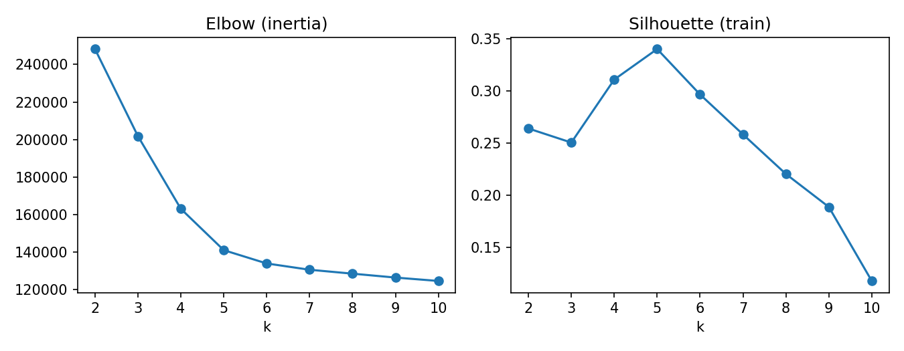
Fig. 1 – Elbow (inertia) and silhouette versus k on the training set.

6. Testing on unseen data and evaluation
The final model was trained once on all 640 training samples and evaluated once on the 161 held-out test samples. Accuracy on unseen data = 99.38% (160/161 samples correctly grouped). Metrics: accuracy (after training-learned cluster→class mapping), Adjusted Rand Index (ARI, 1 = perfect agreement, 0 = random), Normalised Mutual Information (NMI), and silhouette coefficient (cluster compactness/separation, −1…1).
 | Accuracy | ARI | NMI | Silhouette
Training (seen) | 0.9984 | 0.9953 | 0.9937 | 0.3404
Test (unseen) | 0.9938 | 0.9814 | 0.9807 | 0.3209

 | Precision | Recall | F1-score | Support
BRCA | 0.9836 | 1.0000 | 0.9917 | 60
COAD | 1.0000 | 1.0000 | 1.0000 | 16
KIRC | 1.0000 | 1.0000 | 1.0000 | 30
LUAD | 1.0000 | 0.9643 | 0.9818 | 28
PRAD | 1.0000 | 1.0000 | 1.0000 | 27
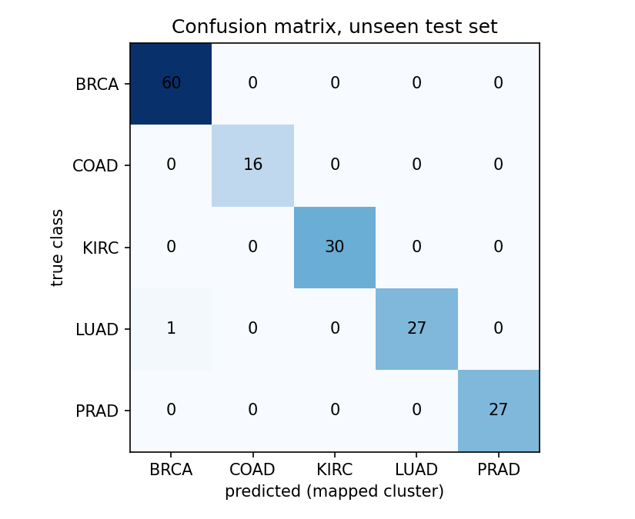
Fig. 2 – Confusion matrix on the unseen test set.
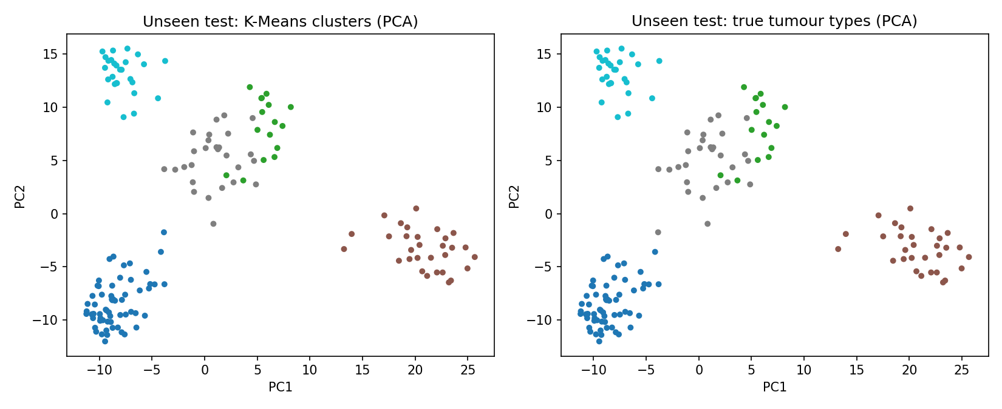
Fig. 3 – Unseen test samples in the first two PCs: K-Means clusters (left) vs true tumour types (right).

7. Testing on a large unseen dataset
To check that the result does not depend on one small test split, the final pipeline (hyper-parameters fixed) was retrained on only 50 % or only 20 % of all 801 samples and tested on the remaining 401 or 641 never-seen samples, repeated over 10 random stratified splits each (results/large_unseen_tests.csv).
 | Accuracy (mean) | Accuracy (std) | Accuracy (min) | ARI (mean)
train 160 / unseen 641 | 0.9977 | 0.0011 | 0.9953 | 0.9929
train 400 / unseen 401 | 0.9980 | 0.0020 | 0.9950 | 0.9940
Even when trained on only 160 samples, the model groups 641 unseen samples with 99.77% mean accuracy, confirming that the tumour-type structure found by K-Means is stable and generalises to new data.

8. Model versions
Three versions were trained in Google Colab; each is stored in its own folder under model/ with its notebook (with outputs), saved model (.joblib), results (.csv/.json) and figures.
 | Changes | Unseen-test accuracy | ARI
v1 – version1_baseline | 2,000 top-variance genes, k = 5; cluster→class matching done on the test set | 98.76% | 0.972
v2 – version2_cv_tuned | 5-fold CV tuning on training set → 500 genes; cluster→class map learned on training labels | 99.38% | 0.981
v3 – version3_large_unseen_test | Version 2 + robustness test on 401 / 641 unseen samples (final) | 99.38% | 0.981
Improvement from v1 to v2 comes from (i) using fewer, more informative genes – 500 instead of 2,000 – which removes noisy dimensions from the Euclidean distance, and (ii) a stricter, leak-free evaluation where the cluster→class mapping is learned only from training data.

9. Analysis of results
- Without ever seeing labels during clustering, K-Means recovered the five tumour types almost perfectly: 99.38% accuracy and ARI 0.981 on unseen samples, close to the training result (99.84%), so the model generalises and does not over-fit.
- Misclassifications on the test set: 1 LUAD sample(s) grouped with BRCA. Errors occur between tissues with related biology/expression programmes (e.g. adenocarcinomas of different organs), while tissue-specific cancers such as KIRC and PRAD form very compact clusters.
- Cross-validation showed that restricting to the 500 most variable genes gave the best accuracy (99.84% CV vs 99.22% with 5,000 genes), while PCA gave no further gain: low-variance genes add noise to Euclidean distances, confirming the paper’s point that the proximity measure and the data representation determine cluster quality.
- The silhouette score is moderate (0.32) even though accuracy is high: in high-dimensional expression space the clusters are well separated in direction but not perfectly spherical – consistent with the paper’s observation that gene-expression clusters are often elongated rather than Euclidean.
- Choosing k: the elbow/silhouette curves support k ≈ 5, agreeing with the five biological tumour types, illustrating the paper’s remark that the number of clusters must be determined by an additional search procedure.

10. Conclusion
Following the assigned paper, RNA-seq expression data were log-transformed and filtered, and K-Means (M11) was used to discover tumour-type clusters without supervision. With hyper-parameters chosen by cross-validation on training data only, the model reaches 99.38% accuracy (ARI 0.981, NMI 0.981) on unseen samples, showing that clustering of gene expression reveals biologically meaningful groups. Limitations: k was fixed using prior knowledge of the five classes, and K-Means assumes spherical clusters; hierarchical, density-based (DBSCAN) or Mahalanobis-distance clustering, as discussed in the paper, are natural extensions.

11. Submission folder structure
- dataset/ – original UCI archive (gene_expression_cancer_rna_seq_UCI401.zip: data.csv 801×20,531 + labels.csv) and labels.csv.
- model/version1_baseline/, model/version2_cv_tuned/, model/version3_large_unseen_test/ – notebook with outputs, model/kmeans_pancan.joblib, results/ (metrics.json, metrics.csv, confusion_test.csv, cv_tuning.csv, large_unseen_tests.csv) and figures/.
- model/build_notebook.py and model/kmeans_gene_expression.ipynb – source that generates the final notebook (run in Google Colab).
- report/ – this report and build_report.py, which builds it from the saved results.

References
- O. Georgieva, “Clustering for Gene Expression Analysis,” ERIS 2022, CEUR-WS Vol-3372, pp. 17–24, 2022.
- S. Fiorini, “Gene expression cancer RNA-Seq,” UCI Machine Learning Repository, 2016, doi:10.24432/C5R88H.
- The Cancer Genome Atlas Research Network et al., “The Cancer Genome Atlas Pan-Cancer analysis project,” Nat. Genet. 45, 2013.
- F. Pedregosa et al., “Scikit-learn: Machine Learning in Python,” JMLR 12, 2011.

