**Nevil K Benny**

**242BDA32**

**1) What is rag in the context of generative AI**

In the context of generative AI, RAG stands for Retrieval-Augmented Generation. It is an approach that combines two main components:

Retrieval: A system that retrieves relevant information from a large external knowledge base, document store, or dataset in response to a query.

Generation: A generative model (like GPT-3, GPT-4, etc.) that produces natural language responses or content based on both the retrieved information and the input query.

How RAG Works:

When a query is input into a RAG system, it first uses a retrieval mechanism to fetch documents or relevant passages from a large corpus (e.g., web pages, databases, internal documentation).

The retrieved content is then fed into a generative language model that incorporates this information to generate more accurate, contextually aware, and detailed responses.

Key Features of RAG:

Combines retrieval with generation: Unlike purely generative models that rely solely on pre-trained knowledge, RAG uses real-time information retrieval to provide more accurate, up-to-date, and factual responses.

Improves factuality and reliability: Since RAG models fetch relevant information from a reliable source, they reduce the chances of hallucinations (i.e., generating incorrect or misleading content), which is common in standalone generative models.

Customizable for specific domains: RAG models can be fine-tuned to specific use cases (e.g., customer support, research) by curating the retrieval source.

Example:

Imagine a model that answers technical questions. In a RAG setup, the system will first retrieve relevant documentation from a knowledge base and then use a generative model to provide a natural language answer, incorporating the retrieved information for higher accuracy.

Applications:

Search engines: RAG can power advanced search where users get well-formed answers instead of a list of links.

Customer support: Provide accurate, detailed responses by retrieving relevant support articles and generating human-like responses.

Research and education: Answer complex questions by pulling information from various sources (books, papers, etc.) and synthesizing a coherent answer.

RAG Model Example:

Facebook AI (Meta) developed a RAG model by combining a retrieval system with BART (a generative model) to answer open-domain questions.

**2) What is attention mechanism in the context of neural networking**

The attention mechanism in the context of neural networks is a computational technique that allows models to focus on specific parts of the input data when making predictions or decisions, effectively prioritizing more relevant information. It was originally introduced to improve the performance of sequence-to-sequence models, especially in tasks like machine translation, but it has since become a core component of many modern neural network architectures, including transformers (e.g., GPT, BERT).

Key Concept of Attention:

In tasks where an input sequence (like a sentence) is processed, not all parts of the sequence are equally important for predicting the output. The attention mechanism allows the model to dynamically weigh the relevance of different parts of the input. It computes a weighted combination of all the elements in the input sequence, giving higher importance (or attention) to parts that are more relevant to the task at hand.

How the Attention Mechanism Works:

Input Representation: The input consists of a sequence of tokens (e.g., words in a sentence), each represented as a vector.

Query, Key, and Value Vectors:

Query: Represents the current word or token that’s being processed (e.g., a word in the output sequence).

Key: Represents each word or token in the input sequence.

Value: Also represents each word or token in the input sequence, but is used to generate the final output.

These vectors are produced through learned linear transformations of the input.

Attention Scores (Relevance): The model computes the similarity (or relevance) between the query and each key vector using a dot product or another similarity measure. This results in attention scores, which indicate how much attention should be paid to each token in the input sequence.

Softmax and Weights: The attention scores are passed through a softmax function, converting them into a probability distribution. This ensures that the weights sum to 1, meaning they represent the relative importance of each token.

Weighted Sum of Values: The weighted sum of the value vectors (based on the attention weights) is computed. This output represents the relevant information that the model uses to make predictions.

Output: The model uses this weighted sum as input for further processing, typically in the generation of the next token in a sequence (e.g., in machine translation, the next word in the translated sentence).

Types of Attention Mechanisms:

Self-Attention (or Intra-Attention): In this mechanism, each token in the sequence pays attention to other tokens in the same sequence. It is widely used in transformers and allows the model to capture long-range dependencies between words, regardless of their position in the sequence.

Global vs. Local Attention:

Global attention: Every word in the sequence can attend to every other word.

Local attention: The model only attends to nearby tokens, reducing computational cost.

Multi-Head Attention: This is an extension where the attention mechanism is applied multiple times (with different learned parameters), allowing the model to attend to different parts of the sequence simultaneously. It is a key feature of transformers.

Importance of Attention Mechanism:

Improves interpretability: Attention weights can show which parts of the input the model is focusing on, making it easier to understand the decision-making process.

Handles long-range dependencies: In tasks like machine translation, long sentences can pose a challenge for traditional neural networks (like RNNs), but attention mechanisms allow the model to capture dependencies between words that are far apart in the sequence.

Parallelizable: The attention mechanism, especially in the transformer architecture, enables parallel processing of sequence data, which is more efficient than sequential processing in traditional RNNs or LSTMs.

Example of Attention in Action (Machine Translation):

In translating the sentence "I love programming" from English to French, the model can learn that "I" should correspond to "Je," "love" to "aime," and "programming" to "la programmation," paying varying levels of attention to each word in the original sentence when generating the translated sentence.

**3) what is carl Pearson correlation coefficient and can it be used on categorical or nomial or ordinal variables**

The Pearson correlation coefficient (also known as Pearson’s r or Carl Pearson correlation coefficient) is a measure of the linear relationship between two continuous variables. It quantifies how strongly two variables are related to each other on a scale from -1 to +1:

+1 indicates a perfect positive linear relationship (as one variable increases, the other also increases).

0 indicates no linear relationship.

-1 indicates a perfect negative linear relationship (as one variable increases, the other decreases).

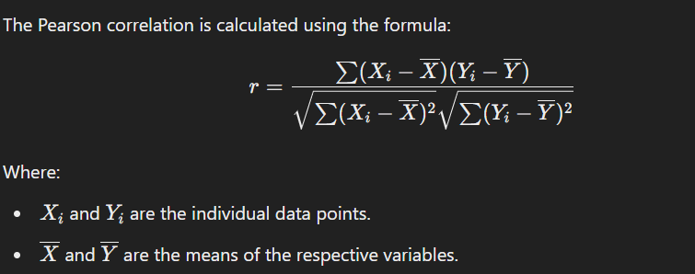

No, the Pearson correlation coefficient is not suitable for categorical, nominal, or ordinal variables for the following reasons:

Why Pearson Correlation Doesn't Work for Categorical Data:

Categorical Data: These data types consist of labels or categories that do not have a meaningful numerical representation. Examples include gender (male/female), marital status (single/married), or types of cars (SUV, sedan). Since Pearson’s r relies on numerical values to compute averages and variances, categorical data cannot be used directly.

Nominal Variables:

Nominal variables are purely categorical and have no inherent order or rank (e.g., colors, types of fruit, gender). Since there is no numerical distance or ranking between categories, Pearson correlation is inappropriate.

Ordinal Variables:

Ordinal variables have a natural order but the differences between ranks are not necessarily equal (e.g., education level: high school, college, graduate). While ordinal variables have some form of ranking, Pearson correlation requires the distances between values to be meaningful and consistent, which is not guaranteed in ordinal data.

Alternatives to Pearson Correlation for Categorical Data:

Spearman’s Rank Correlation:

Suitable for ordinal data where you want to measure the monotonic relationship between variables (whether they increase together, even if not linearly).

Spearman's correlation works by ranking the data and then applying a formula similar to Pearson's but on the ranks instead of raw values.

Kendall’s Tau:

Another non-parametric method for measuring the strength of association between two ordinal variables, particularly useful with small sample sizes or when there are many tied ranks.

Chi-Square Test of Independence:

Appropriate for nominal or categorical data. It tests whether two categorical variables are independent of each other in a contingency table.

Point-Biserial Correlation:

Used when one variable is continuous and the other is binary (e.g., success/failure, male/female).

Cramér's V:

This is a measure of association between two nominal variables in a contingency table. It can handle categorical variables and gives a result between 0 and 1, where 0 indicates no association and 1 indicates a strong association.

In Summary:

The Pearson correlation coefficient is designed for continuous, interval, or ratio variables with a linear relationship.

It cannot be used for categorical (nominal) or ordinal variables because they lack the necessary numerical structure.

For ordinal or categorical variables, consider alternatives like Spearman’s correlation, Chi-square test, or Cramér's V.

**4) How is carl Pearson correlation coefficient is related to bi variate R^2**

Relationship Between Pearson Correlation Coefficient and R^2 in a Bivariate Case

The Pearson correlation coefficient (r) and R^2 are closely related in the context of bivariate linear regression, where you're examining the relationship between two continuous variables X and Y. Specifically:

* The Pearson correlation coefficient (r) measures the strength and direction of the linear relationship between two variables.
* R^2, or the coefficient of determination, measures the proportion of variance in the dependent variable (Y) that is explained by the independent variable (X).

### Key Relationship:

In the case of **simple linear regression** (bivariate case with one independent variable X and one dependent variable Y:

R^2 = r^2

This means that R^2 is simply the **square** of the **Pearson correlation coefficient**.

### Why Is This the Case?

* **Pearson correlation coefficient (**r**)**:
  + Ranges from **-1** to **+1**.
  + A value of r=1 means a perfect positive linear relationship.
  + A value of r=−1 means a perfect negative linear relationship.
  + A value of r=0 means no linear relationship.
* R^2:
  + Ranges from **0** to **1**.
  + It indicates the **proportion of variance** in Y that is explained by X.
  + When r=1, R^2 = 1 (i.e., 100% of the variance in Y is explained by X).
  + When r=0, R^2 =0(i.e., X does not explain any variance in Y).

In summary, when performing **simple linear regression**:

* r describes the linear relationship between X and Y.
* R^2 = r^2 tells you how much of the variance in Y is explained by the linear relationship with X.

**5) Explain Bi-section method at most in 10 steps (Topic from numerical methods)**

### **Bisection Method: Steps in Numerical Methods**

The **bisection method** is a root-finding algorithm used to solve equations of the form f(x)=0f(x) = 0f(x)=0 by iteratively narrowing down the interval that contains the root. Here's a concise explanation of the method in **10 steps**:

1. **Choose Interval [a, b]**:
   * Start with an interval [a,b][a, b][a,b] where the function f(x)f(x)f(x) has opposite signs at the endpoints, i.e., f(a)×f(b)<0f(a) \times f(b) < 0f(a)×f(b)<0. This ensures there is at least one root in the interval by the **Intermediate Value Theorem**.
2. **Check for Exact Root**:
   * Evaluate f(a)f(a)f(a) and f(b)f(b)f(b). If either f(a)=0f(a) = 0f(a)=0 or f(b)=0f(b) = 0f(b)=0, you have found the root directly.
3. **Calculate Midpoint**:
   * Compute the midpoint of the interval: c=a+b2c = \frac{a + b}{2}c=2a+b​.
4. **Evaluate f(c)**:
   * Calculate f(c)f(c)f(c), where ccc is the midpoint.
5. **Check for Root at Midpoint**:
   * If f(c)=0f(c) = 0f(c)=0, then ccc is the root, and the process stops.
6. **Decide New Interval**:
   * If f(a)×f(c)<0f(a) \times f(c) < 0f(a)×f(c)<0, the root lies in [a,c][a, c][a,c], so update b=cb = cb=c.
   * If f(b)×f(c)<0f(b) \times f(c) < 0f(b)×f(c)<0, the root lies in [c,b][c, b][c,b], so update a=ca = ca=c.
7. **Update Interval**:
   * Continue narrowing the interval by selecting the subinterval that contains the root.
8. **Set Tolerance**:
   * Decide on a stopping criterion, such as when the interval length ∣b−a∣|b - a|∣b−a∣ becomes smaller than a chosen tolerance ϵ\epsilonϵ.
9. **Repeat Steps**:
   * Repeat steps 3-8 until the interval is sufficiently small or f(c)f(c)f(c) is close enough to zero.
10. **Return Approximate Root**:
    * The midpoint ccc of the final interval is taken as the approximate root.

**6) Mean VS MEDIAN which is the most stable metric (Answer is -Median)**

The **median** is considered a more stable metric compared to the **mean** in many situations because of its **resistance to outliers** and **skewed data**. Here's a comparison of the two:

### 1. **Mean**:

* The **mean** is the sum of all values divided by the number of values.
* It is **sensitive to extreme values** or outliers because every data point contributes to the calculation.

**Example**:

* + Data: [1, 2, 3, 4, 100]
  + Mean = 1+2+3+4+1005=22\frac{1+2+3+4+100}{5} = 2251+2+3+4+100​=22

In this example, the outlier (100) significantly increases the mean, making it less representative of the central tendency of the data.

### 2. **Median**:

* The **median** is the middle value in an ordered data set, or the average of the two middle values if the dataset has an even number of elements.
* It is **not affected by extreme values** or outliers, as it depends solely on the position of data points, not their magnitude.

**Example**:

* + Data: [1, 2, 3, 4, 100]
  + Median = 3 (middle value in the sorted dataset)

Here, the outlier (100) does not affect the median, which remains at 3, making it a more stable measure of central tendency.

### 3. **Stability and Robustness**:

* The **median** is **more stable** because it remains unaffected by **extreme values** and **skewness** in the dataset.
* The **mean** can be drastically shifted by even one extreme outlier, making it **less reliable** when the data contains anomalies or is skewed.

### In Summary:

The **median** is the most stable metric, especially for datasets with outliers or non-normal distributions, because it better represents the central tendency of such data without being influenced by extreme values.

**7) What is central limit theorem ?**

### **Central Limit Theorem (CLT)**

The **Central Limit Theorem (CLT)** is a fundamental concept in statistics that describes the behavior of the **sampling distribution** of the **sample mean**. It states that, **regardless of the population distribution**, the distribution of the sample means will approximate a **normal distribution** as the sample size becomes large enough, given that the samples are independent and identically distributed (i.i.d.).

### **Key Points of the Central Limit Theorem**:

1. **Population Distribution**:
   * The population from which the samples are drawn can follow any distribution (e.g., normal, skewed, uniform, etc.).
2. **Sampling Distribution of the Mean**:
   * If you take repeated random samples of size nnn from the population and calculate their means, the distribution of these means (called the **sampling distribution of the mean**) will tend to become **normal** as nnn increases.
3. **Approximation to Normality**:
   * The larger the sample size (nnn), the closer the sampling distribution of the sample mean will be to a **normal distribution**, regardless of the original population's distribution.
4. **Sample Size Requirement**:
   * In general, for most distributions, the sampling distribution will be approximately normal if the sample size n≥30n \geq 30n≥30. For distributions that are very skewed or have extreme outliers, a larger sample size may be needed.
5. **Mean and Standard Deviation**:
   * The mean of the sampling distribution of the sample means will be the **same** as the population mean (μ\muμ).
   * The standard deviation of the sampling distribution, called the **standard error** of the mean, will be equal to: σmean=σn\sigma_{\text{mean}} = \frac{\sigma}{\sqrt{n}}σmean​=n​σ​ where σ\sigmaσ is the population standard deviation, and nnn is the sample size.

### **Why the Central Limit Theorem is Important**:

1. **Justifies Normal Approximation**:
   * The CLT allows us to use the **normal distribution** to make inferences about population parameters (like the mean) even when the underlying population is not normally distributed, provided the sample size is sufficiently large.
2. **Foundation for Statistical Inference**:
   * The CLT is the basis for many statistical methods, including hypothesis testing and confidence intervals for the sample mean, because it enables the use of normal distribution tables.
3. **Law of Large Numbers**:
   * As sample size increases, the sample mean converges to the population mean. The CLT supports this by ensuring that the sampling distribution of the mean becomes normal as sample size increases.

### **Example**:

* Imagine you're drawing random samples of size 50 from a population that has a **skewed** distribution. According to the CLT, the distribution of the sample means will approximate a **normal distribution**, even though the population itself is not normally distributed. This allows you to use normal probability models for statistical analysis.

### **Summary**:

The **Central Limit Theorem** is a powerful result in probability and statistics that ensures the **sampling distribution** of the sample mean approaches a **normal distribution** as the sample size increases, regardless of the shape of the original population distribution. This property makes it crucial for statistical inference.

**8) Write about the accelerated failure time prediction algorithm**

### **Accelerated Failure Time (AFT) Prediction Algorithm**

The **Accelerated Failure Time (AFT) model** is a type of **survival analysis** model used to predict the **time until an event occurs** (often called "failure" or "survival time"). Unlike the popular **Cox proportional hazards model**, which focuses on the hazard rate (the instantaneous risk of failure at a given time), the AFT model focuses on **directly modeling the survival time** itself.

The AFT model assumes that the effect of covariates accelerates or decelerates the survival time. In other words, it tries to **explain how different factors either speed up or slow down the time until an event occurs**.

### **Key Concepts of the AFT Model**:

1. **Basic Assumption**:
   * The **logarithm** of the survival time is a **linear function** of covariates. The model assumes that different covariates either accelerate or decelerate the expected survival time.

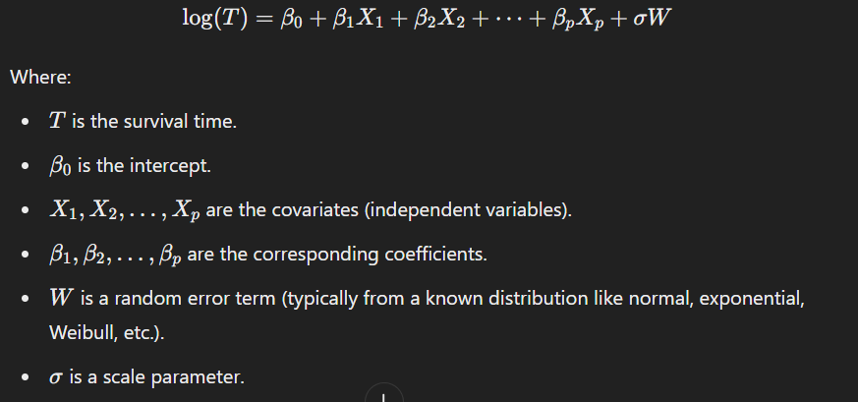

1. **Acceleration Factor**:
   * The model introduces the concept of an **acceleration factor**. This factor tells us how much faster (or slower) an event is expected to happen under certain conditions.
   * For example, an acceleration factor of 0.5 means the process speeds up by half, while a factor of 2 means it slows down, effectively doubling the expected time to the event.
2. **Linear Transformation of Survival Time**:
   * The **log transformation** of the survival time makes the AFT model similar to linear regression in form, and it allows the model to estimate the effect of covariates on survival time in a straightforward way.
3. **Distributional Assumptions**:
   * The AFT model requires that the survival times follow a specific statistical distribution. Commonly used distributions include:
     + **Exponential distribution**
     + **Weibull distribution**
     + **Log-normal distribution**
     + **Log-logistic distribution**
   * The choice of distribution affects the shape of the survival curve and the model’s predictions.

### **Advantages of the AFT Model**:

1. **Direct Prediction of Survival Time**:
   * The AFT model directly predicts how much time until the event (like failure or death) occurs, which is often more interpretable and actionable in real-world settings.
2. **Covariates Have Multiplicative Effect on Time**:
   * The AFT model explains how covariates either speed up or slow down the event time by a constant factor, making it easier to understand the impact of specific variables on time.
3. **Handles Different Distributions**:
   * By choosing different underlying distributions (e.g., Weibull, log-normal), the AFT model can be adapted to a wide variety of survival time shapes.

### **Disadvantages of the AFT Model**:

1. **Distribution Assumptions**:
   * The AFT model requires assumptions about the underlying distribution of survival times. If the assumed distribution does not fit the data well, predictions may be inaccurate.
2. **Less Common in Practice**:
   * While powerful, the AFT model is used less often than the Cox proportional hazards model, which is more flexible and doesn't require assumptions about the distribution of survival times.

### **Example Use Cases**:

1. **Medical Survival Analysis**:
   * Predicting time to death or disease relapse after treatment, while taking into account factors like age, treatment type, and biomarkers.
2. **Reliability Engineering**:
   * Estimating the time until a machine or component fails based on factors like environmental conditions or usage intensity.
3. **Customer Churn Analysis**:
   * Predicting how long a customer will remain with a company before churning, given customer characteristics and behaviors.

### **Summary**:

The **Accelerated Failure Time (AFT) model** is a survival analysis technique that directly models the **time to an event**. It explains how covariates **accelerate or decelerate** the expected survival time, making it useful for applications where you need to predict the time until an event occurs, such as equipment failure, customer churn, or patient survival. The AFT model requires assumptions about the distribution of survival times but provides an intuitive way to understand how variables impact survival duration.

**9) What is a multicollinearity (Why it is bad or what does it cause) - give in detail manner and along with mathematical explanation**

**Definition**: Multicollinearity refers to a situation in regression analysis where two or more independent variables are highly correlated, meaning they contain similar information about the variance in the dependent variable. This correlation can lead to issues in estimating the coefficients of the regression model accurately.

### **Why is Multicollinearity Bad?**

1. **Unstable Coefficient Estimates**:
   * When multicollinearity is present, the coefficients of the correlated variables can become very sensitive to small changes in the data. This instability makes it difficult to determine the individual effect of each independent variable on the dependent variable.
2. **Increased Variance of Coefficient Estimates**:
   * The standard errors of the estimated coefficients can become inflated, which leads to wider confidence intervals. This inflation can cause some independent variables to appear statistically insignificant when they are actually important predictors.
3. **Difficult Interpretation**:
   * When two or more variables are highly correlated, it becomes challenging to interpret the coefficients of those variables. It can be unclear which variable is driving the effect on the dependent variable.
4. **Redundant Information**:
   * Multicollinearity means that at least one of the variables is providing redundant information about the dependent variable. This redundancy can complicate the model and reduce its predictive power.
5. **Impact on Model Performance**:
   * Although multicollinearity does not affect the overall fit of the model (e.g., the R-squared value), it can lead to poorer predictions and more difficulty in model selection and evaluation.

### **Mathematical Explanation**

#### **Variance Inflation Factor (VIF)**:

One common method to detect multicollinearity is to compute the **Variance Inflation Factor (VIF)** for each predictor variable. The VIF quantifies how much the variance of an estimated regression coefficient increases due to multicollinearity.

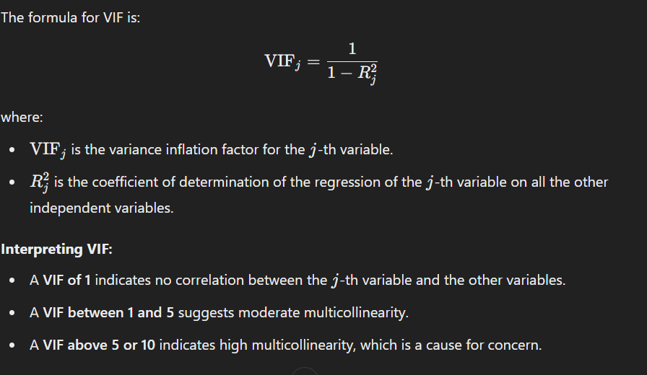

* A **VIF of 1** indicates no correlation between the jjj-th variable and the other variables.
* A **VIF between 1 and 5** suggests moderate multicollinearity.
* A **VIF above 5 or 10** indicates high multicollinearity, which is a cause for concern.

### **Example**:

Suppose you are trying to predict house prices based on several features, including square footage, number of bedrooms, and number of bathrooms. If square footage and number of bedrooms are highly correlated (larger houses tend to have more bedrooms), multicollinearity may arise.

* If you fit a regression model, the estimated coefficients for square footage and number of bedrooms may be unstable. For example, if you slightly change the data (adding or removing a house), the coefficient for square footage might jump significantly, while the coefficient for the number of bedrooms might decrease or even switch signs.

### **Consequences of Multicollinearity**:

* **Loss of Precision**: The confidence intervals for the coefficients will be wider, making hypothesis testing more difficult.
* **Inflated Standard Errors**: The standard errors of the estimated coefficients can increase, affecting the t-statistics and p-values.
* **Redundancy**: Including highly correlated variables may not improve the model but complicates it, making it harder to interpret.

### **Addressing Multicollinearity**:

1. **Remove Highly Correlated Variables**:
   * If two variables are highly correlated, consider removing one of them from the model.
2. **Combine Variables**:
   * Create a new variable that combines the correlated variables (e.g., taking the average or using principal component analysis).
3. **Regularization Techniques**:
   * Use techniques like **Ridge Regression** or **Lasso Regression**, which add a penalty for large coefficients, helping to stabilize estimates in the presence of multicollinearity.
4. **Increase Sample Size**:
   * Sometimes, increasing the sample size can help alleviate the effects of multicollinearity.

### **Summary**:

Multicollinearity is a significant issue in regression analysis that occurs when independent variables are highly correlated. It can lead to unstable estimates, inflated standard errors, and difficulties in interpreting coefficients, ultimately affecting the model's predictive power. Identifying and addressing multicollinearity is crucial for building reliable and interpretable regression models.

**10) If you have multicollinearity can you trust your coefficient**

When multicollinearity is present in a regression model, you should be cautious about trusting the estimated coefficients for several reasons:

1. **Unstable Coefficients**:
   * The presence of multicollinearity can cause the estimated coefficients to become highly sensitive to changes in the data. A small change in the dataset (such as adding or removing observations) can lead to large fluctuations in the coefficient estimates. This instability makes it difficult to interpret the coefficients reliably.
2. **Inflated Standard Errors**:
   * Multicollinearity often results in inflated standard errors for the coefficients. As a consequence, the confidence intervals for the coefficients will be wider, which can lead to p-values that suggest the coefficients are not statistically significant when they might actually be.
3. **Difficulty in Interpretation**:
   * When independent variables are correlated, it becomes challenging to ascertain the individual effect of each variable on the dependent variable. The coefficients may not reflect the true impact of a variable because the effect could be confounded with that of another correlated variable.
4. **Redundancy**:
   * Multicollinearity means that some variables provide overlapping information about the dependent variable. This redundancy can obscure the true relationships in the data, making it difficult to determine which variables are truly important.

### Conclusion:

In summary, when multicollinearity exists, you should **not fully trust** the estimated coefficients for the following reasons:

* They may not represent the true relationships in the data.
* Their variability and uncertainty increase significantly, leading to unreliable predictions and interpretations.

### Recommended Actions:

1. **Assess Multicollinearity**:
   * Use tools like **Variance Inflation Factor (VIF)** to quantify the severity of multicollinearity.
2. **Consider Removing Variables**:
   * Identify and remove one of the correlated variables or combine them into a single variable.
3. **Use Regularization Techniques**:
   * Techniques like **Ridge Regression** or **Lasso Regression** can help mitigate the effects of multicollinearity.
4. **Reassess Model Fit**:
   * After addressing multicollinearity, refit the model and check if the coefficients stabilize and improve in interpretability.

By taking these steps, you can enhance the reliability of your coefficient estimates and the overall robustness of your regression model.

**11) What is the difference between functional and dynamic programming**

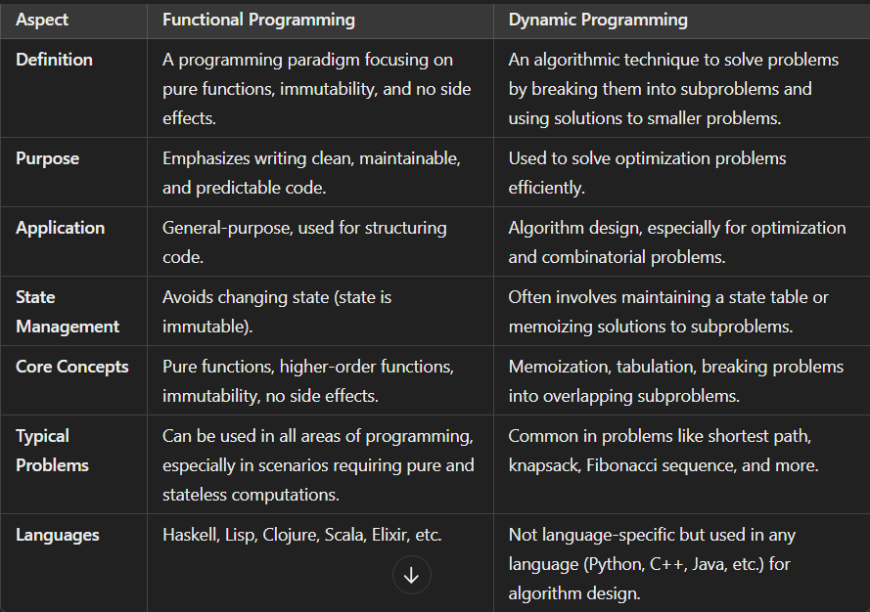

**12) Write A Program to identify Currency notes to be dispatched**

def identify_currency_notes(amount):

# Define the currency notes available

notes = [100, 50, 20, 10, 5, 1]

note_count = {}

# Iterate through each note type

for note in notes:

if amount >= note:

count = amount // note # Find how many notes of this denomination

note_count[note] = count # Store the count in the dictionary

amount -= count * note # Decrease the amount by the dispatched notes

return note_count

# Input: Amount to be dispatched

amount_to_dispatch = int(input("Enter the amount to be dispatched: "))

# Get the currency notes

currency_notes = identify_currency_notes(amount_to_dispatch)

# Output the results

if currency_notes:

print("Currency notes to be dispatched:")

for note, count in currency_notes.items():

print(f"₹{note} x {count}")

else:

print("No currency notes needed.")

**13) How do you find the impact of change on a variable (Statistical significant change)**

To assess the impact of change on a variable and determine whether it is statistically significant, you can follow these steps:

### 1. **Formulate Your Hypotheses**:

* **Null Hypothesis (**H0H_0H0​**)**: There is no significant change in the variable (e.g., the mean before and after the change is the same).
* **Alternative Hypothesis (**H1H_1H1​**)**: There is a significant change in the variable.

### 2. **Collect Data**:

* Gather relevant data before and after the change. This could be time-series data, experimental data, or any other relevant dataset.

### 3. **Choose the Appropriate Statistical Test**:

* Depending on the nature of your data (paired vs. unpaired, normally distributed vs. non-normally distributed), you can choose from several statistical tests:
  + **T-Test**: If you have two sets of normally distributed data (independent samples), use a t-test (independent or paired).
  + **ANOVA**: If comparing more than two groups.
  + **Mann-Whitney U Test**: For non-parametric data (when normality cannot be assumed).
  + **Chi-Square Test**: For categorical variables.

### 4. **Check Assumptions**:

* Ensure that the data meets the assumptions of the selected test, such as normality and homogeneity of variances (for t-tests and ANOVA).

### 5. **Calculate the Test Statistic**:

* Perform the statistical test to calculate the test statistic (e.g., t-value, F-value).

### 6. **Determine the P-Value**:

* The p-value indicates the probability of observing the data, assuming the null hypothesis is true. It helps you decide whether to reject or fail to reject the null hypothesis.

### 7. **Set a Significance Level (**α\alphaα**)**:

* Commonly, α\alphaα is set at 0.05. This means you are willing to accept a 5% chance of incorrectly rejecting the null hypothesis (Type I error).

### 8. **Make a Decision**:

### 

### 9. **Report Results**:

* Clearly report your findings, including the test statistic, p-value, and confidence intervals if applicable.

### Example:

Suppose you want to determine if a new marketing strategy has significantly increased sales:

1. **Hypotheses**:
   * H0H_0H0​: The mean sales before and after the strategy are equal.
   * H1H_1H1​: The mean sales after the strategy are greater than before.
2. **Data**:
   * Collect sales data for a month before and after implementing the strategy.
3. **Statistical Test**:
   * Use a paired t-test if the sales data is normally distributed.
4. **Calculate the Test Statistic**:
   * Perform the t-test and obtain the t-value and p-value.
5. **Decision**:
   * If the p-value is less than 0.05, conclude that the marketing strategy had a statistically significant impact on sales.

### Conclusion:

By following these steps, you can rigorously assess the impact of change on a variable and determine if the change is statistically significant, allowing for informed decision-making based on data.

**14) What is no free lunch theorem in Machine Learning**

The **No Free Lunch (NFL) Theorem** is a concept in optimization and machine learning that states that no single algorithm works best for all problems. This means that if an algorithm performs well on a certain class of problems, it will perform poorly on another class of problems. Here’s a breakdown of the theorem and its implications:

### **Key Points of the No Free Lunch Theorem**:

1. **All Problems Are Equal**:
   * The theorem posits that when averaged over all possible problems, every algorithm has the same performance. Thus, no algorithm can be universally superior across all problem domains.
2. **Performance Trade-Offs**:
   * An algorithm that performs exceptionally well on one type of problem may perform poorly on another type. For example, a gradient descent algorithm might work well for convex optimization problems but struggle with non-convex problems.
3. **Implications for Algorithm Selection**:
   * The NFL theorem emphasizes the importance of selecting algorithms based on the specific characteristics of the problem at hand. Practitioners should consider the nature of the data, the problem structure, and the underlying assumptions of the algorithms.
4. **Diversity in Algorithms**:
   * The theorem encourages the use of diverse algorithms and techniques to address different types of problems. It highlights the need for understanding the strengths and weaknesses of various approaches.
5. **Empirical Evaluation**:
   * Given that there is no one-size-fits-all solution, empirical evaluation and experimentation become crucial. Practitioners should validate algorithms on their specific datasets and problem domains to determine the best approach.

### **Mathematical Basis**:

The NFL theorem can be expressed mathematically in the context of optimization:

* If fff is a function representing a problem, and AAA is an algorithm, the performance of AAA on fff can vary significantly depending on the structure of fff.
* If one algorithm outperforms another on a certain subset of problems, the opposite is also true for a different subset of problems.

### **Practical Implications**:

* **Algorithm Selection**: When tackling a machine learning problem, consider multiple algorithms and evaluate their performance rather than assuming one will be the best choice.
* **Problem Understanding**: Deeply understand the specific characteristics of the problem and data you are working with, as this can guide you in choosing the most suitable algorithm.
* **Continual Learning**: Stay updated with advancements in algorithms, as new techniques may offer better performance for specific classes of problems.

### **Conclusion**:

The No Free Lunch theorem serves as a fundamental principle in machine learning and optimization, reminding practitioners that there is no universally best algorithm. Instead, success in machine learning relies on carefully selecting and tuning algorithms based on the specific problem and data at hand.

**15) What is price elasticity of demand**

**Price elasticity of demand (PED)** measures how the quantity demanded of a good responds to a change in its price. It quantifies the sensitivity of consumers to price changes, providing insight into consumer behavior and helping businesses and policymakers make informed decisions.

### **Key Concepts**:

1. **Definition**:
   * Price elasticity of demand is defined as the percentage change in the quantity demanded of a good divided by the percentage change in its price.

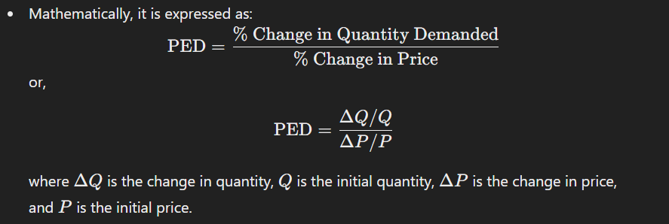

1. **Types of Price Elasticity**:
   * **Elastic Demand (PED > 1)**: A small change in price leads to a larger change in quantity demanded. Consumers are very responsive to price changes (e.g., luxury goods).
   * **Inelastic Demand (PED < 1)**: A change in price leads to a smaller change in quantity demanded. Consumers are less responsive (e.g., necessities like food and medicine).
   * **Unitary Elastic Demand (PED = 1)**: A change in price leads to a proportional change in quantity demanded.
2. **Determinants of Price Elasticity**:
   * **Availability of Substitutes**: More substitutes lead to more elastic demand.
   * **Necessity vs. Luxury**: Necessities tend to have inelastic demand, while luxuries have elastic demand.
   * **Proportion of Income**: Goods that take a larger share of income tend to have more elastic demand.
   * **Time Frame**: Demand elasticity can change over time; demand is often more elastic in the long run as consumers find alternatives.
3. **Importance**:
   * **Pricing Strategy**: Businesses can set prices based on demand elasticity to maximize revenue. For elastic demand, lowering prices may increase total revenue, while for inelastic demand, raising prices may increase total revenue.
   * **Taxation and Policy**: Policymakers consider elasticity when imposing taxes, as taxing inelastic goods (like tobacco) may lead to stable revenue.
4. **Calculation Example**:
   * Suppose the price of a product increases from $10 to $12 (a 20% increase), and the quantity demanded decreases from 100 units to 80 units (a 20% decrease).

\text{PED} = \frac{-20%}{20%} = -1 ]

* + Since the absolute value of PED is 1, the demand is unitary elastic.

### **Conclusion**:

Price elasticity of demand is a crucial concept in economics that helps explain consumer behavior in response to price changes. Understanding PED allows businesses to optimize pricing strategies and helps policymakers assess the impact of economic policies on consumer welfare.

**16) What is spurious correlation?**

**Spurious correlation** refers to a situation in statistics where two variables appear to be correlated, but the correlation is not due to any direct relationship between them. Instead, the correlation is often caused by a third variable or confounding factor that affects both variables, leading to misleading conclusions about their relationship.

### **Key Characteristics**:

1. **False Relationships**:
   * Spurious correlations can create the illusion of a meaningful connection between two variables when, in reality, they are not related. This can lead to incorrect interpretations and conclusions.
2. **Third Variables**:
   * The correlation may be driven by an unseen variable that influences both correlated variables. For example, ice cream sales and drowning incidents might show a positive correlation during summer months, but both are influenced by the warmer weather.
3. **Coincidence**:
   * Sometimes, two variables may show a correlation purely by chance. With enough data, random patterns can emerge, leading to false correlations.

### **Examples**:

1. **Ice Cream Sales and Drowning Rates**:
   * In summer, both ice cream sales and drowning rates increase. While they are correlated, the actual cause is the warmer weather that leads to more people swimming and buying ice cream, not a direct relationship between the two.
2. **Number of Churches and Crime Rates**:
   * A study might find a correlation between the number of churches in a city and crime rates. However, both could be influenced by population size; larger populations tend to have more churches and more crime, leading to a spurious correlation.

### **Implications**:

* **Misleading Interpretations**: Relying on spurious correlations can result in poor decision-making, especially in fields like economics, healthcare, and social sciences.
* **Need for Caution**: It emphasizes the importance of conducting thorough analyses, including checking for confounding variables and understanding the context of the data.

### **Avoiding Spurious Correlation**:

1. **Statistical Controls**: Use statistical techniques (like regression analysis) to control for potential confounding variables.
2. **Causation vs. Correlation**: Always be cautious about inferring causation from correlation. Just because two variables correlate does not mean one causes the other.
3. **Experimental Design**: Conduct experiments or use randomized control trials where possible to establish causal relationships.

### **Conclusion**:

Spurious correlation is a critical concept in statistics that highlights the importance of understanding relationships between variables. By recognizing and addressing spurious correlations, researchers and analysts can make more accurate inferences and avoid misleading conclusions.

Bottom of Form

**17) What is the difference between cross pdt and dot pdt and WAP in python given two matrices are in list of python (do col matrices and row matrices)**

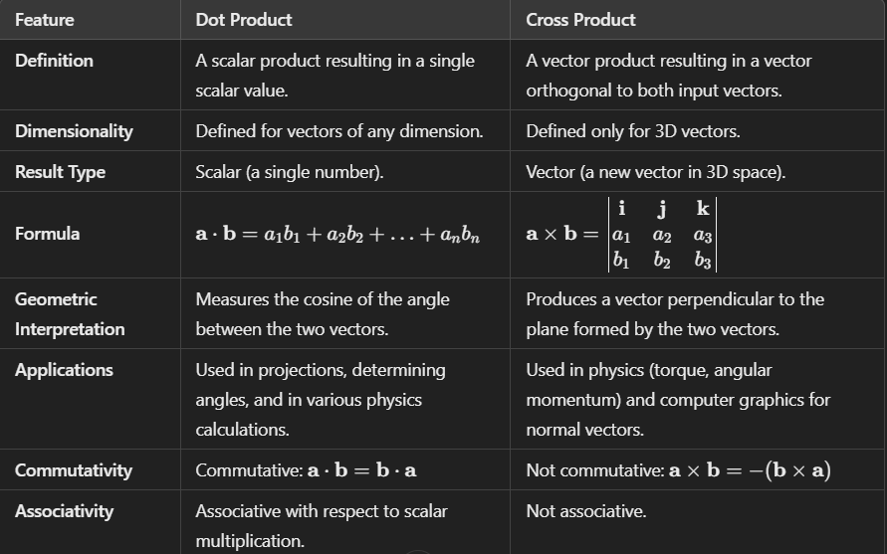

import numpy as np

def calculate_dot_product(matrix_a, matrix_b):

# Convert lists to numpy arrays for easier calculations

a = np.array(matrix_a)

b = np.array(matrix_b)

# Check if the dimensions are compatible for dot product

if a.shape[1] != b.shape[0]:

raise ValueError("Incompatible dimensions for dot product.")

# Calculate dot product

dot_product = np.dot(a, b)

return dot_product

def calculate_cross_product(vector_a, vector_b):

# Convert lists to numpy arrays

a = np.array(vector_a)

b = np.array(vector_b)

# Check if the vectors are in 3D

if a.shape[0] != 3 or b.shape[0] != 3:

raise ValueError("Cross product is defined only for 3D vectors.")

# Calculate cross product

cross_product = np.cross(a, b)

return cross_product

# Example usage

# For dot product

matrix_a = [[1, 2, 3], [4, 5, 6]]

matrix_b = [[7, 8], [9, 10], [11, 12]]

dot_result = calculate_dot_product(matrix_a, matrix_b)

print("Dot Product:")

print(dot_result)

# For cross product

vector_a = [1, 2, 3]

vector_b = [4, 5, 6]

cross_result = calculate_cross_product(vector_a, vector_b)

print("Cross Product:")

print(cross_result)

Bottom of Form

Bottom of Form

Bottom of Form