#### Wireframes

Key mobile wireframes: (a) login (b) input (c) navigation.

**(c)**

**(b)**

**(a)**

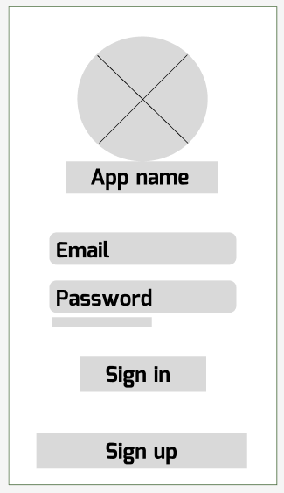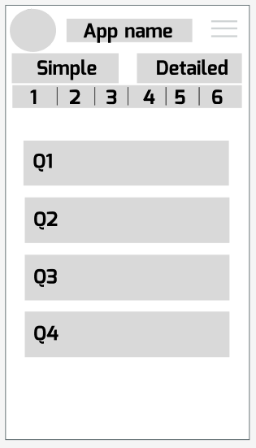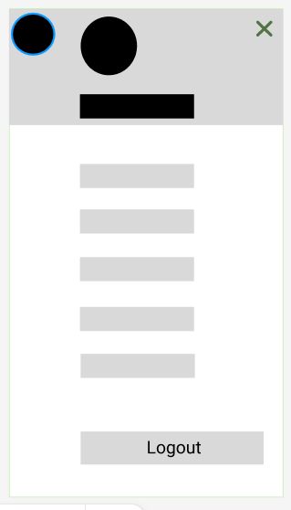

#### Mockups

Mobile mockups: (a) log in (b) sign up (c) navigation (d) dashboard (e) basic input (f) detailed input.

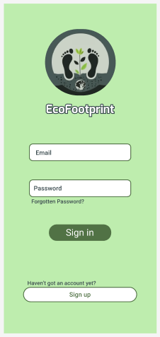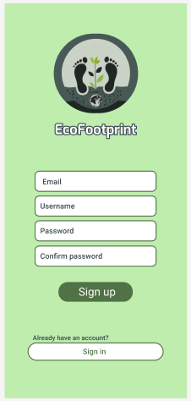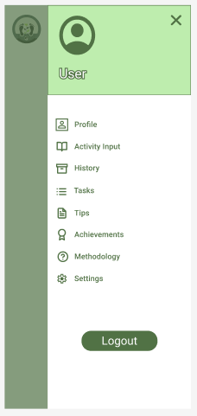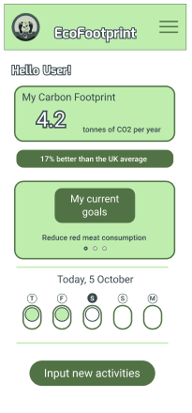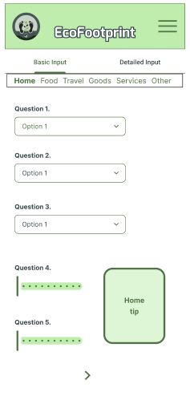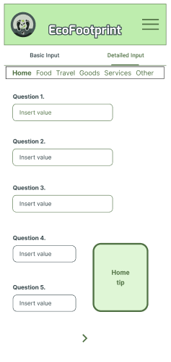

**(d)**

**(e)**

**(f)**

**(a)**

**(b)**

**(c)**