COLLAGEN PAPER: Final version njmods1 November 2018

Some general points:

1. I have a bit of a problem with

“why are we comparing loose_and_supple with wrinkly sheep?”

rather than comparing non-wrinkly with wrinkly sheep.

I know the answer, you just dont say it for the reader's benefit.

It goes like this:

What you really want to compare is sheep-with-hard-collagen with sheep-with soft collagen. That is not easy to arrange, because you cant see collagen when looking t sheep. So what you have done is use your accumulated experience to choose sheep with soft-collagen based on visual clues and skin feel. Choosing hard collagen sheep is easy, you just look at wrinkle.

The net effect is that you have chosen a particular type of non-wrinkled sheep – those who got rid of the wrinkle by getting rid of the collagen. In the process we have managed to ignore the other type of non-wrinkled sheep – those who got rid of thewrinkle by reducing papillary layer expansion by not having as many follicles. So we have ignored the “ordinary” plain bodied sheep, and used the soft skin variety. Are these what you call “flats”?

How are you going to explain this design choice to the reader?

2. There are a lot of measurements in Table2.

By the way you dont refer to Table 2 anywhere in text.

It is not obvious why all these measurements are relevant until page 12 and discussion where you start to discuss “follicle distortion and fibre defects”

**Is collagen quantity and properties involved in wrinkle formation and follicle development of Merino sheep ?**

**Abstract**

The quantity and type of dermal collagen, and associated follicle and fibre characteristics, are reported for adult Merino sheep visually selected as having either wrinkly skins or loose and supple (non-wrinkly) skins.

Wrinkly skin sheep have a thick and continuous layer of hard (type I) collagen in the subfollicular region of the papillary dermis. The follicle groups are large and disrupted. The follicles are highly curved and uneven in length. The follicle bulbs are often bent and encased in collagen. Compared to non-wrinkly sheep with loose and supple skins, the follicle densities and numbers of follicles per group (S/P ratio) are lower. The secondary fibres are higher in mean fibre diameter, and more variable in fibre diameter and fibre length. Fibres become entangled when emerging from the follicle openings into the fleece. The wrinkles are formed by the upfolding of the hardened papillary dermis. A “trade off” hypothesis between the expanding follicular region and the contracting subfollicular region of the papillary dermis is suggested to explain the process of wrinkle formation.

In non-wrinkly sheep with loose and supple skins, the collagen in the subfollicular

define “loose and supple” you need a reference, but also see general point 1 above.

You need an explanation too.

region of the papillary dermis is arranged as thin, reticular sheets associated with soft (type III) collagen. The follicle groups are small and arranged in orderly and well-spaced rows. The sheep have high numbers of secondary follicles per group, and high follicle densities. The follicles are straight and highly aligned, short and uniform in length. The primary fibres and secondary fibres are fine and uniform in diameter and uniform in length. Fibres remain highly aligned when emerging from the follicle openings into the fleece.

It is suggested that the follicle and fibre defects seen in the adult sheep with wrinkly skins occurred during follicle development in the foetal skin. It appears that hard collagen in the papillary dermis presents a “barrier” to follicle downgrowth and may interfere directly with follicle bulb activity and fibre production.

**Introduction**

Most Merino sheep have wrinkly skins. Wrinkles are raised and often hardened areas of skin Bogolyubsky (1940) observed that wrinkles develop in the wool bearing region of the foetal skin from about 100 days of gestation.

Figure 1 depicts a wrinkle as being an upfolding of the outer three layers of the skin (epidermis, papillary dermis and reticular dermis). The underlying muscle layer appears to be clearly separated from the base of the wrinkle whereas, in the region between the wrinkles, the muscle layer is attached.

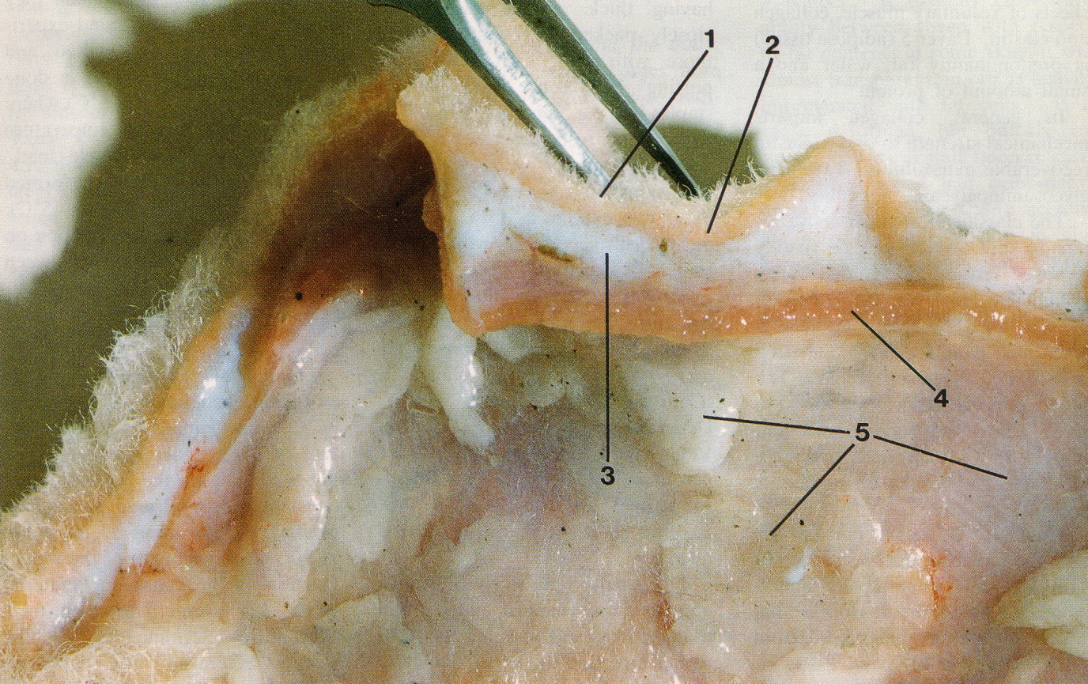

**Figure 1. Merino sheep skin showing layers. 1. epidermis with wool fibres; 2. papillary layer of dermis, 3. reticular layer of dermis; 4. areolar tissue and muscle; and 5. adipose tissue. Two wrinkles are present; one alongside each side of the forceps (from Mitchell et al, 1984).**

Wool follicles are located in the upper region of the papillary dermis and are about two millimetres long. The papillary dermis below the follicles is of similar depth and consists mainly of collagen.

Collagen fibres are formed from cells called fibroblasts. Soft (type III) collagen is highest at 75 days of gestation, and falls progressively as the foetus develops, while hard (type III) collagen is low at day 75 and rises to over 50 percent by birth (Knight 1993).At 75 to 80 days of foetal life, the fibroblasts are plump, immature cells surrounded by a fine, reticular pattern of collagen fibrils. By birth the fibroblasts have matured and the collagen fibrils may be enmeshed and thickened to varying degrees. If the fine, reticular pattern of fibrils remains, it appears to be soft collagen and skin wrinkling does not seem to develop. If the collagen fibrils enmesh, lengthen and thicken, the collagen tissue appears to be hardened.

Wool follicles also derive from fibroblasts that have transformed into prepapilla cells in the foetal skin (Moore et al, 1989; Moore et al, 1998). Primary follicles develop first, from about 65 days of gestation and secondary original follicles follow at 85 days; both as downgrowths of epidermal tissue into the dermis at pre-determined initiation sites. Secondary derived follicles develop from 110 days until shortly after the birth of the lamb at 145 days as branches of secondary original follicles.

Dryer et al (1983) observed that collagen in foetal sheep skin appears to present a “barrier” that deflects descending follicles sideways. This makes sense. We know that the amount of skin wrinkling in Merino sheep is strongly and positively correlated genetically with follicle curvature (0.69 with 95 percent confidence limits 0.65-0.74) (Jackson 2017). Such a barrier may also explain why Merino sheep with highly curved (entangled) follicles have disrupted follicle groups and poorly organised blood vessels compared with sheep with straight follicles (Nay 1966).

Jackson and Watts (2018) have proposed that wrinkles form when a lot of follicles develop in the upper papillary dermis of the foetus, causing this layer to expand considerably. At the same time, they suggest that hard (type 1) collagen sheets form in the papillary dermis below the follicles, binding it against expansion. The conflict between these two tensions is thought to cause the papillary dermis (and epidermis) to fold and a wrinkle to be formed. The muscle layer may also be a source of tension contributing to wrinkle formation. Mitchell (1984) showed that when the muscle layer in skin biopsies is removed, the wrinkles become smaller.

In wrinkly skin sheep, the follicles are arranged as indistinct rows. The follicle groups are uneven in size with low S/P ratio, low follicle density and low fibre length. The follicles are highly curved and unevenly seated.

“unevenly seated” is a bit slangish. What you mean is the bulbs are at varying depths.

The fibres are variable in diameter and length and poorly aligned (reference).

On the other hand, Merino sheep with loose and supple skins are free of skin wrinkle. The follicles are arranged as well-spaced, orderly rows of compact and uniformly sized follicle groups with high secondary follicle to primary follicle (S/P) ratio and high follicle density. The follicles are straight, vertically aligned and evenly seated. The fibres in the fleece are uniform in diameter and length and highly aligned (reference).

This study investigates whether collagen quantity and type differs in adult Merino sheep with either wrinkly skins or loose and supple skins, and if so, whether it impacts on follicle and fibre development.

**Materials and Methods**

**Sheep**

Two trials were conducted. Sheep details are listed in Table 1.

Table 1. Details of sheep studied. (to be completed by JW)

|  |  |  |  |  |  |
| --- | --- | --- | --- | --- | --- |
| Trial | Flock no. | Age of sheep (months) | Sex of sheep | Number of sheep | |
| Loose and supple skin | Wrinkly skin |
| 1 | 1 |  | Rams | 1 | 1 |
|  | 2 |  | Rams | 1 | 1 |
|  | 3 |  | Rams | 1 | 1 |
|  | 4 |  | Rams | 1 | 1 |
|  | 5 |  | Rams | 1 | 1 |
|  |  |  |  |  |  |
| 2 | 6 |  | Ewes | 9 | 9 |
|  | 7 |  | Ewes | 9 | 9 |

In trial 1, a loose and supple skin sheep was compared to a wrinkly skin sheep from each of five Merino flocks. The skin samples had been trimmed so that only layer 1 (epidermis) and layer 2 (papillary dermis) were available for histological observation and measurement.

In trial 2, nine sheep with loose and supple skins were compared with nine sheep with wrinkly skins, in each of two flocks. Wrinkle development was more accentuated in flock 7 than in flock 6. For the sheep with wrinkly skins, measurements and scores were made for skin samples collected from on the wrinkles as well as between the wrinkles. The skin samples included layers 1 to 4 for histological observation and measurement.

Layers 1 to 4 undefined. You could refer to Fig 1 maybe.

**Skin samples**

Midside skin samples were collected using a 10 millimetre circular trephine (Acu Punch® skin biopsy punches, Acuderm, Inc.) and fixed in 10% formol saline solution.

Is it formol or formal?

Skin samples were washed in several changes of water, the wool stubble trimmed and then examined under a magnifying lamp ( x 3 magnification). Scores for suppleness (1 = hardened to 5 = supple) of the papillary layer and reticular layer were made. Each skin sample was examined to determine if the skin layers were free or fixed. This was also done for each skin wrinkle, and the skin layers which constituted each wrinkle were noted.

The thicknesses of the papillary dermis and the reticular dermis were measured using a ruler graduated in one millimetre divisions. A Mitutoyo ballpoint gauge (model no. 2046S) was then used to measure the compressed thickness at four sites for each skin sample.

**Histology**

Skin samples used for haematoxylin and eosin staining (H-E) and picrosirius red (PSR), were fixed in 10% neutral buffered formalin for 24 hours before being processed to wax in an automated tissue processing platform (Shandon Excelsior, Thermo Scientific, USA), and then embedded in paraffin wax. Four micron sections were cut and placed onto slides for H-E staining for tissue morphology. Serial section was also employed on a separate slide for PSR staining to highlight collagen content. Staining was performed manually.

Sections were then reviewed microscopically (BX53 Olympus, Australia)), and images taken on 3 CCD camera (DP72, Olympus, Australia) under both bright field and polarized conditions for PSR staining.

For PSR collagen analysis, the 40x objective was employed at a fixed exposure to take high power images of 5 random deep dermal fields of view for computational analysis.

The images for each sample were then uploaded for quantitative analysis via the ImagePro Plus (Media Cybernetics, USA) 7.1 software in which thresholds were set to count all pixels comprising of the red staining fibres in the PSR stained specimen against the total pixels. A mean was calculated for each of the specimens’ 5 images and graphed. Polarised light was employed to try and determine the type of collagen present within each of the samples.

From the same images, the width, length and orientation of collagen sheets were measured at multiple sites (“point” counts) by overlaying the images on A4 graph paper with counting points spaced 5 cm apart and 5cm distant. For each image, approximately 20 counting sites were defined and for each sampling site, approximately 100 counting sites were available.

Vertical skin sections, approximately 0.3 millimetres wide, were cut freehand with a sharp razor blade on a freezing stage and stained with 0.25 % Nile blue sulphate, as described by Nay (1973). The sections were cut parallel with the angle of emergence of the fibres to avoid cutting through follicles. Mean follicle curvature was scored from 1 = straight follicles to 7 = tangled follicles by reference to a set of standard drawings used by Nay and Johnson (1973). Follicle depth was measured as both the perpendicular and angular distances (in millimetres) between the skin surface and the lower ends of the follicle bulbs, along with follicle bending, as described by Maddocks and Jackson (1988). The angles of emergence of wool fibres from the skin into the fleece over a distance of … microns, relative to the plane of the skin surface, were measured for 20 fibres per sampling site. Also, counts of the number of thin or kinked regions of fibre growth (“nabs”) within the same distance of …. microns from the skin surface were made for 100 consecutive fibres per sampling site.

Horizontal skin sections were prepared as described by Maddocks and Jackson (1988) using the frozen section technique and measurement procedures of Nay (1973). The sections were used to measure follicle density, secondary follicle to primary follicle ratio (S/P ratio), primary fibre diameter and secondary fibre diameter of the sheep. The boundaries of 10 follicle groups at …. magnification from each sampling site were traced onto one centimetre square graph paper in order to determine the mean area and coefficient of variation of follicle group area for each sampling site. The orientation of each follicle group was determined by drawing a line through the longitudinal axis of each follicle group, and then measuring the angle between it and the vertical plane. The orientation of the follicle groups for each sampling site was expressed as the coefficient of variation for 10 angles measured.

Table 2 not mentioned in text.

You might try a smaller font . It is a big table

Table 2. Summary of measurements and scores.

|  |  |  |
| --- | --- | --- |
| Measurement or score | Description | Unit |
| Suppleness of skin | Scores ranged from 1 = rigid to 5 = supple |  |
| Compressibility of skin | Difference between compressed skin thickness and total skin thickness, expressed as a proportion of total skin thickness | % |
| Collagen content |  |  |
| Width of collagen sheets | Measured at multiple equidistant sites on PSR images of papillary dermis | microns |
| Length of collagen sheets | Measured at multiple equidistant sites on PSR images of papillary dermis | millimetres |
| Follicle curvature score | Scores ranged from straight = 1 to highly curved = 7 |  |
| Follicle curvature measurement |  |  |
| Follicle length |  | millimetres |
| Laneway | Distance between follicle groups measured from the central primary follicle to the border of the follicle group in the adjacent row. | microns |
| Follicle group orientation (CV) | The variation in angles of the long axes of follicle groups, relative to the vertical plane, and expressed as co-efficient of variation. | percentage |
| Primary fibre diameter (Dp) | The mean of the diameters of 50 primary fibres per horizontal skin section | microns |
| Standard deviation of Dp |  | microns |
| Secondary fibre diameter (Ds) | The mean of the diameters of 100 secondary fibres per horizontal skin section | microns |
| Standard deviation of Ds |  | microns |
| Follicle density (Fn) | The mean of the number of follicles per square millimetre measured at 10 sites per horizontal skin section | per square millimetre |
| Secondary follicle to primary follicle (S/P) ratio | The numbers of secondary follicles per primary follicle per follicle group for 10 follicle groups per horizontal skin section. |  |
| Fibre length (FL) | The taut lengths of 100 fibres per sheep in midside wool samples | millimetres per day |
| Coefficient of variation of fibre length (FLCV) | The variation in the length of the 100 fibres measured per sheep | percentage |
| Staple area | The mean of 5 fleece staples in each of the midside wool samples. The width and breadth of the proximal end of the staple was measured. | square millimetres |

**Results**

**Trial 1**

**Collagen content, distribution and type**

The collagen content of the follicular and subfollicular regions of the papillary dermis of sheep with wrinkly skins and sheep with loose and supple skins are wrinkly skin are shown diagrammatically in Figure 2.

Figure 2. Collagen content of the follicular region (top) and the subfollicular region (below) of the papillary dermis of wrinkly skin sheep and loose skin sheep.

Units on Y axis?

(Sanaz, for Figure 2, could you please label the y axis and indicate the units of measurement. Could you also insert 'Flock No' on X axis or in caption. Flock 3 in the graph should have mean collagen values of 208267.6626 for wrinkly skin sheep and 44415.03048 for loose skin sheep. The current data shown in the graph for flock 3 is actually flock 4 which has been omitted because the sheep pair comparison were not different for suppleness scores or follicle curvature scores).

In both the follicular and sufollicular

subfollicular

regions of the papillary dermis, wrinkly skin sheep had higher collagen content than loose and supple skin sheep. Significant differences were found in flocks 1 to 3 (P<0.001), flocks 5 (P < 0.01) and flock 6 (P< 0.05). More collagen was present in the subfollicular region of each skin type.

In wrinkly skin sheep, dermal collagen was present as thick, long and enmeshed sheets of predominantly red and orange colours. In loose and supple skin sheep, the reticular collagen was arranged as thin, parallel sheets of predominantly green colour.

You dont say what the colours mean, and we neede a photo.

Skin suppleness scores and skin compressibility measurements were strongly and positively correlated to collagen content (r = …. for suppleness score and P … for skin compressibility).

If you want these correlations, point me to the data, or do I haveit?

**Follicle and fibre disruption**

Wrinkly skin sheep had highly curved follicles producing secondary fibres that were higher and more variable in diameter than were found in loose and supple skin sheep.

We already have a Table 2.

I cant see any collagen content? Do you mean suppleness and compressibility?

**Table 2. Collagen content, follicle curvature and secondary fibre diameter of loose versus wrinkly Merino rams in five flocks.**

|  |  |  |  |  |  |  |  |
| --- | --- | --- | --- | --- | --- | --- | --- |
| Flock no. | Sheep no. | Skin type | Follicle curvature | Ds | DsSD | Supple score | Compress (%) |
| 1 | W206 | Loose | 3 | 23.8 | 2.9 | 5 | 75 |
|  | W205 | Wrinkly | 6 | 29.5 | 4.2 | 2 | 54 |
| 2 | W490 | Loose | 4 | 22.4 | 3.5 | 5 | 64 |
|  | W479 | Wrinkly | 6 | 22.6 | 3.8 | 2 | 39 |
| 3 | W555 | Loose | 3 | 18.4 | 2.6 | 5 | 67 |
|  | W547 | Wrinkly | 7 | 19.9 | 2.9 | 1 | 58 |
| 4 | W567 | Loose | 3 | 18.6 | 1.8 | 5 | 70 |
|  | W558 | Wrinkly | 3 | 21.7 | 5.3 | 2 | 63 |
| 5 | W283 | Loose |  |  |  | 5 | 69 |
|  | W290 | Wrinkly |  |  |  | 2 | 44 |

**Trial 2**

**Fixed and unattached skin layers**

In both flocks, the papillary dermises of the wrinkly skin sheep are not as supple or as compressible as the papillary dermises of the loose and supple skin sheep. Also, the reticular dermises are less supple and thicker in the wrinkly skin sheep (Table 5).

dermises sounds unusual. How about dermis … was instead of dermises … are

Table 5. Do t tests on supple scores and compressibility and thickness data

|  |  |  |  |  |  |  |  |  |  |  |
| --- | --- | --- | --- | --- | --- | --- | --- | --- | --- | --- |
| Flock | | Skin type | | Papillary dermis | | | | | Reticular dermis | |
| Supple score | | Compress (%) | | Supple score | | Thickness (mm) |
| 6 | loose skin | | 3.8 | | 74 | | 4.3 | | | 1.6 |
|  | between wrinkles | | 1.9 | | 43 | | 3.7 | | | 3.1 |
|  | on wrinkle | | 2.9 | | 64 | | 3.3 | | | 3.1 |
| 7 | loose skin | | 3.5 | | 70 | | 4.4* | | | 2.3* |
|  | between wrinkles | | 2.1 | | 54 | | 2.9 | | | 2.7 |
|  | on wrinkle | | 1.9 | | 54 | | 2.8 | | | 3.5 |

* Footnote: 18 sheep sampled

In flock 6, the papillary dermis was fixed to the reticular dermis in all of the wrinkly sheep and unattached in all of the loose and supple skin sheep. All of the 9 wrinkly skin sheep had compressible wrinkles with no “side bridges” of connective tissue connecting the upfolded (sides) formed by the papillary dermis.

I cant believe reticular dermis is totally unattached. Must be some cneection between layers, at least blood vessels.

“fixed to the reticular dermis” how was it fixed?

A photo os “side bridges” would help.

In flock 7, the papillary dermis was fixed to the reticular dermis in 3 of the 9 wrinkly skin sheep, and again, unattached in all of the loose skin sheep. Six of the 9 wrinkly skin sheep had the upfolded sides of the wrinkles formed by the papillary dermis fixed

not “fixed” but bridged. Consistent terms needed.

together.

**Collagen content**

Measurements of collagen content of the subfollicular region of the papillary dermis are shown diagrammatically for each sheep in Figure 3.

Figure 3. Collagen content of the reticular dermis of loose and supple skin sheep and between the wrinkles and on the wrinkles of the wrinkly sheep from flock 6 (top) and flock 7 (bottom).

In both flocks, the wrinkly skin sheep had significantly (P < 0.001) more collagen in the subfollicular papillary dermis than in loose and supple skin sheep. In wrinkly sheep, there was no significant difference in collagen content for the sampling sites, “between wrinkle” and “on wrinkle”.

**Size and colour analysis of collagen sheets**

Measurements of the width and length of the collagen sheets in the subfollicular region of the papillary dermis of wrinkly skin sheep and loose and supple skin sheep are listed in Table 3.

Table 3. Dimensions of the collagen sheets

|  |  |  |  |
| --- | --- | --- | --- |
| Flock | Skin type and sampling site | Collagen sheets | |
| Width (microns) | Length (microns) |
| 6 | wrinkly skin - on wrinkles | 9.1 (0.42) a |  |
| wrinkly skin - between wrinkles | 10.4 (0.48) b |  |
| loose and supple skin | 6.5 (0.21) c |  |
| 7 | wrinkly skin – on wrinkles | 8.1 (0.32) a |  |
| wrinkly skin - between wrinkles | 9.1 (0.22) b |  |
| loose and supple skin | 6.9 (0.17) c |  |

In all of the 18 sheep with wrinkly skins, and for both the “on wrinkle” and “between wrinkle” sites examined, thick, long and enmeshed sheets of collagen fibres were found in the subfollicular region of the papillary dermis, often encircled follicle bulbs and infiltrating the muscle layer (Figure 4). The collagen sheets had mainly red reflectances.

What does red imply?

In the 18 sheep with loose and supple skins, the collagen sheets in the subfollicular region of the papillary dermis were thin and short, and arranged as reticular patterns (Figure 4). The collagen sheets were a mix of green, yellowish-orange and red colours.

Explain the colours again

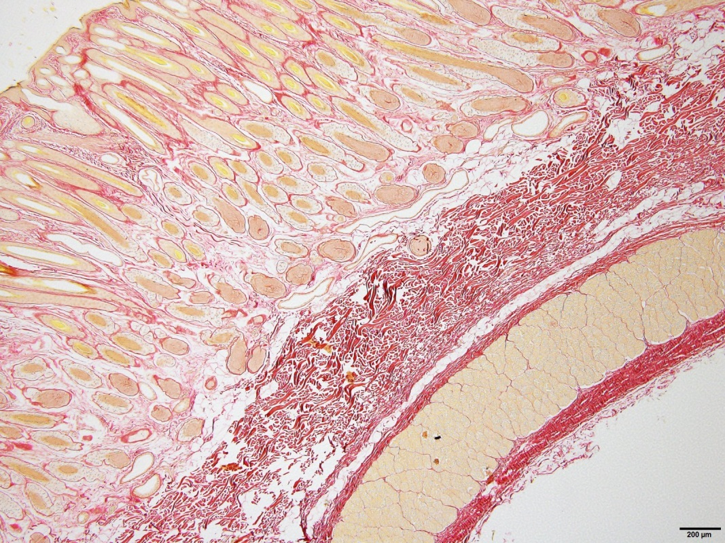

Sanaz – could you please see if there is a loose skin PSR photo of the 4 layers similar to the one above for the wrinkly sheep but does not show the heavy collagen accumulation – photo to be inserted here)

Figure 4. (Top) transverse section of a wrinkly skin showing hard collagen “barrier” (arrows) in the subfollicular region of the papillary dermis. Note some of the follicle bulbs immediately above the barrier are deflected sideways. (Below) transverse section of a loose and supple skin (below) showing thin, short and parallel collagen sheets and undeflected follicle bulbs (PSR x 4 magnification).

**Follicle and fibre disruption**

In sheep with wrinkly skins, the follicle groups are arranged haphazardly and are jammed together. Follicles on the borders of the follicle groups run obliquely and are well separated from other follicles within the groups. Most of the follicles within the groups are poorly aligned (Figure 5a). The follicles are highly curved with a high proportion of deflected follicle bulbs (Figure 5b).

In sheep with loose and supple skins, the follicle groups are compact and arranged in orderly and well-spaced rows. The follicles within the groups are highly aligned and mostly present at right angles to the skin surface (Figure 5c). The follicles are straight and evenly seated with no deflected follicle bulbs (Figure 5d).

**(insert photos here)**

**Figure 5. A. horizontal section ( x … magnification) of wrinkly skin showing disrupted arrangement of follicle groups. B. A transverse section ( x …magnification) of wrinkly skin showing highly curved follicles with bent follicle bulbs. C. A horizontal section (x… magnification) of loose and supple skin showing orderly arrangement of follicle groups. D. a transverse section (x … magnification) of loose and supple skin showing straight follicles with follicle bulbs that are not bent.**

The group means for follicle, fibre and fleece traits are shown in Table 4.

Table 4. Mean values (standard errors in brackets) of follicle and fibre measurements for wrinkly skin and loose and supple skin Merino sheep. Within each flock, traits with different superscripts are highly significantly different (P<0.0001).

|  |  |  |  |  |
| --- | --- | --- | --- | --- |
| Trait | Flock 6 | | Flock 7 | |
| Between wrinkles | Loose skin | Between wrinkles | Loose skin |
| Follicle curvature  score | 3.8 a | 1.7 b | 5.1 a | 2.7b |
| Follicle curvature sagitta |  |  |  |  |
| Straight follicle depth |  |  |  |  |
| Laneways | 90 a (5.3) | 150 b (6.5) | 79 a (5.0) | 151 b (5.5) |
| Follicle group orientation (CV) | 20.2 a | 13.3 b | 37.5 a | 15,2 b |
| Follicle group area (mm2) |  |  |  |  |
| Follicle group area (CV) |  |  |  |  |
| Dp | 18.8 c (0.7) | 16.4 d (0.6) | 20.5 (1.0) | 17.7 (1.0) |
| Dp SD | 2.6 (0.2) | 2.1 (0.1) | 2.8 (0.4) | 2.5 (0.1) |
| Ds | 20.7 a (0.6) | 18.4 b (0.5) | 20.7 a (0.4) | 18.4 b (0.2) |
| Ds SD | 2.6 a | 1.9 b | 3.7 a (0.4) | 1.9 b (0.1) |
| Follicle density | 76.7 (4.9) | 83.9 (5.8) | 66.8 c (5.8) | 94.9 d (7.5) |
| S/P ratio | 21.8 c (0.8) | 27.8 d (1.5) | 22.6 a (1.1) | 27.8 b (0.9) |
| FL | 0.55 | 0.56 | 0.40 a (0.01) | 0.48 b (0.01) |
| FLCV | 10.9 c (0.9) | 8.0 d (0.7) | 14.5 a (1.2) | 7.7 b (0.8) |
| Fibre emergence angle (CV) | 24.0 a (1.6) | 14.3 b (0.9) | 25.8 a (1.2) | 16.3 b (1.3) |
| Fibre nabs  (% affected fibres) |  |  |  |  |
| Staple area (mm2) | 25.1 a (2.4) | 6.7 b (0.5) | 27.4 a (2.8) | 13.1 b (1.6) |

The measurements shown in Table 4 confirm that the histological observations on the spatial distribution of follicle groups and follicles within groups are correct. We can add that wrinkly skin sheep differed significantly from the loose and supple skin sheep for the following traits. The follicles are more uneven in depth. The follicle groups are larger and more variable in area. There are fewer secondary follicles per group (lower S/P ratio). The secondary fibres are higher and more variable in diameter. The fibres are more variable in length with more weakened, thin places (“nabs”) and form thicker staples. For flock 7, the follicle densits is significantly lower and the fibres are significantly shorter.

Whilst the primary fibre diameter is higher in wrinkly skin sheep than in loose and supple skin sheep, the difference are not statistically significant in either flock.

**Discussion**

These studies were conducted on adult sheep and not on foetal lambs. The assumption is that the follicle and fibre abnormalities observed in the adult sheep occur in foetal life. It is thought that these abnormalities are the result of hardened collagen interfering with follicle downgrowth and follicle bulb activity.

Dermal collagen is present in greater amounts in the papillary dermis of sheep with wrinkly skins than in sheep with loose and supple skins. The collagen sheets of wrinkly skin sheep are thick, long and entangled, and show mainly red reflectance under polarised light examination of PSR sections. Both the thickness and reflectance pattern of the collagen sheets are considered to be diagnostic for hard collagen (type I) fibres (references).

On the other hand, the dermal collagen in the papillary dermis of sheep with loose and supple skins is present as reticular networks of thin, short and parallel sheets with a mix of green, yellow and red reflectances. Thin sheets are generally thought to be soft collagen (type III) fibres (references). Green fibres have also been considered by some workers to be soft collagen fibres (references). However, Rich and Whittaker (2005) consider that a green fibre may also be an immature, thin type I fibre or the result of a sectioning artefact of an otherwise thick type I fibre.

All of the sheep with wrinkly skins have follicle distortion and fibre defects. In the wrinkly skin sheep, the follicles are highly curved and unevenly seated. The follicle bulbs are often deflected sideways. Compared to the loose and supple skin sheep, the follicle groups are larger and more variable in size, poorly oriented and jammed together. There are fewer secondary follicles per group (lower S/P ratio), lower follicle density and greater variation in secondary fibre diameter. The fleece fibres are entangled, variable in diameter and length, often have thin places (“nabs”), and form thick staples.

On the other hand, sheep with loose and supple skins show no signs of follicle distortion and fibre defects. The follicle groups are small and compact and are arranged in well-spaced, orderly rows. The follicles are straight, vertically aligned and evenly seated. There is no deflection of the follicle bulbs. There are high numbers of secondary follicles per group (high S/P ratio), high follicle densities and low variation in secondary fibre diameter. The fleece fibres are highly aligned, uniform in diameter and length, and form thin staples.Lower fibre curvature too.

We suggest that three developmental processes are involved in differentiating

differentiating has other meanings. How about distinguishing or discriminating?wrinkly skin from loose and supple skin. Firstly, there may be a “trade off” process whereby certain foetal fibroblasts are committed to differentiate into prepapilla cells and wool follicles, whereas the remaining fibroblasts are committed to producing collagen. Secondly, there may be an “interference” process where if hard (type I) collagen is laid down in excessive amounts in the foetal skin, secondary follicle initiation, maturation and fibre growth are impaired. If soft (type III) collagen is mainly laid down, follicle and fibre development proceeds normally. Thirdly, there may be a “folding” process where the high dermal expansion accompanying high follicle initiation and excessive deposition of hard collagen in the underlying dermis create opposing tensions for skin wrinkle to develop (Figure 2).

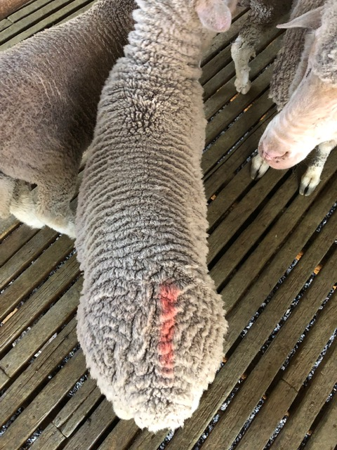

Figure 2. A six week old Merino lamb (centre) with severe wrinkling of the skin.

Skin wrinkle is a sequel to hard collagen accumulating in the papillary dermis. Wrinkles may be fixed or compressible. Fixed wrinkles occur when fibrous adhesions form “side bridges”, connecting the undersurfaces of the opposing, upfolded papillary dermis. Six of the 9 wrinkly skin sheep in Flock 7 had fixed wrinkles and “side bridges”. All nine wrinkly skin sheep in Flock 6 had compressible wrinkles and no “side bridges”. Wrinkles may form at locations where there is slightly less collagen in the papillary dermis. The significantly lower amounts of hard collagen measured at “on wrinkle” sites compared with “between wrinkle” sites (see Table 3) suggest this. Moreover, the wrinkle pattern conforms to the dermatome pattern of the sheep. Vertically descending and equidistant wrinkle lines on both sides of the sheep corresponded to the number and origin points of the spinal nerves from the vertebral column.

It is the hardening of collagen, and not wrinkle per se, that interferes with wool follicle development. So, it is expected that sheep can be plain bodied (wrinkle free) and still have hard collagen and impaired follicle development. If the skin is not supple and compressible, hard collagen is likely to be present. If the skin has limited dermal expansion because of low follicle numbers, wrinkles are unlikely to develop. These possibilities indicate that hard collagen deposition may interfere with foetal follicle development in all breeds of sheep, and not just breeds where skin wrinkling occurs.

We know something about the development process of the loose and supple skin sheep. The pre-papilla cell model of Moore et al (1989) and Moore et al (1998) shows that some of the foetal fibroblasts transform into pre-papilla cells. The pre-papilla cells are then directed to aggregate as small “packages” to form many wool follicles that produce fine wool fibres of uniform diameter. This model explains why suppression of the size of primary follicles (and therefore suppression of primary fibre diameter), leads to greater numbers of secondary derived follicles (higher S/P ratio) developing. In the loose and supple skin sheep, the fibroblasts that do not transform into pre-papilla cells, appear to be programmed to produce soft (type III) collagen rather than hard (type I) collagen. This is what we refer to as the “trade off” hypothesis. Fibroblasts are common to collagen formation and prepapilla cell formation which sets the stage for a possible “tradeoff” between collagen and follicles. The distinctly better suppleness scores and compressibility measurements for loose and supple skin sheep compared to wrinkly skin sheep suggest this is the case. Suppleness score might be a simple way of detecting the amounts of soft collagen and hard collagen in sheep skin.

We propose that genes for follicle number (and therefore for papillary layer expansion) interact with genes for collagen development, the interaction being the basis of the formation of skin folds. This is an epistatic effect - two sets of genes interacting. Epistatic variance of wrinkle score can be detected in analyses of quantitative variation of wrinkle scores (Jackson and Watts, 2018). It accounts for approximately 25 percent of phenotypic variation in wrinkle score (Jackson and Watts (2018)). These analyses of quantitative variation support our “folding” hypothesis for wrinkle formation

The reticular dermises of all sheep in this study are supple and low in collagen content, and are not directly involved in wrinkle formation. However, this layer is usually retained at the base of the wrinkle (see Figure 1). It is possible that as wrinkly sheep age, or more extreme cases of wrinkly sheep are studied, that hard collagen deposition in the reticular dermis may be found.

This last para is a strange thing to end on.

You need a “hit line” at the end. Along the lines of

If we are right about collagen and wrinkle, then there is a better way of getting rid of wrinkle than going to plain bodied low density sheep. That way is to go to soft skinned high density sheep. Getting rid of wrinkle does not have to mean loss of productivity.

**Acknowledgements**

Sam Gordon, “Manton”, Young, New South Wales, Australia for supplying flock 7 sheep for study.

**References**

Bogolyubsky, S.N. (1940) cited by Fraser A.S. and Short B.F. (1960). The Biology of the Fleece. Animal Research Laboratories Technical Paper No. #. CSIRO Melbourne 1960.

Dreyer, J.H., Rossouw Ellenor and Steyn, M.G. (1982). The histology of the pre-natal follicle and hair fibre in four curl types of the Karakul sheep. S.Afr. Anim. Sci. 13 (3);180-191.

Jackson, N. (2017). Genetics of primary and secondary fibre diameters and densities in Merino sheep. URL <https://github.com/nevillejackson/atavistic-sheep/mev-rewrite/supplementary/genetic-parameters/psparam.pdf>

Jackson, N. (2017). Genetic relationship between skin and wool traits in Merino sheep. Part I Responses to selection and estimates of genetic parameters. URL <http://github.com/nevillejackson/Fleece>genetics/tree/master/skinandfleeceparameters/ab3220/skinwool1.pdf

Jackson, N. and Watts, J.E. (2017). What is known about the genetics of wrinkle score in Merino sheep? URL <http://github.com/nevillejackson/Fleece-genetics/wrinkle/wrinkle.pdf>

Knight, K.R., Lepore, D.A., Horne, R.S., Ritz, M., Kumta, S. and O’Brian, B.M. (1993). Collagen content of uninjured skin and scar tissue in foetal and adult sheep. Int, J. Exp. Pathol. 74 (6):583-591.

Maddocks, I.G., and Jackson, N. (1988). Structural studies of sheep, cattle & goat skin. CSIRO Division of Animal Production.

Mitchell, T.W., Ann Nieass, Rigby, B.J. and Snaith, J.W. (1984). Some physical and mechanical properties of sheep skin with a comparison of “thick” and “thin” skins. Wool Technology and Sheep Breeding. 22(4), 200-206.

Moore, G.P.M., Jackson, N. and Lax, J. (1989). Evidence of a unique developmental mechanism specifying both wool follicle density and fibre size in sheep selected for single skin and fleece characteristics. Genet. Res. Camb. **53**, 57-62.

Moore, G.P.M., Jackson, N., Isaacs, K. and Brown, G. (1998). Pattern and morphogenesis in skin. J. theor. Biol. **191**, 87-94.

Nay, T. (1966). Wool follicle arrangement and vascular pattern in the Australian Merino. Aust. J. Agric. Res. 17: 797-805.

Nay, T. (1973). Wool follicles – A manual for breeders. Australian Wool Corporation, Melbourne.

Rich, Lillian and Whittaker, Peter (2005). Collagen and picrosirius red staining: a polarized light assessment of fibrillary hue ans spatial distribution. *Braz. J.morphol. Sci. 22 (2),* 97-104*.*