horizontal line

**Assignment 02 | Advance Algorithms**

**CE-092**

Assignment submission for Advance Algorithms subject week 2.

nevilparmar24@gmail.com

**─**

**Task 1:**

Implement naive string matching algorithm, brute force approach.

Code:

/*

*\* @Author: nevil*

*\* @Date: 2020-07-17 15:35:27*

*\* @Last Modified by: nevil*

*\* @Last Modified time: 2020-07-26 14:59:50*

*/

#*include* <bits/stdc++.h>

using namespace std;

void *naiveMatch*(string pat, string txt)

{

int M = pat.*length*();

int N = txt.*length*();

bool found = 0;

*for* (int i = 0; i <= N - M; i++) {

int j;

*for* (j = 0; j < M; j++)

*if* (txt*[*i + j*]* != pat*[*j*]*)

*break*;

*if* (j == M) {

cout *<<* "Pattern found at index "

*<<* i *<<* *endl*;

found = 1;

}

}

*if*(!found)

cout *<<* "Pattern not found" *<<* *endl*;

}

int *main*()

{

string text, pattern;

cout *<<* "Enter Your TEXT : ";

cin *>>* text;

cout *<<* "Enter pattern to search : ";

cin *>>* pattern;

*naiveMatch*(pattern, text);

*return* 0;

}

Output:

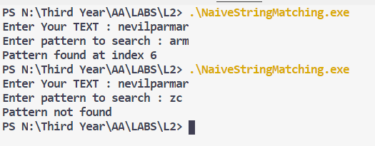

**Task 2:**

Implement horspool string matching algorithm.

Code :

/*

*\* @Author: nevil*

*\* @Date: 2020-07-17 16:05:53*

*\* @Last Modified by: nevil*

*\* @Last Modified time: 2020-07-26 15:01:56*

*/

#*include*<bits/stdc++.h>

using namespace std;

int *horspoolStringMatching*(*const* string *&*P, *const* string *&*T) {

// *P = input text*

// *T = pattern to be searched in the text*

// *shift table for algo*

int table[126];

int k = 0, flag = 0;

int m = T.*length*();

int n = P.*length*();

int i, j;

*for* (i = 0; i < 126; i++)

table[i] = m;

*for* (j = 0; j < m - 1; j++)

table[T*[*j*]*] = m - 1 - j;

i = m - 1;

*while* (i <= n - 1) {

k = 0;

*while* (k <= m - 1 && T*[*m - 1 - k*]* == P*[*i - k*]*) {

k++;

}

*if* (k == m) {

*return* i - m + 1;

flag = 1;

*break*;

}

*else* {

i = i + table[P*[*i*]*];

}

}

// *returns -1 if the pattern is not found in the given input string*

*if* (!flag)

*return* -1;

}

int *main*()

{

string text, pattern;

cout *<<* "Enter Your TEXT : ";

cin *>>* text;

cout *<<* "Enter pattern to search : ";

cin *>>* pattern;

int index = *horspoolStringMatching*(text, pattern);

*if*(index != -1)

cout *<<* "Pattern found at : " *<<* index *<<* *endl* ;

*else*

cout *<<* "Patter not found !" *<<* *endl*;

*return* 0;

}

Output:

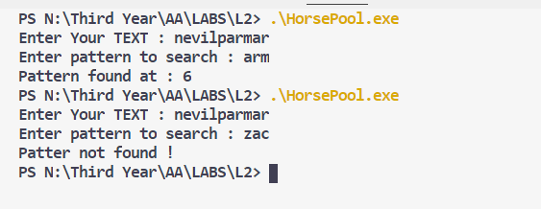

**Conclusion :**

The Boyer-Moore-Horspool algorithm execution time is linear in the size of the string being searched. It can have a lower execution time factor than many other search algorithms.

For one, it does not need to check all characters of the string. It skips over some of them with the help of the Bad Match table.

The algorithm gets faster as the substring being searched for becomes longer. This is because with each unsuccessful attempt to find a match between the substring and the string, the algorithm uses the Bad Match table to rule out positions where the substring cannot match.

**Complexity :**

The Naive approach for string matching compare the pattern with all the characters in given text hence its time complexity is O(m*n).

Horspool's algorithm for string matching requires some pre-processing. In the worst-case the performance of the Boyer-Moore-Horspool algorithm is O(mn), where m is the length of the substring and n is the length of the string.

The average time is O(n).

Nevil Parmar

CE-092

https://nevilparmar.me