**ASSIGNMENT – 1 Roll No. – CE092**

1. **Use the FILL command (F) to initialize the 10h storage locations starting at**

**DS:10 with the value 11h, the 10h storage locations starting at address DS:30**

**with 22h, the 10h storage locations starting at address DS:50 with 33h, and the**

**10h storage locations starting at address DS:70 with 44h.**

* The following commands are required to achieve above mentioned goal.

1. f 0010 0020 0011 or F DS:0010 L 10 11
2. f 0030 0040 0022 or F DS:0030 L 10 22
3. f 0050 0060 0033 or F DS:0050 L 10 33
4. f 0070 0080 0044 or F DS:0070 L 10 44

* Below is the image of code output:
* 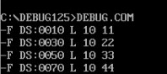

1. **Verify the result of step 6 using the DUMP command.**

* The following command is needed to verify the step 6.
* Command: d DS:0010
* The output of the above command will be as shown in below image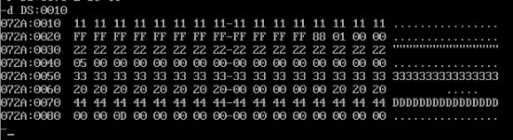

1. **Use the ENTER command (E) to load locations CS:50, CS:52, and CS:54 with AA, BB, and CC, respectively.**

* The following commands are needed to achieve above goals:

1. E CS:50 “AA”
2. E CS:52 “BB”
3. E CS:54 “CC”
4. **What is the extension of the file produced by the linker?**

* Extension of the output file produced by the linker is .exe or .map.

1. **Which debug commands allows us to see the memory contents?**

* Dump (D) command allows us to see the memory contents.

1. **What is the difference between a logical address and a physical address?**

* Physical address points to a physical location on memory and that storage cell can be accessed by a program and is generated by Memory Management Unit (MMU).
* Logical address is a virtual address generated by Central Processing Unit (CPU), at compile time. Which maps to a physical address of a memory location.

1. **Show how a physical address is generated from a logical address.**

* The 8086 addresses a segmented memory. The complete physical address which is 20-bits long is generated using segment and offset registers each of the size 16-bit. The content of a segment registers also called as segment address, and content of an offset register also called as offset address. To get total physical address, put the lower nibble 0H (or multiply it by 10) to segment address and add offset address.
* It is calculated by using this formula
* physical address=segment address * 10H + offset address
* Assuming segment address = 1000H and offset address = 2345H we have,
* = 1000 * 10H + 2345H
* = 12345H
* Graphical Representation of generation of Physical Address in 8086 Processor
* 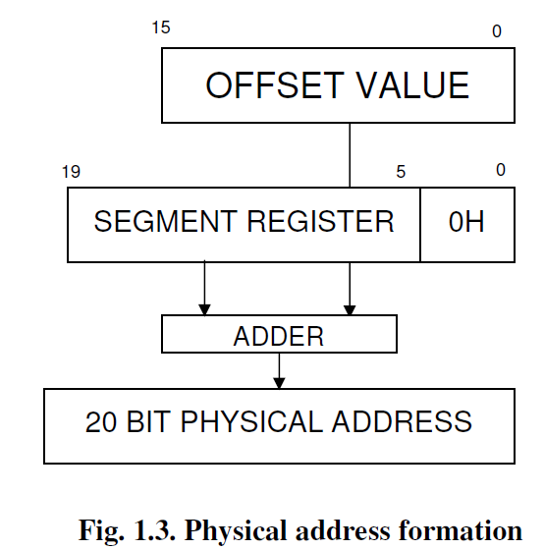

1. **What are the following registers used for: DS, CS, SS, SP, IP, AX?**

* DS: Stores starting address of Data Segment
* CS: Stores starting address of Code Segment
* SP: Stores offset value within the program stack
* SS: Stores starting address of the Stack
* IP: Stores offset address of the next instruction
* AX: AX is used in input/output and storing results of arithmetic operation

1. **Define the function each of the following flag bits in the flag register: Overflow, Carry, Sign, and Zero.**

* Overflow flag: indicates overflow of high-order bit of data after any operation
* Carry flag: contains the carry from result after arithmetic operation
* Sign flag: shows the sign of result after operation
  + 0: positive value
  + 1: negative value
* Zero flag: indicates result is zero or not after arithmetic or comparison operation
  + 0: non-zero value
  + 1: zero

1. **Use a REGISTER command to first display the current contents of IP and then change this value to 0300h.**

* r IP
* IP 0100 :0300

1. **Use a REGISTER command to first display the current contents of the flag register and then reset the overflow, sign, and auxiliary flags.**

* r F
* NV UP EI NG NZ NA PO NC: NV PL NA

1. **Using the ASSEMBLE command (A), load the program shown below into memory starting at address CS: 0100.**
   1. 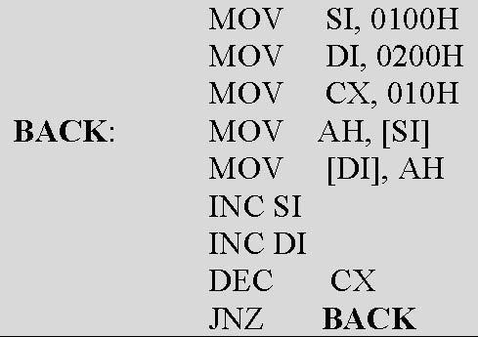

Since assemble command does not support labels , we will have to use offset value to the JNZ instruction as argument.

* + 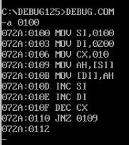
  1. **Verify the loading of the program by displaying it with the UNASSEMBLE (U) command.**

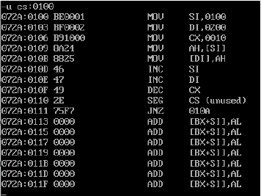

* 1. **How many bytes of memory does the program take up?**
  + This program (Program without int 03 at the end, same as image code) occupies 11 bytes in the memory.
  1. **What is the machine code for the DEC CX instruction?**
  + 49 is the machine code for DEC CX instruction.
  1. **What is the address offset for the label BACK?**
  + CS: 0109

1. **What is the difference between T, G and P debug commands?**

* Trace (T): This command executes individual loop iterations or procedure calls.
* Proceed (P): This command executes a procedure or subroutine entirely.
* Go (G): This command only stops execution where a break point is set.