Guidelines for submission

Create and upload a document/pdf file with solutions of following questions in the google form provided by instructor.

File name should be MFP_Lab_01_CE001.pdf

Each student has to upload/submit individually.

Each assignment/task will be evaluated and graded.

Assignment questionnaire are useful for subsequent theory/practical/viva-voce/quiz examinations.

Students have to put efforts on their own. If the content of a submitted document of a student matches of other student’s document significantly, marks of both the students would be downgraded to zero

The deadline for submitting the assignment is 12th July 2020 4.00 PM

ASSIGNMENT 1

Using Debug Commands discussed in the Laboratory session perform following functions:

1. Use the FILL command (F) to initialize the 10h storage locations starting at DS:10 with the value 11h, the 10h storage locations starting at address DS:30 with 22h, the 10h storage locations starting at address DS:50 with 33h, and the 10h storage locations starting at address DS:70 with 44h
2. Verify the result of step 6 using the DUMP command.
3. Use the ENTER command (E) to load locations CS:50, CS:52, and CS:54 with AA, BB, and CC, respectively.
4. What is the extension of the file produced by the linker?
5. Which debug commands allows us to see the memory contents?
6. What is the difference between a logical address and a physical address?
7. Show how a physical address is generated from a logical address.
8. What are the following registers used for: DS, CS, SS, SP, IP, AX
9. Define the function each of the following flag bits in the flag register: Overflow, Carry, Sign, and Zero.
10. Use a REGISTER command to first display the current contents of IP and then change this value to 0300h.
11. Use a REGISTER command to first display the current contents of the flag register and then reset the overflow, sign, and auxiliary flags.
12. Using the ASSEMBLE command (A), load the program shown below into memory starting at address CS: 0100.
    1. 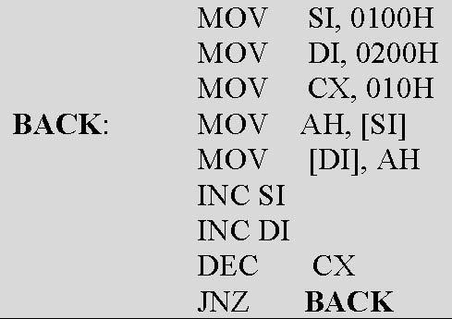
    2. Verify the loading of the program by displaying it with the UNASSEMBLE (U) command.
    3. How many bytes of memory does the program take up?
    4. What is the machine code for the DEC CX instruction?
    5. What is the address offset for the label BACK?
13. What are the difference between T,G and P debug commands.