**Microprocessor Fundamentals and Programming**

**Assignment 3 CE092: Nevil Parmar**

**Task1:**

Write a program to find the smallest number in an array of words and store it in the variable named small of the data segment.

DATA SEGMENT

      A DB 5,2,5,6,4,3

      SMALLEST DB ?

DATA ENDS

CODE SEGMENT

      ASSUME DS:DATA,CS:CODE

START:

      MOV AX,DATA

      MOV DS,AX

      MOV CX,0000

      MOV CL,06

      LEA BX,A

      MOV AX,0000

      MOV AL,0FFH

      MOV AH,BYTE PTR[BX]

CHECK:

      CMP AL,BYTE PTR[BX]

      JNC SAVE

      JMP NEXT

SAVE:

      MOV AL,BYTE PTR[BX]

      JMP NEXT

NEXT:

      INC BX

      DEC CL

      CMP CL,00

      JNZ CHECK

      MOV SMALLEST,AL

      INT 03

CODE ENDS

END START

**Output:**

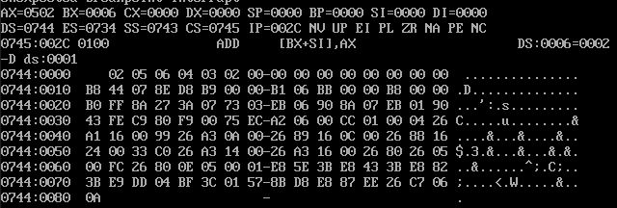

**Task2:**

Write a program to sort an array of signed numbers given in the data segment.

DATA SEGMENT

    ARRAY DB 99H,12H,56H,45H,36H

DATA ENDS

CODE SEGMENT

    ASSUME CS:CODE,DS:DATA

START:

    MOV AX,DATA

    MOV DS,AX

    MOV CH,04H

UP2:

    MOV CL,04H

    LEA SI,ARRAY

UP1:

    MOV AL,[SI]

    MOV BL,[SI+1]

    CMP AL,BL

    JC DOWN

    MOV DL,[SI+1]

    XCHG [SI],DL

    MOV [SI+1],DL

DOWN:

    INC SI

    DEC CL

    JNZ UP1

    DEC CH

    JNZ UP2

    INT 3

CODE ENDS

END START

**Output:**

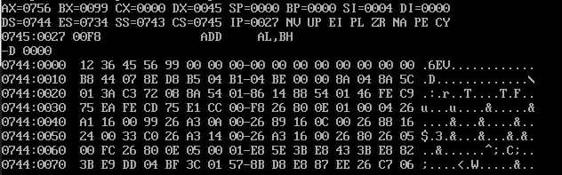

**Task3:**

Write a program to find the square root of a given number.

DATA SEGMENT

      NUMBER DW 19H

      ANS DW ?

DATA ENDS

CODE SEGMENT

      ASSUME DS:DATA,CS:CODE

START:

      MOV AX,DATA

      MOV DS,AX

      MOV AX,NUMBER

      MOV CX,0000H

      MOV BX,0FFFFH

REPEAT:

      ADD BX,02H

      INC CX

      SUB AX,BX

      JNZ REPEAT

      MOV ANS,CX

      INT 03H

CODE ENDS

END START

**Output:**

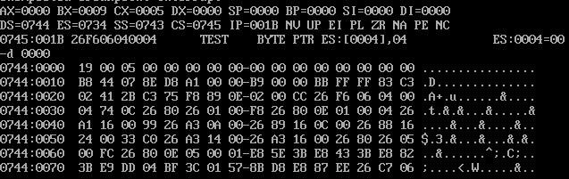

**Task4:**

Consider an array(array1) of 20 random numbers ranging between 1 to 4. Write a program to Count the number of 1’s, 2’s, 3’s and 4’s in the array1 and store the result of the count in one more array(array 2) of size 4 elements. At first location of array2 it has to store the count of 1’s, at second location it has to store count of 2’s and so on...

DATA SEGMENT

        ARRAY2 DB 4 DUP(0)

        ARRAY1 DB 01h,01h,02h,04,03h,02h,01h,00h,04h,02h,03h,00h,01h,02h,03h,04h,01h,03h,00h,02h

DATA ENDS

CODE SEGMENT

        ASSUME DS:DATA,CS:CODE

START:

        MOV AX,DATA

        MOV DS,AX

        LEA SI,ARRAY1

        LEA DI,ARRAY2

        MOV CX,14H

        MOV BX,0000H

COMPUTE:

        MOV BL,[SI]

        INC [DI+BX-1]

        INC SI

        DEC CX

        JCXZ STOP

        JMP COMPUTE

   STOP:

        INT 03H

CODE ENDS

END START

**Output:**

