horizontal line

**Assignment 04 | MFP**

**CE-092**

Assignment submission for Microprocessor Fundamentals and Programming subject week 4.

nevilparmar24@gmail.com

**─**

Note: Some programs are tested in emu8086 due to the permission issues in tasm and windows 10.

**Task 1:**

Write a program to find all the prime numbers between 1 to 50.

Code:

*;Author : Nevil Parmar*

*;Roll NO: CE092*

data segment

prime_numbers *db* 20 dup (0)

data ends

code segment

assume cs:code, ds:data

mov ax, data

mov ds, ax

mov bl, 01h

mov cx, 10h

mov si, offset prime_numbers

up:

mov dl, 02h

add bl, 01h

cmp bl, 02h

je loop2

cmp bl, 03h

je loop2

cmp bl, 04h

jge Loop1

loop1:

mov ah, 00

mov al, bl

div dl

cmp ah, 00h

je up

add dl, 01h

cmp dl, al

jle loop1

jmp loop2

loop2:

mov [si], bl

inc si

loop up

int 21h

code ends

end

Output:

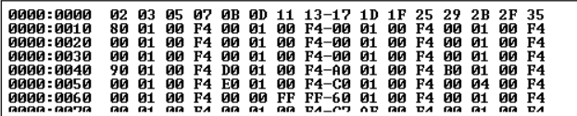

**Task 2:**

Write a program to read a string of lowercase letters and convert to upper case and display the string on the console.

Code:

*;Author : Nevil Parmar*

*;Roll NO: CE092*

data segment

LSTR DB 30,?,30 DUP('')

data ends

code segment

Assume cs:code, ds:data

Begin:

mov ax, data

mov ds, ax

mov dx,offset LSTR

mov ah,0ah

int 21h

*; printing new line*

mov ah,2

mov dl,0Dh

int 21h

mov dl,0Ah

int 21h

mov bl,LSTR[1]

CONVERT:

cmp bx,00

je EXIT

mov al,LSTR[bx+1]

sub al,20h

mov LSTR[bx+1],al

dec bx

jmp CONVERT

EXIT:

xor bx,bx

mov bl,LSTR[1]

mov LSTR[bx+2],'$'

mov dx,offset LSTR+2

mov ah,09h

int 21h

mov ah, 4Ch

int 21h

Code Ends

End Begin

Output:

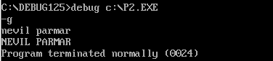

**Task 3:**

Write a program to create a file and write 10 bytes of data into the file. Create one more file and make a copy of the first file. (i.e Read from the first file and write into the second file)

Code:

*;Author : Nevil Parmar*

*;Roll NO: CE092*

data segment

*;creating a new file*

fname1 *db* 'C:\emu8086\MyBuild\file1', 0

fname2 *db* 'C:\emu8086\MyBuild\file2', 0

fp1 *dw* ?

fp2 *dw* ?

string *db* 'Hey There, Nevil Here !'

temp *db* 40 dup(?)

data ends

code segment

assume cs:code, ds:data

start:

mov ax, data

mov ds, ax

mov ah, 3ch *; new file1*

mov dx, offset fname1

mov cl, 1

int 21h

mov fp1, ax

mov ah, 3ch *; new file2*

mov dx, offset fname2

mov cl, 1

int 21h

mov fp2, ax

mov ah, 3eh *; closing file1*

mov dx, fp1

int 21h

mov ah, 3eh *; closing file2*

mov dx, fp2

int 21h

mov ah, 3dh *; open existing file1*

mov dx, offset fname1

mov al, 1 *; writing mode*

int 21h

mov fp1, ax

mov ah, 40h *; updation in file1*

mov bx, fp1

mov cx, 23h

mov dx, offset string

int 21h

mov ah, 3eh *; closing file1*

mov dx, fp1

int 21h

mov ah, 3dh

mov dx, offset fname1

mov al, 0 *; reading mode*

int 21h

mov fp1, ax

mov ah, 3fh *; reading 23 bytes from file1*

mov bx, fp1

mov dx, offset temp

mov cx, 23h

int 21h

mov ah, 3dh *; open existing file2*

mov dx, offset fname2

mov al, 1 *; writing mode*

int 21h

mov fp2, ax

mov ah, 40h *; copy from file2 to file2*

mov bx, fp2

mov cx, 23h

mov dx, offset temp

int 21h

mov ah, 3eh *; closing file1*

mov dx, fp1

int 21h

mov ah, 3eh *; closing file2*

mov dx, fp2

int 21h

code ends

end start

Output:

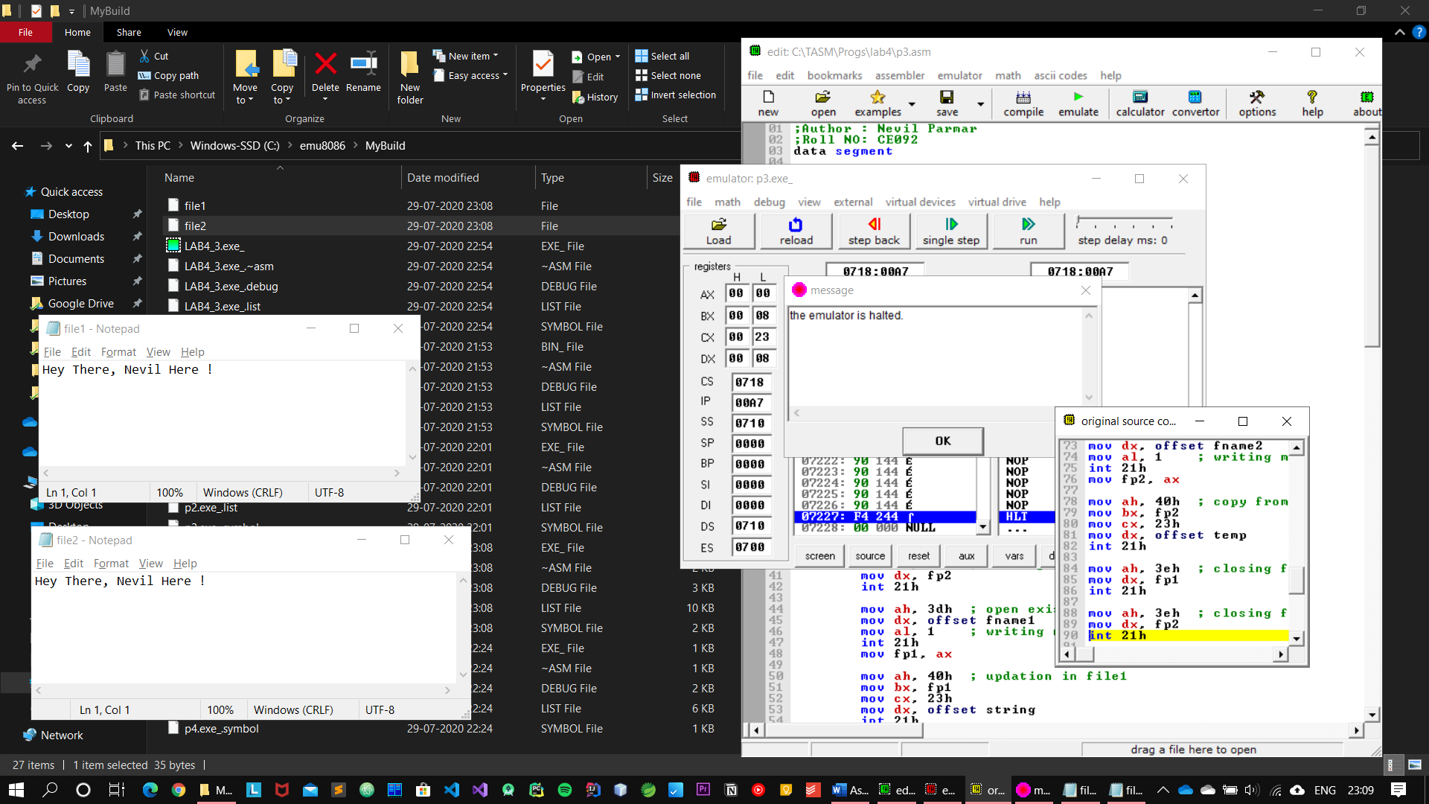

**Task 4:**

Write a program to display the string “Hello World” when the character ‘Y’ is pressed.

Code:

*;Author : Nevil Parmar*

*;Roll NO: CE092*

*; It reads character from the console, and prints "Hello world" only if the entered character is 'Y'*

*;otherwise the loop continues and keep on asking for input character*

data segment

SAYHI DB 'Hello World !','$'

data ends

code segment

Assume cs:code, ds:data

Begin:

mov ax,data

mov ds,ax

READ:

*;read a character*

mov ah,1

int 21h

*;save input character to bl register and go to new line*

mov bl,al

mov ah,2

mov dl,0dh

int 21h

mov dl,0ah

int 21h

*; check if the entered character is 'Y' by subtracting its ascii value*

CHECK:

mov al,59h

sub al,bl

jz EXIT

jmp READ

*; terminate*

EXIT:

*; print hello world and exit*

lea dx,SAYHI

mov ah,09h

int 21h

*; return back to console*

mov ah,4ch

int 21h

Code Ends

End Begin

Output:

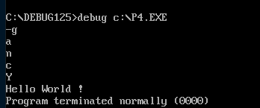

Nevil Parmar

CE-092

https://nevilparmar.me