**Operating System**

**Practical-3 CE092: Nevil Parmar**

**Aim:** Process Creation and Termination (Use of fork, wait, getpid, and getppid systemcalls).

**Theory:**

**Fork System Call:**

**#include <[unistd.h](http://linux.die.net/include/unistd.h)>**

**pid_t fork(void);**

**fork**() creates a new process by duplicating the calling process. The new process, referred toas the *child*, is an exact duplicate of the calling process, referred to as the *parent*, except for the following points:

* The child has its own unique process ID, and this PID does not match the ID of any existing process group.
* The child's parent process ID is the same as the parent's process ID.

On success, the PID of the child process is returned in the parent, and 0 is returned in the child.

On failure, -1 is returned in the parent, no child process is created, and *errno* is set appropriately.

**Zombie Process:**

A process which has finished the execution but still has entry in the process table to report to its parent process is known as a zombie process.

A child process always first becomes a zombie before being removed from the process table. The parent process reads the exit status of the child process which reaps off the child process entry from the process table.

**Orphan Process:**

A process whose parent process no more exists i.e. either finished or terminated without waiting for its child process to terminate is called an orphan process.

**Getpid and Getppid System Calls:**

**#include<**[**sys/types.h**](http://linux.die.net/include/sys/types.h)**>**

**#include <[unistd.h](http://linux.die.net/include/unistd.h)>**

**pid_t getpid(void);**

**pid_t getppid(void);**

**getpid**() returns the process ID of the calling process.

**getppid**() returns the process ID of the parent of the calling process.

**Wait System Call:**

**#include<**[**sys/types.h**](http://linux.die.net/include/sys/types.h)**>**

**#include <**[**sys/wait.h**](http://linux.die.net/include/sys/wait.h)**>**

**pid_t wait(int \**status*);**

wait system call is used to wait for state changes in a child of the calling process, and obtain information about the child whose state has changed.

A state change is considered to be: the child terminated; the child was stopped by a signal; or the child was resumed by a signal.

In the case of a terminated child, performing a wait allows the system to release the resources associated with the child; if a wait is not performed, then the terminated child remains in a "zombie" state.

If a child has already changed state, then this call returns immediately. Otherwise it blocks until either a child changes state or a signal handler interrupts the call.

On success, returns the process ID of the terminated child; on error, -1 is returned.

**Tasks**

**Task 1:**

Call fork once, twice, thrice and print “Hello”. Observe and interpret the outcomes.

**Subtask 1: Calling fork once**



**Output:**

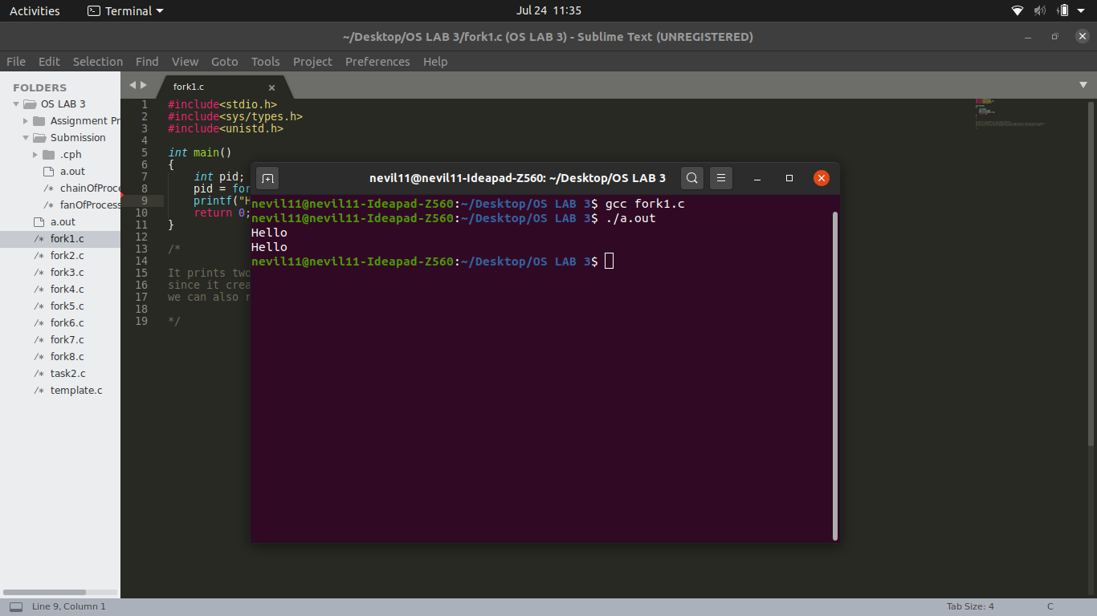

**Subtask 2: Calling fork twice**

#*include*<stdio.h>

#*include*<sys/types.h>

#*include*<unistd.h>

int *main*()

{

    int pid;

    pid = *fork*();

    pid = *fork*();

*printf*("Hello\n");

*return* 0;

}

/*

*It prints 4 hello.*

*also sometimes between terminal prompts .*

*Process dispatchers dispatches the process on the basis of some contexts, so while running this prog multiple times we might get this kindof behaviour.*

*/

**Output:**

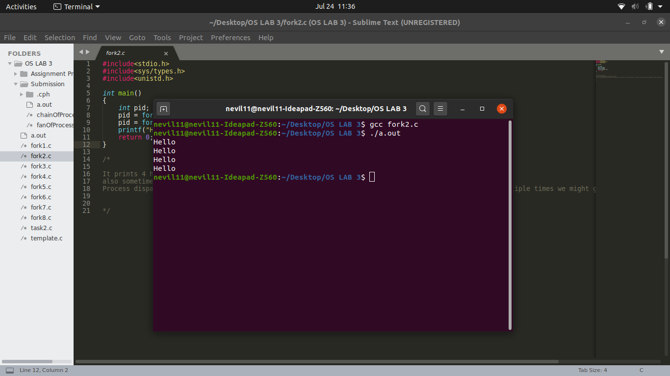

**Subtask 3: Calling fork thrice**

#*include*<stdio.h>

#*include*<sys/types.h>

#*include*<unistd.h>

int *main*()

{

    int pid;

    //*printf("World");*

    pid = *fork*();

    pid = *fork*();

    pid = *fork*();

*printf*("Hello\n");

*return* 0;

}

/*

*It prints 8 hello.*

*after 1st fork there are 2 process . IP will point to second fork*

*each of newly createrd 2 processes points to third process.*

*and same for the third fork, but this processes will point to printf.*

*So in total 8 processes will print :hello: 8 times.*

*Extra:*

*if we uncomment printf world line. Then the output is unpredictable. It will not flush the memory buffer and the word wordl will stay there.*

*/

**Output:**

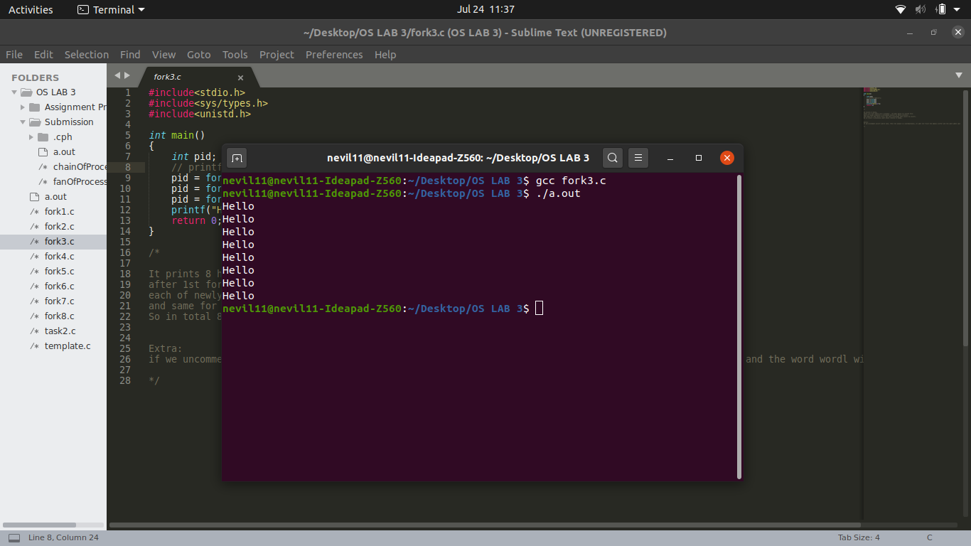

**Task 2:**

Print PID and PPID for parent and child processes. Observe and interpret the outcomes.

#*include*<stdio.h>

#*include*<sys/types.h>

#*include*<unistd.h>

//*#include<sys/wait.h>*

int *main*()

{

    int pid;

    //*int status;*

    pid = *fork*();

*if*(pid == -1)

    {

*printf*("Error!\n");

    }

*else* *if*(pid > 0)

    {

        //*wait(&status);*

*printf*("Hello from parent\n");

*printf*("pid = %d\n",*getpid*());

*printf*("ppid = %d\n",*getppid*());

    }

*else*

    {

        //*child part*

        //*pid = 0*

*printf*("Hello from child\n");

*printf*("child pid = %d\n",*getpid*());

*printf*("child ppid = %d\n",*getppid*());

    }

*return* 0;

}

/*

*Output:*

*Hello from parent*

*Hello from child*

*Extra:*

*can be useful to achieve separeate tasks independently*

*1. Inside parent block we can run ls in terminal*

*2. whose output will be given to child ( here child block )*

*which will sort the output of ls, executed in parent block.*

*- By uncommenting the wait line we can achieve the following goal.*

*- we can terminate the child process first, then and only then the parent process will execute.*

*/

**Output:**

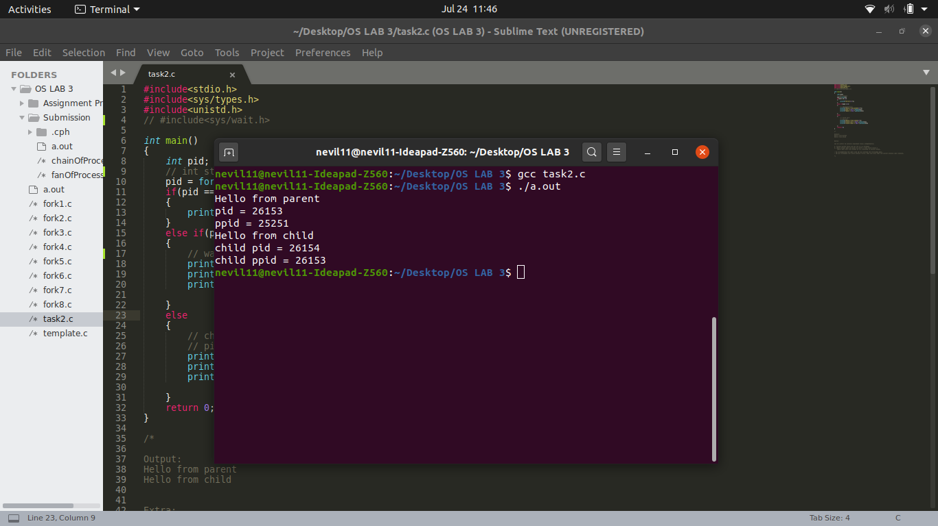

**Task 3:**

Add wait to the code of task 2. Observe and interpret the outcomes.

#*include*<stdio.h>

#*include*<unistd.h>

#*include*<sys/types.h>

#*include*<sys/wait.h>

int *main*()

{

    int pid;

    int status;

    pid = *fork*();

*if*(pid == -1)

    {

*printf*("Error!\n");

    }

*else* *if*(pid > 0)

    {

*wait*(&status);

*printf*("Hello from parent\n");

*printf*("pid = %d\n",*getpid*());

*printf*("ppid = %d\n",*getppid*());

    }

*else*

    {

        //*child part*

        //*pid = 0*

*printf*("Hello from child\n");

*printf*("child pid = %d\n",*getpid*());

*printf*("child ppid = %d\n",*getppid*());

    }

*return* 0;

}

/*

*Output:*

*Hello from child*

*Hello from parent*

*Exaplanation:*

*Here we are terminating the child process first, and then we will execute parent process.*

*/

**Output:**



**Task 4:** Write a program to implement fan of n processes.

C2

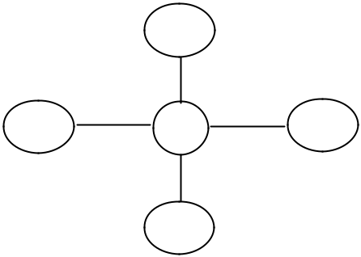

C1 P C3

C4

#*include*<stdio.h>

#*include*<sys/types.h>

#*include*<stdlib.h>

#*include*<sys/wait.h>

#*include*<unistd.h>

int *main*()

{

*for*(int i=0;i<4;i++) //*loop will run n times (n=4)*

    {

*if*(*fork*() == 0)

        {

*printf*("[son] pid %d from [parent] pid %d\n",*getpid*(),*getppid*());

*exit*(0);

        }

    }

*for*(int i=0;i<4;i++) //*loop will run n times (n=4)*

*wait*(*NULL*);

*return* 0;

}

**Output:**

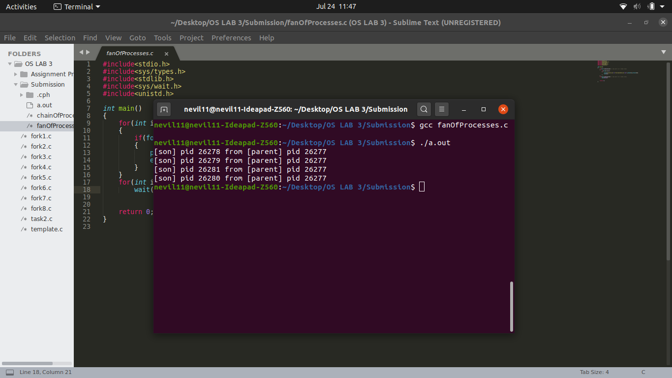

**Task 5:** Write a program to implement chain of n processes.

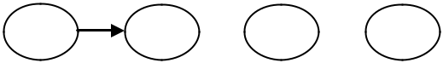

P1 P2  P3  P4

#*include* <sys/types.h>

#*include* <unistd.h>

#*include* <stdio.h>

#*include* <stdlib.h>

#*include* <sys/wait.h>

int n=4;

int *foo*(*const* char *whoami) {

*printf*("I am a %s.  My pid is:%d  my ppid is %d\n", whoami, *getpid*(), *getppid*() );

*return* 1;

}

int *func*(int n)

{

*if* (n == 0)

    {

*return* 0;

    }

    int pid = *fork*();

*if* (pid == -1) {

*exit*(0);

    }

*if* (pid==0) {

*foo*("child");

        n = n-1;

*func*(n);

*exit*(0);

    }

*else* {

*wait*(*NULL*);

    }

*return* 0;

}

int *main*()

{

*func*(n);

*return* 0;

}

**Output:**

