horizontal line

**Assignment 06 | Operating System**

**CE-092**

Assignment submission for Operating System subject week 6.

nevilparmar24@gmail.com

**─**

**Aim - Inter process communication ( Use of pipe system call and mkfifo )**

**Pipe system call:**

**#include <unistd.h>**

**int pipe(int pipefd[2]);**

pipe() creates a pipe, a unidirectional data channel that can be used for inter process communication.

The array pipefd is used to return two file descriptors referring to the ends of the pipe.

pipefd[0] refers to the read end of the pipe.

pipefd[1] refers to the write end of the pipe.

Data written to the write end of the pipe is buffered by the kernel until it is read from the read end of the pipe.

On success, zero is returned. On error, -1 is returned, and errno is set appropriately.

**Close system call:**

**#include <unistd.h>**

**Int close(int fd);**

close() closes a file descriptor, so that it no longer refers to any file and may be reused.

Any record locks held on the file it was associated with, and owned by the process, are removed (regardless of the file descriptor that was used to obtain the lock).

close() returns zero on success. On error, -1 is returned, and errno is set appropriately.

**mkfifo system call: make a fifo special file (named pipe)**

**#include <sys/types.h>**

**#include<sys/stat.h>**

**Int mkfifo(const char * pathname, mode_t mode);**

**#include<fcntl.h>**

mkfifo() makes a FIFO special file with name *pathname*.

A FIFO special file is similar to a pipe, except that it is created in a different way. Instead of being an anonymous communications channel, a FIFO special file is entered into the filesystem by calling mkfifo().

On success mkfifo returns 0 , on error -1 is returned.

**Task 1:**

Write a program to create a pipe and print the values of pipe file descriptors.

Code:

#*include*<unistd.h>

#*include*<stdio.h>

int *main*()

{

int pipefd[2];

int secondpipefd[2];

int err = *pipe*(pipefd);

*if*(err!=0)

*printf*("Error creating a file.\n");

*else*

*printf*("pipefd0 : %d\tpipefd1 : %d\n", pipefd[0],pipefd[1]);

int err1 = *pipe*(secondpipefd);

*if*(err1!=0)

*printf*("Error creating a file.\n");

*else*

*printf*("secondpipefd0 : %d\tsecondpipefd1 : %d\n", secondpipefd[0],secondpipefd[1]);

*return* 0;

}

/*

*Output:*

*3 4*

*5 6*

*because 0 1 2 are stdin stdout stderr*

*so they are reserverd and other can be accessed by the process.*

*although, this values are not fixed for all the time. System might take appropriate action and can assign the avaialble resources.i.e pipes here.*

*/

Output:

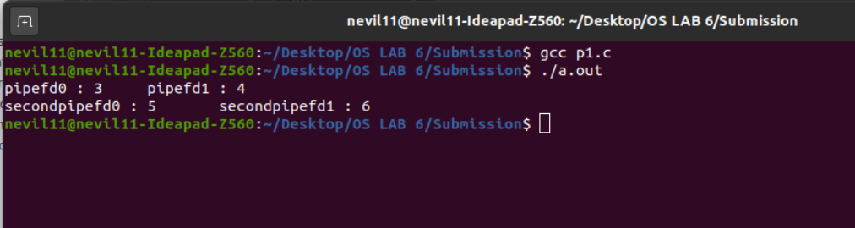

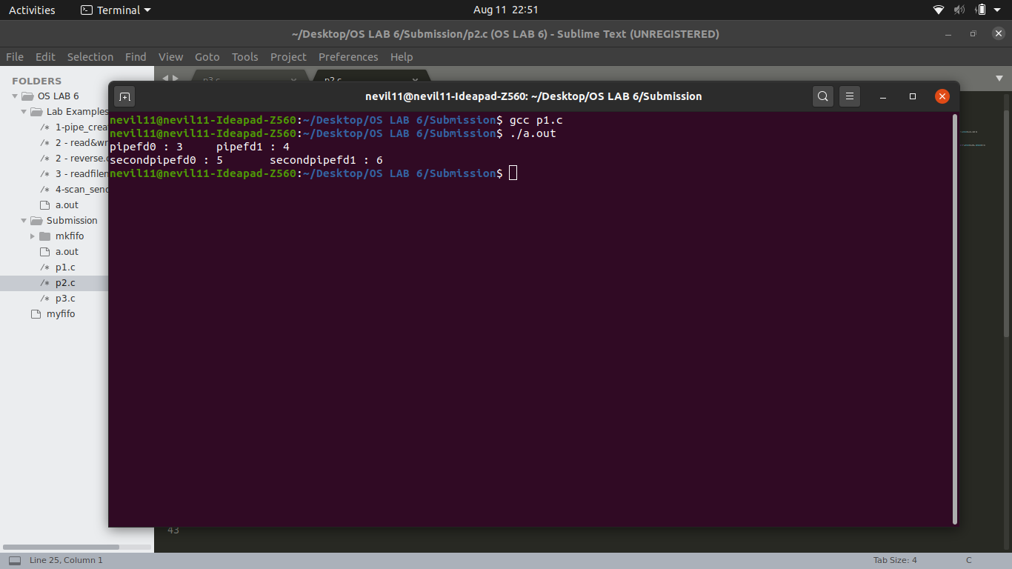

**Task 2:**

Write a program to pass a message from parent process to child process through a pipe..

Code:

#*include*<unistd.h>

#*include*<stdio.h>

int *main*()

{

int pid;

int pipefd[2];

int err = *pipe*(pipefd);

*if*(err!=0)

{

*write*(1,"error",5);

}

pid = *fork*();

*if*(pid == -1)

*printf*("Process creation error\n");

*else* *if*(pid > 0)

{

//*parent part*

*close*(pipefd[0]);

char ch[1000] = {'\0'};

*read*(0,ch,1000);

*printf*("Parent pid: %d sending message: %s to child pid: %d \n",*getpid*(),ch, pid );

*write*(pipefd[1],ch,1000);

}

*else*

{

//*child part*

*close*(pipefd[1]);

char ch2[1000] = {'\0'};

int n = *read*(pipefd[0],ch2,1000);

*printf*("Child pid: %d received message: %s from parent pid: %d \n",*getpid*(),ch2, *getppid*() );

*write*(1,ch2,1000);

}

*return* 0;

}

Output:

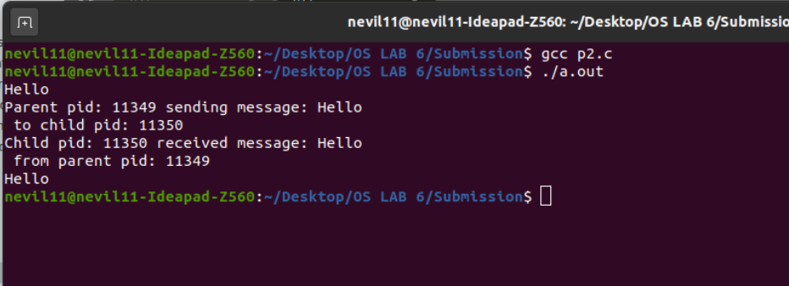

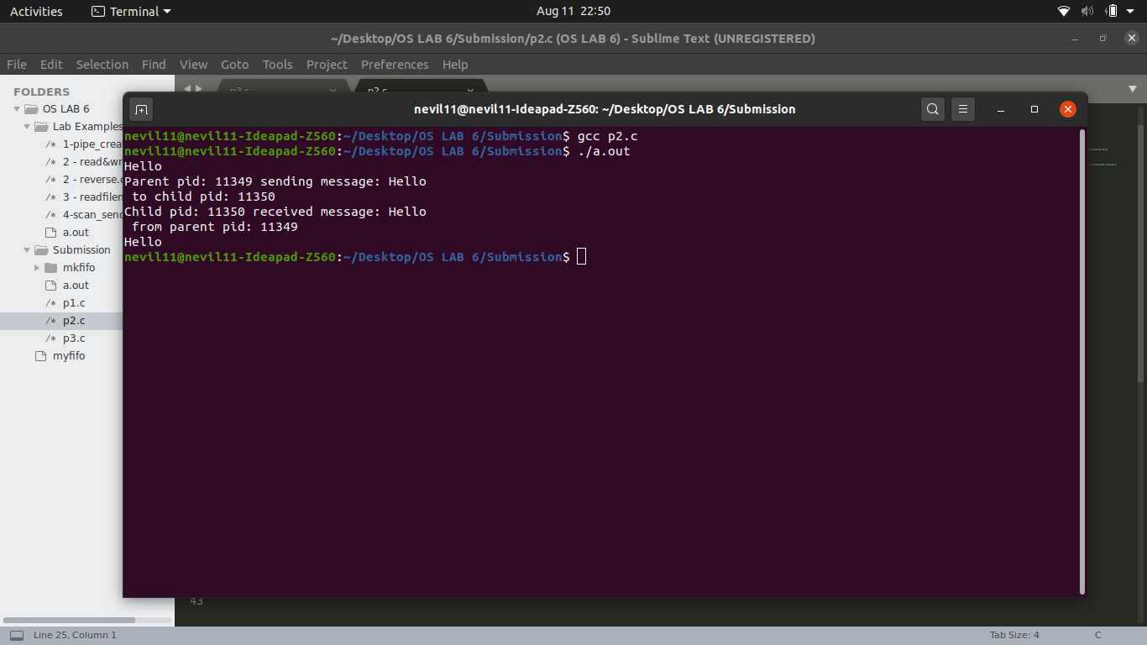

**Task 3:**

Write a program to pass file name from parent process to child process through a pipe, child process should pass the file contents to parent process and parent should print the contents

Code:

// *parent send filename*

// *child send contents*

// *parent prints contents*

#*include*<stdio.h>

#*include*<unistd.h>

#*include*<sys/types.h>

#*include*<sys/stat.h>

#*include*<fcntl.h>

#*include*<string.h>

#*include*<stdlib.h>

#*include*<sys/wait.h>

int *main*(int argc,char* argv*[]*)

{

int pipefd[2],pipefd2[2];

*pipe*(pipefd);

*pipe*(pipefd2);

int pid = *fork*();

char buffer[100];

*if*(pid == -1)

{

*printf*("Error\n");

}

*else* *if*(pid > 0)

{

*close*(pipefd[0]);

*close*(pipefd2[1]);

//*parent part*

*write*(pipefd[1],argv[1],sizeof(argv[1]));

*wait*(*NULL*);

*bzero*(buffer,sizeof(buffer));

int m = *read*(pipefd2[0],buffer,sizeof(buffer));

*write*(1,buffer,m);

}

*else*

{

*close*(pipefd[1]);

*close*(pipefd2[0]);

//*child part*

*bzero*(buffer,sizeof(buffer));

*read*(pipefd[0],buffer,sizeof(buffer));

int fd = *open*(buffer,*O_RDONLY*);

int n = *read*(fd,buffer,sizeof(buffer));

*write*(pipefd2[1],buffer,n);

}

*return* 0;

}

Output:

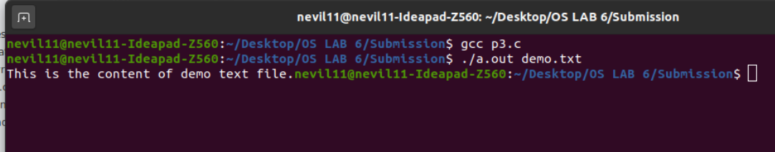

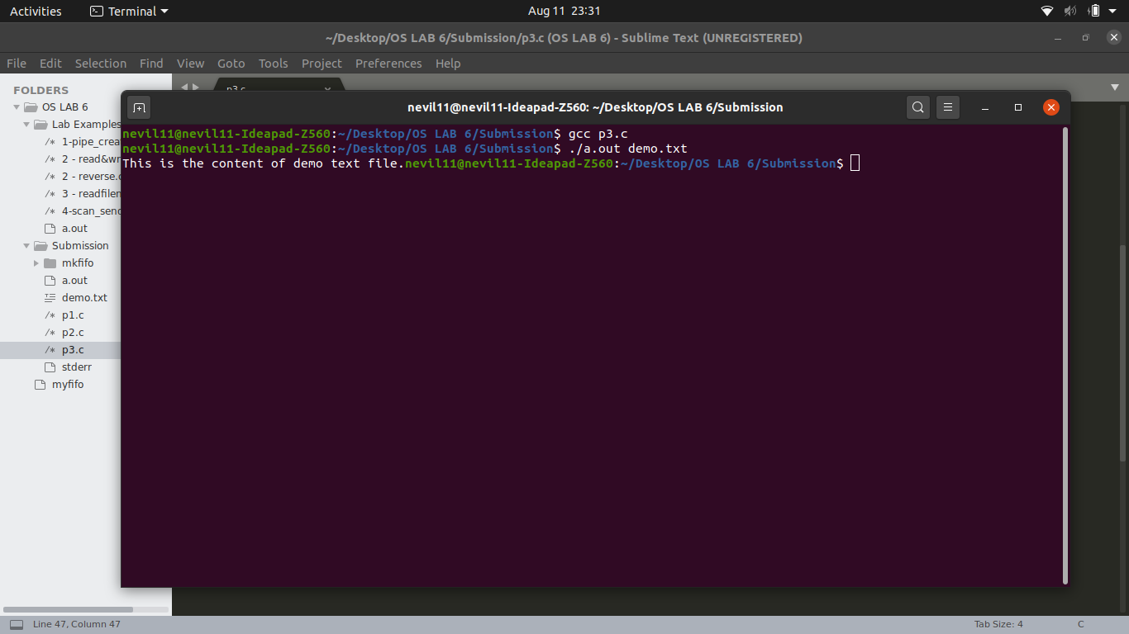

**Task 4:**

Demonstrate the use of named pipe with appropriate programs and commands.

Code:

**Prog1.c**

/// *Prog 1 to mimic the behaviour of mkfifo in linux*

// *It reads input from the user and write it into the created pipe*

#*include* <string.h>

#*include* <fcntl.h>

#*include* <sys/stat.h>

#*include* <sys/types.h>

#*include* <unistd.h>

#*include*<stdio.h>

int *main*()

{

int fd;

// *FIFO file path in the same directory of the program*

char * myfifo = "./customFifo";

// *Creating the named file(FIFO)*

*mkfifo*(myfifo, 0666);

char buffer[80];

*while* (1)

{

// *Open FIFO for write only*

fd = *open*(myfifo, *O_WRONLY*);

// *Take an input buffering from user.*

// *80 is maximum length*

*fgets*(buffer, 80, *stdin*);

// *Write the input buffering on FIFO*

// *and close it*

*write*(fd, buffer, *strlen*(buffer)+1);

*close*(fd);

}

*return* 0;

}

**Prog2.c**

// *Prog 1 to mimic the behaviour of mkfifo in linux*

// *It reads from the created pipe by the first program and outputs on the terminal*

#*include* <string.h>

#*include* <fcntl.h>

#*include* <sys/stat.h>

#*include* <sys/types.h>

#*include* <unistd.h>

#*include*<stdio.h>

int *main*()

{

int fd;

// *FIFO file path in the same directory of the prog*

char * myfifo = "./customFifo";

// *Creating the named file(FIFO)*

*mkfifo*(myfifo, 0666);

char buffer[80];

*while* (1)

{

// *First open in read only and read*

fd = *open*(myfifo,*O_RDONLY*);

*read*(fd, buffer, 80);

// *Print the read string and close*

*printf*("%s", buffer);

*close*(fd);

}

*return* 0;

}

Output

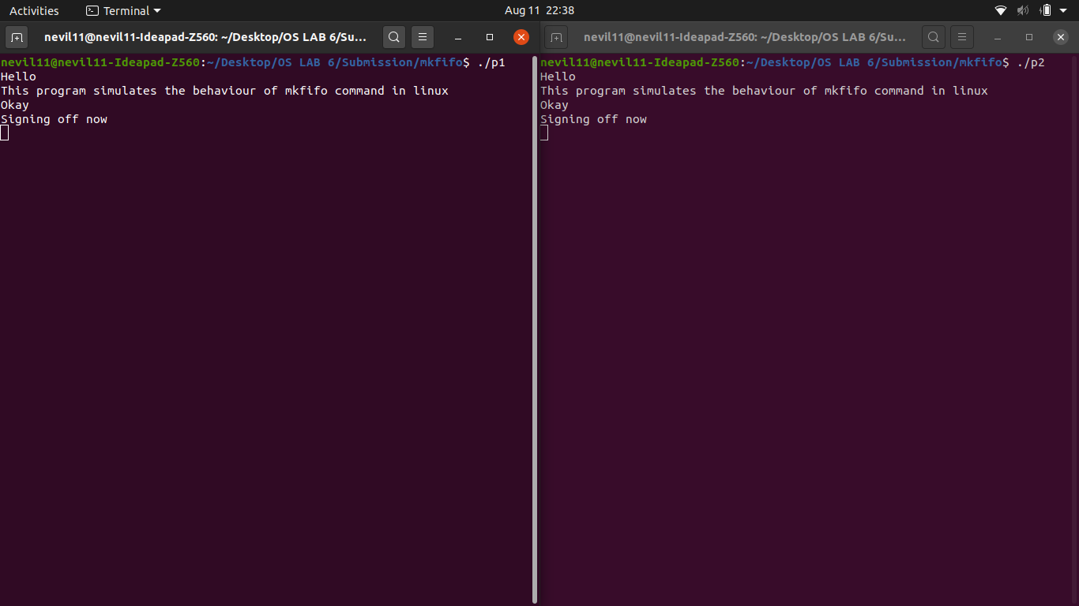

Nevil Parmar

CE-092

https://nevilparmar.me