NESTLIFY

Group Members

1. A-Poojan Kheni
2. B-Harshil Parmar
3. C-Nevil Sachapara
4. D-Hiten Patel
5. E-Sagar Nakrani

PROG8751-25W-Sec3-Capstone (Web Development)

Winter 2025

Submitted to

Jaspinder kaur

NESTLIFY

## **Introduction**

Canada is going through a housing crisis, especially in urban areas like Toronto and Vancouver. For many people, it is hard to find a house that fits their budget due to rent prices that are skyrocketing; also, people lack awareness about governmental assistance and separate information sources.

**Why this project?**

* The program enables people to locate suitable housing options available within their financial reach.
* The platform serves users with a simple system to both search properties along with comparison tools and automatic notification services for housing opportunities.
* Integrates government subsidy programs for financial assistance.

**Project Goal:**

Our Groups project goal is to develop a web application that helps people to find a house based on their income and needs like location, amenities Etc. also checks for government assistance eligibility.

**Design and Data Flow**

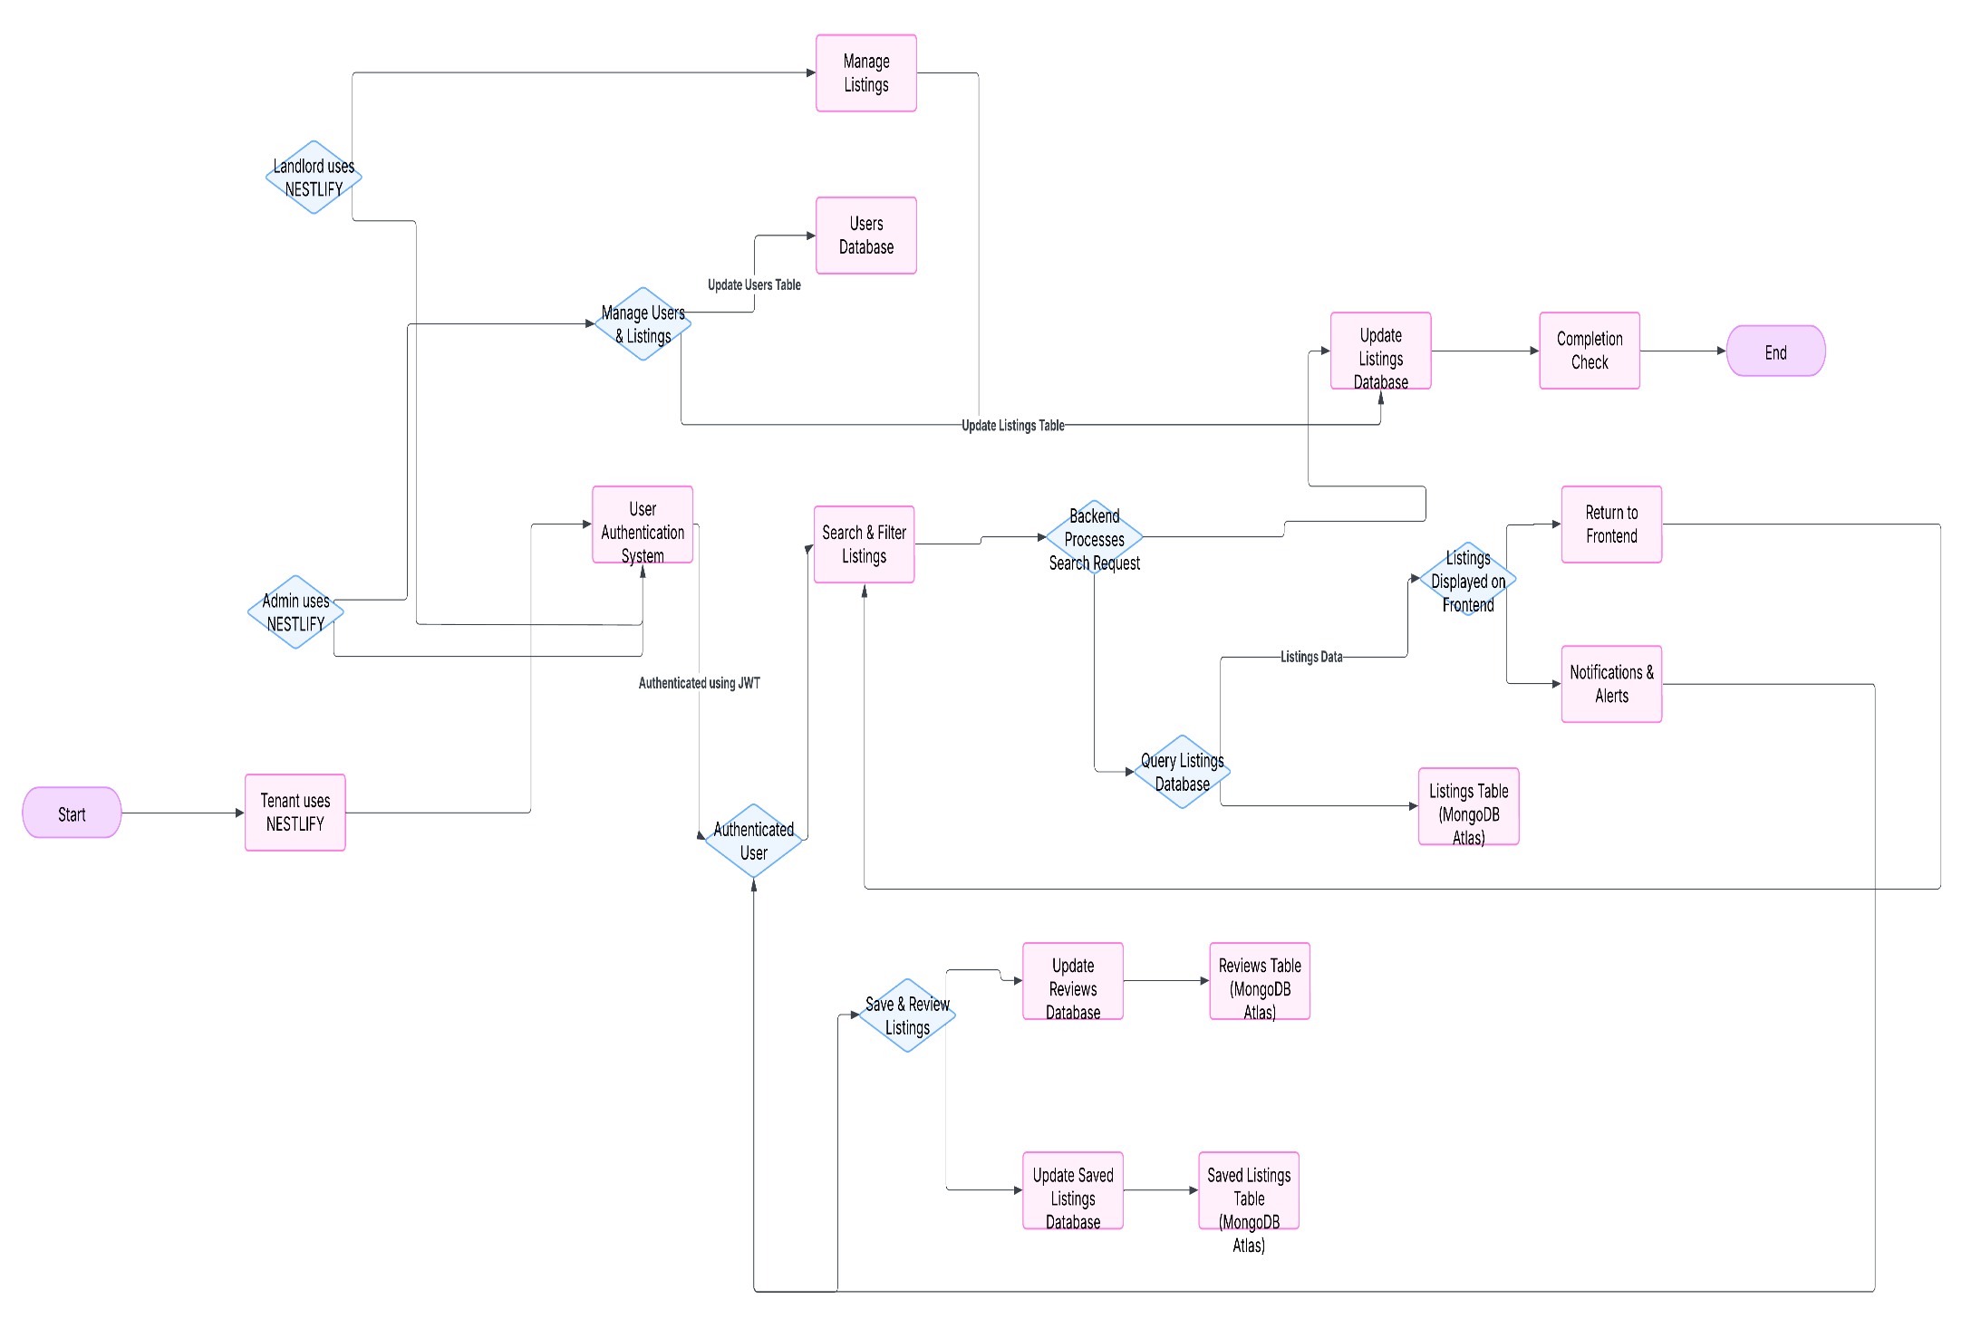

**Data Flow Diagram**

**ER** **Diagram**

# **Pages**

1.Home Page

2.Listing Explore Page

3.Contact Us Page

4.Login/Regestration Page

5.Search Page

## **Technology Description**

Frontend: React.js with TailwindCSS/MUI for responsive UI.

Backend: Node.js with Express.js for API handling.

Database: MongoDB Atlas (GeoJSON for spatial data).

Authentication: JWT-based secure login/logout.

Mapping API: Leaflet Maps API for property visualization, Geoapify for Address Autocomplete API

## **Market Survey**

1. React.js
2. Next.js
3. Node.js
4. Express.js
5. Django
6. PostgreSQL
7. MongoDB
8. Firebase
9. AWS
10. Docker

## **Conclusion**

This project aims to provide a housing search system that is easy to access , feature-rich, and efficient for everyone. The system integrates housing data, governmental assistance data, and user requirements with improved ways of communication between tenants and landlords. Project Completion Timeline follows agile methods with four sprints ensuring iterative improvements

## **GitHub Link**

* [**GitHub Repository**](https://github.com/nevilsanchpara/nestlify)
  1. [Nevil](https://github.com/nevilsanchpara/) [Sanchpara](https://github.com/nevilsanchpara/)
  2. [Harshil](https://github.com/Harshil312) [Parmar](https://github.com/Harshil312)
  3. [Sagar](https://github.com/sagarnakranicad/) [Nakrani](https://github.com/sagarnakranicad/)
  4. [Hiten Patel](https://github.com/hiten1805)
  5. [Poojan Kheni](https://github.com/poojan0502)