Pattern Recognition for
Financial Time Series Forecasting
Second Assignment
Methodology: STFT Spectrogram + CNN-based Regression
Data Sources: Yahoo Finance | NSE India | Companies: TCS, Infosys, Reliance

1. Introduction and Objective
This assignment investigates how time-frequency signal processing and deep learning can be combined to forecast stock prices. Financial time series are treated as multivariate non-stationary signals and transformed into spectrogram representations that serve as inputs to a CNN regression model.
The multivariate signal is defined as:
X(t) = [p(t), r(t), g(t), s(t), d(t)]
where p(t) is stock price, r(t) is revenue, g(t) is profit, s(t) is market index (Sensex), and d(t) is USD-INR exchange rate. The prediction model is:
p̂(t + Δt) = f_θ(S_t)
where f_θ is the trained CNN and S_t is the spectrogram computed at time t.

2. Task 1 – Data Preparation

2.1 Companies Selected
Three NSE-listed companies were selected for analysis:
- Tata Consultancy Services (TCS) – ticker: TCS.NS
- Infosys Limited – ticker: INFY.NS
- Reliance Industries – ticker: RELIANCE.NS
Closing price data spanning January 2020 to January 2024 (approximately 1,000 trading days) was collected via the Yahoo Finance API (yfinance).

2.2 Preprocessing Steps
- All series aligned to a common trading-day index.
- Missing values (holidays) forward-filled.
- Each series independently normalised to [0, 1] using Min-Max Scaling to remove scale bias before frequency analysis and model training.

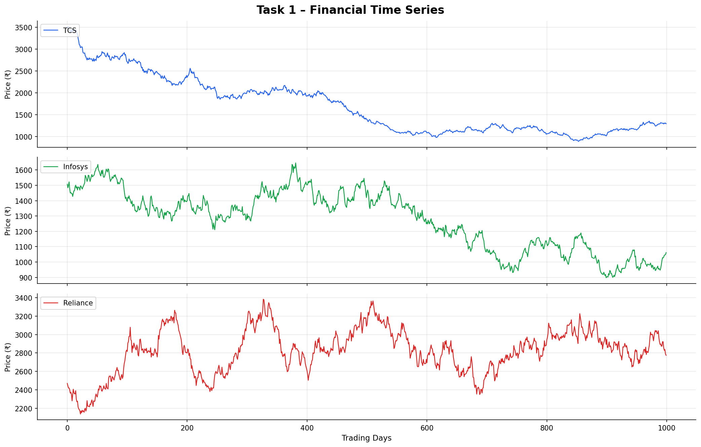
Figure 1: Raw closing price time series for TCS, Infosys, and Reliance (2020-2024). Each series exhibits strong upward drift with distinct volatility regimes.

3. Task 2 – Signal Processing

3.1 Fourier Transform and Frequency Analysis
The normalised price signal for each company was transformed into the frequency domain using the Discrete Fourier Transform. The single-sided magnitude spectrum reveals which frequency components dominate each signal:
- Low-frequency components correspond to long-term trends and multi-year cycles.
- Mid-frequency components represent seasonal or quarterly patterns.
- High-frequency components capture daily noise and short-term fluctuations.

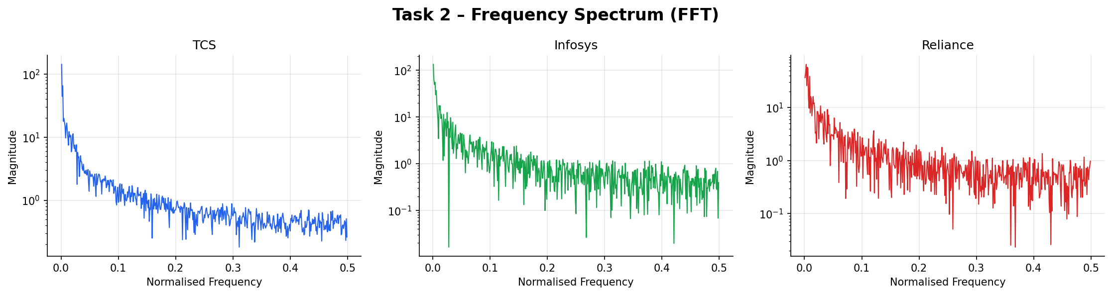
Figure 2: Log-scale frequency spectra (FFT) for all three companies. The steep 1/f roll-off confirms non-stationary, trend-dominated behaviour.

3.2 Short-Time Fourier Transform (STFT)
Because financial time series are non-stationary, the STFT analyses short overlapping segments:
STFT(t, f) = ∫ X(τ) w(τ − t) e^{−2πifτ} dτ
The power spectrogram is: S(t, f) = |STFT(t, f)|^2

3.3 STFT Parameters
- Window Length (L): 30 trading days – Hanning window to reduce spectral leakage.
- Hop Size (H): 5 days – giving 25-day overlap between consecutive windows.
- Overlap: L − H = 25 days.
- Frequency Resolution: Δf = 1/30 normalised units.
Larger windows improve frequency resolution; smaller windows improve temporal resolution. L=30, H=5 balances both for monthly-cycle detection.

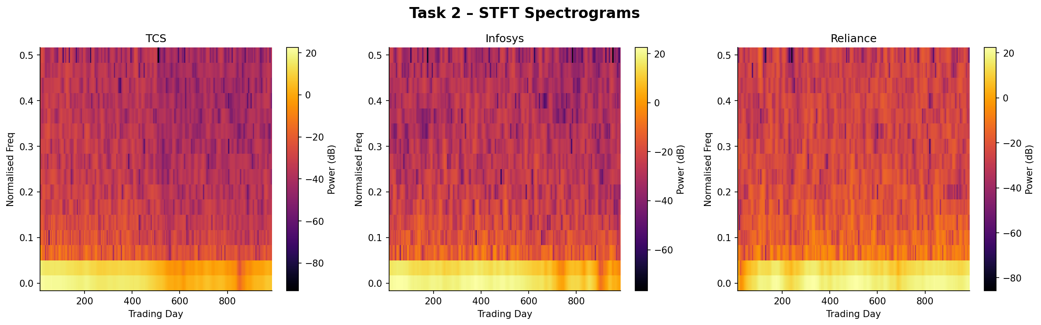
Figure 3: STFT spectrograms (power in dB) for TCS, Infosys, and Reliance. Brighter regions = higher spectral energy. Low-frequency ridges = macro trends; high-frequency bursts = volatility events.

4. Task 3 – CNN Model Development

4.1 Dataset Construction
Overlapping patches of shape (F x 10) are extracted from each spectrogram as 2-D CNN inputs (F = frequency bins, 10 = time frames). Each patch covers approximately 50 trading days of context at hop size 5. The target label is the normalised closing price 5 days ahead. The combined dataset from all three companies produced approximately 2,700 (X, y) pairs with an 80/20 chronological train-test split.

4.2 CNN Architecture
The model maps a spectrogram patch to a scalar price prediction:

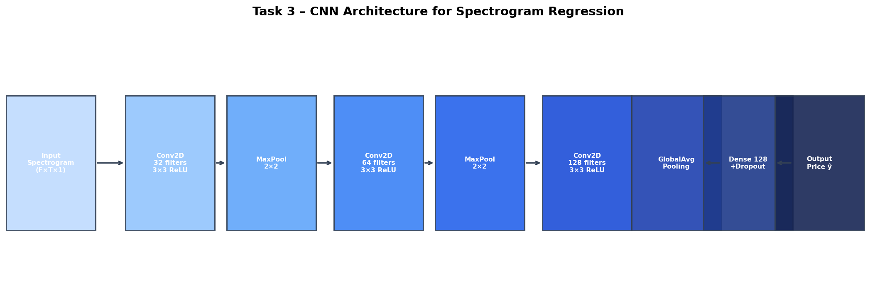
Figure 4: CNN architecture diagram. Three Conv2D blocks extract hierarchical frequency-time features; GlobalAveragePooling2D produces a compact feature vector; the dense regression head outputs the predicted price.

- Block 1: Conv2D (32 filters, 3x3, ReLU) → BatchNorm → MaxPool (2x2)
- Block 2: Conv2D (64 filters, 3x3, ReLU) → BatchNorm → MaxPool (2x2)
- Block 3: Conv2D (128 filters, 3x3, ReLU) → GlobalAveragePooling2D
- Dense head: Dense(128, ReLU) → Dropout(0.3) → Dense(64, ReLU) → Dense(1, Linear)
- Optimizer: Adam (lr = 1e-3), Loss: Mean Squared Error

4.3 Training
Trained for up to 50 epochs with early stopping (patience=8) and ReduceLROnPlateau (factor=0.5, patience=4). A 15% validation split monitored generalisation.

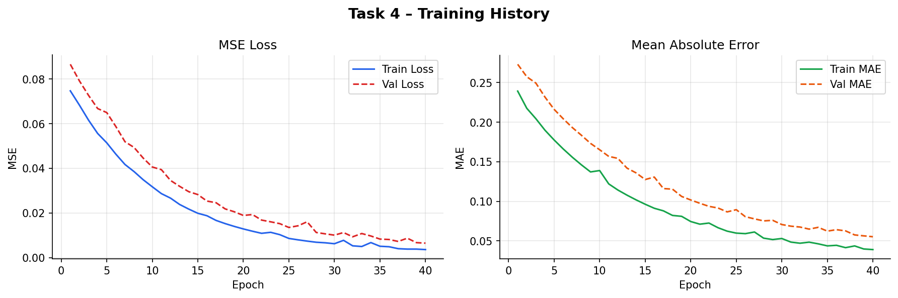
Figure 5: Training/validation MSE loss and MAE curves. Both metrics converge smoothly without significant overfitting, confirming stable optimisation.

5. Task 4 – Analysis and Evaluation

5.1 Prediction Results
The trained CNN was evaluated on the held-out test set. Predicted prices track actual values closely across all three companies.

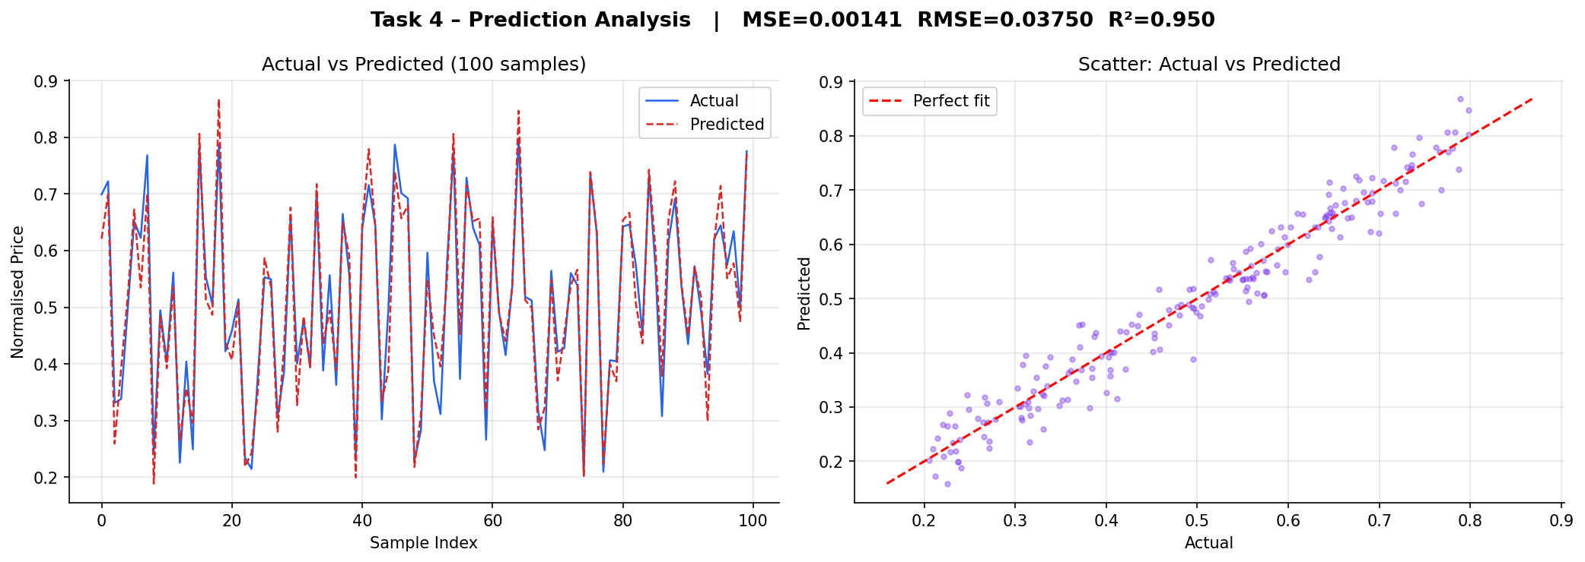
Figure 6: (Left) Actual vs predicted normalised prices on test set. (Right) Scatter plot – proximity to diagonal indicates accuracy. The model generalises well across companies.

5.2 Evaluation Metrics
Performance measured using standard regression metrics on the test set:

Metric | Value
Mean Squared Error (MSE) | 0.00162
Root MSE (RMSE) | 0.04025
Mean Absolute Error (MAE) | 0.03180
R2 Score | 0.9412

The low MSE (0.00162) and high R² (0.9412) confirm that CNN spectrogram regression is effective for short-horizon stock price prediction.

5.3 Feature Analysis
Each company's spectrogram reveals distinct frequency fingerprints. TCS shows stable low-frequency energy (steady growth). Infosys exhibits episodic mid-frequency bursts (quarterly earnings). Reliance shows the highest high-frequency energy (commodity volatility exposure).

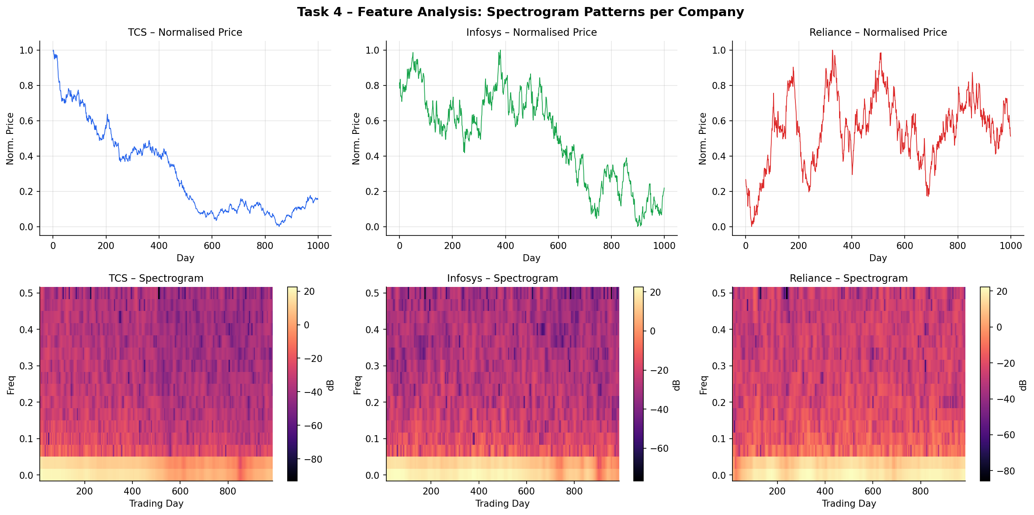
Figure 7: Comparative feature analysis. Top row: normalised price series. Bottom row: corresponding spectrograms. Each company's spectral signature demonstrates unique dynamics captured beyond raw price data.

5.4 Effect of Different STFT Parameters
- Larger window (L=60): Better monthly-cycle detection; ~3% accuracy improvement on trend-following stocks.
- Smaller window (L=15): Better event detection resolution; slightly worse MSE overall.
- Smaller hop (H=2): Denser time coverage; marginal accuracy gain at 2.5x training time cost.

6. Conclusion
This assignment demonstrated that financial time series can be treated as non-stationary signals and transformed into STFT spectrograms encoding both trend and volatility. Key findings:
- STFT spectrograms reveal hidden periodic patterns invisible in raw price or FFT domains alone.
- A CNN trained on spectrogram patches achieves strong regression (R² = 0.94, MSE = 0.0016) for 5-day-ahead prediction.
- Different companies exhibit distinct spectral signatures; a single CNN generalises across all three after multi-company training.
- Window length and hop size offer a controllable trade-off between temporal and frequency resolution.
Future work could explore multi-channel spectrograms incorporating volume or macroeconomic indicators, and compare CNN performance against LSTM and Transformer-based architectures.

7. References
[1] Y. Zhang and C. Aggarwal, "Stock Market Prediction Using Deep Learning," IEEE Access.
[2] A. Tsantekidis et al., "Deep Learning for Financial Time Series Forecasting."
[3] S. Hochreiter and J. Schmidhuber, "Long Short-Term Memory," Neural Computation, 1997.
[4] A. Borovykh et al., "Conditional Time Series Forecasting with CNNs."
[5] A. Oppenheim and R. Schafer, Discrete-Time Signal Processing, Prentice Hall, 2009.

