



Essay / Assignment Title: Creating a Comprehensive Project Plan Document for an IT-related University Project

Programme title: BSc(Hons) Computer Science and Digitisation

Name: NEVIN NELSON (Q1071615)

Year: 2024-2027

CONTENTS

CHAPTER NO. | TITLE | PAGE NO.
 | Introduction | 4
1. | Initiation Phase | 5
2. | Planning Phase | 9
3. | Execution Phase | 13
4. | Monitoring and Controlling Phase | 14
5. | Closing Phase | 15
 | Conclusion | 16
 | References | 17
 | Bibliography | 18

Statement of compliance with academic ethics and the avoidance of plagiarism

I honestly declare that this dissertation is entirely my own work and none of its part has been copied from printed or electronic sources, translated from foreign sources and reproduced from essays of other researchers or students. Wherever I have been based on ideas or other people texts I clearly declare it through the good use of references following academic ethics.
(In the case that is proved that part of the essay does not constitute an original work, but a copy of an already published essay or from another source, the student will be expelled permanently from the program).

Name and Surname (Capital letters):

NEVIN NELSON

Date: 08/02/2026

INTRODUCTION

This project is a systematically developed proposal for the creation, development, deployment and assesment for a mobile application that is suitable for the requirements of a university employees and students. By combining a number of crucial features into a single digital platform, the proposed software targets to improve and simplify the administration of events connected to the campus (Kerzner, 2017). These include comprehensive event listings, an east to use system for finding events, real time event registration, automated push notifications, customised scheduling tools and a thorough process for sending feedback. When taken as a whole, these charecteristics aim to improve how the university community engages with extracarricular, academic, administrative and social activities.
The project’s main goal is to improve engagement and communication in the academic setting. Many institutions now mainly rely on printed posters, email announcements or manual sign-up procedures (Slack, Brandin-Jones & Burgess, 2022). The project aims to improve student awareness, increase involvement rates and greatly reduce the administrative load on university departments in charge of organising events by combining event management into a single, user friendly mobile application.
The project has a budget of €20,000 and is planned to take five months. This timeline and cost are based on a careful review of the project’s scope, available resources and the technical challenges involved.
Also, this program supports the university’s wider digital transformation, which priortises operational effectiveness, data-driven planning and improved user experience through cutting edge, user centred software solutions. Also, the projects provides a chance to put well know project managemnt techniques like scope definition, risk assessment, scheduling strategies and agile development practices showing the connection between understanding and real world appllications (Schwalbe, 2018).

INITIATION PHASE

1.1 Project Scope
In Scope
The following elements fall clearly within the boundaries of this project and will be delivered within the specified five month period (Project Management Institue, 2021). They are:
- Development of a fully functional mobile application designed to operate easily on both android and iOS devices. This ensures accessibility for the majority of students and staff to reduce the need for separate development projects.
- Key application features:
- Event listing and discovery interface: A central hub where users can browse upcoming academic, social, cultural and administrative events. Listings will include event descriptions, times, venues and organiser details.
- User friendly event registration system: Students and staff can register for events instantly, enabling organisers to track attendance in real time.
- Push notifications: Automated alerts that inform users about scheduled changes, new event uploads, registration confirmation and upcoming reminders.
- Post event feedback system: A web based interface where designated staff members can create and publish events, update schedules, monitor registration numbers and review user feedback.
- Basic Analytic dashboard: Visual metrices displaying attendance figures, feedback ratings, trends in engagement and participation patterns (Sommerville, 2016).

Out of Scope
To maintain project focus, ensure feasibility and stay within resource limits, the following items will not be included:
- Advanced AI driven event recommendations, such as personalised suggestions based on behavioural patterns or academic interests.
- Event management for external organisations, as the application is focused on internal university use.
- Event mangaement for external organisations, as the application is focused on internal university use.
- Integration with commercial third party ticketing systems would require additional costs and compatibility risks.
- Payment processing increased security and administrative requirements involved.
1.2 Project Objectives
The project wants to achieve the following objectives:
- Deliver fully functioning and user friemdly mobile application within the five month timeline.
- Increase student access to event information and reduce dependency on inefficient and different communication channels such as email or physical posters.
- Reduce manual administrative workload by atleast 60% by automating core processes such as registration tracking, attendence reporting and feeback collection (Slack, Brandon Jones and Burgess, 2022).
- Increase overall participation and engagement in university organised events through improved visibilty, convenience and timely notifications.
- Enhance feedback collection rates to enable evidence based improvements in future event planning and institutional decision making (Schwalbe, 2018).
1.3 Deliverables
The following outputs will be produced by the project:
- A fully developed and validated requirement specification document.
- Complete Android and iOS mobile applications, fully integrated with backend systems.
- A strong web based admini9strative dashboard.
- Testing documentation including test plans, bug reports, quality assurance results and regression testing outcomes.
- User training modukle including written guides, video tutorials and onboarding instructions.
- A complete package ready for installation and distribuition.
- A final examination and closure report, summarising performance outcomes, lessons learned and reccomendations.
1.4 Milestones
M1: Requirements approval - End of Month 1
M2: Prototype completion - Mid of Month 2
M3: Core development completion - End of Month 3
M4: Testing and quality check - Month 4
M5: Training and system launch - Month 5
1.5 Assumptions
Key Assumptions under the project include:
- Stakeholders will provide timely input during requirements gathering and sprint review sessions.
- All necessary hardware, software tools and license will be accessible from the project start.
- Students and staff will have access to suitable mobile devices that meet the app’s minimum technical specifications.
1.6 Constraints
The project will operate under the following constraints:
- Fixed budget of €20,000 allowing no deviation due to institutional limitations.
- Limited availability of technical staff, demanding correct scheduling and task prioritisation.
- Strict five month deadline for final delivery.
1.7 Stakeholder Identification
Stakeholder | Interest | Influence | Role
IT Manager | High | High | Sponsor and decisiom maker
Student Affairs | High | Medium | Requirements provider
Students | High | Low | End users
Developers | Medium | High | System Implementation
Admin Staff | Medium | Medium | System management
Table 1
The different roles and degrees of influence within the project are presented by the stakeholder analysis. Stusent affairs provides the needed resources and requirements, whereas the IT manager makes the majority of the decisions. The devlepoers and administrative staff assist with the system management and implementation, but students are the main users. Clarity in coordination is ensured by an understanding of these roles.

2. PLANNING PHASE

2.1 Work Breakdown Structure (WBS)
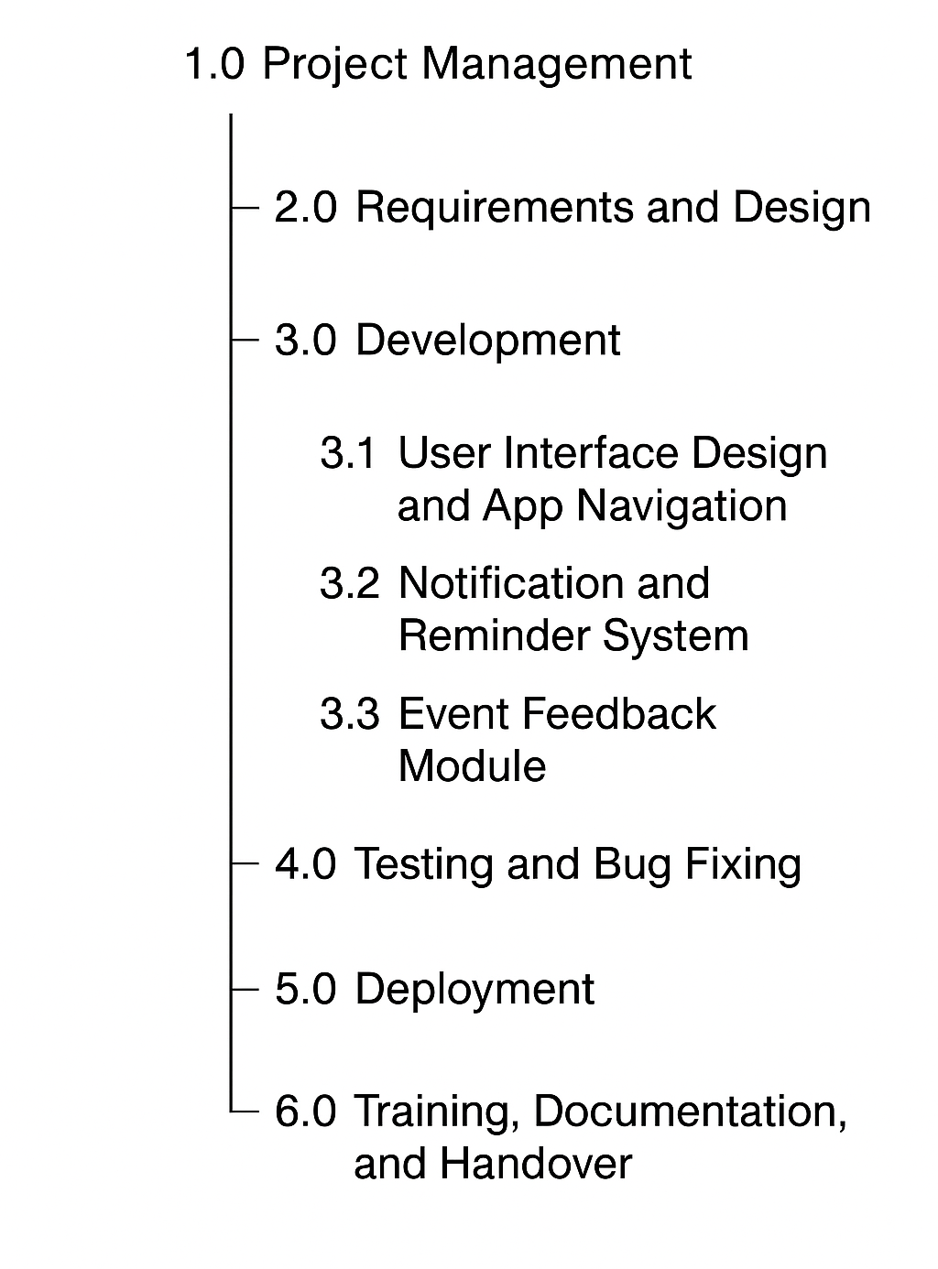
Figure 1
2.2 Agile Methodology
Agile methodology was selected because the project involves changing user expectations. Short development and sprints make it easier to test features with students and adjust quickly. However, agile also requires disciplined communication and frequent reviews, without these the scope may drift and deadlines can slip (Schwalbe, 2018). Agile also requires strong coordination to prevent uncontrolled scope changes (Project Management Institute, 2021).
2.2.1 Agile vs Waterfall Methodology
Waterfall is a step by step method where each project phase is finished before the next begins. It works best when requirements are stable and clear. This approach provides good documentation and planning, but it is not flexible. If changes are made late in the process, they can add a lot of time and cost (Kerzner, 2017). Whereas, agile uses short cycles and regular feedback, helping teams adjust as needed. This approach suits the project because the user’s needs for usability and engagement change during deployment. Agile projects need clear communication and careful scope management, since poor coordinationn can lead to budget issues (Project Management Institue, 2021). Therefore, agile methodology is the better choice because it is flexible and user focused, which fits the changing university environment.
2.2.2 Sprint Overview
Sprint 1-2: Essential requirements gathering, UI design, initial prototypes.
Sprint 3-5: Development of main mobile function.
Sprint 6-7: Development of administrative dashboard.
Sprint 8: System wide integration and API alignment
Sprint 9: Testing, debugging and quality assurance.
Sprint 10: Deployment, user training refinement.
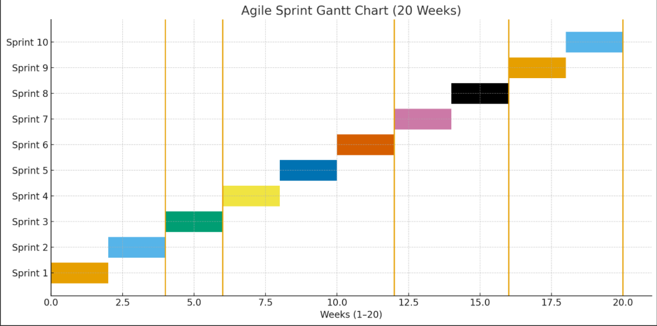
Figure 2
2.3 Budget Estimate
Category | Description | Cost
Internal labour | Developers, PM, QA tester | 12,000
Materials | Software licences, cloud hosting | 2,000
Equipment | Tesing devices, server upgrades | 3,000
Subcontract labour | UI/UX design, external tester | 3,000
Total |  | 20,000
Table 2
2.4 Risk Management Plan
Risk | Likelihood | Impact | Mitigation Strategy
Feature delays | Medium | High | Priortisation, flexible sprints
Budget overrun | Low | Medium | Strict monitoring, cost tracking
Low user engagement | Medium | High | Promotional campaigns, intuitive interface
Technical issues | Medium | Medium | Early testing, system diagnostics
GDPR concerns | Low | High | Compilance audits, secure data handling
Table 3

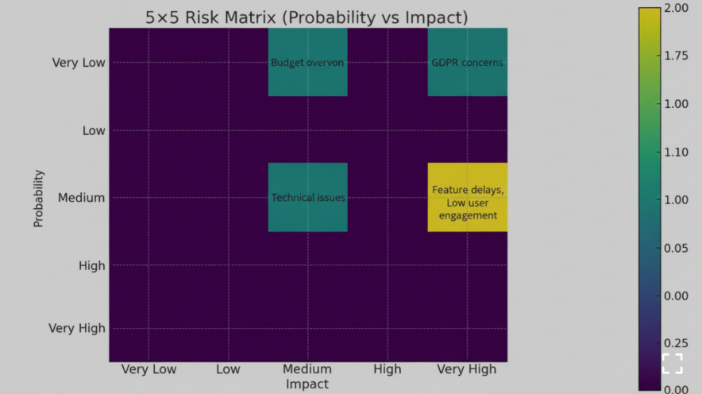
Figure 3
From the chart, we understand that:
- Feature delays managed closely with prioritising sprints.
- Monitor budget overrun, but don’t over focus on it.
- GDPR needs policies, control and audits.
2.5 Communication Plan
To guarantee agreement among all stakeholders, communication will be organised an will be consistent throughout the project. To ensure monitoring and decisiom=n making, the project manager will prepare and deliver weekly progress reports to the project sponsor, To monitor progress and promptly address problems, the development team will take part in daily scrum meetingsconducted by the Scrum Master. Through surveys and notifications organised by student affairs, students will be involved on a monthly basis providing input on usability and egagement. To ensure perfect adoption and continued system use, the project manager will oversee training and workshops for administrative staff at the endof the project.

3. EXECUTION PHASE

3.1 Strategy
Assemble a project team, including:
- 1 Project Manager
- 2 Mobile Developers
- 1 Backend Developer
- 1 UI/UX Designer
- 1 QA Tester
3.2 Resource Requirements
The software tools we need are:
- Android Studio, Xcode
- Firebase or AWS backend
- Jira for Agile management
3.3 Execution Approach
For the final stage of the execution phase, we should follow some things to ensure the needed output :
- Hold daily meetings to ensure transparency and track progress.
- Conduct regular sprint reviews and reports to improve workflow.
- Set milestones based on functional outputs, not just documentation.
- Integrate code continuously to avoid conflicts and boost efficiency.

4. MONITORING AND CONTROLLING PHASE

4.1 Key Performance Indicators (KPIs)
- App stability measured by crash free sessions..
- Number of registered and active users.
- Increase in event attendance versus previous periods.
- Number of events receiving feedback
- Sprint completion rates.

4.2 Performance Tracking
- Usage of charts to visualise progress.
- Weekly risk assessments.
- Continuous testing reports and defect tracking.
- Budget monitoring.

The project stays on track with its budget, timeline and quality standards. The project team can detect problems early and avoid significant disruptions by regularly monitoring performance, assessing risks and making time adjustments.

5. CLOSING PHASE

5.1 Evaluation of Project Success
The project will be successful if:
- Delivery occurs within the five month timeline.
- Stay within the budget of €20,000.
- All core functionality is implemented and tested.
- User acceptance testing shows high satisfaction.
- Strong adoption is observed during the first month.

5.2 Stakeholder Feedback Strategies
- Post deployment surveys.
- In-app meetings with administrative staff.
- Debriefing meetings with administrative staff.
- A formal lessons learned workshop.

The project is completed in a structured and official manner during the closing phase. Inorder to identify recommendations learnt for upcoming projects, all deliverables are validated, unfinished tasks are completed and feedback is gathered. This stage ensures that the documentation is finished, the system is successfully transferred to stakeholders and the project is formally approved.

CONCLUSION

This project plan provides a clear and organised approach to designing and building a University Event Management Mobile Application. It addresses the need for better communication, engagement and efficiency at the university. This proposed solution targets the drawbacks of traditional event management methods by universities and other organisations. The project demonstrates how established project management methods can be used in practice. It ensures clear scope, realistic scheduling and careful resource management. Using agile method allows flexibility, ongoing stakeholder input and early risk detection.
A well defined goal, measurable objectives, detailed deliveravbles and a strong risk managemnt strategy, all build the foundation for a transformatiom objectives are supported by the focus on user centered design, automated procedures and evidence based feedback procedures. The application’s efficiency can be continuously assessed and improved sfter deployment.
Overall, this project plan not only sugests a workable technological solution, but also highlights the strategic importance of effective project management in achieving organisational goals. If everything goes according to plan, the University Event Management Mobile Application could increase student participation, minimise administrative issues and improve the whole campus event experience. As a result, the project is an investment in instituitional efficiency and technological and digital innovation.

REFERENCES

- Kerzner, H. (2017) Project Management, Google Books. Available at: https://books.google.de/books?hl=en&lr=&id=JRlHEQAAQBAJ&oi=fnd&pg=PR1&dq=Kerzner%2C%2BH.%2B%282017%29%2BProject%2BManagement%3A%2BA%2BSystems%2BApproach%2Bto%2BPlanning%2C%2BScheduling%2C%2Band%2BControlling.%2B12th%2Bedn.%2BWiley.&ots=eegJZ3J4Uk&sig=iPM4NEughcahhGkan70Twrk5uSQ#v=onepage&q&f=false (Accessed: 10 December 2025).
- Project Management Institute (2021) PMBOK GUIDE. Available at: chrome-extension://efaidnbmnnnibpcajpcglclefindmkaj/https://tegnum.edu.pe/wp-content/uploads/2023/09/Project-Management-Institute-A-Guide-to-the-Project-Management-Body-of-Knowledge-PMBOK-R-Guide-PMBOK%C2%AE%EF%B8%8F-Guide-Project-Management-Institute-2021.pdf
- Schwalbe, K. (2018) Copyright 2021 Schwalbe Pub ishing An Jutroduction to project. Available at: chrome-extension://efaidnbmnnnibpcajpcglclefindmkaj/https://pmtexts.com/wp-content/uploads/2021/08/schwalbe-intro-pm-7e-sample-chapter-1.pdf (Accessed: 10 December 2025).
- Slack, N., Brandon-Jones, A. and Burgess, N. (2022). Operations Management. [online] Available at: chrome-extension://efaidnbmnnnibpcajpcglclefindmkaj/https://api.pageplace.de/preview/DT0400.9781292408217_A43165390/preview-9781292408217_A43165390.pdf
- Sommerville, I. (2016). Software Engineering Tenth Edition. [online] Available at: chrome-extension://efaidnbmnnnibpcajpcglclefindmkaj/https://dn790001.ca.archive.org/0/items/bme-vik-konyvek/Software%20Engineering%20-%20Ian%20Sommerville.pdf

BIBLIOGRAPHY

Figures
- Work Breakdown Structure
- Agile Sprint Gantt Chart
- Probability vs Impact in Risk Management
Tables
- Stakeholder Identification
2. Cost Estimation
3. Risk Management Plan

